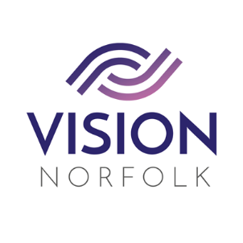

Volunteering Opportunities
Role Title: | Hub Volunteer
Hours and Location: | Flexible Mon – Fri , (Great Yarmouth, Kings Lynn, Norwich)
About the organisation: | We are Vision Norfolk and our mission is to support people living with sight loss to enjoy active, independent and fulfilled lives.
About the role: | Our Hub Volunteer role is very important in assisting us with delivering the services and activities that support people living with sight loss in our County (area)  The Hubs offer a wide range of information, signposting, equipment, services, support and activities.  We are looking for Volunteers who would be interested in supporting with daily running of the Hubs, whether it is supporting with running an activity, learning about and supporting clients around equipment or some reception work then we will give you all the training you need. No two days are the same and you get a great buzz when you finish a session knowing that you have Provided the support, information or face to face contact that really makes a difference to someone’s day to day life.
Main Responsibilities | - Hub Volunteers will support with the day to day running of the Hub, making phone calls, provide information, support with Equipment and the delivery of activities within the Hub
General Responsibilities: | - Telephone the Hub Coordinator as soon as possible, if unable to fulfil your commitment so that replacement cover can be arranged.  - Maintain strict confidentiality at all times.  - Adhere to the Vision Norfolk volunteer policies and procedures  - Be kind and courteous when you are representing Vision Norfolk.  - The role would be in your local Hub, but the use of a car could be beneficial depending on what aspect of running the Hub you wished to be involved in.
Skills / Experience needed: | We are looking for personable and approachable volunteers who are enthusiastic about the work we do here at Vision Norfolk and confident with speaking to members of the Public.  Our volunteers will be  - Able to work both independently and as part of a team.  - Empathetic with Vision Norfolk’s cause and committed to our aims and objectives.  - Well organised with strong verbal and written communication skills.  - be friendly and approachable
Benefits of Volunteering in this role: | Becoming a Hub Volunteer gives you the chance to:  - Give a huge boost to your social skills and confidence  - Experience the camaraderie and fun of being part of our team  - Learn new skills and take part in training  - Do something good for local people  Vision Norfolk also offers:  - Ongoing support and training (including Visual Awareness Training).  - Payment of out of pocket expenses agreed in advance
Contact details: | If you would like to discuss the opportunities we have Vision Norfolk, please contact the Volunteer Coordinators on 01603 573000:  Jo Howard (Norwich & South Norfolk) ext 407  Penny Whitby (West Norfolk) ext 406  Catherine Bond (East Norfolk) ext 325  Email: volunteers@visionnorfolk.org.uk

