Vision Norfolk
Magpie News – Autumn 2023

Welcome to the autumn edition of Magpie News with updates from Vision Norfolk, your local sight loss charity.
If you would like this newsletter in another format please let us know by calling 01603 573000 or emailing office@visionnorfolk.org.uk. Magpie News is currently available by mail in printed, Braille, or audio on a memory stick or CD. A digital format is also available on our website and by email as a Word Document or a PDF

Celebrating Our Volunteers
On Thursday 8th June around 30 volunteers joined staff members for our annual outing to celebrate the contributions made by our volunteers as part of National Volunteers Week. Attendees had the opportunity to enjoy coffee and pastries aboard a train pulled by a 1959 ‘Black Prince’ steam locomotive. The trip was on the Poppy Line from Holt to Sheringham and included free time in Sheringham before the return journey.
We would not be able to provide our services without the support of our dedicated volunteers who help to run activities, provide guiding, provide transportation, volunteer as telefriends, support fundraising activities and provide support for our Children, Young People and Families Service. If you or someone you know is interested in volunteering for Vision Norfolk you can contact volunteers@ visionnorfolk.org.uk or call your local hub (details at the end of the newsletter). We need volunteers for all roles but are particularly looking for drivers in the Fakenham, Emneth and Norwich area; activities volunteers for the Fakenham Coffee morning; sighted guides for outings across the county and volunteers to help with activities for children and families.

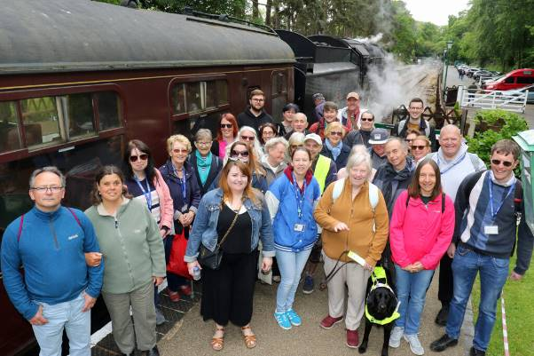
Image: The group of around 30 volunteers and Vision Norfolk staff at the annual volunteer outing. They are standing on the platform in front of a dark red and black steam train smiling at the camera

In This Edition
Vision Norfolk News - Updates from your local sight loss charity Community
Hub Updates - News from each of our community hubs in Norwich, King’s Lynn and Great Yarmouth
Children, Young People and Families - Learn about our service for local people ages 0-25 and their families
Equipment News - Updates about equipment and technology including events and tips
Activities - List of activities and events coming up over the next few months across the county
Other Things - Other opportunities, appeals for feedback and equipment for sale Contact Details Find out how to reach us with your questions

Community Outreach Workers
We are pleased to announce that we have launched our new Community Outreach Service which aims to provide emotional and practical support to vision impaired people in their local community.
Our friendly team of Community Outreach Workers will provide a range of support services designed to help anyone experiencing sight loss to live a more independent lifestyle. The type of support on offer includes:
- Assistance and advice on welfare, benefit and housing applications
- Information and advice on the latest assistive technology and equipment for your home
- Providing support to reduce loneliness and isolation
- Information and advice on specific eye conditions and helpful tips to make the best of remaining vision
- Support for families, friends and carers
- Identifying additional support needs and signposting to other relevant services
To contact a member of our Community Outreach Team please call 01603 573000.

Charity Christmas Cards
Our thanks goes out to everyone who participated in this year’s Christmas Art Competition! We really enjoyed seeing all your lovely artwork.
The winning designs will be printed on our 2023 Christmas cards that are sold to raise funds to support our services for local people. The cards will be available for purchase from October to December at the Original Norwich Charity Christmas Card Shop at St Peter Mancroft (across from the Forum in Norwich) and at our community hubs in Norwich, King’s Lynn and Great Yarmouth.
With the wonderful response we’ve had to the competition we hope to hold another art competition for designs to appear on our 2024 Christmas cards.
More details coming soon.

Winning Designs
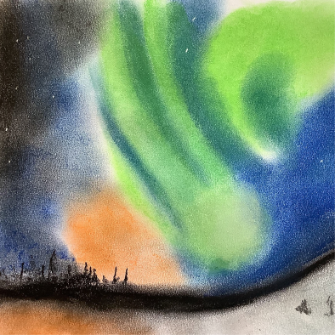
Image: Drawing of the green, blue and orange Northern Lights behind the black outline of trees. Artist: Roy Meredith

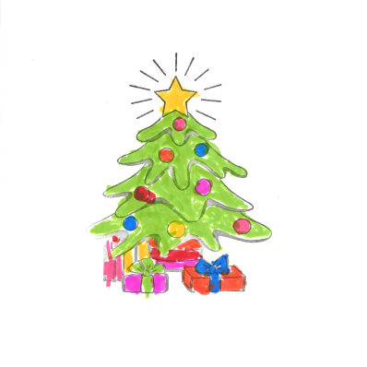
Image: Stamped outline of a decorated Christmas tree with presents and a star on top. Coloured in with felt tip pens in bright green, yellow, pink, orange, red, purple and blue. Artist: Rhiannon (Age 6)

Other Entries

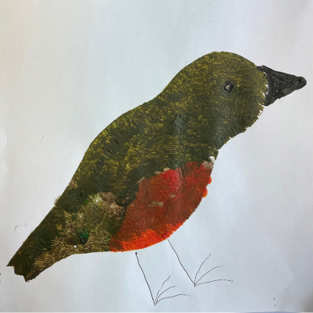
Image: Brown and red robin painted on white paper. It has a black beak and eye and legs drawn on with pen. Artist: Maggie Duffy

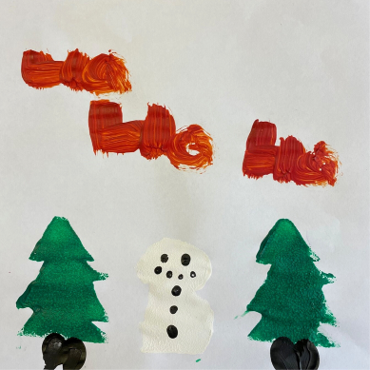
Image: A snowman and two evergreen trees painted on white paper. At the top of the image “ho ho ho” is written in red paint. Artist: Kelci Batch

Image: A Christmas tree with red and blue sparkly ornaments and a sparkly star on brown patterned paper. There is a sparkly red bow in the top left corner. Artist: Paige Simonds

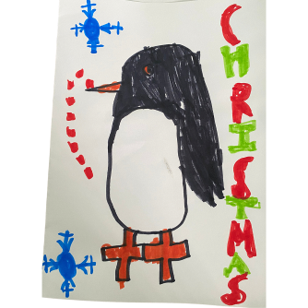
Image: A penguin with an orange beak and feet drawn with marker on white paper. There are two snowflakes on the left and the word “Christmas” in red and green on the right. Artist: Evie

Norwich Hub Updates

What We’ve Been Up To
Over the spring and summer our long distance walking group have been very active. Average distance covered per walk is about four miles.
We have been very fortunate this year in that most of our walks have been educational as well. An early morning stroll through RSPB Nature Reserve Lakenheath Fen to listen to the bird song resulted in us hearing 53 different types of birds singing their hearts out. We know this because our guide from the British Trust for Ornithology listed them all for us. Thank you to the Brecks Council for organising our visit.
We also went to the Thetford Arboretum at Lindford at the invitation of the Forestry Commission. There we found out about the work they do making sure there are healthy trees and forests across the country. A trip to Redwings Horse and Donkey Sanctuary at Aylsham, gave our clients a chance to get up close and stroke various horses, donkeys and goats. Some for the very first time.

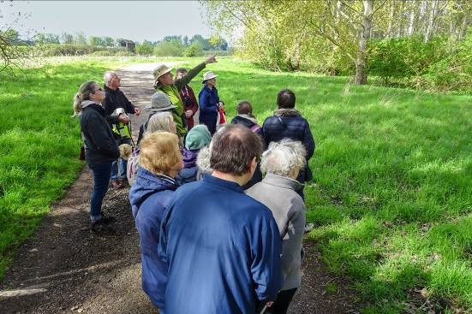
Image: A group of about thirteen people from behind. They are standing on a pathway in a sunny field in Lakenheath Fen. The guide is pointing up towards a nearby collection of trees.

Coming up
We have a very busy autumn coming up at the Norwich Hub.
On Thursday 5th October, back by popular demand is Quiz and Chips. This time to add a little bit of spice to proceedings, as if any extra were needed, it’s an inter-hub competition. Teams of no more than four people, but don’t worry if you don’t have three vision impaired friends, teams will be made up on the day.
On Friday 13th October, Richard Mathew from the Norwich Society, will be coming along to the Norwich Hub to give a talk on the historic Dragon Hall. This will take place immediately after the Macular Society have had their monthly get together. If you have Macular Degeneration why not come along at 12 noon and join in with their meeting first? Richard Mathew will be there from 1pm.
On Thursday 2nd and 16th November, Rebecca Amphlett from Dragon Mosaics will be making a very welcome return. Clients will be able to make a Christmas themed tesserae decoration. You must be able to make both dates to complete their decoration.
All events listed must be booked in advance with Richard Polley on 01603 57300 Ext. 322 or richard.polley@visionnorfolk.org.uk.

King’s Lynn Hub Updates
Tandem Cycling
We are delighted to be working with the West Norfolk branch of Cycling UK to offer the opportunity for our clients to try tandem cycling. From short taster sessions to longer cycle rides we have something to suit everyone.
Our clients have told us they are enjoying the freedom of being back on a bicycle, the fresh air, lovely countryside and the coffee stop along the way.

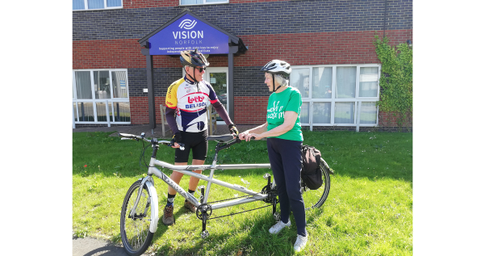
Image: A man and a woman standing next to a tandem bicycle in front of the King’s Lynn Hub.

Sound and Vision Choir
The Vision Norfolk Choir, also known as Sound and Vision, are delighted to welcome their new tutor Helen Havis.
Helen started with the choir in July. Helen and the choir are working on a full list of songs to incorporate a range of musical tastes and styles. The choir is currently working on the songs ‘A Million Dreams’ from the Greatest Showman, ‘Walking on Sunshine’ by Katrina and the Waves and ‘Let it Be’ by The Beatles.
The fun and friendly sessions take place fortnightly on a Wednesday from 1pm until 3pm at the Workshop in Kings Lynn.

Stody Lodge
On Tuesday 23rd May a group from the King’s Lynn Hub took a trip out to enjoy the azaleas and water gardens in the beautiful grounds of Stody Lodge.
The colourful and scented gardens were a spectacular feast for the senses and along with the lovely sunshine and tasty homemade ice creams made it a memorable day.

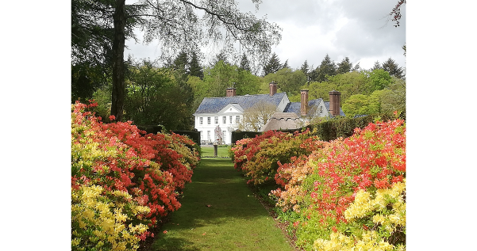
Image: A straight grass pathway lined with pink and yellow flowers ending at the large white building that is Stody Lodge.

More Members Welcome
We are looking for more clients to get involved in the following activities:
- Knitting
- Shuffleboard
- Choir
- Tandem cycling
- Sit Fit (in Downham Market)

Great Yarmouth Hub Updates

We have had a very busy few months both in and out of the Great Yarmouth Hub. We have welcomed several new members and always looking for more. If anyone would like to volunteer to help us support our growing client base, or know someone who might, please do contact us for further details.

Summer Adventures
In early July we took a group to the Lavender Farm in Heacham for a sensory experience and then a day at the seaside in Cromer crabbing on the pier. The Great Yarmouth Hub were again invited to fundraise at the Great Yarmouth Racecourse in August, and similar to last year it was tremendous success raising over £300.

New Activities and Events
As autumn now approaches we will be introducing a new cookery activity that will run monthly in the hub. In addition, we are continuing with our Clip n’ Climb sessions at the Marina Centre in Great Yarmouth.
In the next few months we hope to be taking a group to Bressingham Steam and Garden, Fritton Owl Sanctuary, Diss Aviation Museum, Time and Tide Museum in Great Yarmouth and also the Robin Hood pantomime at St George’s Theatre in Great Yarmouth.

Walk Norfolk 2023
We are excited to have been given the opportunity to collaborate with our friends at Pathmakers again this year and in October they will be taking a group from each of our hubs around the sights of Great Yarmouth to experience everything it has to offer.

Find more information on our upcoming activities later in this newsletter or by getting in contact.
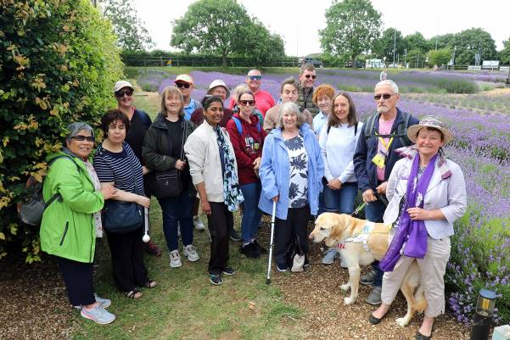
Image: A group of 17 participants, volunteers and staff members, as well as one guide dog, standing outside at the Norfolk Lavender Farm. The group is smiling at the camera and there are fields of lavender in the background.

Children, Young People and Families
The CYPF Service organises activities and events to improve confidence and encourage independence. By including the whole family, we empower these families through shared experience and knowledge and build lifelong friendships.
Since the last edition, the CYPF department have taken the children and their families to the Norfolk Snowsports Centre for snow tubing, the Great Yarmouth Sea Life Centre and the Hippodrome Circus. These were great fun and was wonderful to see so many people enjoying the sessions.
In the coming months we would like to continue to reach more families across the county with the focus of running more events in the Great Yarmouth and King’s Lynn areas. We are starting a new preschool group for Great Yarmouth in the near future, as well as bowling groups and a trip to Hunstanton Sea Life Centre.
Some of the future events we are running later this year are:
- Snow tubing at Norfolk Snowsports Centre
- Laboratory Media music session
- Christmas party with Captain Fantastic
- Sleeping Beauty Christmas Panto at the Norwich Theatre Royal
- Christmas train ride with a visit from Santa
For more information please email Josh at cypf@visionnorfolk.org.uk or call 01603 573000 Ext. 505.
In order for the CYPF Service to expand the activities that we offer across the county, we need volunteers to help support the amazing and fun events. DBS checks need to be completed so volunteers are able help out when needed. If you or someone you know would like to volunteer please email volunteers@ visionnorfolk.org.uk.

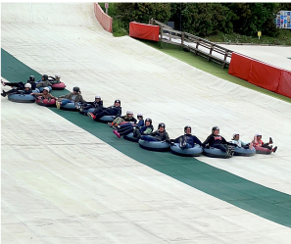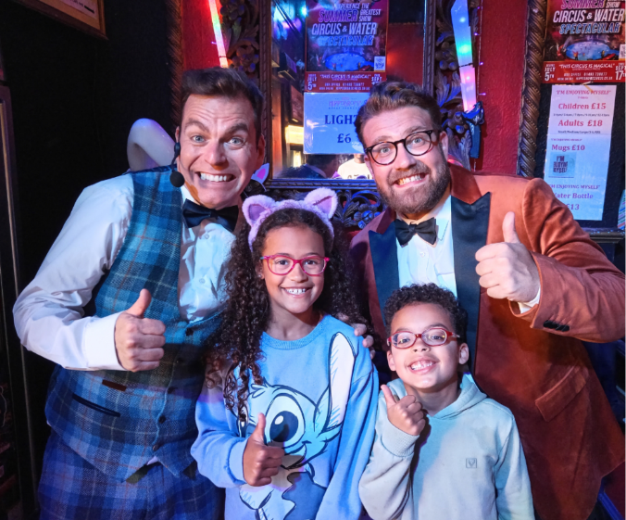
Image: Left - A long chain of 16 children staff and volunteers slide down the slope holding hands. Right - Two children posing with two hosts from the Hippodrome Circus. All four have big smiles and are showing a thumbs up. The hosts are wearing bright formalwear and bowties. They are standing in front of lights, signs and a mirror inside the circus.

Equipment News

Technology Sessions
We have partnered with RNIB to hold digital technology sessions for local people with visual impairment. These are one to one problem solving days to help you with any issues you are having with digital technology and devices.
Sessions will take place at the Norwich Hub on the 25th September, 30th October and 27th November.
Appointments last 20 minutes each and must be pre-booked with Richard by calling 01603 573000 Ext. 322.

Tech Tip: Be My Eyes App
The Be My Eyes App is a free app available on iOS and Android devices. It connects blind and partially sight people to sighted volunteers across the globe through a live video connection.
You can use your camera-enabled smartphone to request instant video support with basic tasks at any time, day or night. It allows for free unlimited calls and is anonymous.
Common tasks that people request help with include: checking expiration dates, distinguishing colours, reading instructions, navigating new surroundings, sorting laundry and more.
You can find the app by searching for “Be My Eyes” in the Apple or Google Play store on your smart phone or tablet.

Vision Zone 2023 – Solutions for low vision
Join Vision Norfolk, Optelec UK and Blind Veterans for a drop in chat and technology demonstration.
Come along to our open day where you can meet your local society learn about the support we can offer you and activities you can join. Gain hands on experience with products and technology with a consultant taking you through the different solutions when it comes to day-today activities.
There will be an opportunity to learn more about electronic magnifiers, reading machines, desktops and much more. Blind Veterans will also be there to talk about the guidance they can give in rebuilding lives after sight loss.
Monday 11th September – 10am to 2pm at the Norwich Bradbury Activity Centre, Beckham Place, Edward Street, Norwich, NR3 3DZ
Tuesday 12th September – 10am to 2pm at the Great Yarmouth Hub, 12 Hall Quay, Great Yarmouth, NR30 1HP
Wednesday 13th September – 10am to 2pm at the King’s Lynn Hub, Unit 3 Dundee Court, Hamburg way, King’s Lynn, PE30 2ND.

Activities

Following is the list of activities that are currently available for adults across the county. Please contact CYPF@visionnorfolk.org.uk for activities for children and young people. All of our activities are free of charge unless otherwise stated.
Please contact your local hub for the latest updates on activities.

Norwich and South Norfolk
Unless otherwise stated please contact Richard at 01603 573000 Ext. 322 or richard.polley@visionnorfolk.org.uk.

Regular Activities
Arts and Crafts – Norwich, Thursdays 10am-12:30pm
Undertake a variety of arts and crafts with support from Helen and the volunteers. Contact Mark on 01603 573000 Ext. 341 or mark.smith@visionnorfolk.org.uk.
Audiobook Clubs
Our friendly, informal audiobook clubs offer a chance to get together and enjoy a chat about a chosen book. The book clubs are free to join and we can supply a memory stick player if you don’t have one. Contact Mark on 01603 573000 Ext. 341 or mark.smith@visionnorfolk.org.uk.
Diss Audiobook Club – 4th Friday of the Month, 2pm-3:30pm
Norwich Audiobook Club – 2nd Monday of the Month, 1:30pm-3pm
Boccia – Norwich, 1st and 3rd Friday of the Month, 10am-12pm
Join us for a session of the competitive precision ball sport boccia, open to all abilities and levels of experience.
Bowling – Norwich, 2nd and 4th Friday of the Month, 12:15pm-3:30pm
Come and enjoy some friendly competition with ten pin bowling at Namco Funscape. Transportation available from the Norwich Hub. Regular bowling fee to be paid to Namco Funscape.
Creative Writing – Norwich, 3rd Tuesday, 2pm-3:45pm
Join a creative writing group that will give you the opportunity to express yourself through the written word. Contact Mark on 01603 573000 Ext. 341 or mark.smith@visionnorfolk.org.uk.
Darts – Norwich, 1st and 3rd Friday of the Month, 1pm-3pm
Join us for a few friendly games of darts. Volunteers are around to help you position or read the numbers on the board if needed.
Macular Society – Norwich, 2nd Friday of the Month, 12pm-1:30pm
This group is organised and run by the Macular Society at the Norwich Hub. Vision Norfolk staff usually gives an update on new equipment and activities and there are sometimes guest speakers.
Norwich Coffee Morning – Last Monday of the Month, 10am-11:30am
Come and enjoy a cup of coffee, a slice of cake and a chat about everything and anything.
Photography Group – Norwich, 1st and 3rd Friday of the Month, 1:30pm-3:30pm
The first meeting in each month is an outdoor photoshoot and the second is an indoor opportunity to review photographs. Some outings may have a cost for refreshments. Contact Mark on 01603 573000 Ext. 341 or mark.smith@visionnorfolk.org.uk.
Sailing – Norwich, Fortnightly, 12:30pm-5pm
Come and enjoy an afternoon of boating on the Norfolk Broads with the Nancy Oldfield Trust. From April to October the group goes out sailing and during winter months they go out on an undercover motor cruiser. Trips cost £17 per person. Contact Mark on 01603 573000 Ext. 341 or mark.smith@visionnorfolk.org.uk.
Tandem Cycling – Norwich, By Appointment Tandem cycling allows you to continue to enjoy a good (and safe) bike ride regardless of your vision loss.

Special Events
Guided Walks
We try to organise walks of various lengths when the weather is nice. Please get in contact for more details.
Inter-Hub Quiz and Chips – Norwich, 5th October, 1:15pm-4pm
Join the Norwich Hub for an inter-hub quiz. Come along and enjoy a fun quiz time and some chips too. Costs £5 per person including chips.
Dragon Hall Talk – Norwich, 13th October, starting at 1pm Richard Mathew from the Norwich Society, will be coming along to the Norwich Hub to give a talk on Norwich’s historic Dragon Hall.
Felbrigg Hall Visit – Felbrigg, 25th October, leaving at 11am
Join us on a trip to explore the historic Felbrigg Hall. Lunch and an early afternoon introductory talk will be available as well as an opportunity to explore the house. There is a new guide book available in Braille for those of you who are Braille readers. Contact Mark on 01603 573000 Ext. 341 or mark.smith@visionnorfolk.org.uk.
Walk Norfolk - Great Yarmouth, 30th October, 10am-3pm
A facilitator from Pathmakers will be leading a walk in Great Yarmouth. Transportation can be provided from all Vision Norfolk hubs.
Mosaics Workshops – Norwich, 2nd and 16th November. Time to be Confirmed Rebecca Amphlett from Dragon Mosaics will be making a very welcome return to the Norwich Hub. You will be able to make a Christmas themed tesserae decoration. You must be able to make both dates to complete your decoration.
GardenEyes Annual Meal – Norwich, November. Further Details to be Confirmed
During mid to late November we will be holding our annual GardenEyes meal at the Norwich City College. Date, time, and cost to be confirmed. Contact Mark on 01603 573000 Ext. 341 or mark.smith@visionnorfolk.org.uk.
Northern Ballet’s Beauty and the Beast –Norwich, 25th November, 2:30pm-5pm. Must be booked by 13th October. Northern Ballet bring their signature sparkle to this timeless love story. Choreographed by David Nixon CBE and set to a hand-picked score of classic music from the likes of Bizet and Debussy. Tickets cost £49.50. Contact Mark on 01603 573000 Ext. 341 or mark.smith@visionnorfolk.org.uk.
Christmas Flower Arranging Session – Norwich, 11th December, 10am-12:30pm
We will be holding a Christmas flower arranging session at the Bradbury Activity Centre. Come and join flower arrangers Hazel and Crystal to make a Christmas wreath and flower swag, over a coffee and mince pie. Contact Mark on 01603 573000 Ext. 341 or mark.smith@visionnorfolk.org.uk.
Christmas at Strangers’ Hall Museum – Norwich, 13th December, 10:30am-12:30pm
Must be booked by 1st December. The Heritage Group will be visiting Strangers’ Hall to hear a talk by curator Bethan Holdridge about how Christmas was celebrated back in medieval times. The session includes the opportunity to handle items and visit all the various rooms inside the museum. Contact Mark on 01603 573000 Ext. 341 or mark.smith@visionnorfolk.org.uk.
Sleeping Beauty Pantomime – Norwich, 28th December, 2:30pm-5pm
Must be booked by 22nd September. Sleeping Beauty, that famous story, a prince’s kiss the saving glory? With opportunity to boo and hiss, but will the prince and princess kiss? Tickets cost £40. Contact Mark on 01603 573000 Ext. 341 or mark.smith@visionnorfolk.org.uk.
Agatha Christie’s And Then There Were None – Norwich, 1st February 2024, 2:30pm-5pm
Must be booked by 8th December. Ten strangers are lured to a solitary mansion off the coast of Devon. When a storm cuts them off from the mainland, the true reason for their presence on the island becomes horribly clear. Directed by Lucy Bailey this brand-new production of the bestselling crime novel of all time will keep you on the edge of your seat. Tickets £38.50. Contact Mark on 01603 573000 Ext. 341 or mark.smith@visionnorfolk.org.uk.

West Norfolk
Unless otherwise stated contact Abigail at 01553 660808 or kingslynnhub@visionnorfolk.org.uk.

Regular Activities
Archery - Downham Market, 1st Monday of the month, 4pm-6pm
Sight loss doesn’t need to prevent you from trying new and exciting things. Join one of our archery sessions designed to be accessible for all abilities and skill levels.
Art Workshops – King’s Lynn, 1st Friday of the Month, 2pm-3pm
Starting in September we are holding small art workshops with painting, print making, collage and more.
Audiobook Clubs
Our friendly, informal audiobook clubs offer a chance to get together and enjoy a chat about a chosen book. The book clubs are free to join and we can supply a memory stick player if you don’t have one. Contact Mark on 01603 573000 Ext. 341 or mark.smith@visionnorfolk.org.uk.
Dereham Audiobook Club – 3rd Wednesday of the Month, 10:30am-12pm
Fakenham Audiobook Club - 3rd Monday of the Month, 10:30am-12pm
Gaywood Audiobook Club – 1st Thursday of the Month, 2pm-3:30pm
Choir – King’s Lynn, Fortnightly on Wednesday, 1pm-3pm
Join the Vision Norfolk Choir to improve your mental wellbeing, meet new people and most importantly have fun.
Coffee Mornings and Socials
Come and enjoy a cup of coffee, a slice of cake and a chat about everything and anything at one of our socials.
Emneth Coffee Morning – 3rd Thursday of the Month, 2pm-4pm
Free to attend but any refreshments must be purchased from the café.
Downham Market Social – 4th Wednesday, 11am-1pm
Fakenham Coffee Morning – 4th Tuesday of the Month, 10am-12pm
Free to attend but any refreshments must be purchased from the café.
West Norfolk Coffee Morning – King’s Lynn, 1st Wednesday and 3rd Tuesday of the Month, 10am-12pm
Free to attend but any refreshments must be purchased from the café.
West Norfolk Men’s Group - King’s Lynn, 2nd Monday of the Month, 12pm-2pm
Special activities paid for by the group directly.
Knitting – King’s Lynn, 2nd Tuesday of the Month, 1:30pm-3:30pm
Whether you are a complete beginner who would like to take up knitting or a seasoned knitter, our sessions are a fun and sociable way of getting together with fellow yarn fans.
Sit Fit – Downham Market, 3rd Friday of the Month, 1:30pm-3:30pm
A seated exercise class suitable for all adults regardless of age, gender or ability.
Tandem Cycling – King’s Lynn, By Appointment
Tandem cycling allows you to continue to enjoy a good (and safe) bike ride regardless of your vision loss. A sighted guide sits at the front to steer and describe.

Special Events
Guided Walks
We try to organise walks of various lengths when the weather is nice. Please get in contact for more details.
Inter-Hub Quiz and Chips – King’s Lynn, 5th October, 2pm-4pm
Join the King’s Lynn Hub for an inter-hub quiz. Come along and enjoy a fun quiz time and some chips too. £5 per person including chips.
Walk Norfolk - Great Yarmouth, 30th October, 11am-2pm
A facilitator from Pathmakers will be leading a walk in Great Yarmouth. Transportation can be provided from the Vision Norfolk hubs in Great Yarmouth and King’s Lynn.

East Norfolk
Unless otherwise stated please contact Catherine at 01493 745973 or greatyarmouthhub@visionnorfolk.org.uk.

Regular Activities
Audiobook Clubs
Our friendly, informal audiobook clubs offer a chance to get together and enjoy a chat about a chosen book. The book clubs are free to join and we can supply a memory stick player if you don’t have one. Contact Mark on 01603 573000 Ext. 341 or mark.smith@visionnorfolk.org.uk.
Great Yarmouth Audiobook Club – Last Friday of the Month, 1:30pm-3pm
Cromer Audiobook Club – 3rd Monday of the Month, 2pm-3:30pm
Bingo – Great Yarmouth, 3rd Tuesday of the Month, 10am-12pm
Try your luck at one of our Bingo sessions with prizes available for winners. Costs £5 per person. Money raised goes towards the Bingo prizes and the hub Christmas party. The December session will be a week early on 12th December.
Bowling – Great Yarmouth, Last Tuesday of the Month, 12pm-3pm
The Great Yarmouth hub runs group bowling trips to Wellington Pier. We are asking for a £5 refundable deposit. There will be no session in December.
Clip n’ Climb – Great Yarmouth, Monthly on a Thursday (19th October, 23rd November, 14thDecember), 3pm-4pm
Clip n’ Climb is made up of a number of unique climbing elements at the indoor climbing gym at the Great Yarmouth Marina Centre.
Coffee Mornings and Socials
Come and enjoy a cup of coffee, a slice of cake and a chat about everything and anything at one of our socials.
Great Yarmouth Coffee Morning – Wednesdays, 10am-12pm
Cromer Coffee Morning – Last Wednesday of the Month, 10am-1pm
Contact John at 01603 573000 Ext. 323 or john.morland@visionnorfolk.org.uk.
Cooking and Eating Sessions – Great Yarmouth, 2nd Monday of the Month, 10am-12pm
We will be starting with pizzas, cakes, biscuits and other food that you can prepare to your individual liking and then staff will cook the food in the air fryer and we can all enjoy together.
Games Morning – Great Yarmouth, Thursdays, 10am-12pm
We usually play a variety of dominoes and card games.
Weaving Group – Great Yarmouth, Fridays, 10am-12pm
We use different types of soaked cane to make baskets of all shapes and sizes.

Special Events
Guided Walks
We try to organise walks of various lengths when the weather is nice. Get in contact to find out more.
Time and Tide Museum – Great Yarmouth, 2nd October, Tour Starting at 11am
This is a touch tour visit to the Bare Bones Exhibition at the Time and Tide Museum. The exhibition invites visitors to explore the beauty, and secrets, of animal skeletons. We are asking for a £5 refundable deposit.
Inter-Hub Quiz and Chips – Great Yarmouth, 5th October, 2pm-4pm
Join the Great Yarmouth Hub for an inter-hub quiz. Come along and enjoy a fun quiz time and some chips too.
Norfolk and Suffolk Aviation Museum – Bungay, 10th October, Times to be Confirmed
A trip to Norfolk and Suffolk’s Aviation Heritage Centre in Bungay where we will be having a tour and lunch. We are asking for a £5 donation towards the museum for hosting us.
Walk Norfolk - Great Yarmouth, 30th October, 11am-2pm
A facilitator from Pathmakers will be leading the walk in Great Yarmouth. Transportation can be provided from all Vision Norfolk hubs.
Great Yarmouth Hub Service Users Christmas Party – Great Yarmouth, 19th December, Times to be confirmed
Time for the Great Yarmouth service users to enjoy some festive food and refreshments. Further details to be confirmed.
Robin Hood Pantomime – Great Yarmouth, 21st December, starting at 1pm We are running another trip to the St George’s Theatre pantomime this year which is Robin Hood. Seats are priced at £12.

Other Things

Feedback
Possible Activities
From time to time we receive requests for new activities and if any readers are interested in the below list of possible activities, please call Mark on 01603 573000 Ext. 341. We also run a separate leisure activities mailing list with monthly updates on various outings and visits for the Gardening, Heritage, Photography and Theatre groups, so let Mark know if you would like to receive this in your chosen format.
- A monthly meeting for a crossword puzzle group in the Holt area
- A session at the Norwich Rage Rooms
- Horse riding sessions
- Lunchtime pub or breakfast group
- Tennis sessions
- An online virtual bridge club

Glaucoma Support Group
We have been requested to start a self-help group for those suffering from Glaucoma. Glaucoma is the second most common eye condition that results in poor sight, after Macular Degeneration. Is this group something you would be interested in joining? Please let Richard know your thoughts at 01603 573000 Ext. 322.

Motorsport with the Sporting Car Club of Norfolk
There may be passenger opportunities for keen vision impaired motor sports enthusiasts to be a passenger in a car competing in an autsolo or taking part in a production car trial.
Being a passenger is not a passive experience and can involve active participation particularly in a trial when you will be asked to bounce up and down to help the car get traction on slippery ground. Autosolos are driven in a forward gear, through a course of cones in accordance with the course map. Most drivers do this in first gear but it is still quick, exciting and can involve going sideways.
Production car trials are off road on grassy hillsides, which can get rather muddy by the end of the day. The aim is to gain zero points by driving up a twisty course on the hillside between lines of stakes, each of which are numbered for 12 to 0.
If you would like to know more or if you are interested in taking part please contact Mark on 01603 573000 Ext. 341.

Merlin Ultra For Sale
Gordon Mills is looking to sell his used a Merlin Ultra 24 inch full HD Video magnifier with the stand. The cost is £1500 and it can be delivered. Please contact Gordon for more details by calling 07962783294 or emailing Ga.mills@outlook.com.

Norwich Phab Club
The Norwich Phab Club is a free local community group open to people with disabilities. They meet on Mondays from 7pm until 8:30pm at Hellesdon Community Centre, Woodview Road, NR6 5QB to socialise and create music. They have a number of members with sight loss and would welcome anyone else who would like to come along. For more information contact Martin Fuller by calling 01603404558 or emailing anneandmartinfuller@gmail.com.

Contact Information

For further information on how we can support you and how you can get involved:
Website: visionnorfolk.org.uk
Telephone: 01603 573000
Email: office@visionnorfolk.org.uk

Our hubs can be found at:

Norwich
Bradbury Activity Centre, Beckham Place Edward Street, Norwich, NR3 3DZ
Telephone: 01603 573000
Email: office@visionnorfolk.org.uk

King’s Lynn
Unit 3, Dundee Court, Hamburg Way King’s Lynn, PE30 2ND
Telephone: 01553 660808
Email: kingslynnhub@visionnorfolk.org.uk

Great Yarmouth
12 Hall Quay, Great Yarmouth, NR30 1HP
Telephone: 01493 745973
Email: greatyarmouthhub@visionnorfolk.org.uk

Registered charity no. 207060

