Vision Norfolk Annual Review 2022 - 2023
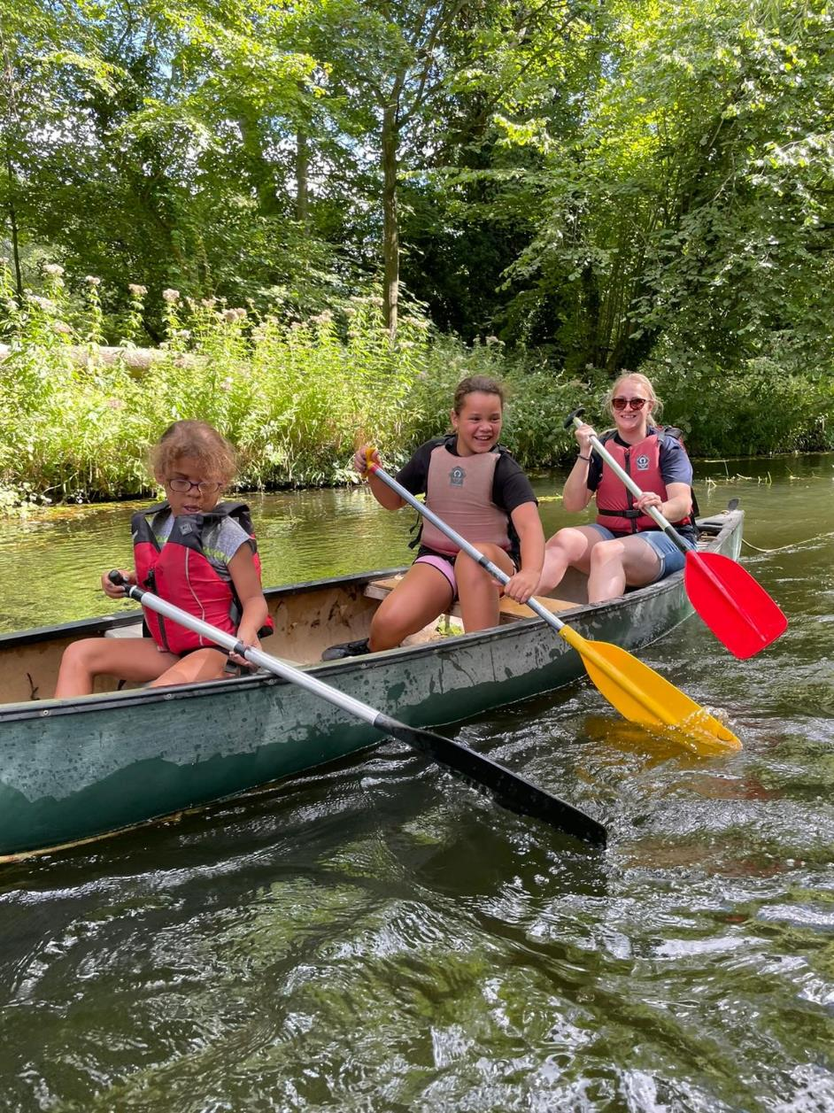
Image: Vision impaired youngsters enjoy canoeing as part of the Children, Young People and Families Programme.

Chair’s Message
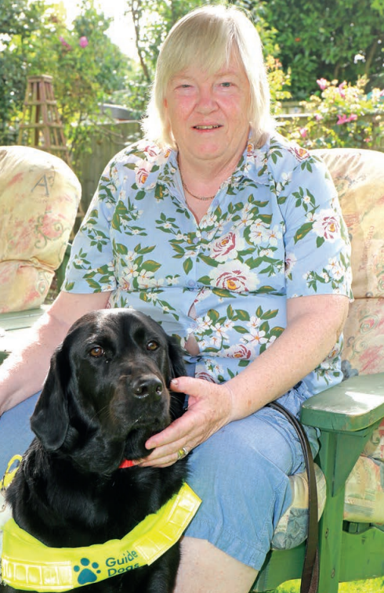
Image: Karen Norton with guide dog Mabel

When I wrote my message this time last year, we were just emerging from Covid; this time I am delighted to be able to report on a year which has seen Vision Norfolk re-energise the services it offers vision impaired people in Norfolk, as well as take some major and necessary steps to transform the charity so that it is fit for the future.

The year saw the completion of the sale of our care home, Thomas Tawell House. This was a bittersweet moment: ‘TTH’ has been a big part of Vision Norfolk for many years, but changes in the regulatory and financial environment meant that managing a standalone care home was not really viable.

I am delighted that the home is now in the excellent hands of the Black Swan Care Group, a very highly regarded provider, in whose hands the home, its staff and most importantly its residents will go from strength to strength. Black Swan is already investing in the home to improve the quality of care it provides.

The sale was a very complex process, and I would like to thank the many people who worked so hard to make it happen. Thomas Tawell House may no longer be in the hands of Vision Norfolk, but it is very much still there, and its future is secure.

As one door closed, another opened. One of the direct benefits of the sale was that it freed up resources to invest in Hammond Court, our supported living accommodation in Norwich, which was built 43 years ago.

The year saw the launch of an extensive programme to significantly upgrade the 20 flats in the complex, including expanding 13 bedsit studios into one-bedroom flats, installing new adapted kitchens and bathrooms, and adding patio doors in every flat. This is now complete, and Phase Two is about to start.

I wrote last year about a very generous legacy, which helped us emerge from the pandemic on a more stable footing. At a time when traditional fundraising and Trust and Foundation grant-giving has never been more stretched, legacies remain a vital part of our funding.

I am pleased to report that we have received legacies totalling more than £400,000 this year. We are extremely grateful to those who choose to remember the charity in their wills, which has enabled us to invest in expanding what we do.

One of the most important parts of that growth has been the creation of a new Community Outreach team, which will enable us to support more vision impaired people across Norfolk to lead independent lives in their own homes.

The year has also seen the reinvigoration of our activities programme, run from our hubs in King’s Lynn, Norwich and Great Yarmouth. This vibrant line-up of social, sporting and leisure activities is a key part of supporting those living with sight loss to avoid the social isolation which can so accompany sight loss.

That expansion in activity has also applied to our Children, Young People and Families programme, which provides emotional and practical support to families with a visually impaired young person, as well as specialist information, advice, guidance and signposting to other relevant organisations. The young people continue to enjoy a wide-ranging programme of activities.

Much of this activity is only possible because of the amazing support provided by our army of volunteers. The pandemic was just as tough for them as it was for all of us, and many found themselves shielding. We are so grateful that so many have returned to offer their services – but as we expand our programmes, we need more, and we encourage anyone considering it to come forward and discover just how rewarding and fun being a volunteer can be.

Finally, I would like to thank everyone who has worked so hard to put the charity in the strong position it finds itself in as we close our 217th year. That includes, staff, trustees, volunteers, fundraisers, funders and donors, and of course our wonderful clients whose resolute cheerfulness and determination makes it all worthwhile.

On a personal note, after a three year wait I finally met my new guide dog, Mabel, earlier this year. Living without a guide dog for so long made me realise how important independence is for people living with sight loss. She has put the spring back into my step! I am proud that after a couple of years of transition, Vision Norfolk is in a strong position to help all vision impaired people in Norfolk lead fulfilled and independent lives.

Karen Norton, Chair of the Trustees.

Chief Executive’s Message

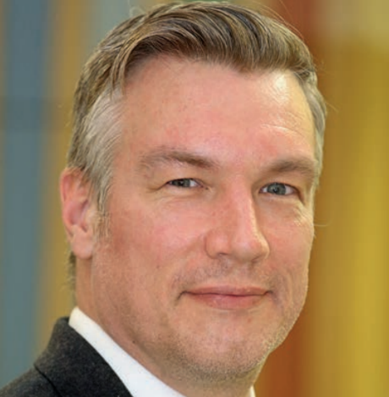
Image: Andrew Morter

As this annual review reveals, 2022/23 was another year of transition for Vision Norfolk, but a positive one and one which has firmly put the charity on a strong foundation for the future.

The year has seen the full re-opening of our hubs in King’s Lynn, Norwich and Great Yarmouth; it has seen the completion of the sale of our care home, Thomas Tawell House; it has seen a major refurbishment programme at our supported living accommodation, Hammond Court; it has seen the creation of our new Community Outreach service; and it has seen a significant growth on our activities programme.

As we look to the future, it is important that our focus is not just on the next 12 months, but further ahead. That is why we have developed a new strategy, entitled ‘A Shared Vision’, the key elements of which are outlined overleaf.

As we look to deliver our four key strategic priorities over the next five years, we need to be realistic about the challenges we face, but I remain optimistic that we are in a good place to overcome them and succeed. We now have the right structure, the right Board and the right staff to achieve our goals.

Our main priority for the coming years will be reaching out to more vision impaired people across the county, ensuring that they receive the right support, at the right time, and in the right place. We know the need is huge, and will continue to grow, and we will develop our services to meet this demand head on.

Our renowned Eye Clinic Liaison Officers (ECLOs) are central to this, as they are well-placed to engage people at the point of their diagnosis. Our new Community Outreach Service also plays an essential role in providing a person-centred, place-based approach to supporting the vision impaired population of Norfolk.

Our Inclusion and Wellbeing Teams continue to provide a range of social and leisure activities which improve people’s confidence, increase social connections, and reduce instances of social isolation. We will continue to invest in all of our services to ensure we can reach more people who need our support.

As well as reaching more people, we need to continue to develop and improve our services. I am very grateful to the members of the Vision Norfolk User Group, who help us do just that. No-one is better placed to understand the needs of people living with sight loss than those who are experiencing it for themselves, and the User Group has been invaluable in shaping our strategy, developing our services, and bringing forward our Community Outreach service. We will again look to invest and expand the ways in which the voice of our service users can help us shape our services.

Perhaps the most important factor in being able to deliver all of this is our workforce. Our staff and volunteers are at the heart of everything we do, are our greatest asset and the absolute key to our success. Over the past couple of years, they have experienced a period of considerable change, and I pay tribute to the way that they have pulled together to move the charity forward.

In recognition of this, we have committed to putting our people at the very centre of our approach, encouraging a ‘people first’ culture where we value people’s experiences and wellbeing.

A central part of that strategy is ensuring that our staff are properly rewarded for their commitment, dedication and hard work. We are proud to announce that we have made the commitment to become a Real Living Wage Employer, achieving our accreditation in the spring. However, we recognise that we need to continue employing the best people and ensuring that they are valued in order to deliver the high quality services which we aspire to for our clients.

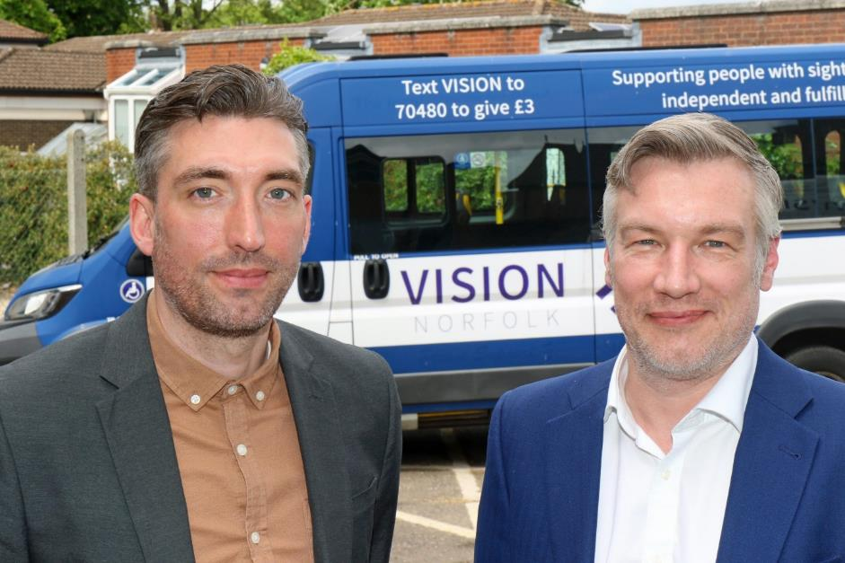
Image: Daniel Childerhouse of the Norwich Living Wage City Action Group (left) with Vision Norfolk chief executive Andre Morter, after the charity was accredited as a Living Wage Employer.

Funding, of course, remains a priority. We have been extremely fortunate to benefit from more than one very generous legacy over the past two years, and the sale of Thomas Tawell House has freed up resources that we can invest into local communities. But the funding environment remains very challenging, and we will need to continue to explore new ways of raising the money we need to deliver our services in a sustainable way, and best meet the needs of those we support.

Despite the challenges, Vision Norfolk has a sound platform to deliver the strategy we have set ourselves. We have a clear vision and mission, and clear strategic priorities. Now we must get on and deliver that strategy so that we can provide the best possible outcomes for vision impaired people in Norfolk.

Andrew Morter, Chief Executive

5 Year Strategy
‘A Shared Vision’

A Shared Vision is the name given to Vision Norfolk’s new five year strategy, which runs from 2023 to 2028.

The strategy is focussed on how Vision Norfolk can continue to develop and improve for the benefit of vision impaired people in Norfolk. It outlines a clear process for breaking down its long-term aims into manageable action, allowing the charity to track progress and stay on course.

In developing the strategy, we listened to many voices:
- We heard directly from the people using our services, asking them what they valued about our work, and what they would like to see us focus on in the future.
- We consulted with our staff and volunteers to find out how they felt we were doing and what we could do to make Vision Norfolk a better workplace.
- We worked closely with colleagues and commissioners from other organisations from across the Voluntary, Community and Social Enterprise (VCSE) and statutory sectors, and discussed how we could make a bigger difference for our communities.

We undertook assessments of our own impact and performance in the context of our client needs and situations, and the wider environment locally and nationally. We also considered the socio-political climate, the commissioning, funding and organisational strategies of key agencies, impact reports, research documents, and more.

We brought together all of this information and knowledge to identify the best approach to achieving our vision and strategic intent over the next five years.

Our Vision
‘All vision impaired people in Norfolk live independent and fulfilled lives’

Our Mission
‘To improve the confidence, skills, and social engagement of vision impaired people of all ages in Norfolk by delivering high-quality services and practical and emotional support which enable them to live independent and fulfilled lives.’

Our Four Strategic Priorities
- Grow current levels of service to ensure we reach the people who need us most
- Improve the quality, effectiveness and impact of our services
- Improve the financial strength and resilience of the charity
- Build strategic partnerships to develop Vision Norfolk as a credible leader within the voluntary and sight loss sectors

From Strategy to Reality
The strategy has been translated into action plans which outline specific milestones which we will achieve over the next five years.

These strategic action plans will be broken down into operational plans, which will be delivered by our dedicated staff and volunteer teams. Our progress will be measured by the use of key performance indicators which will help the trustees and the leadership team to measure progress against key targets.

Our Core Values

Integrity
We are committed to being open, honest and transparent in everything we do. We will always try to do our best and hold ourselves to the highest possible standards.

Determination
We are relentlessly dedicated to our mission, resilient, and care deeply for our work and our beneficiaries. We will not give up until we have successfully delivered on our goals.

Empathy
We are aware and sensitive to the feelings and emotions of our service users, and treat one another with respect, courtesy and compassion.

Accountability
As individuals we are responsible and accountable for our words, actions and behaviour. We take individual and collective ownership for our actions, and are willing to explain and justify them when necessary.

Leadership
We set direction and help ourselves and others to succeed, to move forward by inspiring and motivating, and making positive changes for us and those around us.

Photo Montage

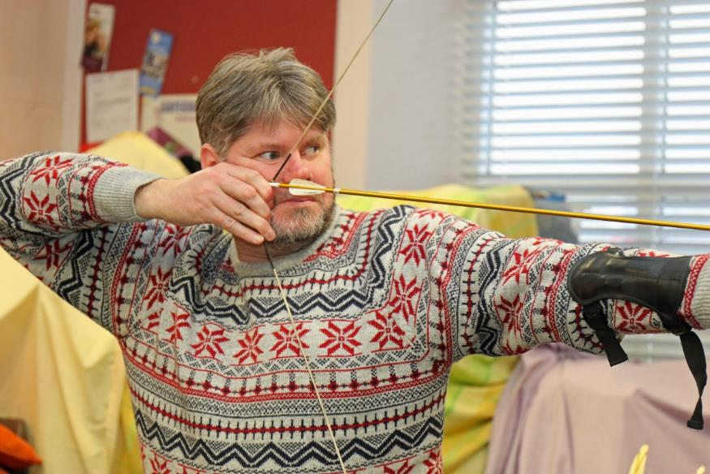
Image: A man in a patterned jumper holding a bowstring with arrow tight.
Vision impaired people in west Norfolk added a string to their bow by taking part in indoor archery sessions, with the help of a grant from King’s Lynn & West Norfolk Borough Council.

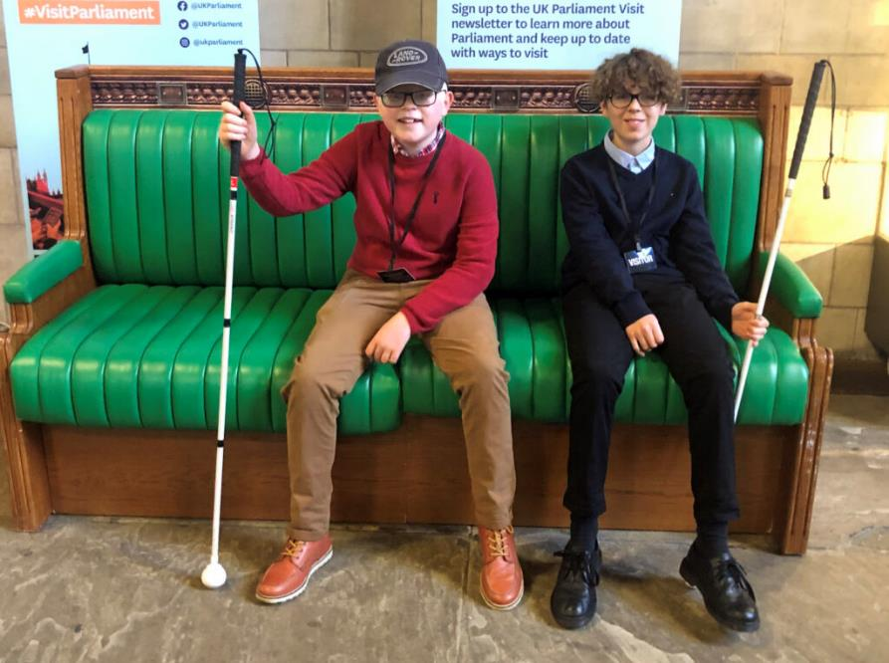
Image: Two young people with white canes sitting on a green bench in Parliament.
Vision impaired youngsters George Edwards and Marcus Dunn told MPs about the needs of young people living with sight loss at a special forum at the Houses of Parliament.

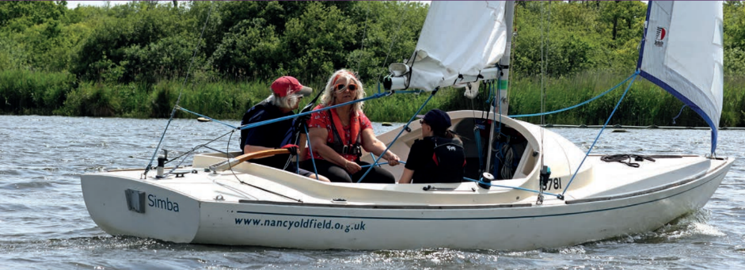
Image: Three people in lifejackets sitting on sailboat in the Norfolk Broads. The boat has the text “www.nancyoldfield.org.uk” on the back and “Simba” on the back.
Working with the Nancy Oldfield Trust, a group of vision impaired sailing enthusiasts have been enjoying getting out on the Norfolk Broads.

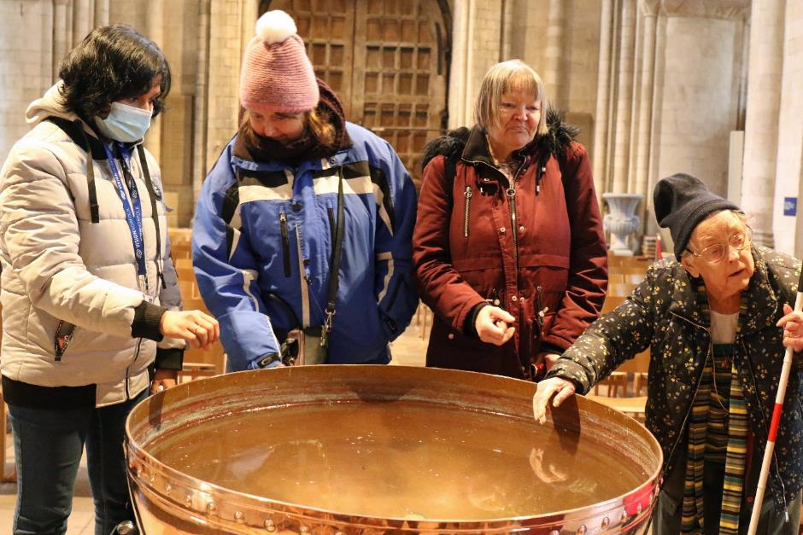
Image: Four participants are standing around a large brass water container in Norwich Cathedral.

A group from the Great Yarmouth hub was given special access to the treasures of Norwich Cathedral, including the chance to get hands-on with the building’s architecture, decorations and ecclesiastical features.

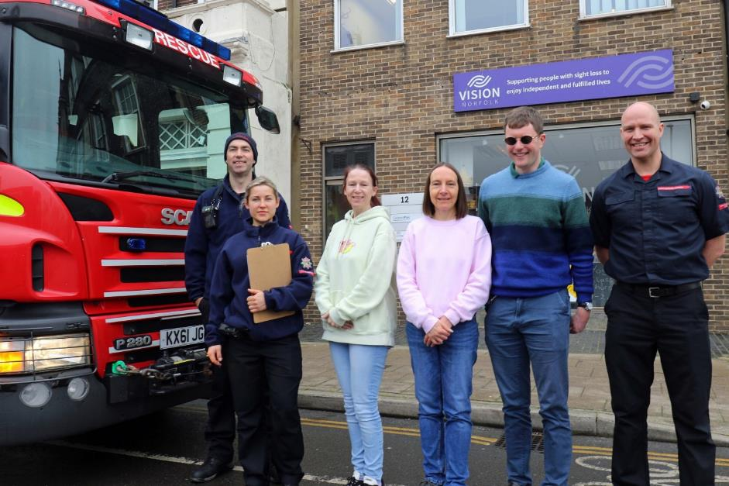
Image: Three firefights and three members of Vision Norfolk staff standing outside the Great Yarmouth hub. There is the front of a fire truck to the left.

Firefighters from Great Yarmouth’s Fire Station dropped in on a coffee morning for vision impaired people in the town to talk to them about fire safety – and to offer extra assistance to make sure they are safe in their homes.

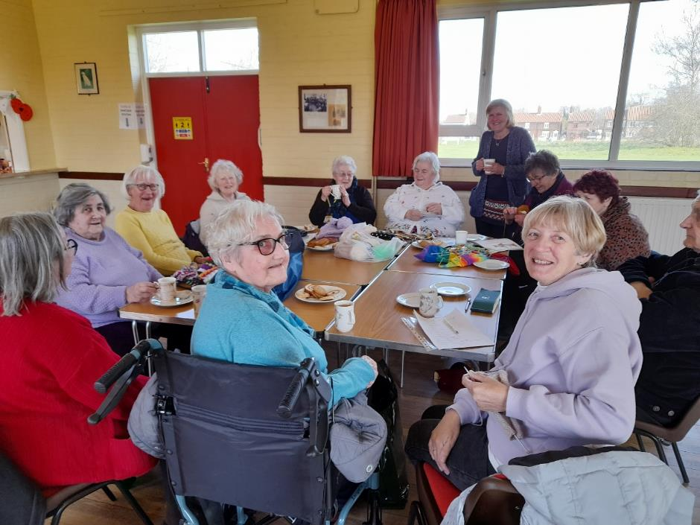
Image: Twelve members of the Knit and Knatter group sitting around a large table with tea cups and plates of biscuits.

West Norfolk Knitters get together every month for a ‘Knit and Natter’ session where they can spin yarns of every description.

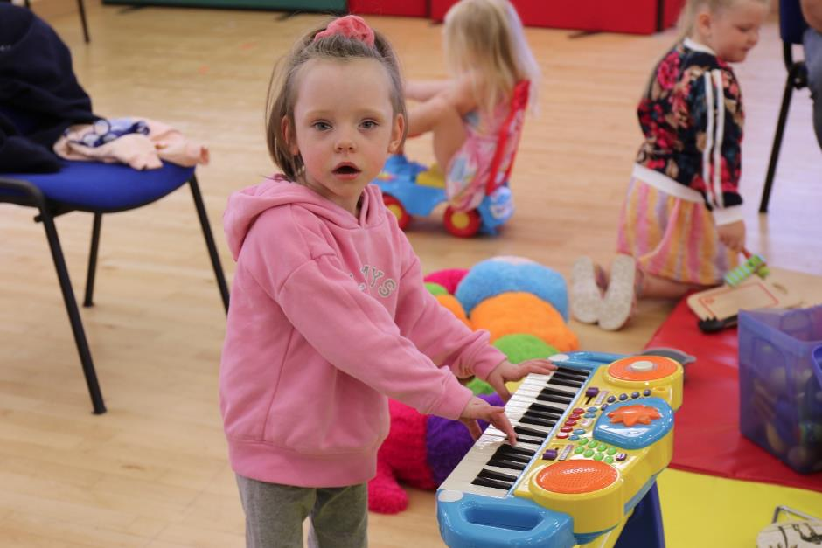
Image: A toddler in a pink jumper playing a colourful toy keyboard. Other children are playing with toys in the background.
Play sessions for pre-school children living with sight loss are a great place for parents and carers to socialise too.

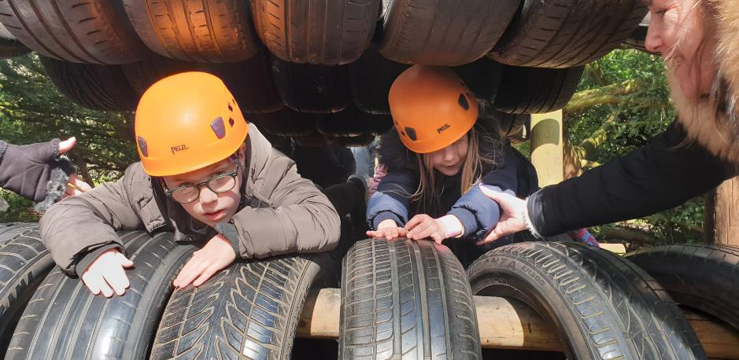
Image: Two children wearing orange helmets squeeze through a tunnel of car tires as two volunteers help them through.

As part of the Children, Young People and Families activity programme, groups have enjoyed several visits to the Hautbois activity centre for a day of adventure.

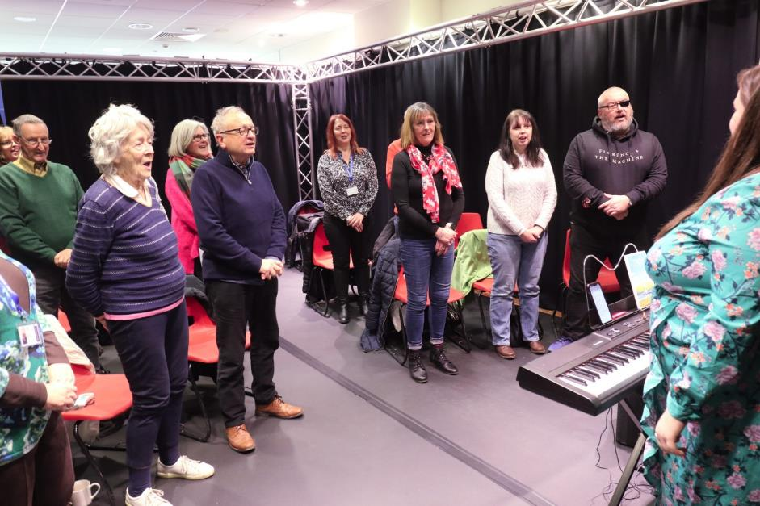
Image: Member of the Vision Norfolk Choir stand and sing inside the The Workshop in King’s Lynn.
A new choir for vision impaired people in west Norfolk was set up in a joint initiative between Vision Norfolk and King’s Lynn performing arts hub the Workshop.

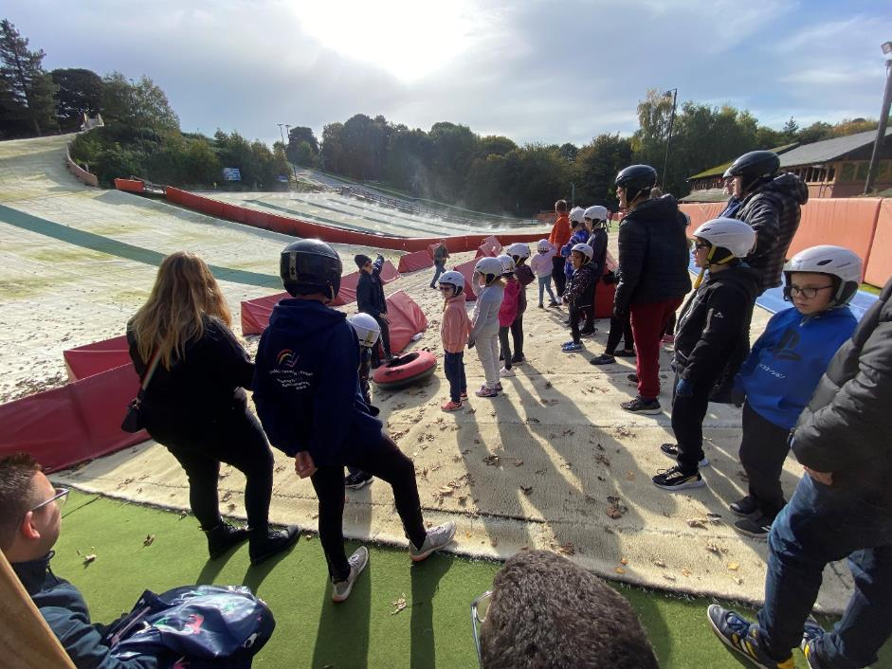
Image: Children, volunteers and staff stand at the bottom of the tubing hill listening to a safety briefing.
A group of vision impaired youngsters enjoyed snowtubing at the Whitlingham dry ski slope.

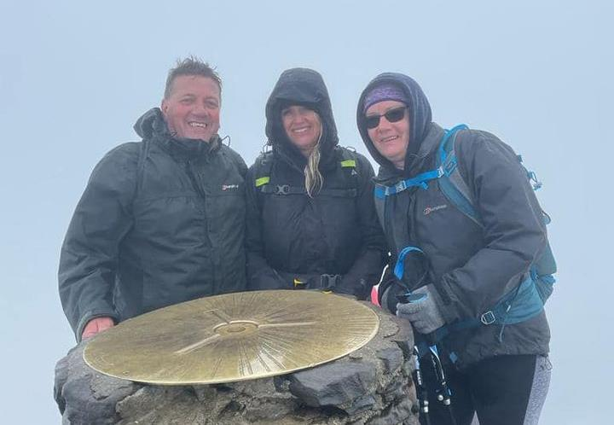
Image: Three people in warm hiking gear standing at the Mount Snowdon summit marker.
A group of staff and volunteers braved dreadful weather to conquer Mount Snowdon to raise more than £3,000 for the Children, Young People and Families programme.

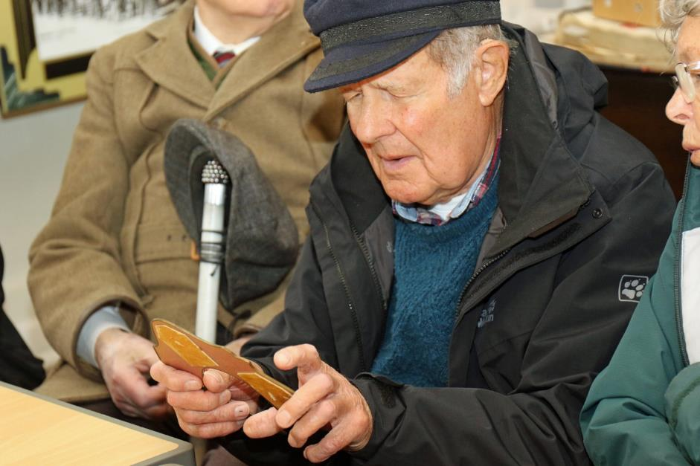
Image: A man holding a tactile exhibition piece at the Museum of Norwich.
Members of the Vision Norfolk Heritage Group enjoyed a special hands-on visit to the Bridewell Museum of Norwich to learn about Norfolk’s shoe-making history.

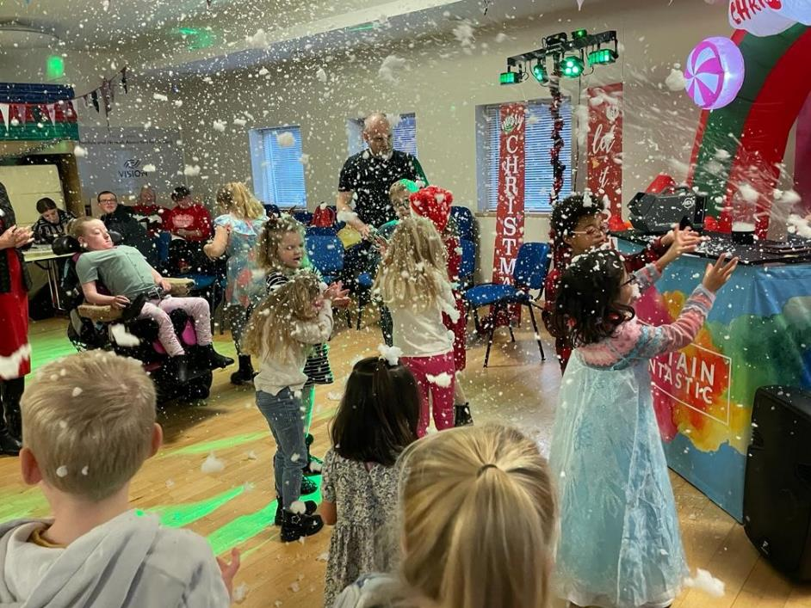
Image: Children dancing in the disco lights and simulated snow coming from the Captain Fantastic table in the Norwich Hub.
The Children, Young people and Families Christmas party was complete with its very own snowstorm!

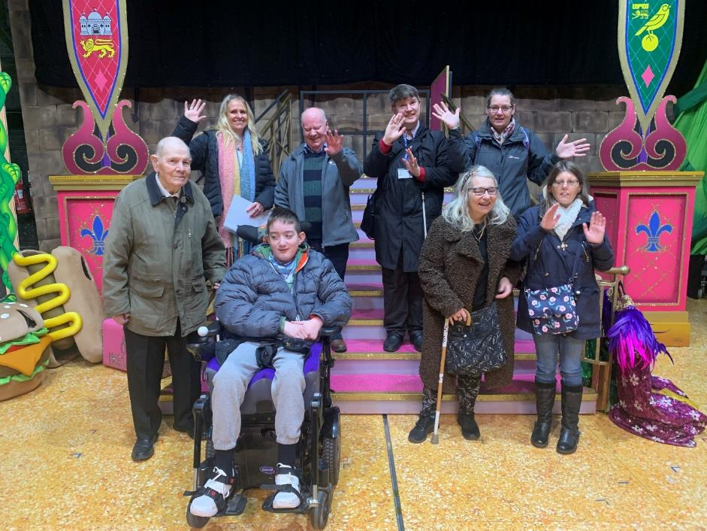
Image: A small group of staff and service users standing on the steps of a brightly coloured prop staircase for a panto.

A group were given a behind-the-scenes tour at the Theatre Royal Norwich before enjoying the panto.

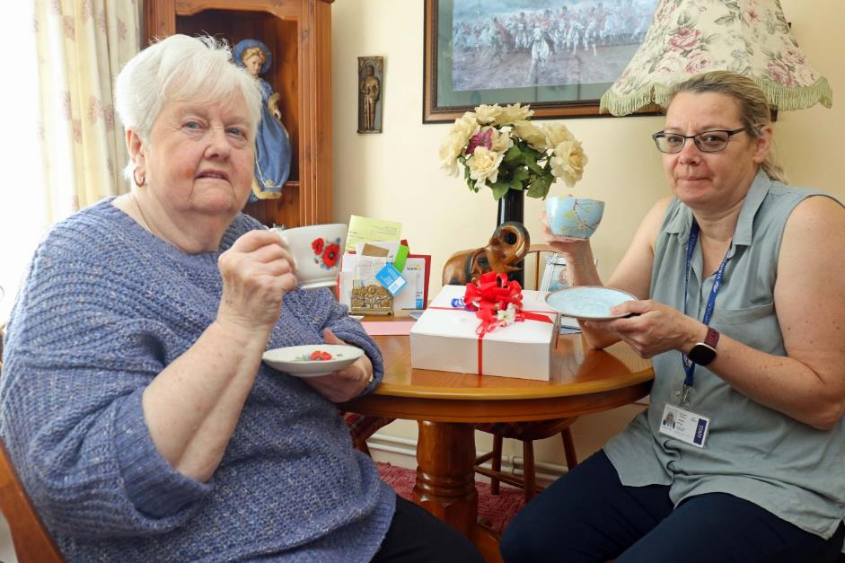
Image: Two women holding up cups of tea to celebrate the Queen’s Platinum Jubilee. There is a gift box on the table in front of them.
Staff and volunteers delivered dozens of sumptuous afternoon tea boxes to vision impaired people across Norfolk to help them celebrate the late Queen’s platinum Jubilee.
Facts & Figures

- 877: support calls made by Vision Norfolk staff to vision impaired people in the county
- 3,774: calls made by volunteers via our Telefriends service during the year
- 64: families attended events in the Children, Young People & Families programme
- 42: referrals received for children newly diagnosed with sight loss
- 275: new referrals received for adults newly-diagnosed with sight loss
- 372: activity sessions completed during the year
  - audio book clubs
  - heritage group
  - theatre visits
  - coffee mornings
  - sports including yoga, archery, boccia and darts
  - arts and crafts including knitting, weaving, art and photography
  - creative writing
  - games mornings
  - walks and rambles
- 1,200: people took part in activity sessions
Vision Norfolk Volunteers
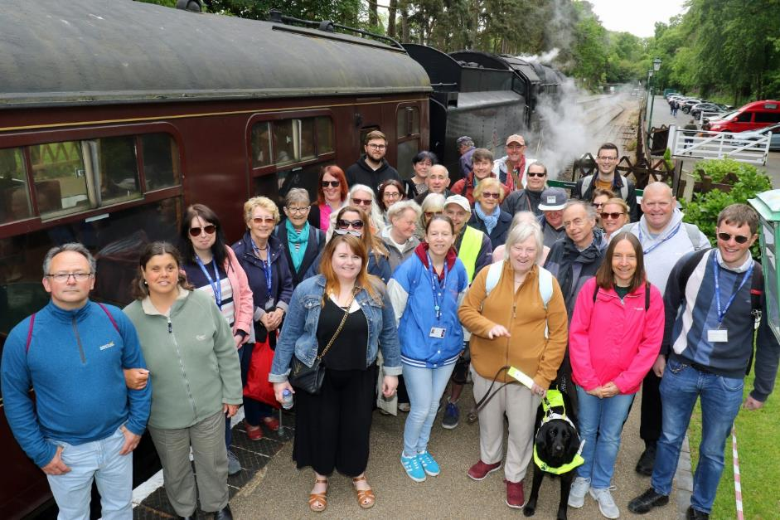
Image: Vision Norfolk volunteers at the North Norfolk Railway

The contribution made by volunteers to Norfolk’s sight loss charity was celebrated during National Volunteers Week with a special trip abord the North Norfolk Railway.

Around 30 of the more than 100 volunteers who support Vision Norfolk were treated to coffee and pastries aboard train pulled by a 1959 ‘Black Prince’ steam locomotive.

The event was to recognise the work done by the charity’s team of volunteers, who come from a wide range of backgrounds and who undertake a huge range of activities.

Vision Norfolk chair of trustees Karen Norton welcomed the volunteers on board the train at Holt Station before they enjoyed refreshments while en route for Sheringham, where they spent a couple of hours before making the return trip.

“Without our wonderful volunteers we would simply not be able to offer the range of services that we do for vision impaired people across Norfolk,” said Mrs Norton.

“The demand for our services continues to grow, and it is only through the dedication and loyalty of our army of volunteers that we are able to meet that demand.

“Volunteering is a richly rewarding thing to do, and we would very much welcome anyone who is thinking of volunteering some time to consider helping Vision Norfolk.”

Volunteer Case Study - Dawn Barber

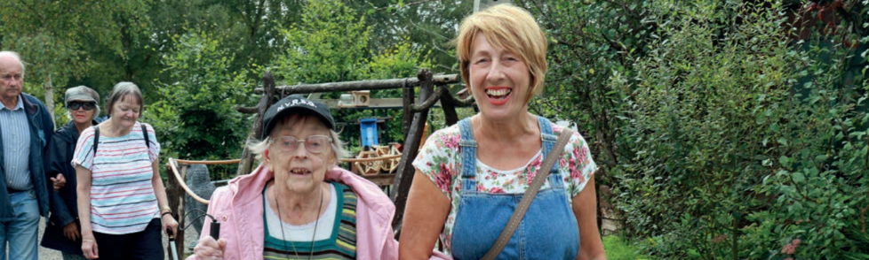
Image: Volunteer Dawn Barber volunteering as a sighted guide on a group walk.

Vision Norfolk volunteer Dawn Barber started giving her time at the charity’s Great Yarmouth hub after she retired two years ago – and now regards its clients and hubs as her ‘Vision Norfolk family’.

A former children and families outreach worker at Great Yarmouth and Gorleston Children’s Centre, Dawn was already volunteering for animal charity the Cinnamon Trust while she was still working, but had always planned to find new volunteering opportunities when she stopped working.

“I missed being part of the community, and both the sense of purpose and the social interaction which my job had offered me,” says Dawn. “So I knew I wanted to do more volunteering when I had the time to do so.”

After a year working with the Great Yarmouth & Gorleston Food Bank, a friend mentioned that Vision Norfolk was looking for more volunteers as the charity started to ramp up its activities programme again following the pandemic.

She then spoke to the Great Yarmouth volunteer co-ordinator Catherine Bond, and realised that their paths had crossed in a previous life – and she knew it was meant to be.

“From the first time I walked through the door of the Yarmouth hub, I felt at home,” says Dawn. “I love going to the hub, and helping out on the outings. They are a fab, fun bunch of people, and we have so many laughs. You really feel part of something when you go there.

“I have learnt so many new things, it has given me a new confidence and empowered me. I decided to volunteer because I wanted to put something back; in fact, it’s a real two-way street – I get so much out of it myself.”

Dawn helps with guiding clients on the busy programme of outings, as well as visiting the hub once a week. Within a short period of time, she felt a real part of the team.

“They are like my Visio Norfolk family. They always check in on me and remember to ask how I am. It is so much fun and so rewarding – I would encourage anyone who is thinking about volunteering for Vision Norfolk to do it.”

Sidebar
Would you like to offer your services as a volunteer for Vision Norfolk?

Our team of volunteers undertake a huge range of activities, including helping at sports and leisure activities, advising at eye clinics, being Telefriends, driving, fundraising, escorting and guiding, and working in the charity’s equipment and information centres.

For more information, go to www.visionnorfolk.org.uk/get-involved/volunteer, email volunteers@visionnorfolk.org.uk, or call on 01603 573000.

The Financial Year
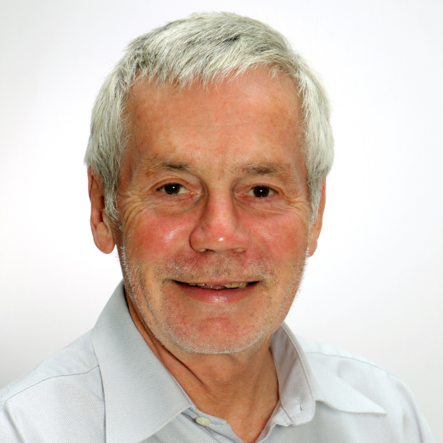
Image: Vision Norfolk Treasurer Julian Foster

Following last year when we benefited from a very large legacy, 2022/23 was another unique year financially – but one which ended with the charity in a more stable position to move forward.

After the exceptional boost provided by the legacy last year, we expected income in 2022/23 to reduce significantly. At a time when all charities are finding fundraising challenging, and when costs are soaring, Vision Norfolk would be facing a significant year-on-year deficits without legacy income. It underlines just how important legacies are to the financial wellbeing of our charity.

Following several years of a challenging operational environment, the trustees made the difficult decision to sell our care home, Thomas Tawell House. Managing a standalone care home in the context of increasing regulation, difficulties in recruiting qualified staff, and reduced income had become increasingly difficult.

The sale was completed in December 2022, two-thirds of the way through the financial year. This has impacted on both our income and expenditure, but h the surplus generated from the sale was sufficient to offset our large operating deficit and meant that we are able to report a financial result close to break-even.

It is no secret that 2022/23 presented major challenges to organisations relying on income from investments, such as Vision Norfolk. We were not immune from the financial turbulence, but diligent financial management has limited the impact, and we expect the position to improve over the coming months and years – although of course we do not have a crystal ball on matters economic or political!

Legacy income is by its nature something which we cannot plan for, but after last year’s very generous legacy, we received a further £408,000 in legacy income this year. We are very grateful indeed to those who choose to remember the charity in this way.

The declining trend in traditional fundraising sources (in common with the entire charitable sector) means we are running a significant underlying deficit. But after two exceptional years, Vision Norfolk has emerged debt-free, and with a sound foundation to tackle that deficit, while maintaining and expanding services for vision impaired people in Norfolk.

Julian Foster, Treasurer

Financial Charts
Income
- Accommodation and Care 41%
- Gain on sale of Fixed Assets 28%
- Legacies 17%
- Investments 6%
- Grants and Donations 5%
- Other Income 2%
- Fundraising 1%

Expenditure
- Accommodation and Care 53%
- IT, Marketing and Admin 12%
- Countywide Activities 8%
- West Norfolk Hub 6%
- Gt Yarmouth Hub 6%
- Norwich Hub 5%
- FR Costs 4%
- Exceptional Costs 3%
- Depreciation 3%

Financial Facts
- Financial position for the year break even, including sale of Thomas Tawell House care home
- Income reduced by 67% on last year (largely due to last year’s exceptional £5.3m legacy and sale of TTH)
- Expenditure reduced by 14% to £2.1m (much of this due to sale of TTH)
- Investment income and revaluation losses resulted in a deficit of £50,000 (last year = £232,000 surplus)
- Net expenditure was £30,000, after an exceptional surplus of £4.8m last year
- The underlying deficit for the year (ignoring the property sale) was £835,000
- Charity funds remained £8.9m (same as last year)
- The remaining bank loan was repaid, and the charity is now debt-free

Vision Norfolk
Annual Review
2022-2023

Norwich Hub
Bradbury Activity Centre, Beckham Place, Edward Street, Norwich, NR3 3DZ
01603 573000

West Norfolk Hub
Unit 3 Dundee Court, Hamburg Way, King’s Lynn, PE30 2ND
01553 660808

Great Yarmouth Hub
12 Hall Quay, Great Yarmouth, NR30 1HP
01493 745973

Full financial accounts, details of Patrons, Presidents, Vice-Presidents, Trustees, Executive Staff and other officers, along with other statutory information, can be obtained by downloading the charity’s 2022/23 Financial Statements from www.visionnorfolk.org.uk/about-us/reports

Printed copies can be requested by calling 01603 573000.

To receive this report in other formats (Braille, larger print, audio CD and USB, or as a PDF via email), please contact office@visionnorfolk.org.uk or call 01603 573000.

Vision Norfolk is the brand name of Norfolk and Norwich Association for the Blind

Registered charity No. 207060

