Happy Holidays from Vison Norfolk

Vision Norfolk Christmas Cards Available Now
Our 2023 charity Christmas cards are available now including two designs created by the 2023 Christmas Art Competition winners. Roy Meredith made fantastic use of his CCTV loaned to him by Vision Norfolk to create the ‘Northern Lights’ design while ‘Christmas Tree’ was created by Rhiannon from the Children, Young People and Families programme using a rubber stamp and felt tipped pens.
The cards are being sold at the Original Norwich Charity Christmas Card Shop at the Church of St. Peter Mancroft. The card shop opened in mid-October and will remain open until 3pm on Thursday 14th December. Our Christmas cards can also be purchased from our community hubs in Norwich, King’s Lynn and Great Yarmouth.
Last year we raised over £600 through the sale of Christmas cards.

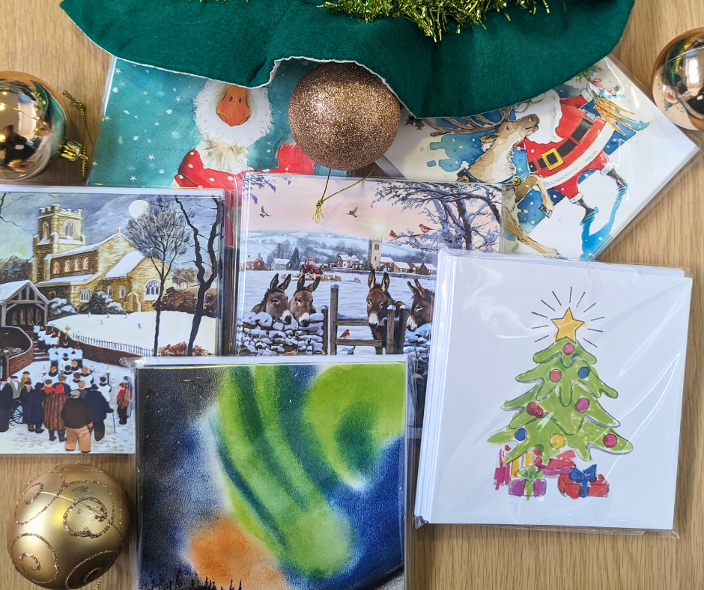
Image: Six packs of Christmas cards on a table with gold baubles. The bottom two packs feature the ‘Northern Lights’ and ‘Christmas Tree’ designs created by service users. The remaining designs feature a church choir, donkeys, a festive goose and Santa Claus

In This Edition

Vision Norfolk News
Updates from your local sight loss charity
Community Hub Updates
News from each of our community hubs in Norwich, King’s Lynn and Great Yarmouth
Children, Young People and Families
Learn about our service for local people ages 0-25 and their families
Equipment and Technology
Updates about equipment and technology including information and events
Activities
List of activities and events coming up over the next few months across the county
Other Things
Additional details on available newsletter formats and the 2024 Christmas Art Competition
Contact Details
Find out how to reach us with your questions

Christmas Opening Hours
Our community hubs will be closed from Monday 25th December through Monday 1st January for the holiday season.
No regular activities will be taking place during this time period with the exception of the trips to the Sleeping Beauty panto in Norwich and the Dick Whittington panto in King’s Lynn. If you have any questions please get in contact.

2024 Christmas Art Competition
With the resounding success of this year’s Christmas cards we are looking for submissions for designs for cards to be sold in 2024.
We will be accepting entries for the 2024 Christmas Art competition from 1st December 2023 until 29th February 2024 for the possibility of featuring your artwork on our charity Christmas cards!
The competition is open to anyone in Norfolk who is vision impaired. All ages are welcome. Please find more details at the end of this newsletter, on our website or by getting in contact with your local hub.

A Year in Review
On Thursday 12th October Vision Norfolk service users, volunteers, staff members and trustees met with members of the public for the Vision Norfolk Annual Public Meeting. There was a short presentation on the challenges and accomplishments of the last few years and plans for moving the charity forward including questions from the audience. This was followed by a chance for everyone to snack, mingle and get to know one another.
Our 2022 - 2023 Annual Review was made available at the event. The Annual Review includes a short review of some of the accomplishments of the past year, messages from our Chair of Trustees and Chief Executive and an introduction to Vision Norfolk’s new five year strategy.
Copies of the Annual Review are available on our website as a PDF, Word or audio file. Printed copies are available at our hubs. Audio versions on CD or USB and Braille versions are available on request.

A Shared Vision
A Shared Vision is the name given to Vision Norfolk’s new five year strategy, which runs from 2023 to 2028. The strategy is focussed on how Vision Norfolk can continue to develop and improve for the benefit of vision impaired people in Norfolk. It outlines a clear process for breaking down our long-term aims into manageable action, allowing the charity to track progress and stay on course.
You can find a further exploration of our five year strategy in the 2022-2023 Annual Review including an explanation of our core values and an overview of how we intend to strive to reach our strategic priorities.

Our Vision
‘All vision impaired people in Norfolk live independent and fulfilled lives’
Our Mission
‘To improve the confidence, skills, and social engagement of vision impaired people of all ages in Norfolk by delivering high-quality services and practical and emotional support which enable them to live independent and fulfilled lives.’

Our Four Strategic Priorities
- Grow current levels of service to ensure we reach the people who need us most
- Improve the quality, effectiveness and impact of our services
- Improve the financial strength and resilience of the charity
- Build strategic partnerships to develop Vision Norfolk as a credible leader within the voluntary and sight loss sectors

Our Core Values
- Integrity
- Determination
- Empathy
- Accountability
- Leadership

Support from the Community
A sold-out charity fashion show held at a Norfolk vineyard has raised over £1,500 to support Vision Norfolk’s work. Chet Valley Vineyard in Bergh Apton hosted over 50 fashion-lovers at their winery for the event, which showcased clothes from French fashion brand Elora.
Among the amateur models taking to the catwalk was Lana Hempsall, who retains only around one percent of her sight having been affected by Stargardt disease in her teenage years. She was joined on the catwalk by Labrador Retriever Zorin, who has been her guide dog for the past five years.
Our Children, Young People and Families service has also recently received a £250 donation from the Lowestoft branch of the Royal Society of St George, who have chosen to support Vision Norfolk’s work with vision impaired young people and their families for three years.
We are incredibly grateful to all our supporters who contribute to our work through donations, fundraising and remembering Vision Norfolk in their wills. As a local charity we are dependent on your support and every bit helps!

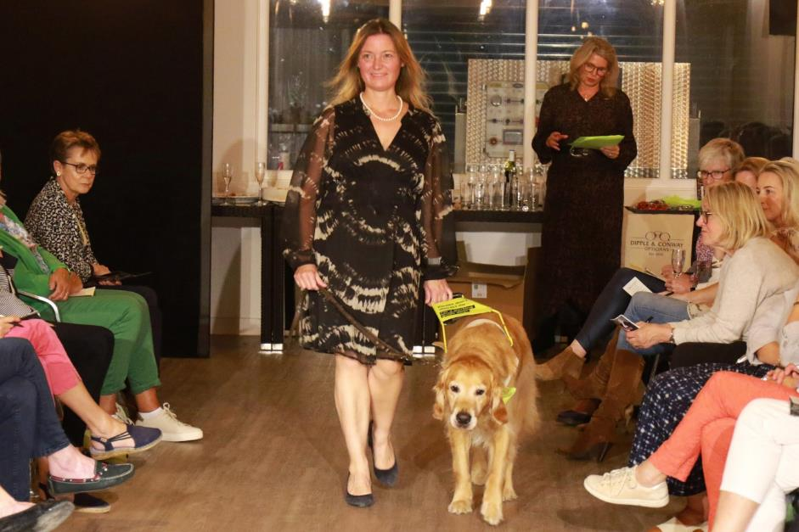
Image: Acle Councillor Lana Hempsall in a flowy black print dress walking down the catwalk with her guide dog Zorin. The audience sits on either side of the walk.

Norwich Hub Updates

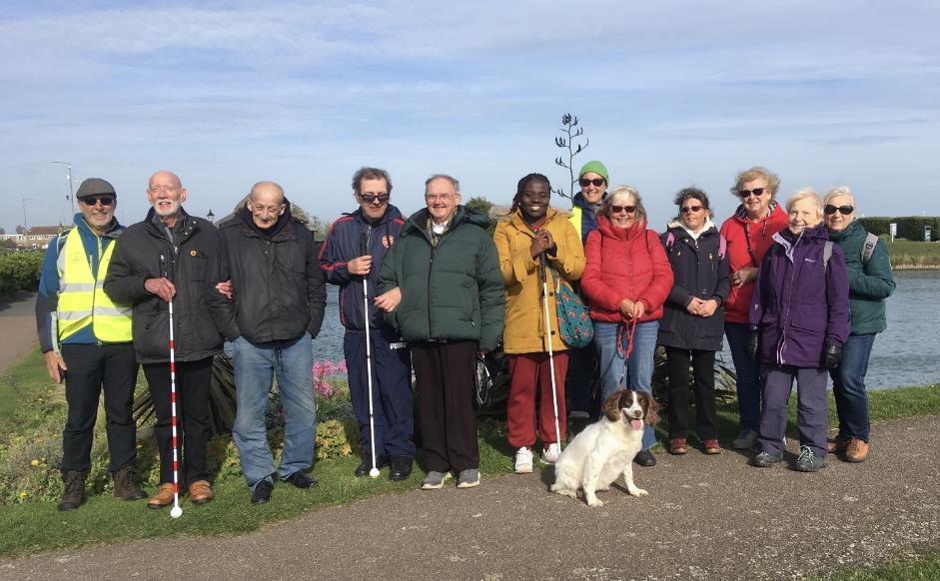
Image: Twelve people, and one dog, standing on a pathway in front of a body of water in Great Yarmouth. They are dressed for walking with warm jackets and walking shoes

Walk Norfolk 2023
On Wednesday 18th October the Norwich Short Walk Group descended on Great Yarmouth at the invitation of Pathmakers and Under Open Sky to take part in a sensory walk. The walk focused on using senses other than sight. It was a lovely sunny day but with a very blustery wind, which didn’t help when trying to listen to things other than the wind. We were still able to use our sense of smell and touch while walking through the Venetian Waterway Gardens which are full of lovely herbs.

Cooking with Sue
Each month we will be running a cookery lesson at the Norwich Hub. The sessions will be led by Sue Warnes, one of our Community Outreach Workers. The first lesson was on Thursday 26th October. It focused on making soups using the cooker hob and using a soup maker.
Following sessions will teach practical skills designed to be transferable to your home kitchen. Each session will focus on a different dish with the chance to explore a variety of cooking techniques, make and try something yummy and take home the recipe with personal tips.

Glaucoma Support Group
On Friday 9th February we will be starting a Glaucoma Support Group at the Norwich Hub. This will run immediately after the Norwich Macular Society meetings held on the second Friday of each month.
At present, we are dealing with almost as many enquiries about Glaucoma, as we are Age Related Macular Degeneration (AMD) and unfortunately, it’s not uncommon for someone to have both eye conditions at the same time. The group will be a self-help and discussion session and we hope to introduce speakers to talk about both AMD and Glaucoma as well other interesting subjects

King’s Lynn Hub Updates

Flower Arranging
In September we were joined by Audrey for a flower arranging workshop. Scented leaves such as basil and rosemary were used alongside fresh flowers to create arrangements that delighted the senses. The session was complete with cupcakes and lots of friendly chat.
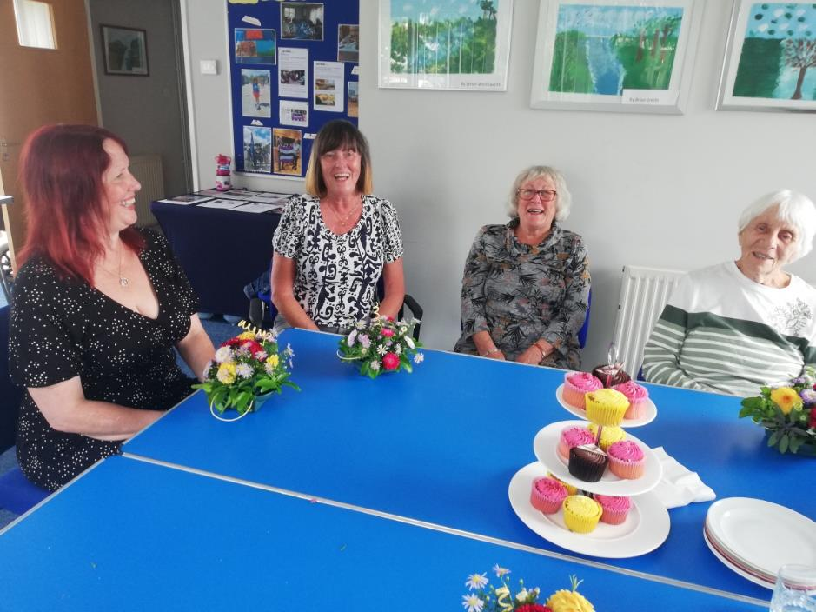
Image: Four women laughing while sitting at a table with floral arrangements and a tray of cupcakes. From left to right there is Penny, Jackie, Audrey and Sheila.

Celebrating the Holiday Season
Festive joy has made its way to the hub and we are looking forward to sharing this joy with all of you. This year we have a few different opportunities to enjoy the season.
The Sound and Vision Choir is working local radio and some of the local talking newspapers to produce and share a Christmas recording. The choir will also be doing a small performance before Christmas for friends and family.
We are once again holding our hub Christmas party on Tuesday 5th December complete with festive refreshments and holiday cheer.
On the 27th December we are going to see the Dick Whittington pantomime at the Corn Exchange in King’s Lynn. This will the Corn Exchange’s first audio described pantomime and they have been a fantastic partner in taking feedback as to how to adapt performances to be accessible to all.

New Activities
Looking forward to 2024 we are in the process of setting up some new events and the activities for you all to have the chance to get involved in.
These include:
- Monthly art workshops which have already started at the King’s Lynn Hub
- A ladies luncheon club
- A regular walking club that will start once as the warmer weather returns
Please get in contact if you are interested in these activities or any of our other activities.

Great Yarmouth Hub Updates

Autumn Adventures
Time and Tide Museum Visit
In October we took a group to the historic Time and Tide Museum in Great Yarmouth for a private tour of some of the exhibits. We had chance to experience the smells and sounds of the herring industry and were treated to a guided tour with a description of the artefacts.
Norfolk and Suffolk Aviation Museum
We also had the chance to take a group to the Norfolk and Suffolk Aviation Museum. They were assisted by two excellent tour guides, Ian and Bob, who gave the group a touch tour and a history on some of the planes and artefacts.

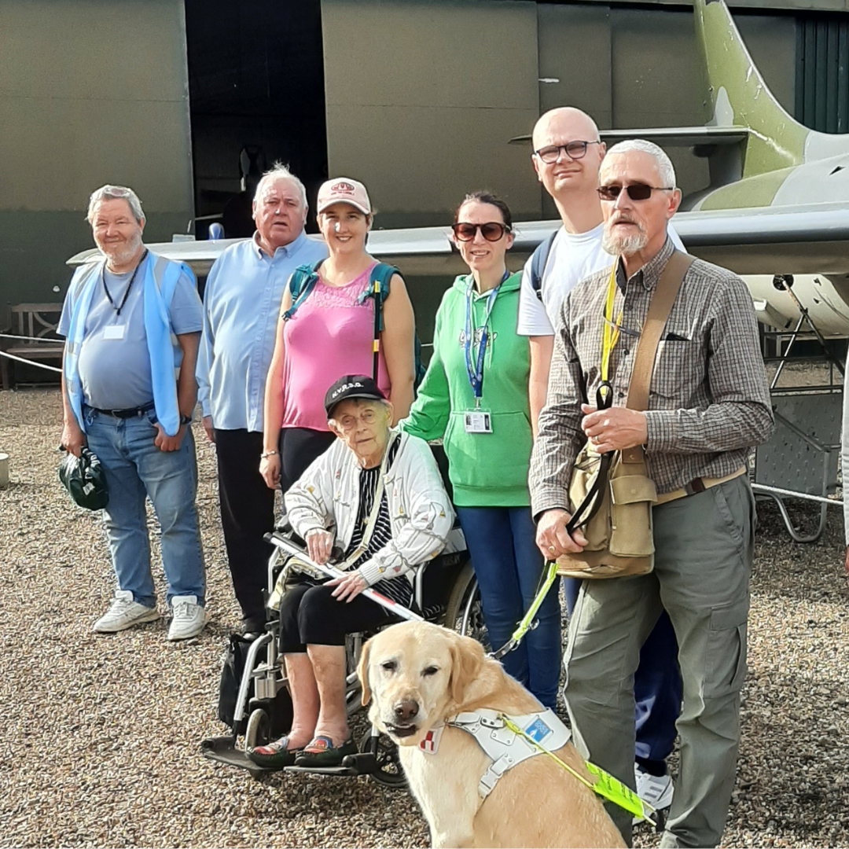
Image: Photo of service users, volunteers, a guide dog and staff standing beside an aeroplane and aeroplane hangar at Norfolk and Suffolk Aviation Museum

Fritton Owl Sanctuary
In September we visited the Fritton Owl Sanctuary. We learned about the work the sanctuary does caring for owls that don’t have another home and visitors had the chance to hold and interact with three of the feathered residents.

Coming Up
The Holiday Season
- The annual Great Yarmouth Hub Christmas Party is back on the 19th December complete with refreshments and holiday joy.
- We’re off to the Robin Hood Panto at St George’s Theatre in Great Yarmouth on 21st December. There will be a chance to have mince pies beforehand.
- We will also have a special Christmas session of our regular cooking group on 11th December and Christmas Bingo on 12th December.
Seafront Walks
From February you can join us to enjoy the sea air as we go for a walk along one of the seafronts in Great Yarmouth or Gorleston.
Knit and Natter
Also starting in February is our new Knit and Natter group in Great Yarmouth.

Children, Young People and Families

The CYPF Service organises activities and events to improve confidence and encourage independence. By including the whole family, we empower these families through shared experience and knowledge and build lifelong friendships.
Since our last edition we finished the summer off with a plethora of exciting activities during the school holidays including zip wire and canoeing at Hautbois Activity Centre, archery at Eaton Vale Activity Centre, an Amazing Animals Day with Miniature Donkeys and Bert’s Amazing Creatures, a trip to Wymondham Alpacas and Llamas, bowling trips in Norwich and Great Yarmouth and a visit to Sea Life Hunstanton. We have also had the pleasure of hosting Lab Media for several musical storytelling workshops.
In the coming months we are looking forward to our remaining Christmas events including the Children’s Christmas Party, an outing to the Sleeping Beauty Christmas Panto and the Christmas Bowling Party for Year 7’s and above. Our Norwich Preschool Group is also continuing out of the Norwich Hub offering support and a safe shared play space for families with vision impaired preschoolers and vision impaired parents with sighted babies.
- Children’s Christmas Party with Captain Fantastic
- Sleeping Beauty Christmas Panto at the Norwich Theatre Royal
- Christmas Bowling Party for older children and young adults
- Circus Starr performance at The Marina Theatre in Lowestoft
- Norwich Preschool Group including sessions with Musical Keys
We welcome ideas and suggestions for new activities and other ways we can better support you. If you would like a particular activity organised please contact barbara.dunn@visionnorfolk.org.uk.

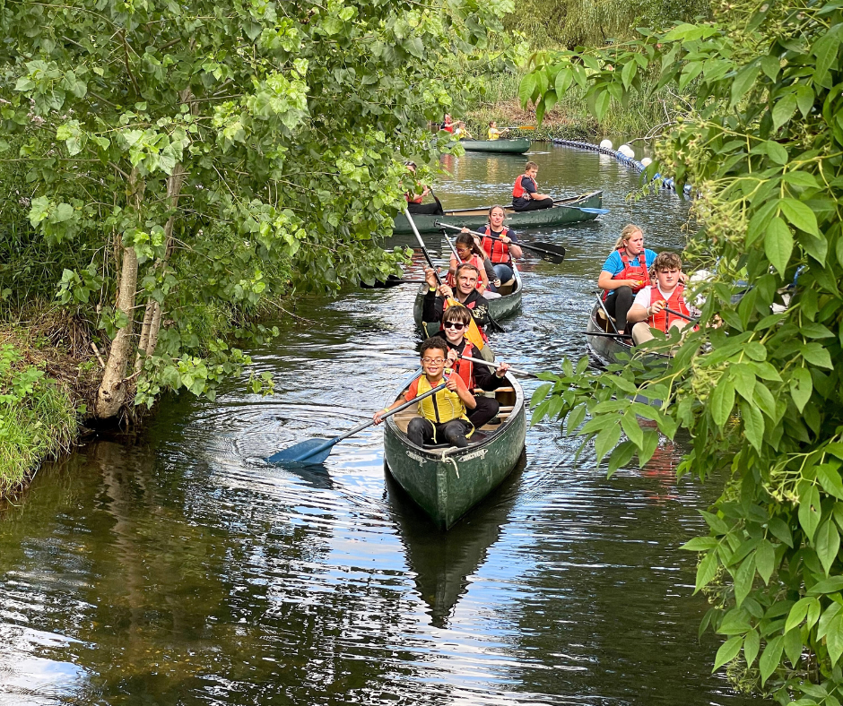
Image: Five teams in canoes working their way down a river surrounded by trees and bushes.

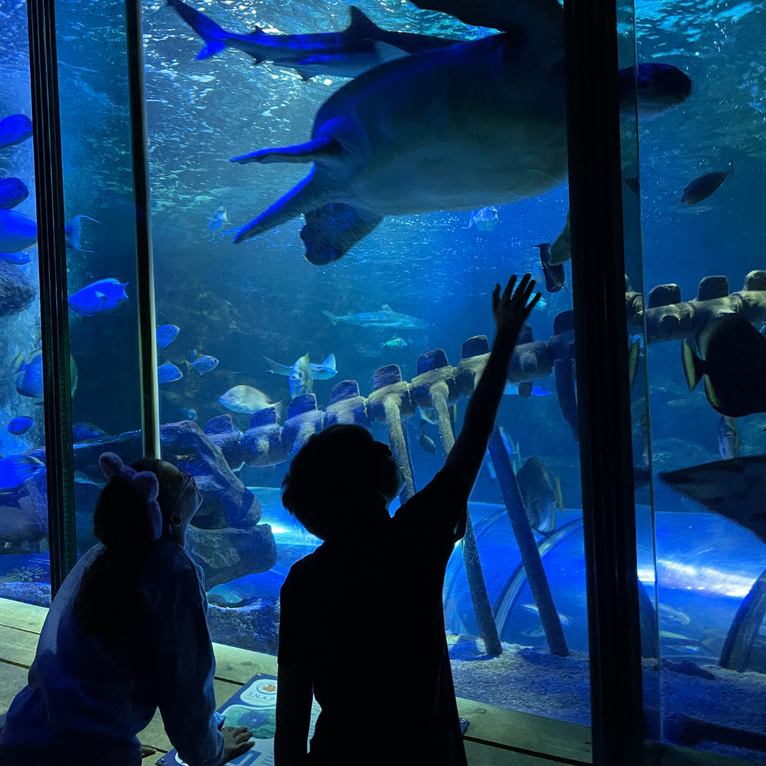
Image: The outline of two children staring up at a large turtle in an aquarium tank.

Equipment and Technology

If you have any questions about daily living equipment we can provide support at our community hubs in Norwich, King’s Lynn and Great Yarmouth or over the phone. Our new Community Outreach Workers are also now available for home visits where they can discuss which of our services may be of interest to you, including discussing equipment and how your living space can best work for you. To find out more please get in contact with John at 01603 573000 Ext. 323 or email john.morland@visionnorfolk.org.uk.

Calendars and Diaries
Large print 2024 calendars and diaries are now available to purchase from Vision Norfolk. Calendars are £7.50 each and diaries are between £7.50 and £10.50 each depending on the size and type.

Discussing Technology
We’ve been hearing from our service users that you would like more chances to discuss your digital devices. Therefore we’ve been working with some wonderful partners and volunteers to provide opportunities for you to come together at our hubs and talk about your technological concerns. Some of these opportunities have already been taking place and others are planned for the next few months and hopefully into the future.

Technology Training with RNIB
Over the past couple of months we have had the privilege of hosting Mohammed Atif, Technology for Life Coordinator at RNIB, in our Norwich and King’s Lynn hubs for one-to-one technology training sessions with service users. He has been meeting with individuals for 20-40 minute sessions to work through any concerns they have around using digital technology.

Technology Support Sessions
Starting in January the Great Yarmouth Hub will be hosting monthly technology support sessions. These new sessions are being run on an appointment basis by one of our volunteers. The sessions will be available on the last Wednesday of the month from 1pm-2pm. Please contact the Great Yarmouth Hub to find out more at 01493 745973 or greatyarmouthhub@visionnorfolk.org.uk.

Tea and Tech
Come along to the Norwich Hub and chat about your tech products. This is not a training session but a discussion session for likeminded people. Chat about what you have, how you use it and how you want to be able to use it while enjoying a cup of tea (or coffee). We are hoping to run these sessions monthly but we require participants to keep them going. If you might be interested please contact Richard at 01603 573000 Ext. 322 or richard.polley@visionnorfolk.org.uk.

Activities

Following is the list of activities that are currently available for adults across the county. Please contact CYPF@visionnorfolk.org.uk for activities for children and young people. All of our activities are free of charge unless otherwise stated. We always welcome ideas and suggestions for new activities and other ways we can better support you. If you would like a particular activity organised please contact barbara.dunn@visionnorfolk.org.uk.

Norwich and South Norfolk

Unless otherwise stated please contact Richard at 01603 573000 Ext. 322 or richard.polley@visionnorfolk.org.uk

Regular Activities
Arts and Crafts – Norwich, Thursdays 10am-12:30pm
Undertake a variety of arts and crafts with support from Helen and the volunteers. Contact Mark on 01603 573000 Ext. 341 or mark.smith@visionnorfolk.org.uk.

Audiobook Clubs
Our friendly, informal audiobook clubs offer a chance to get together and enjoy a chat about a chosen book. The book clubs are free to join and we can supply a memory stick player if you don’t have one. Contact Mark on 01603 573000 Ext. 341 or mark.smith@visionnorfolk. org.uk.
Diss Audiobook Club – 4th Friday of the Month, 2pm-3:30pm
Norwich Audiobook Club – 2nd Monday of the Month, 1:30pm-3pm
Thetford Audiobook Club – 24th January 2024 and then 4th Wednesday of the Month, 2pm-3:30pm

Boating – Norwich, Monthly on a Thursday (14th December, 18th January, 22nd February, 21st March), 12:30pm-5pm
Come and enjoy an afternoon of boating on the Norfolk Broads. During the winter the group goes out on an undercover motor cruiser. Trips cost £17 per person. Contact Mark on 01603 573000 Ext. 341 or mark.smith@visionnorfolk.org.uk.

Boccia – Norwich, 1st and 3rd Friday of the Month, 10am-12pm
Join us for a session of the competitive precision ball sport boccia, open to all abilities and levels of experience.

Bowling – Norwich, 2nd and 4th Friday of the Month, 12:15pm-5pm
Come and enjoy some friendly competition with ten pin bowling at Namco Funscape. Transportation available from the Norwich Hub. Regular bowling fee to be paid to Namco Funscape.

Cooking with Sue – Norwich, Monthly on a Thursday (18th January, 29th February, 28th March), 2pm-4pm
Each month we will be running a cookery lesson at our Norwich Hub teaching practical skill that can be used at home.

Creative Writing – Norwich, 3rd Tuesday, 2pm-3:45pm
Join a creative writing group that will give you the opportunity to express yourself through the written word. Contact Mark on 01603 573000 Ext. 341 or mark.smith@visionnorfolk.org.uk.

Darts – Norwich, 1st and 3rd Friday of the Month, 1pm-3pm
Join us for a few friendly games of darts. Volunteers are around to help you position or read the numbers on the board if needed.

Glaucoma Support Group - Norwich, 9th February and Then 2nd Friday of the Month, 2pm-3:30pm
On Friday 9th February we will be starting a Glaucoma Support Group at the Norwich Hub. It will be a self-help and discussion session and we hope to introduce speakers to talk about both AMD and Glaucoma as well as other interesting subjects. Bring your packed lunch, or just indulge yourself in our tea and biscuits.

Macular Society – Norwich, 2nd Friday of the Month, 12pm-1:30pm
This group is organised and run by the Macular Society. Vision Norfolk staff usually gives an update on new equipment and activities and there are sometimes guest speakers.

Meet Jo – Norwich, 10th January 2024 Then Fortnightly on Wednesday, 11am-12pm
Jo Barnes, one of our Community Outreach Workers, will be attending Plumstead Road Library’s Just a Cuppa sessions to chat about any questions you may have. Please contact Jo Barnes for more information at 01603 573000 Ext. 454 or via email at jo.barnes@visionnorfolk.org.uk.

Norwich Coffee Morning – Last Monday of the Month, 10am-11:30am
Come and enjoy a cup of coffee, a slice of cake and a chat about everything and anything.

Photography Group – Norwich, 1st and 3rd Friday of the Month, 1:30pm-3:30pm
The first meeting in each month is an outdoor photoshoot and the second is an indoor opportunity to review photographs. Some outing may have a cost for refreshments. Contact Mark on 01603 573000 Ext. 341 or mark.smith@visionnorfolk.org.uk.

Tea and Tech – Norwich, 2nd Monday of the Month, 1:30pm-3:30pm
Rachael and Darryl Andrews invite you to come along to the Norwich Hub and chat about your tech products. This is not a training session but a discussion session for likeminded people to talk about tech products.

Willow Weaving – Norwich, Approximately Fortnight on a Wednesday (17th January, 7th February, 21st February, 6th March), 10am-1pm
Join us for willow weaving with Jonathan Carrie to learn how to weave baskets and sunflowers. Cost to be confirmed. Contact Mark on 01603 573000 Ext. 341 or mark.smith@visionnorfolk.org.uk.

West Norfolk

Unless otherwise stated contact Abbi at 01553 660808 or kingslynnhub@visionnorfolk.org.uk.

Regular Activities
Archery - Downham Market, 1st Monday of the Month, 4pm-6pm
Join one of our archery sessions designed to be accessible for all abilities and skill levels.

Art Workshops – King’s Lynn, 1st Friday of the Month, 2pm-3pm
We are holding small art workshops with painting, print making, collage and more.

Audiobook Clubs
Our friendly, informal audiobook clubs offer a chance to get together and enjoy a chat about a chosen book. The book clubs are free we can supply a memory stick player. Contact Mark on 01603 573000 Ext. 341 or mark.smith@visionnorfolk.org.uk.
Dereham Audiobook Club – 3rd Wednesday of the Month, 10:30am-12pm
Fakenham Audiobook Club - 3rd Monday of the Month, 10:30am-12pm
Gaywood Audiobook Club – 1st Thursday of the Month, 2pm-3:30pm

Choir – King’s Lynn, Fortnightly on Wednesday, 1pm-3pm
Join the Vision Norfolk Choir to improve your mental wellbeing, meet new people and most importantly have fun.

Coffee Mornings and Socials
Come and enjoy a cup of coffee, a slice of cake and a chat about everything and anything at one of our socials.
Downham Market Social – 4th Wednesday of the Month, 11am-1pm
Free to attend but any refreshments must be purchased from the café.
Fakenham Coffee Morning – 4th Tuesday of the Month, 10am-12pm
Free to attend but any refreshments must be purchased from the café.
West Norfolk Coffee Morning – King’s Lynn, 3rd Tuesday of the Month, 10am-12pm

Knitting – King’s Lynn, 2nd Tuesday of the Month, 1:30pm-3:30pm
Whether you are a complete beginner who would like to take up knitting or a seasoned knitter, our sessions are a fun and sociable way of getting together with fellow yarn fans.

Ladies Luncheon – Further Details to be Confirmed
A relaxed and friendly group that meet for a chat over lunch at local venues. Special activities paid for by the group directly.

Men’s Group - King’s Lynn, 2nd Monday of the Month, 12pm-2pm
A relaxed and friendly group that meet for a chat over lunch at local venues. Special activities paid for by the group directly.

Photography Club – King’s Lynn, 3rd Monday of the month

Sit Fit – Downham Market, 3rd Friday of the Month, 1:30pm-3:30pm
A seated exercise class suitable for all adults regardless of age, gender or ability.

Walking Club – King’s Lynn, 4th Monday of the Month

Special Events
Dick Whittington Touch Tour – King’s Lynn, 27th December, starting at 4:30pm Join a group from the King’s Lynn Hub for an audio described performance and touch tour of the Corn Exchange’s Christmas panto Dick Whittington.

East Norfolk

Unless otherwise stated please contact Catherine at 01493 745973 or greatyarmouthhub@visionnorfolk.org.uk.

Regular Activities
Audiobook Clubs
Our friendly, informal audiobook clubs offer a chance to get together and enjoy a chat about a chosen book. The book clubs are free to join and we can supply a memory stick player if you don’t have one. Contact Mark on 01603 573000 Ext. 341 or mark.smith@visionnorfolk.org.uk.
Great Yarmouth Audiobook Club – Last Friday of the Month, 1:30pm-3pm
Cromer Audiobook Club – 3rd Monday of the Month, 2pm-3:30pm

Bingo – Great Yarmouth, 13th February Then Alternate Months 2nd Tuesday of the Month, 10am-12pm
Try your luck at one of our Bingo sessions with prizes available for winners. Costs £5 per person. Money raised goes towards the Bingo prizes and the Easter raffle.

Bowling – Great Yarmouth, 27th February, Then Last Tuesday in Alternate Months, 12pm-3pm
The Great Yarmouth Hub runs group bowling trips to Wellington Pier. We are asking for a £5 refundable deposit per trip.

Braille Class – Great Yarmouth, 24th January Then 1st and 3rd Wednesday of the Month, 1pm-2pm
Join our fun and friendly beginners Braille class run by one of our volunteers. You will have the opportunity to learn a new skill at your own pace with the support of the teacher.

Coffee Mornings and Socials
Come and enjoy a cup of coffee, a slice of cake and a chat about everything and anything at one of our socials.
Great Yarmouth Coffee Morning – Wednesdays, 10am-12pm
Cromer Coffee Morning –20th December and 24th January and Then the Last Wednesday of the Month, 10am-1pm Contact Karl at 01603 573000 Ext. 451 or karl.bloor@visionnorfolk.org.uk.

Cooking Group – Great Yarmouth, 12th March Then 2nd Tuesday of Alternate Months, 10am-12pm
We will be continuing with our cooking where you can prepare a variety of items both sweet and savoury cooked to your individual liking in the air fryer which we can all enjoy together. Costs £5 per session to cover ingredients.

Dial Morning – Great Yarmouth, Tuesdays, 10am-12:30pm
A representative from Dial holds appointments in the hub to discuss all things related to benefits. Please book appointments with Annette directly on 01493 856900.

Games Morning – Great Yarmouth, Thursdays, 10am-12pm
Join our fun and welcoming games group to play a variety of board and card games along with other interactive floor games.

Knit and Natter – Great Yarmouth, 8th February Then 2nd Thursday of the Month, 1pm-2pm
Join our new Knit and Natter group where we will be learning together how to knit along with having a good natter and chance to meet new people and gain a new skill.

Seafront Walks – Great Yarmouth, 29th February, Then the Last Thursday of Alternate Months, 1pm-3pm
Join us for a breath of fresh air and a leisurely stroll along the one of our many local seafronts. A refreshment stop will be included during the afternoon. Destinations to be decided.

Seated Yoga – Great Yarmouth, 1st February and 15th February then 1st and 3rd Thursday of the Month, 1pm-2pm
We will be continuing with our armchair yoga sessions where you can join our teacher Hazel who runs a low impact and very chilled yoga session. No experience necessary.

Technology Support Sessions – Great Yarmouth, 31st January, then the Last Wednesday of Each Month, 1pm-2pm
This new session is being run on an appointment basis by one of our volunteers who is offering his help and support to anyone who might be experiencing issues with their technology.

Weaving Group – Great Yarmouth, Fridays, 10am-12pm Use different types of soaked cane to make baskets of all shapes and sizes.

Special Events
Great Yarmouth Hub Christmas Party – 19th December, 1pm-3pm
Join the Great Yarmouth team for the annual celebration of the holiday season. Costs £5 to cover refreshments.

Robin Hood Panto – Great Yarmouth, 21st December, 11am-4pm
Come along for mince pies followed by a performance of Robin Hood at St. George’s Theatre. Costs £12.

Mosaic Workshop - Great Yarmouth, 23rd January, 11am-1pm
Join us for a workshop where you can make a 15cm hanging mosaic plaque, which will be posted to you after the workshop. £10 per person to cover material costs.

The Walled Garden, Little Plumstead – 19th March, Time and Price to be Confirmed Join the Great Yarmouth Hub for a visit to the Walled Garden in Little Plumstead for a wander around the gardens and also to have the opportunity to get a bite to eat and a browse around their shop.

Other Things

Other Formats
If you would like this newsletter in another format please let us know by calling 01603 573000 or emailing office@visionnorfolk.org.uk. Magpie News is currently available by mail in printed, Braille, or audio on a memory stick or CD. A digital format is also available on our website and by email as a Word Document or a PDF.

2024 Christmas Art Competition
Please find details below for the Christmas Art Competition to design our 2024 charity Christmas cards. For further details please speak to your local community hub or email fundraising@visionnorfolk.org.uk. The competition is open to anyone in Norfolk who is vision impaired. All ages are welcome to send in their artwork. There will be three age groups: 0-8 years, 9-25 years and 26+.
Artwork
The final design will be 14cmx14cm covering the front of a square Christmas card. Participants are welcome to create and submit larger pieces of artwork. However please be aware that the artwork will be shrunk down to fit that size so it may be difficult to see some details.
The artwork should be either Christmas or winter themed. You are welcome to take creative interpretations.
Artist Statement
We are asking all artists to submit a 1-2 sentence artist statement that may appear with the artwork.
Submission
We are asking for all artwork to be submitted by the end of the day on Thursday 29th February 2024. Only one design per applicant please.
You can submit your art digitally by scanning your artwork and emailing it with a completed submission form to fundraising@visionnorfolk.org.uk.
You can submit your artwork in person by bringing it in to one of our community hubs in Norwich, Great Yarmouth or King’s Lynn. Staff members should be able to help you scan your artwork and complete a submission form if necessary.
Submission forms can be found in the News section of our website or you can ask for one by email or at our hubs. If you are struggling with the submission form please let us know and we can take the information in another format.
These art competitions are still new to us so if you have any questions, concerns or suggestions please let us know.

Contacts

For further information on how we can support you and how you can get involved:
Website: visionnorfolk.org.uk
Telephone: 01603 573000
Email: office@visionnorfolk.org.uk

Our hubs can be found at:

Norwich
Bradbury Activity Centre, Beckham Place Edward Street, Norwich, NR3 3DZ
Telephone: 01603 573000
Email: office@visionnorfolk.org.uk

King’s Lynn
Unit 3, Dundee Court, Hamburg Way King’s Lynn, PE30 2ND
Telephone: 01553 660808
Email: kingslynnhub@visionnorfolk.org.uk

Great Yarmouth
12 Hall Quay, Great Yarmouth, NR30 1HP
Telephone: 01493 745973
Email: greatyarmouthhub@visionnorfolk.org.uk

Registered charity no. 207060

