Magpie News – Spring 2024

Welcome to the spring edition of Magpie News with updates from Vision Norfolk, your local sight loss charity.

If you would like this newsletter in another format please let us know by calling 01603 573000 or emailing office@visionnorfolk.org.uk. Magpie News is currently available by mail in printed, Braille, or audio format on a memory stick or CD. A digital format is also available on our website and by email as a Word Document or a PDF

Happy 2024!
After a fantastic end to the year full of holiday themed events we have started off 2024 with a variety of new activities to get involved with and are looking forward to the return of tandem cycling, sailing, walks along the seafront and more.
We have been working with our knowledgeable volunteers and partners to provide more opportunities to talk about equipment and technology at our three community hubs in Norwich, King’s Lynn and Great Yarmouth and will be joined by experts from Optelec, Synapptic and Cobolt Systems for a series of equipment exhibitions in May. Our other services have been continuing to run including support in hospitals, community outreach, telephone befriending, advice, signposting and specialised support for children, young people and families. Please get in contact if you have any questions on how we can support you.

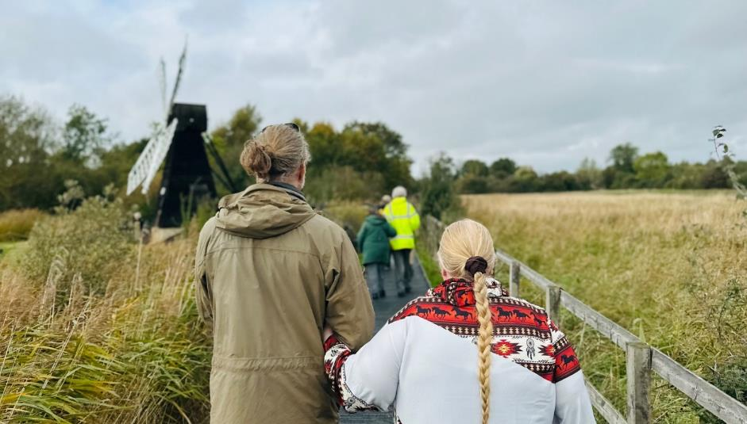
Image: Photo taken at an outing to Wicken Fen Nature Reserve as part of the Inspired by Nature Project in collaboration with CamSight, Babylon Arts, Tom Adams, Ely Museum and RNIB. Image Credit: CamSight.

In This Edition

Vision Norfolk News - Updates from your local sight loss charity
Community Hub Updates - News from each of our community hubs in Norwich, King’s Lynn and Great Yarmouth
Children, Young People and Families - Learn about our services for local people aged 0-25 and their families
Equipment and Technology - Updates about equipment and technology including upcoming events and opportunities
Activities - List of activities and events coming up over the next few months across the county
Contact Details - Find out how to reach us with your questions

Are you interested?
Norfolk County Council runs Adult Education courses for everything from practical life skills to English and Maths. We are exploring the possibility of working with the Adult Education team to provide Vision Norfolk service users with a course on using the Internet. This course would focus on using your computer to access emails or search the Internet
Do you think you, or someone you know, might be interested? Please contact Barbara at 01603 573000 Ext. 504 or barbara.dunn@visionnorfolk.org.uk to tell us what you think.
We always welcome ideas and suggestions for new activities and other ways we can better support you. If you would like a particular activity organised please get in contact.

Change to Charitable Incorporated Organisation
In the coming weeks you may notice that Vision Norfolk is going through the process of changing our legal status from a Registered Charity to a Charitable Incorporated Organisation (CIO).
Many charities which own property, employ staff or deliver service contracts are becoming CIOs. This can simplify the way the charity operates, it means that the charity becomes a legal entity in its own right, and it makes it much easier to enter into contracts, for example to deliver a service on behalf of a local authority, the NHS or another statutory body.
As a CIO, Vision Norfolk will retain our charitable status, and will continue to be regulated by the Charity Commission.
In practice, for our clients, nothing will change. You will continue to benefit from the same services, and all of our staff will become employees of the CIO, so you will continue to see the same faces that you know and value. We will continue to be called Vision Norfolk, and the board of trustees will continue to oversee the charity.
Other benefits of becoming a CIO include reassuring potential funders about our legal status, and attracting new trustees, both of which are important factors in Vision Norfolk being able to continue and grow our services for vision impaired people in the county.
We plan to change our status to that of a CIO in April.

Vision Norfolk Visual Awareness Training
We believe everyone should be able to lead a fulfilled life and we work to ensure people living with sight loss are able to access the same opportunities as sighted people. This often requires conversations with individuals and organisation across the community about how they can better champion accessibility.
We are delighted to announce that our Vision Awareness and Guiding Training course has been officially accredited by the Charted Institute of Personnel and Development! We can provide this training course to individuals or as part of a group.
The course costs £20 per person or £250 per group booking (minimum 12 participants, maximum 16).
If you know anyone who may be interested please contact Barbara at 01603 573000 Ext. 504 or barbara.dunn@visionnorfolk.org.uk.
We can also provide resources and educational talks for businesses, schools and organisations that want to support those living with vision impairment.

Fundraising
Throughout the holiday season we received some wonderful support from the community and local businesses. Our Christmas cards, including two designs created by service users, raised over £850 to support our services.
New Medica Eye Health Clinic held a Christmas tombola at their Norwich office. Staff at Broadland Council collected toys and crafting supplies for our Children, Young People and Families Programme as part of a Christmas Giving Tree.
In February Swingymabob Dance held a Valentine’s tea dance to raise funds for the Children, Young People and Families Programme.
Coming up in May, two of our staff members from East Norfolk, Edward and Matthew, are hiking Mount Snowdon to raise funds. In July the Mulbarton Allotments and Gardens Association has chosen Vision Norfolk to benefit from any proceeds from their Mulbarton Open Gardens event.

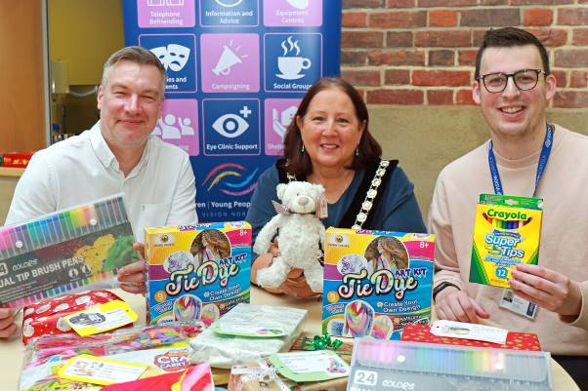
Image: From left to right - Vision Norfolk Chief Executive Andrew Morter, Council Chair Caroline Karimi-Ghovanlou and Children, Young People and Families Coordinator Joshua Bartholomew. They are sitting behind a table covered in donated presents and crafting supplies.

Buy a Brick
Help support Vision Norfolk’s work supporting people with sight loss across the county by buying a brick to appear in the Norwich community hub.
Bricks can be sponsored with a minimum donation of £25. We will create a custom sticker which will be placed on one of the bricks by the stairwell leading from the ground floor up to the staff offices in the Bradbury Activity Centre.
Bricks can have your name, the name of someone you would like remembered, the name of a group or a short message of support. Businesses may also choose to have their logo appear on bricks.
Money raised will go toward our services which include:
- Our programme of creative, cultural, sports and social activities
- Our community hubs in Norwich, King’s Lynn and Great Yarmouth
- The eye clinic team which are based in the hospitals across Norfolk
- Community Outreach Workers who provide support and information out in the community and in people’s homes
- Specialised support available to children, young people and families
- Administration and operational needs which allow Vision Norfolk to continue to provide its services
If you are interested in buying a brick please contact our fundraising department at fundraising@ visionnorfolk.org.uk or 01603 573000 Ext. 366 and inform them you would like to buy a brick.

Norwich Hub Updates

We’ve had a busy end of the year with many of our groups celebrating the holidays including a Heritage Group trip to Stranger’s Hall to learn about Medieval Christmas traditions, a trip to see the Sleeping Beauty Panto at Norwich Theatre Royal, a Christmas flower arranging workshop and more.
We also had our non-Christmas activities including a two-part mosaics workshop with Dandelion Mosaics and more sessions of our new Tea and Tech discussion group.
2024 has started off fast and furious with a number of with new activities including the first meeting of the Glaucoma Support Group at the Norwich Hub and a new audiobook club in Thetford.

Arts and Crafts Group Christmas Display
The Thursday Arts and Crafts Group had a Christmas creation on display in the hub throughout the holiday season complete with pompoms on a latch hook rug, a crochet guide dog in a hot air balloon and even hidden sound buttons.
Darryl came up with the idea of a tactile Christmas display back in March. In April the hard work began making approximately 300 red pompoms which are tied on a latch hook rug to form the words “Merry Christmas”. Then the latch hooking began and 35,000 strands later, with the help of some very dedicated people, the background was white and completed by the end of October. Darryl and his wife took on the task of backing the wall hanging and then came the fun part of attaching angels, baubles, lights, bells and various other parts to give us the finished product
This creation has been made during the Thursday art sessions and everyone has done something toward it.

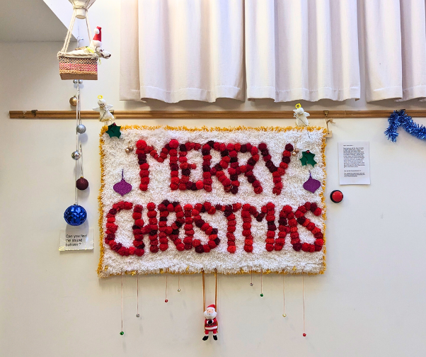
Image: The latch hook rug using red pompoms to spell out the words “Merry Christmas”. The art display is completed with a Santa hanging from the bottom, angels at the top corners, baubles and labels.

Spring Activities
As the weather improves we are looking forward to adventuring outside more. We are hoping to start guided walks around April depending on the weather and return to sailing after Easter. We have an April Fools Quiz and Chips on the 4th April.

Tandem Cycling
We are looking for some more volunteers to be tandem cycle guides so that we can offer rides to more people and allow more flexibility for our current volunteers.

King’s Lynn Hub Updates

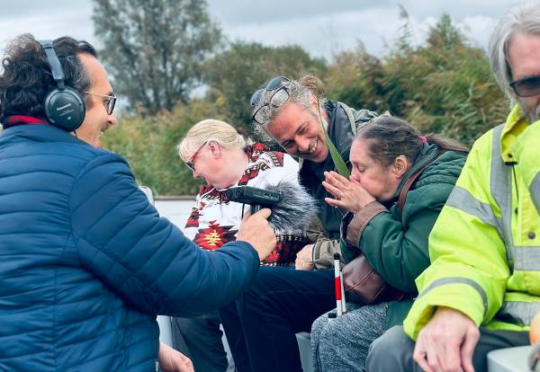
Image: (Image Credit CamSight) A small group of people gathered on a boat traveling through Wicken Fen. One woman is blowing on a leaf while a man with headphone records her on a handheld recorder

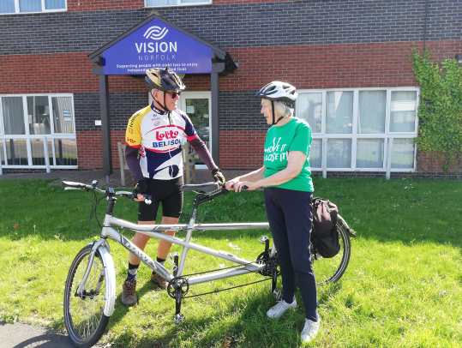
Image: A man and a woman in cycling attire are standing next to a tandem bicycle in front of the grey and red brick Vision Norfolk Hub

Inspired by Nature Project
Over the last six months participants from Vision Norfolk and Cam Sight have been working with artist Tom Adams, Babylon Arts, Wicken Fen Nature Reserve, Ely Museum and RNIB to create a piece of sound artwork inspired by the Lantern Men. According to local folklore the Lantern Men are mysterious white lights that hover over the fenland at night, luring wanderers into the reed beds.
Together the participants explored Wicken Fen by boat and on-foot, handled museum objects at Ely Museum and developed songs, sonic meditations and a whistling choir in response to their experiences.
Their final piece will be available to the public at Babylon Gallery in Ely from the 1st to the 24th of March as part of the Sensing Nature exhibition. There will also be a virtual tour on the Babylon Arts website with the sound piece.

Tandem Cycling
We will be restarting our tandem cycling rides as soon as the weather is better. We started running tandem cycling in King’s Lynn last year and have had some fantastic feedback from our first few riders. We are looking for more participants to get involved both as riders and as sighted guide.

Photography Club
We’ve recently started a photography club based out of the King’s Lynn Hub. The club is run by one of our volunteers who is also an amateur photographer. The first few sessions have focused on exploring options for setting up a camera and framing shots but the group is looking forward to trips out around the local area during the summer.

Great Yarmouth Hub Updates

Finishing Off 2023
We finished off 2023 with our hub Christmas Party. Some of the attendees went all out with their festive attire and everyone had the chance to enjoy Christmas crackers, snacks and good company. There was even a visit from the big man himself (Santa)! A group also had the opportunity to visit St George’s Theatre to see the Robin Hood Panto.

New Events and Activities
So far in 2024 we have hosted a variety of interesting activities to start the year off, and we are looking forward to even more.
In January, we held a mosaics workshop with Dandelion Mosaics. This went down well with everyone who attended and, as it went so well, we are organising another one for later in the year. Watch this space!
We had our first Knit and Natter session in February, run by the Norfolk Knitters. If anyone fancies making some yarns, while telling some good yarns, we’d love to hear from you.
Have you ever wanted to learn Braille? If anyone wants to come along for a oneto-one taster session in learning Braille, this can be arranged. Spaces will be limited.
If you have a query about a piece of technology, then why not pop in to our new tech support session which is run by one of our volunteers on the last Wednesday of the month. Please be aware this will need to be booked in advance.

Returning Activities
As well as these, we also have some of our favourites returning including bingo, bowling, and walks along the seafront in Great Yarmouth. These will continue on alternate months.

For information about upcoming opportunities at the Great Yarmouth Hub, there is a full list of activities later in this newsletter or you can get in contact with Catherine by calling 01493 745973 or emailing greatyarmouthhub@visionnorfolk.org.uk.

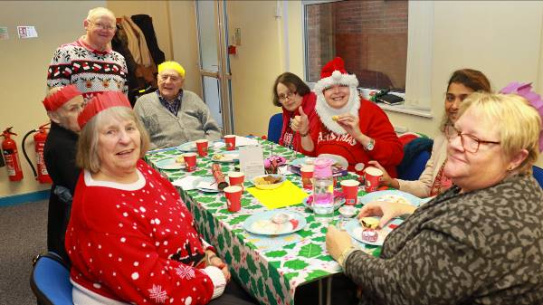
Image – Left: Eight people around a table in the Great Yarmouth Hub smiling at the camera. One person is wearing a Santa hat with a full beard and showing a thumbs up.

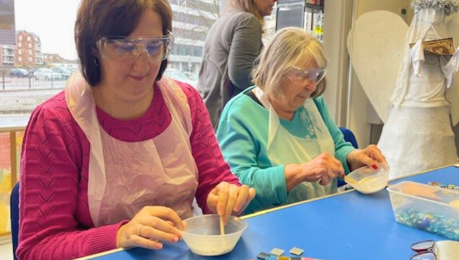
Image: Two women wearing aprons and safety glasses sit at a table mixing paste in a bowl. Another woman is walking behind them and there is a crafted angel in the corner of the room.

Children, Young People and Families

The CYPF Service organises activities and events to improve confidence and encourage independence. By including the whole family, we empower these families through shared experience and knowledge and build lifelong friendships.
During the festive season, the CYPF department treated children and their families to various events, including the Sleeping Beauty Pantomime at the Norwich Theatre Royal, a Christmas bowling party for older children and young adults and a ride on the Bure Valley Festive Train. Our annual Christmas Party was a fun occasion, where numerous families celebrated the festivities together
Looking ahead, we aspire to extend our reach to more families throughout the county, focusing on organising events in the Great Yarmouth and King’s Lynn areas while also providing opportunities for parents and carers. Upcoming activities include a visit from Lab Media to create digital music and stories using iPads and other electronic music devices, a family craft day, a trip to Wroxham Barns for our preschool group and younger children, and an Escape Room experience for our teenagers.
Additionally, new Parent Support Groups will commence in the spring at each of our hubs, offering guidance to parents of newly diagnosed preschool children. Parents can gain knowledge from our expert staff while their children stay and play, building connections with others in similar situations.
We continue to provide one-on-one emotional and practical support for families, offering an essential service to help them understand the impact of vision impairment. Our assistance includes advice on benefits, grants, and funding available for children with vision loss, along with referrals to various relevant services and organisations.

We welcome your input and encourage you to share suggestions for new activities and other ways we can offer support. Please reach out to CYPF@visionnorfolk.org.uk with any questions or ideas for 2024.

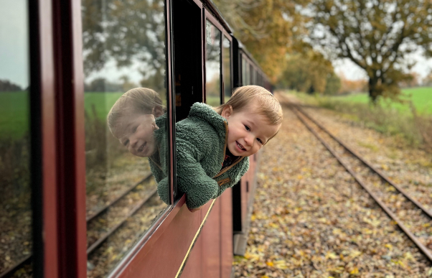
Image: A smiling toddler hanging out of a train window with colourful trees and leaves on the track behind them.

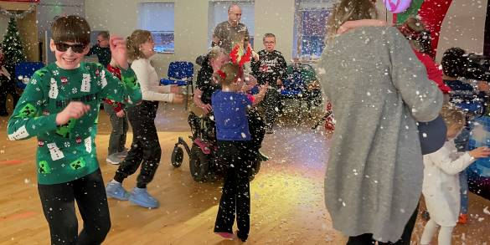
Image – Right: Children dancing in artificial snow created by the Captain Fantastic booth at the Children’s Christmas Party in the Norwich Hub.

Equipment and Technology

If you have any questions about daily living equipment we can provide support at our community hubs in Norwich, King’s Lynn and Great Yarmouth or over the phone. Our Community Outreach Workers are also available for home visits where they can discuss which of our services may be of interest to you, including discussing equipment and how your living space can best work for you. To find out more please get in contact with John at 01603 573000 Ext. 323 or email john.morland@visionnorfolk.org.uk.

Talking About Technology
Tea and Tech – Norwich, 2nd Monday of the Month, 1:30pm-3:30pm
Rachael and Darryl Andrews invite you to come along to the Norwich Hub and chat about your tech products. This is not a training session but a discussion session for likeminded people to talk about tech products. If you might be interested please contact Richard at 01603 573000 Ext. 322 or richard.polley@visionnorfolk.org.uk.

Technology Sessions with RNIB
King’s Lynn, Monthly on a Wednesday (15th May, 12th June), 11am-3:45pm
These are one-to-one problem solving sessions with Mohammed Atif, Technology for Life Coordinator at RNIB, to help you with any issues you are having with digital technology and devices. Free 45 minute sessions must be booked ahead of time. If you might be interested please contact Penny at 01553 660808 or kingslynnhub@visionnorfolk.org.uk.

Technology Support Sessions
Great Yarmouth, Last Wednesday of Each Month, 1pm-2pm
These new sessions are being run on an appointment basis by one of our volunteers who is off ering his help and support to anyone who might be experiencing issues with their technology. Please be aware this will need to be booked in advance. If you might be interested please contact Catherine at 01493 745973 or greatyarmouthhub@visionnorfolk.org.uk.

Vision Zone 2024 – Solutions for Low Vision
Would you like to find out more about assistive technology, support, services, groups and much more?
Come to one of our Vision Zone events to find out more about activities and services available in your local area from Vision Norfolk and have expert demonstrations of assistive technology from Optelec, Synapptic, Cobolt Systems and more.
Entry is free and all are welcome.
Monday 20th May – 10am to 2pm Norwich Hub, Bradbury Activity Centre, Beckham Place, Edward Street, Norwich, NR3 3DZ
Tuesday 21st May – 10am to 2pm Great Yarmouth Hub, 12 Hall Quay, Great Yarmouth, NR30 1HP
Wednesday 22nd May – 10am to 2pm Kings Lynn Hub, Unit 3 Dundee Court, Hamburg Way, King’s Lynn, PE30 2ND

Activities

Following is the list of activities that are currently available for adults across the county. Please contact CYPF@visionnorfolk.org.uk for activities for children and young people. All of our activities are free of charge unless otherwise stated.
We always welcome ideas and suggestions for new activities and other ways we can better support you. If you would like a particular activity organised please contact barbara.dunn@visionnorfolk.org.uk.

Norwich and South Norfolk

Unless otherwise stated please contact Richard at 01603 573000 Ext. 322 or richard.polley@visionnorfolk.org.uk.

Regular Activities

Arts and Crafts – Norwich, Thursdays 10am-12:30pm
Undertake a variety of arts and crafts with support from Helen and the volunteers. Contact Mark on 01603 573000 Ext. 341 or mark.smith@visionnorfolk.org.uk.

Audiobook Clubs
Our friendly, informal audiobook clubs offer a chance to get together and enjoy a chat about a chosen book. The book clubs are free to join and we can supply a memory stick player if you don’t have one. Contact Mark on 01603 573000 Ext. 341 or mark.smith@visionnorfolk.org.uk.
Diss Audiobook Club – 4th Friday of the Month, 2pm-3:30pm
Norwich Audiobook Club – 2nd Monday of the Month, 1:30pm-3pm
Thetford Audiobook Club – 4th Wednesday of the Month, 2pm-3:30p,

Bowling – Norwich, 2nd and 4th Friday of the Month, 12:15pm-5pm
Come and enjoy some friendly competition with ten pin bowling at Namco Funscape. Transportation available from the Norwich Hub. Regular bowling fee to be paid to Namco Funscape.

Braille Classes – Norwich, Thursdays, By Appointment
Join our Braille class taught by one of our volunteers. The classes are small, usually on a one-to-one or one-to-two basis.

Cooking with Sue – Norwich, Monthly on a Thursday (28th March, 25th April, 23rd May), 2pm-4pm
Each month we will be running a cookery lesson at our Norwich Hub teaching practical skill that can be used at home.

Creative Writing – Norwich, 3rd Tuesday of the Month, 2pm-3:45pm
Join a creative writing group that will give you the opportunity to express yourself through the written word. Contact Mark on 01603 573000 Ext. 341 or mark.smith@visionnorfolk.org.uk.

Darts – Norwich, 1st and 3rd Friday of the Month, 1pm-3pm
Join us for a few friendly games of darts. Volunteers are around to help you position or read the numbers on the board if needed.

Glaucoma Support Group - Norwich, 2nd Friday of the Month, 2pm-3:30pm
We are working with Glaucoma UK to start a support group at the Norwich Hub. It will be a self-help and discussion session and we hope to introduce speakers to talk about Glaucoma as well as other interesting subjects.

Sailing – Norwich, Fortnightly from 11th April, 12:30pm-5pm
Come and enjoy an afternoon of boating on the Norfolk Broads. During the winter the group goes out on an undercover motor cruiser. From April we will be returning to fortnightly sailing while we enjoy the warmer weather. Trips cost £17 per person. Contact Mark on 01603 573000 Ext. 341 or mark.smith@visionnorfolk.org.uk.

Macular Society – Norwich, 2nd Friday of the Month, 12pm-1:30pm
This group is organised and run by the Macular Society. Vision Norfolk staff usually give an update on new equipment and activities and there are sometimes guest speakers.

Coffee Mornings and Socials
Come and enjoy a cup of coffee, a slice of cake and a chat about everything and anything at one of our socials.
Norwich Coffee Morning – Last Monday of the Month, 10am-11:30am
Attleborough Coffee Morning – Fortnightly from 11th March, 11am-12:30pm
Please contact Chris Linstead at 07743 921430 or email chris.linstead@visionnorfolk.org.uk.

Seated Yoga – Tuesdays, 1pm-2pm and 2:15pm-3:15pm
Come stretch and relax with yoga. Sessions are designed to be accessible to all abilities and levels of experience.

Short Mat Bowls – Tuesdays, 10am-12pm
Come and enjoy some friendly competition with the traditional British game short mat bowls. We play inside the Bradbury Activity Centre. There are volunteers around to aid.

Tandem Cycling – By Appointment
Our tandem cycling sessions will be returning once as the weather is more predictably mild. Tandem cycling allows you to continue to enjoy a good (and safe) bike ride regardless of your vision loss. A sighted guide sits at the front to steer and describe. Sessions are subject to volunteer availability.

Tea and Tech – Norwich, 2nd Monday of the Month, 1:30pm-3:30pm
Rachael and Darryl Andrews invite you to come along to the Norwich Hub and chat about your tech products. This is not a training session but a discussion session for likeminded people to talk about tech products.

Photography Group – Norwich, 1st and 3rd Friday of the Month, 1:30pm-3:30pm
The first meeting in each month is an outdoor photoshoot and the second is an indoor opportunity to review photographs. Some outing may have a cost for refreshments. Contact Mark on 01603 573000 Ext. 341 or mark.smith@visionnorfolk.org.uk.

Special Events

Easter Flower Arranging – Norwich, 27th March, 10am-12pm
Come and make an arrangement of spring flowers with the lovely tutor Crystal. Contact Mark on 01603 573000 Ext. 341 or mark.smith@visionnorfolk.org.uk.

April Fool’s Quiz – Norwich, 4th April, 1:15pm-3:30pm
Join us for another competitive round of Quiz and Chips, April Fool’s edition. We will enjoy chips from 1.15pm - 2pm then the quiz will start at 2pm and finish around 3.30pm. If you would like chips they are £2.50 per person.

Pottery Workshops – Norwich, April 17th and May 1st, 10am-12:30pm
Try your hand at pottery with the instruction of an expert. Small group sessions with the chance to use a potter’s wheel. Spaces are very limited. Contact Mark on 01603 573000 Ext. 341 or mark.smith@visionnorfolk.org.uk.

Vision Zone 2024 – Norwich, 20th May, 10am-2pm
Come to one of our Vision Zone events to find out more about activities and services available in your local area from Vision Norfolk and have expert demonstrations of assistive technology from Optelec, Synapptic, Cobolt Systems and more.

Theatre Trip: Grease – Norwich, 5th June, 2:30pm-5pm
After a whirlwind summer romance, leather-clad greaser Danny and girl-nextdoor Sandy are unexpectedly reunited when she transfers to Rydell High for senior year. But can they survive the trials and tribulations of teenage life and find true love once more? Tickets are priced at £55. This includes a sighted companion ticket if required. Contact Mark on 01603 573000 Ext. 341 or mark.smith@visionnorfolk.org.uk.

West Norfolk

Unless otherwise stated contact Abigail at 01553 660808 or kingslynnhub@visionnorfolk.org.uk.

Regular Activities

Archery - Downham Market, 1st Monday of the Month, 4pm-6pm
Join one of our archery sessions designed to be accessible for all abilities and skill levels.

Art Workshops – King’s Lynn, 1st Friday of the Month, 2pm-3pm
We are holding small art workshops with painting, print making, collage and more.

Audiobook Clubs
Our friendly, informal audiobook clubs offer a chance to get together and enjoy a chat about a chosen book. The book clubs are free and we can supply a memory stick player. Contact Mark on 01603 573000 Ext. 341 or mark.smith@visionnorfolk.org.uk.
Dereham Audiobook Club – 3rd Wednesday of the Month, 10:30am-12pm
Fakenham Audiobook Club - 3rd Monday of the Month, 10:30am-12pm
Gaywood Audiobook Club – 1st Thursday of the Month, 2pm-3:30pm

Choir – King’s Lynn, Fortnightly on Wednesday, 1pm-3pm
Join the Vision Norfolk Choir to improve your mental wellbeing, meet new people and most importantly have fun.

Coffee Mornings and Socials
Come and enjoy a cup of coffee, a slice of cake and a chat about everything and anything at one of our socials.
Downham Market Social – 4th Wednesday of the Month, 11am-1pm
Free to attend but any refreshments must be purchased from the café.
Fakenham Coffee Morning – 4th Tuesday of the Month, 10am-12pm
Free to attend but any refreshments must be purchased from the café.
West Norfolk Coffee Morning – King’s Lynn, 1st and 3rd Tuesday of the Month, 10am-12pm

Knitting – King’s Lynn, 2nd Tuesday of the Month, 1:30pm-3:30pm
Whether you are a complete beginner who would like to take up knitting or a seasoned knitter, our sessions are a fun and sociable way of getting together with fellow yarn fans.

Ladies Luncheon – King’s Lynn, 3rd Thursday of the Month, 12pm-2pm
A relaxed and friendly group that meet for a chat over lunch at local venues. Special activities paid for by the group directly.

Men’s Group - Sedgeford, 2nd Monday of the Month, 12pm-2pm
A relaxed and friendly group that meet for a chat over lunch at The King William Pub in Sedgeford. Special activities paid for by the group directly.

Photography Club – King’s Lynn, 3rd Monday of the month, 1:30pm-3:30pm
Join our new photography club run by one of our volunteers. We will be alternating session between outings to do photoshoots and session in the hub reviewing photographs and talking about different techniques.

Sit Fit – Downham Market, 3rd Friday of the Month, 1:30pm-3:30pm
A seated exercise class suitable for all adults regardless of age, gender or ability.

Tandem Cycling – King’s Lynn, By Appointment
Our tandem cycling sessions will be returning once as the weather is more predictably mild. Tandem cycling allows you to continue to enjoy a good (and safe) bike ride regardless of your vision loss. A sighted guide sits at the front to steer and describe. Sessions are subject to volunteer availability.

Technology Sessions – King’s Lynn, Monthly on a Wednesday (15th May, 12th June), 11am-3:45pm
These are one-to-one problem solving sessions with Mohammed Atif, Technology for Life Coordinator at RNIB, to help you with any issues you are having with digital technology and devices. Free 45 minute sessions must be booked ahead of time.

Walking Club – King’s Lynn, 4th Monday of the Month, Times Vary
Join the King’s Lynn team for walks around the local area with transportation available from the King’s Lynn Hub. We will be starting with some shorter walks, around 2 miles, with the possibility of doing some longer walks in the summer. Get in contact for more details of where we are going each month.

Special Events

Vision Zone 2024 – King’s Lynn, 22nd May, 10am-2pm
Come to one of our Vision Zone events to find out more about activities and services available in your local area from Vision Norfolk and have expert demonstrations of assistive technology from Optelec, Synapptic, Cobolt Systems and more.

East Norfolk

Unless otherwise stated please contact Catherine at 01493 745973 or greatyarmouthhub@visionnorfolk.org.uk.

Regular Activities

Audiobook Clubs
Our friendly, informal audiobook clubs off er a chance to get together and enjoy a chat about a chosen book. The book clubs are free to join and we can supply a memory stick player if you don’t have one. Contact Mark on 01603 573000 Ext. 341 or mark.smith@visionnorfolk.org.uk.
Great Yarmouth Audiobook Club – Last Friday of the Month, 1:30pm-3pm
Cromer Audiobook Club – 3rd Monday of the Month, 2pm-3:30pm

Bingo – Great Yarmouth, 9th April Then Alternate Months 2nd Tuesday of the Month, 10am-12pm
Try your luck at one of our bingo sessions with prizes available for winners.

Bowling – Great Yarmouth, 30th April Then Last Tuesday in Alternate Months, 12pm-3pm
The Great Yarmouth Hub runs group bowling trips to Wellington Pier. Places are limited.

Braille Class – Great Yarmouth, 1st and 3rd Wednesday of the Month, 1pm-2pm
Join our fun and friendly Braille class run by one of our volunteers. You will have the opportunity to learn a new skill at your own pace with the support of the teacher. Spaces will be limited for this activity.

Clip and Climb – Great Yarmouth, 26th March and Then Last Tuesday of Alternate Months, 3pm-4pm
Ever fancied rock climbing? Clip n’ Climb is made up of a number of unique climbing elements at the indoor climbing gym at the Great Yarmouth Marina Centre.

Coffee Mornings and Socials
Come and enjoy a cup of coffee, a slice of cake and a chat about everything and anything at one of our socials.
Great Yarmouth Coffee Morning – Wednesdays, 10am-12pm
Cromer Coffee Morning – Last Wednesday of the Month, 10am-1pm
Contact Karl at 07864 615929 or karl.bloor@visionnorfolk.org.uk.
Potter Heigham Coffee Morning – 1st Monday of the Month, 10am-12pm
Contact Matthew at 01603 573000 Ext. 455 or email matthew@visionnorfolk.org.uk.

Cooking Group – Great Yarmouth, 12th March Then 2nd Tuesday of Alternate Months, 10am-12pm
We will be continuing with our cooking sessions where you can prepare a variety of items both sweet and savoury cooked to your individual liking in the air fryer which we can all enjoy together.

Games Morning – Great Yarmouth, Thursdays, 10am-12pm
Join our fun and welcoming games group to play a variety of board and card games.

Knit and Natter – Great Yarmouth, 2nd Thursday of the Month, 1pm-2pm
Join Norfolk Knitters at our new Knit and Natter group where we learn together how to knit along with having a good natter and chance to meet new people.

Seafront Walks – Great Yarmouth, 25th April Then the Last Thursday of Alternate Months, 1pm-3pm
Join us for a breath of fresh air and a leisurely stroll along the one of our many local seafronts. A refreshment stop will be included during the afternoon.

Technology Support Sessions – Great Yarmouth, Last Wednesday of Each Month, 1pm-2pm
These new sessions are being run on an appointment basis by one of our volunteers who is offering his help and support to anyone who might be experiencing issues with their technology. Please be aware this will need to be booked in advance.

Weaving Group – Great Yarmouth, Fridays, 10am-12pm
Use different types of soaked cane to make baskets of all shapes and sizes.

Special Events

The Walled Garden, Little Plumstead – 19th March, Time to be Confirmed
Join us for a visit to the Walled Garden in Little Plumstead for a wander around the gardens and also to have the opportunity to get a bite to eat and a browse around their shop. Transportation available from the Great Yarmouth Hub. Please be aware that spaces are very limited. Departure times are still to be confirmed.

Vision Zone 2024 – Great Yarmouth, 21st May, 10am-2pm
Come to one of our Vision Zone events to find out more about activities and services available in your local area from Vision Norfolk and have expert demonstrations of assistive technology from Optelec, Synapptic, Cobolt Systems and more.

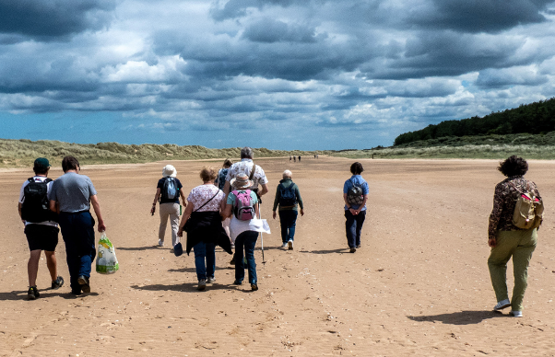
Image: Seaside Walks – Great Yarmouth: Ten figures walking across flat sand under a cloudy sky. Some of the figures are walking in pairs while others are walking on their own.

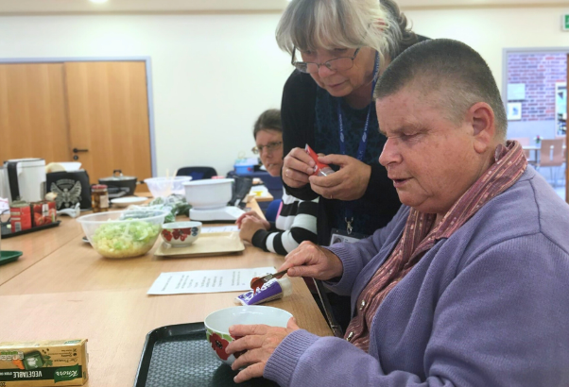
Image: Cooking with Sue – Norwich: A woman measuring tomato paste into a bowl while another woman watches over her shoulder. In the background the table is covered with bowls and various cooking instruments.

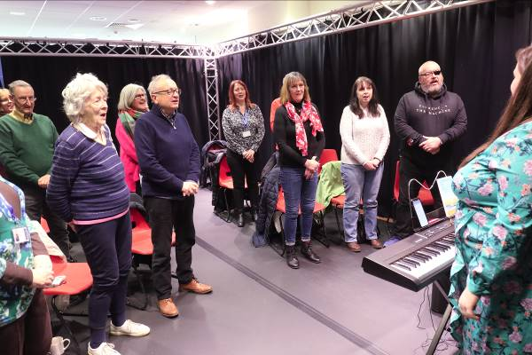
Image: Choir – King’s Lynn: Members of the Vision Norfolk Choir standing and singing inside The Workshop in King’s Lynn.

Contacts

For further information on how we can support you and how you can get involved:
Website: visionnorfolk.org.uk
Telephone: 01603 573000
Email: office@visionnorfolk.org.uk

Our hubs can be found at:

Norwich
Bradbury Activity Centre, Beckham Place Edward Street, Norwich, NR3 3DZ
Telephone: 01603 573000
Email: office@visionnorfolk.org.uk

King’s Lynn
Unit 3, Dundee Court, Hamburg Way King’s Lynn, PE30 2ND
Telephone: 01553 660808
Email: kingslynnhub@visionnorfolk.org.uk

Great Yarmouth
12 Hall Quay, Great Yarmouth, NR30 1HP
Telephone: 01493 745973
Email: greatyarmouthhub@visionnorfolk.org.uk

Registered charity no. 207060

