**Vision Norfolk**

**Magpie News Winter 2024**

Welcome to the Winter edition of Magpie News with updates from Vision Norfolk, your local sight loss charity.

If you would like this newsletter in another format please let us know by calling 01603 573000 or emailing office@visionnorfolk.org.uk. Magpie News is currently available by mail in printed, Braille or audio format on a memory stick or CD. A digital format is also available on our website and by email as a Word Document or a PDF.

**Holiday Opening Hours**

Please note that our community hubs in Norwich, King’s Lynn and Great Yarmouth will be closed from Christmas Day through New Year’s Day. We will not be running any of our regular activities during this time with the exception of the trip to the Aladdin Panto in Norwich on 30th December. If you have any questions please get in contact.

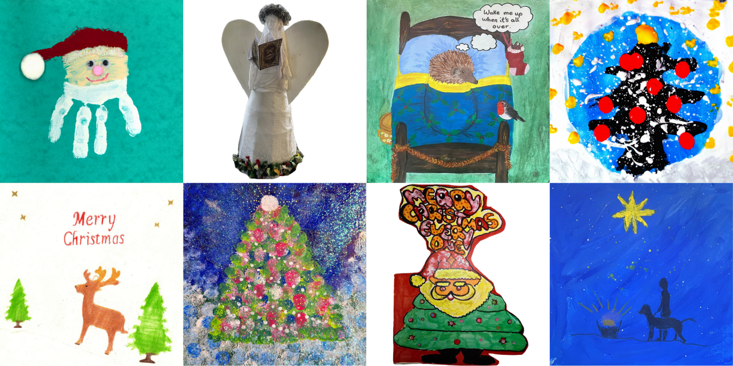

Image: Eight Christmas card designs created by local people with sight loss

**In This Edition**

Vision Norfolk News – Page 3

Updates from your local sight loss charity

Children, Young People and Families – Page 9

Learn about our services for local people aged 0 to 25 and their families

Equipment and Technology – Page 11

Updates about equipment and technology including information and opportunities to learn more

Norwich and South Norfolk – Page 16

Updates from our Norwich Community Hub and upcoming events and activities in Norwich and South Norfolk

West Norfolk – Page 23

Updates from our King’s Lynn Community Hub and upcoming events and activities in West Norfolk

East Norfolk – Page 29

Updates from our Great Yarmouth Community Hub and upcoming events and activities East Norfolk

Other Information – Page 36

A reminder about Pension Credit

Contact Details – Page 39

Find out how to reach us with your questions

**Vision Norfolk is Hosting a Wellness Event**

Save the Date – Wednesday 23rd April 2025

Join Vision Norfolk for an all-day wellness event at the Bradbury Activity Centre in Norwich. We will be joined by other organisations who can offer advice and support around physical and mental wellbeing and healthy eating as well as leisure activities. We will be doing some craft and gardening activities through the day too.

**Summiting Snowdon**

On Friday 13th September five of our staff members took on Wales’ highest mountain to raise money to boost the charity’s support for people living with sight loss.

Included in the group was Edward Bates, Hub Coordinator at the Great Yarmouth Hub who is blind. His ambition to climb to base camp on Mount Everest was frustrated for medical reasons but he was inspired to find a new climb. Ed was joined by Community Outreach Worker Matthew Hodder, Chief Executive Andrew Morter, Services Manager and Deputy Chief Executive Barbara Dunn, and Leisure and Activities Coordinator Helen King.

The hikers fought through a cold and misty hike. Fortunately by the time they reached the top, the mist had cleared and they were thoroughly warmed up.

Fundraising from the hike has raised over £4,000 to support Vision Norfolk services.

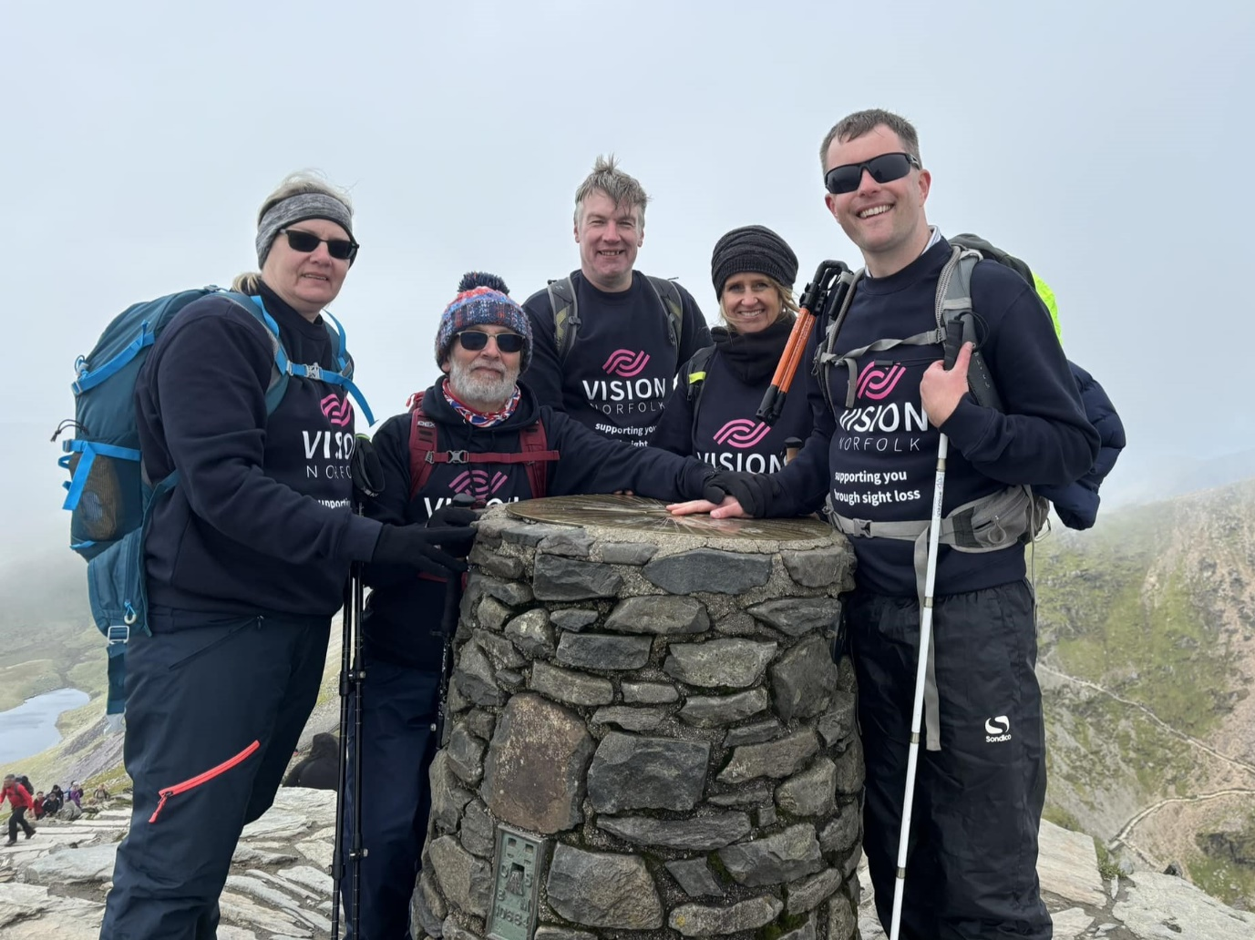

Image: The climbers Helen, Matthew, Andrew, Barbara and Ed standing triumphantly with their hands on the summit marker of Mount Snowdon.

**Annual Review and Financial Statements**

The Vision Norfolk Annual Review for 2023/24 is now available to download on our website or you can pick up a physical copy from our community hubs.

Services Highlights from 2023/24:

509: patients supported by our Eye Clinic Team in the county’s eye clinics

1,069: interventions by our Community Outreach Service for vision impaired people in their home or local community

3,648: calls made by volunteers via our Telefriends service during the year

349: people helped with access to equipment and technology in our Equipment Centres

222: families received support from the Children, Young People & Families Programme

814: activity sessions completed during the year, including:

* audiobook clubs
* cookery lessons
* heritage group
* theatre visits
* coffee mornings
* sports including yoga, archery, boccia and darts
* arts and crafts including pottery, weaving, art and photography
* creative writing
* walks and rambles and much more

To receive this report in other formats please contact: office@visionnorfolk.org.uk or 01603 573000.

Full financial accounts, details of Patrons, Presidents, Vice-Presidents, Trustees, Executive Staff and other officers, along with other statutory information, can be obtained by downloading the charity’s 2023/24 Financial Statements from www.visionnorfolk.org.uk/about-us/reports.

**Leave a Lasting Legacy – Buy a Named Brick**

Support Vision Norfolk and make a meaningful impact by buying a named brick! By purchasing a brick personalised with your name, or the name of a loved one, you’ll be helping us build a brighter future for vision impaired adults and children living in Norfolk.

Your contribution will:

* Help fund our Wellbeing and Inclusion Team and Community Outreach Workers
* Provide much-needed support to people of all ages in Norfolk with a diagnosed sight condition
* Create a permanent tribute of your generosity

Each named brick will be placed in the stairway of Vision Norfolk’s Bradbury Activity Centre in Norwich serving as a lasting tribute to your support.

How It Works:

* Purchase a brick for just £50
* Choose a name or short message to be added to your brick
* Leave a legacy that will inspire others and support a worthy cause.

Contact Vision Norfolk on 01603 573000 and ask to speak to our Fundraising Department to secure your brick today and help us create something extraordinary. Together we are supporting people through sight loss.

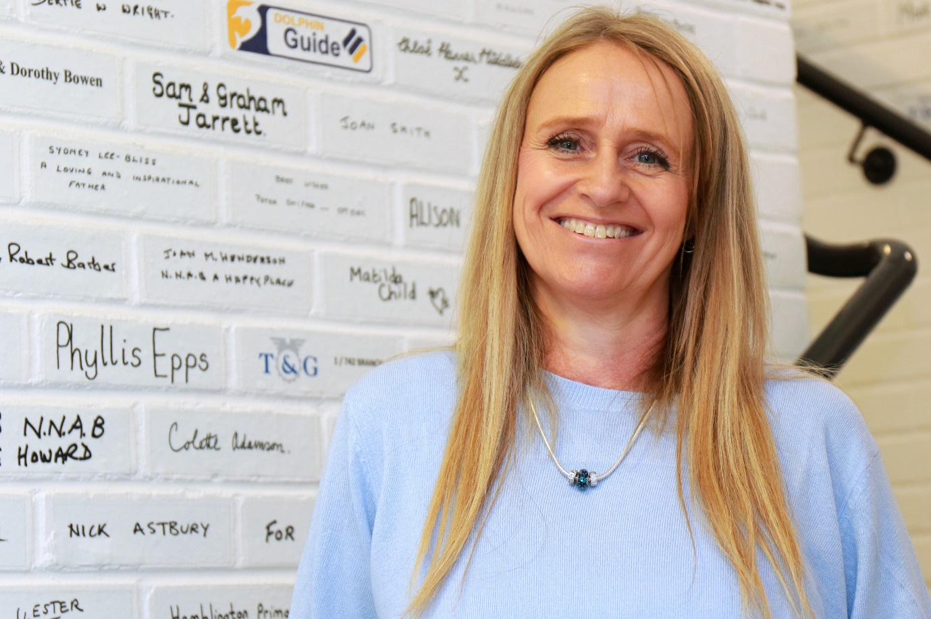

Image: Services Manager and Deputy Chief Executive Barbara Dunn standing in front of the wall of fundraising bricks.

**Support Vision Norfolk This Holiday Season**

The Christmas season is here! There are lots of ways you can celebrate, shop and support local people with vision loss.

Christmas Cards We are selling Christmas cards to help raise funds to support our services. This year we are selling eight new designs created by service users that feature everything from Christmas trees and smiling Santas to grouchy hedgehogs and a tribute to a guide dog companion. Cards can be purchased from any of our hubs or at The Original Norwich Charity Christmas Card Shop at St. Peter Mancroft in Norwich.

Save Your Stamps Drop off your used stamps at our one of our community hubs and we can turn them into funds for our charity. We use a service that will take used stamps and give us around £20 per kilogram. They then earn money back by sorting through for valuable stamps and selling bulk stamps on to special projects such as artists that use stamps in sculptures.

Shopping For a Good Cause

We are inviting everyone to support Vision Norfolk while Christmas shopping from the comfort of your own home! We’re using easyfundraising.org.uk, a free fundraising platform that allows us to earn money when you shop online. EasyFundraising works with over 7,000 online brands. Just go to www. easyfundraising.org.uk and sign up, it takes about 1 minute.

Once signed up all you need to do is start your shopping journey at the EasyFundraising website and the retailer you shop with will send us a donation based on how much you spend. The donation per purchase will generally be between 0.5% and 10%.

**Children, Young People and Families**

The CYPF department recently organised a series of engaging activities for children and their families, aimed at fostering fun, teamwork, and new experiences. One highlight was a thrilling archery session, where families had the opportunity to learn the basics of this exciting sport while building their confidence and skills. Following that, we enjoyed a lively day of ten-pin bowling in Great Yarmouth, which brought out everyone’s competitive spirit and laughter, creating wonderful memories together. Additionally, we took a trip to Thrigby Hall, where families could explore the beautiful wildlife and engage with nature, enhancing their appreciation for the environment.

Alongside these special outings, our weekly tennis sessions continued, providing a fantastic way for children to develop their physical fitness and coordination in a supportive and friendly atmosphere. The tennis sessions however, will be stopping for the winter, in the hope of running a future session in February half term.

We continue to provide the popular one-on-one emotional and practical support for families, offering an essential service to help them understand the impact of vision impairment. Our assistance includes home visits, advice on benefits, grants, and funding, along with referrals to various relevant services and organisations. Unfortunately, the Stay and Play sessions will be stopping, and in their place, we will be introducing new activities to better serve the needs of our community. We have launched a monthly online parent forum, providing families with the opportunity to connect with one another, ask questions, and share suggestions about what they would like from the CYPF service. As well as bi-monthly events specifically for children aged 0-7.

The CYPF department has an exciting line-up of events to bring joy and holiday cheer to our community. We’re thrilled to announce our upcoming visit to the Norwich Theatre Royal Pantomime, a magical ride on the Christmas Train, and our annual Christmas Party filled with games, music, and a special visit from Santa, creating a perfect celebration to wrap up the year.

We welcome your input and encourage you to share suggestions for new activities and other ways we can offer support. Please reach out to CYPF@visionnorfolk.org.uk with any questions or ideas for 2025.

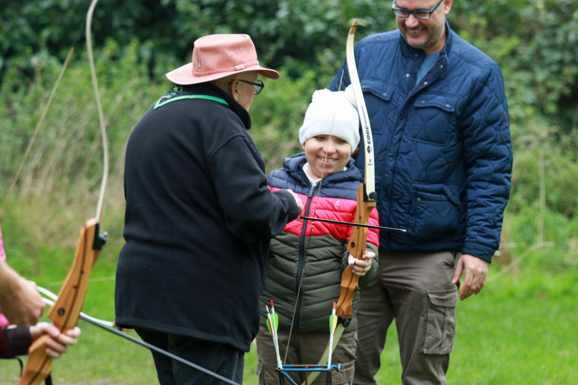

Image: Two adults support a smiling boy as he notches an arrow onto his bow at the half term archery session.

**Equipment and Technology**

If you have any questions about daily living equipment we can provide support at our community hubs in Norwich, King’s Lynn and Great Yarmouth or over the phone. Our Community Outreach Workers are also available for home visits where they can discuss equipment and how your living space can best work for you. To find out more please get in contact with John at 01603 573000 extension 323.

**Opportunities to Talk About Technology**

New - Digital Accessibility Class - Norwich, Wednesday 4th December, 10am-12pm

Are you a laptop user with a vision impairment? Discover how to make technology work for you at our new Digital Accessibility Classes! Join our taster session at the Bradbury Activity Centre. Bring your own laptop and let our teams from Adult Education, Vision Norfolk, and IT Norwich guide you through accessible digital tools and techniques. This introductory session will explore your needs and outline future class content. To secure your spot, please contact Barbara Dunn at barbara.dunn@visionnorfolk.org.uk or call 01603 573000.

Tea and Tech – Norwich, Last Monday of the Month, 1:30pm-3:30pm

Rachael and Darryl Andrews invite you to come along to the Norwich Hub and chat about your tech products. This is not a training session but a discussion session for likeminded people to talk about technology. Please contact Richard on 01603 573000 extension 322.

Technology Support Sessions – Great Yarmouth, Last Wednesday of the Month, 1pm-2pm

One of our volunteers is offering oneto-one help and support to anyone who might be experiencing issues with their technology. Please be aware this will need to be booked in advance. Please contact Catherine at 01493 745973.

**Equipment Tip – Calendars and Diaries**

As we approach 2025 many of us are starting to plan our appointments for the year to come. Traditional calendars and diaries often come in very small print and include design elements that can be difficult to use. However there are options which are more user-friendly. The first thing to think about when picking a way to store information and appointments is your preferred way of getting information. Would you prefer to read out your appointments in large print, Braille or audio? How much information do you want to include with each appointment? You may end up using multiple diaries in different formats, for example if you like to keep a detailed calendar at home but also need something mobile for when you are on the go.

Large Print Calendars and Diaries – This can be a good option if you like to have a physical diary and have enough remaining sight to read larger, high contrast text. There are hanging and portable options of varying sizes. Vision Norfolk sells large print calendars and diaries or they can be purchased from most places that sell equipment for people with sight loss.

Boards and Notes – If you want an even larger option calendars can be made on large white boards. Notes can then be added on thick lined paper.

Penfriend Notes – If you would like to receive information audibly a Penfriend can add notes to tactile stickers which can be used along with a physical outline to make your own talking calendar or to add more detail to a large print calendar.

Smartphone and Tablet Calendars – Many smartphones and tablets have a built-in calendar feature which can be used with the accessibility settings that you have set on your device, whether you prefer audio, large print or some combination. This can be quite usefully when you are out and about.

Virtual Assistants – Virtual assistants are available on most smartphones and tablets to make creating notes and appointments and accessing information even easier. Siri on Apple devices and Google Assistant on Android will allow you to set appointments and reminders by speaking to your phone and the device will enter the details to your digital calendar. You can then access the information by asking the assistant to read out what events you have on the calendar for a particular date.

Smart Speakers – If you have a smart speaker such as the Amazon Echo or Google Assistant, you can set and receive reminders audibly, similar to using a virtual assistant on a smartphone or tablet.

Braille Notetakers - If you prefer to write or read your notes and reminders in Braille, you could use a Braille notetaker. These are small, electronic and portable devices and you can use either the built-in speech synthesizer or Braille display to store information.



Image: Four large print diaries of various sizes and colours that are available at the Vision Norfolk Equipment Centre.

Large print 2025 calendars and diaries are now available to purchase from Vision Norfolk. Calendars are £7.50 each and diaries are between £7.50 and £11 each depending on the size (from pocket sized to A4). Please call John for more information.

**Norwich Hub Updates**

Our autumn months have been very busy making the most of the remaining sun. We had a group take a sensory tour of Norwich Cathedral, the return of the interhub Quiz and Chips (Halloween edition) and we were joined by the Big C Cancer Charity for an important talk about cancer signs, symptoms and care.

**Tennis Returns to Norwich**

At the end of September service users and volunteers joined a coach from the National Tennis Association, for the first session of tennis at Waterloo Park in Norwich. Fortnightly sessions have been put on pause for the winter months but we are planning to open sessions up for more participants in the spring.

**Autumn Gardening Workshop**

Some local people with sight loss explored the joys of gardening at our autumn workshop. Tim Gee from Mousehold Garden Centre visited the hub to lead a bulb-planting workshop. The group planted up ‘lasagne pots’ – which contain layers of bulbs and plants which thrive at different times, ensuring a continuing display as new plants replace those which are coming to an end.

**Christmas in Norwich**

The holiday season has arrived at our Norwich Hub!

We are holding a Christmas Celebration on Wednesday 11th December for service users and volunteers. The afternoon will be complete with carols, light refreshments and merriment. Our Leisure Department has arranged for a free winter themed flower arranging workshop on Wednesday 18th December. Participants will be taken through the basics of flower arranging by a local expert while creating a magical arrangement to brighten up their homes.

We are running a trip to the audio described performance and touch tour of Aladdin the Panto at Norwich Theatre Royal on Monday 30th December.

**Trips out to the Theatre – Planning for 2025**

Due to the nature of the theatre, we often have to book our trips to audio described performances far ahead of time, especially if they are popular shows.

In October 2025 the global sensation Hamilton is coming to Norwich Theatre Royal! Hamilton is the story of America’s Founding Father Alexander Hamilton, an immigrant from the West Indies who helped shape the foundations of the America we know today. We’ve booked some early tickets for a group trip to the audio described evening performance on Friday 3rd October 2025. Tickets cost £95 including a sighted guide if required.

We are also working on plans for other theatre trips throughout 2025. All theatre trips are taken with Vision Norfolk staff and volunteers available to support you as required. We are often able to book audio description and touch tours to allow for more exciting theatre experiences for everyone involved.

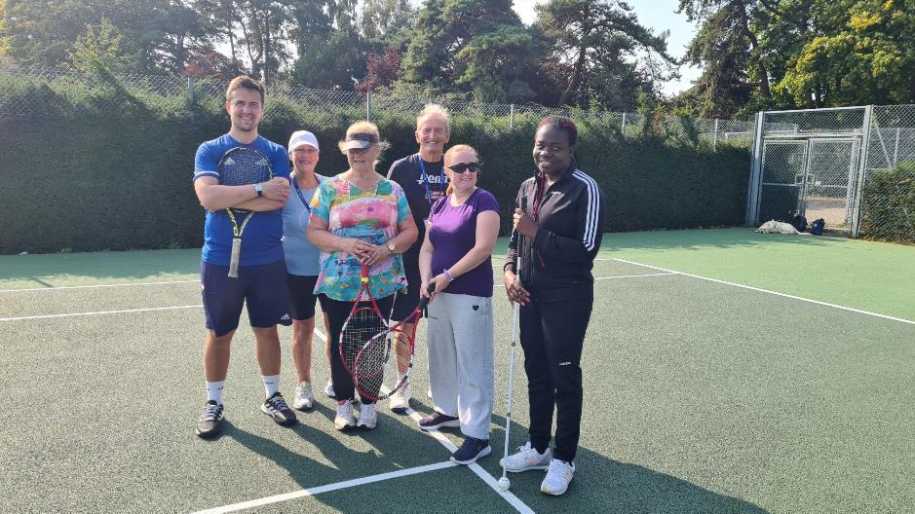

Image: Six people standing on a tennis court in Waterloo Park smiling at the camera. The coach and two players are holding tennis rackets, another player is holding her long cane.

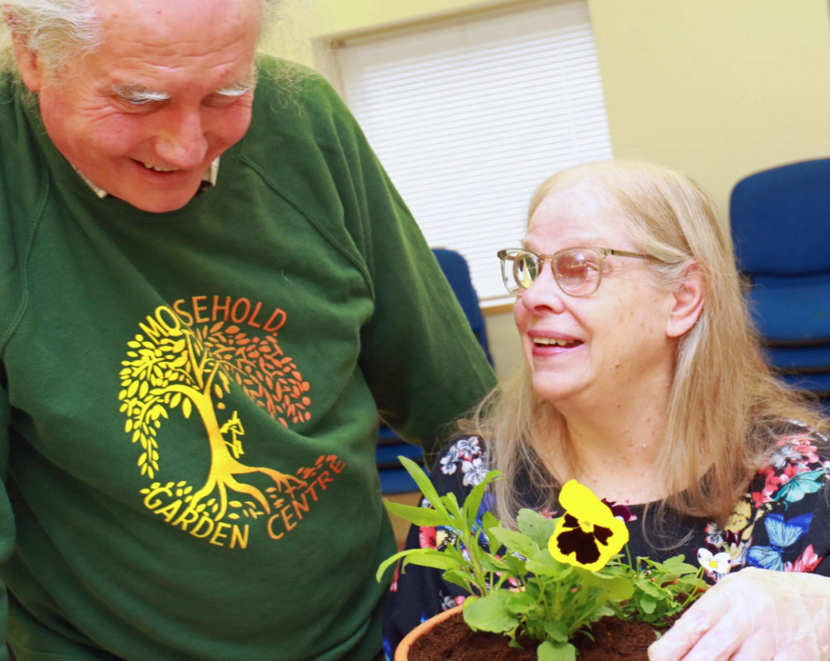

Image: A man and a woman laugh inside the Bradbury Activity Centre. The woman is adjusting a plant pot filled with dirt, greens and a yellow flower.

**Norwich and South Norfolk Activities**

Unless otherwise stated please contact Richard on 01603 573000 extension 322 or richard.polley@visionnorfolk.org.uk.

**Special Events**

Christmas Celebration – Norwich, 11th December, arrive from 2pm

Join the Vision Norfolk community to celebrate the holiday season. Please notify us by the end of November if you will be attending and if you would like the order of service in large print or Braille.

Christmas Flower Arranging – Norwich, 18th December, Morning and Afternoon

Come make a Christmas wreath and flower swag. Please call Mark on 01603 573000 extension 341.

Hamilton – Norwich, 3rd October 2025, 7:30pm performance

We’ve book some early tickets for next year’s performance of Hamilton at the Norwich Theatre Royal. Tickets cost £95 including a sighted guide if required. Please call Mark on 01603 573000 extension 341.

**Regular Activities**

Arts and Crafts – Norwich, Every Thursday 10am-12:30pm

Undertake a variety of arts and crafts with support from Helen and the volunteers. Contact Helen on 01603 573000 extension 342.

Audiobook Clubs

Our friendly, informal audiobook clubs offer a chance to get together and enjoy a chat about a chosen book. The book clubs are free to join and we can supply a memory stick player if you don’t have one. Contact Mark on 01603 573000 extension 341.

Diss Audiobook Club – 4th Friday of the Month, 2pm-3:30pm

Norwich Audiobook Club – 2nd Monday of the Month, 1:30pm-3pm

Boccia – Norwich, 1st and 3rd Friday of the Month, 10am-12pm

Join us for the competitive precision ball sport boccia. Sessions are open to all abilities and levels of experience.

Bowling – Norwich, 2nd and 4th Friday of the Month, 9:30am-1pm

Come and enjoy some friendly competition with ten pin bowling at Namco Funscape. Transportation available from the Norwich Hub. Regular bowling fee to be paid to Namco Funscape.

Braille Classes – Norwich, Every Thursday, By Appointment

Join our Braille class taught by one of our volunteers. The classes are small, usually on a one-to-one or one-to-two basis.

Coffee Mornings and Socials

Come and enjoy a cup of coffee and a chat at one of our socials.

Attleborough Drop-in Café – Fortnightly on a Monday from 2nd December, 11am-12:30pm, contact Chris Linstead on 07743 921430

Norwich Coffee Morning – Last Monday of the Month, 10am-11:30am

Norwich Drop-in Café at Plumstead Road Library – Fortnightly from 27th November, 11am-12pm, contact Jo on 01603 573000 extension 454.

Thetford Drop-in Café – 4th Wednesday of the Month, 2pm-3:30pm, contact Chris Linstead on 07743 921430

Cooking with Sue – Norwich, Monthly on a Thursday, 2pm-4pm

Each month we will be running a cookery lesson teaching practical skills.

Creative Writing – Norwich, 3rd Tuesday of the Month, 2pm-3:45pm

Join a creative writing group that will give you the opportunity to express yourself through the written word. Contact Mark on 01603 573000 extension 341.

Darts – Norwich, 1st and 3rd Friday of the Month, 1pm-3pm

Join us for a few friendly games of darts. Volunteers are around to help position or read the numbers if needed.

Glaucoma Support Group - Norwich, 2nd Friday of the Month, 2pm-3:30pm

A self-help and discussion session for local people living with Glaucoma created in partnership with Glaucoma UK.

Macular Group – Norwich, 2nd Friday of the Month, 12pm-1:30pm

This group is organised and run by the Macular Society. Vision Norfolk staff usually give an update on new equipment and activities.

Motor Cruiser – Norwich, 3rd Thursday of the Month, 12:30pm-5pm

Come and enjoy an afternoon motor cruiser ride on the Norfolk Broads. There is a suggested donation of £20 per session paid directly to the Nancy Oldfield Trust. Contact Mark at 01603 573000 on extension 341.

Photography Group – Norwich, 1st and 3rd Friday of the Month, 1:30pm-3:30pm

The first meeting in each month is an outdoor photoshoot and the second is an indoor opportunity to review photographs. Contact Mark on 01603 573000 extension 341.

Short Mat Bowls – Norwich, Every Tuesday, 10am-12pm

Come and enjoy some friendly competition with the traditional British game short mat bowls.

Yoga – Norwich, Every Tuesday, 1pm2pm and 2:15pm-3:15pm

Stretch and relax with yoga. Sessions are designed to be accessible to all abilities and levels of experience.

**King’s Lynn Hub Updates**

We are very well settled now at 20 Thoresby College, after a busy move in week at the end of September. Thanks to Andrew, Barbara and Josh from the Norwich office and to John from The Talking Newspaper who did all the heavy lifting during the move!

Thoresby College is in the centre of town just by the Saturday Market Place. The easiest way to access the building is to come into the courtyard via the archway opposite the Town Hall. The door to our office is then around to the left in its own little covered area. Please note there is a step up into the office but we do now have a temporary ramp available so please let up know if you need this. There is no smoking or vaping permitted in the courtyard and no dogs except guide dogs allowed.

**New Bowling Group in Dereham**

Our Community Outreach Worker Chris Linstead has started a new bowling group for people with sight in Dereham. The group is on the last Friday of each month starting at 11am (except in December when it’s on Friday the 20th at the same time). The first game is free but you are welcome to stay, drink and chat afterwards at your own cost.

**Planning for 2025**

Guided Walks – The King’s Lynn team are liaising with King’s Lynn Town Guides to set up some interesting historic walks next year. Extra Drop-In Coffee Mornings/ Afternoons at Hub – Due to the huge popularity of the twice monthly coffee mornings at the hub, the team are planning to hold extra coffee mornings, and afternoons, next year. We currently run regular socials or dropins in Downham Market, Fakenham, Hunstanton, King’s Lynn and Swaffam.

**Highlight: Tandem Cycling**

The tandem cycle rides have again been a big success this year, with over 1300 miles of cycling taking place, along with some lovely refreshment stops.

We would like to say a huge thank you to Colin P, Colin E, Michael and David from the West Norfolk Group of Cycling UK for their time, expertise and support of all our riders (Stokers) who have gone out this year. Our final ride of the season took place on Monday 28th October which was a lovely ride to Castle Rising.

Fred who joined pilot Colin on a 13 mile trip round trip to Castle Rising and an even longer trip all the way to Sandringham was keen to encourage other riders to take part.

“I personally found this a great sensory experience, especially the feel of the movement of the bike when freewheeling. I would recommend this experience to any vision impaired people in King’s Lynn if you have not done it already. It gets people out of the house, it is good exercise and great fun.” Plans are already in place for next year, and we hope the rides will begin again in April. We are really excited to have the prospect of some additional pilots for next year, meaning that we can offer even more opportunities to get out and about and enjoy the exercise, local countryside and plenty of social interaction

The success of our tandem cycling sessions has been greatly aided by Borough Council of King’s Lynn & West Norfolk Small Grants Scheme whose funding has helped us purchase a new bicycle and safety equipment.

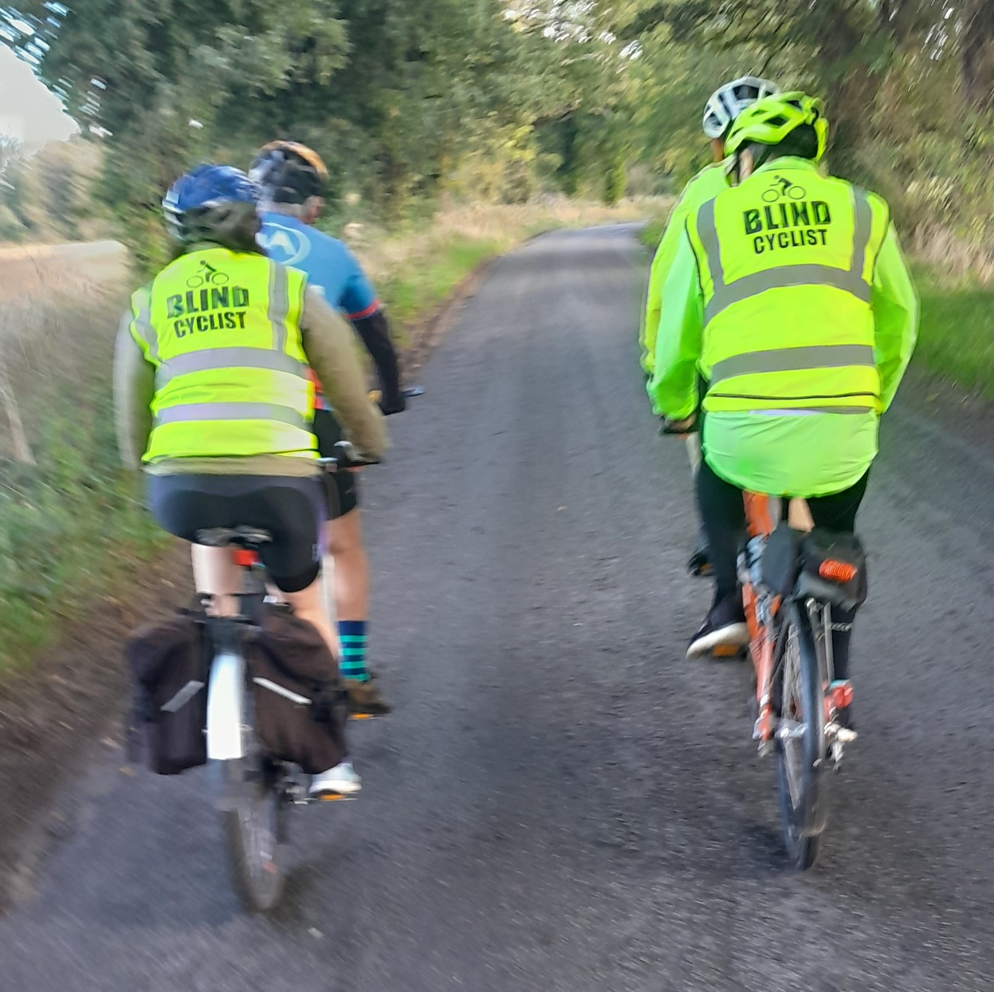

Image: Four cyclists on tandem bicycles going down a small road. The riders at the back are wearing reflective jackets that say “Blind Cyclist”.

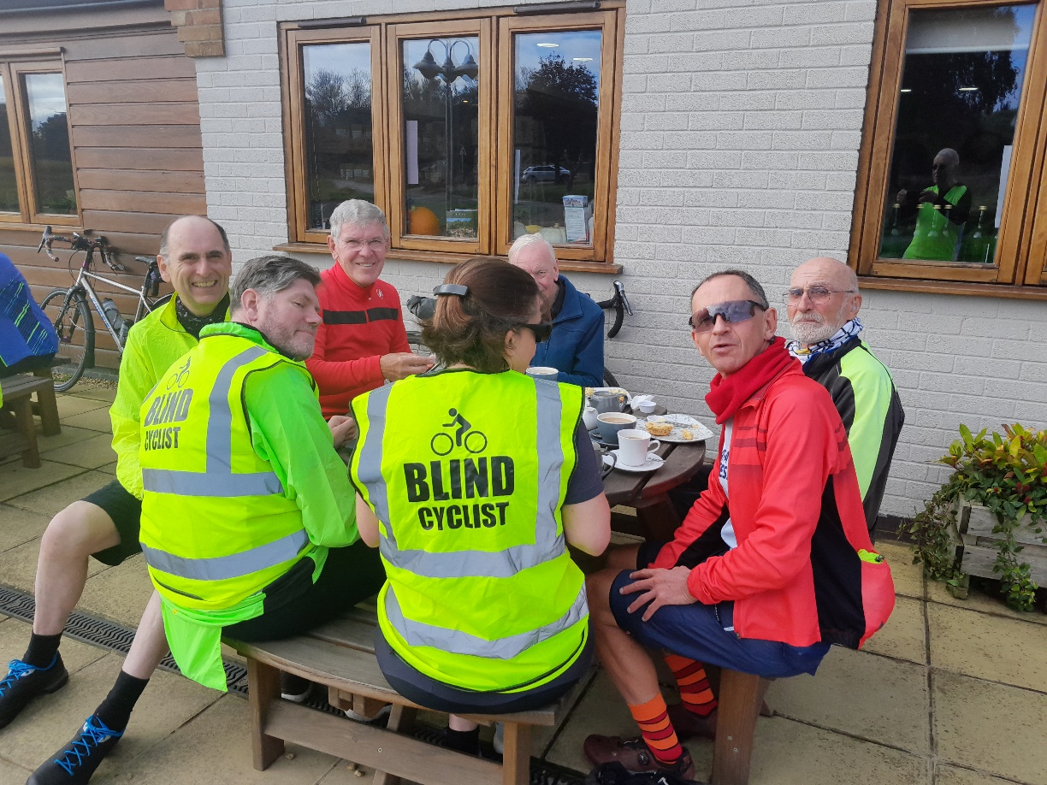

Image: Seven of the cyclists sat down for tea and refreshment at the Castle Rising Tearoom.

**West Norfolk Activities**

Unless otherwise stated contact Abbi on 01553 660808 or kingslynnhub@ visionnorfolk.org.uk.

Please be aware that any activities that take place at the King’s Lynn Hub will be taking place at our new community hub at 20 Thoresby College, Queen Street, King’s Lynn, Norfolk, PE30 1HX. If you have any questions or concerns please get in contact.

**Special Events**

Christmas Quiz – King’s Lynn, 16th December

Our volunteer Fred Hargreaves is once again hosting one of his very popular quizzes. The Hargreaves cup is presented to the winning team.

Christmas Celebration – King’s Lynn, 17th December, 10am – 1pm

Our last coffee morning before Christmas will be our big festive celebration for clients and volunteers. Expect cheesy Christmas music, Santa hats and mince pies.

**Regular Activities**

Archery

Join one of our free archery sessions designed to be accessible for all abilities and skill levels.

Downham Market Archery - 1st Monday of the Month, 4pm-6pm

Fakenham Archery – 4th Wednesday of the Month, 2pm-4pm

Art Workshops – King’s Lynn, 1st Friday of the Month, 1pm-3pm

We hold regular small art workshops with painting, print making, collage and more. Free to attend and no prior experience necessary.

Audiobook Clubs

Our friendly, informal audiobook clubs offer a chance to get together and enjoy a chat about a chosen book. The book clubs are free and we can supply a memory stick player. Contact Mark on 01603 573000 extension 341.

Dereham Audiobook Club – 3rd Wednesday of the Month, 10:30am-12pm

Fakenham Audiobook Club - 3rd Monday of the Month, 10:30am-12pm

Gaywood Audiobook Club – 1st Thursday of the Month, 2pm-3:30pm

Bowling – Dereham, Last Friday of the Month, Starting at 11am

Join other local people with sight loss for a good chat and a lively game at Strikes Bowl Dereham. Please contact Chris on 07743 921430.

Coffee Mornings and Socials

Come and enjoy a cup of coffee, a slice of cake and a chat about everything and anything at one of our socials.

Downham Market Social – 4th Wednesday of the Month, 11am-1pm

Fakenham Coffee Morning – 3rd Thursday of the Month, 10am-12pm

Fakenham Drop-in Café – 1st Thursday of the Month, 9:30am-11:30am

Hunstanton Drop-in Café – 2nd Wednesday of the Month, 10am-12pm

King’s Lynn Coffee Morning – 1st and 3rd Tuesday of the Month, 10am-12pm

King’s Lynn Drop-in Café – 3rd Wednesday of the Month, 11am-1pm

Swaffam Drop-in Café – 3rd Thursday of the Month, 10am-12pm

Darts and Shuffleboard – King’s Lynn, 4th Thursday of the Month, 10am-12pm

Come and enjoy your choice of darts or shuffleboard with assistance and competition available as needed.

Knitting – King’s Lynn, 2nd Tuesday of the Month, 1:30pm-3:30pm

Whether you are a complete beginner who would like to take up knitting or a seasoned knitter, our sessions are a fun and sociable way of getting together with fellow yarn fans.

Pub Club – Varies Locations, 2nd Monday of the Month, 12pm-2pm

A relaxed and friendly group that meet for a chat over lunch at local pubs. The group is free to attend but some special activities and outings are paid for by participants directly.

Sit Fit – Downham Market, 3rd Friday of the Month, 1:30pm-3:30pm

A seated exercise class suitable for all adults regardless of age, gender or ability.

Sound and Vision Choir – King’s Lynn, Fortnightly on Wednesday, 1pm-3pm

Join the Sound and Vision Choir to improve your mental wellbeing, meet new people and most importantly have fun. The choir is run in partnership with The Workshop in King’s Lynn. We are doing a couple concerts throughout holiday season so our dates and time may change.

**Great Yarmouth Hub Updates**

We have had a very busy few months with a variety of events taking place. Our regular groups such as walks, rug making, knitting, fishy Friday, and our other established activities are coming along nicely. If you would like to find out more about what we do please give us a call.

**Tea Dance**

We recently attended an afternoon tea dance run by Great Yarmouth Borough Council. This was something very new to us, but we were made to feel extremely welcome and have been invited back. If you are interested, we will be able to share details of future sessions in the coming months.

**A Warm Welcome to Louise and Karl**

The team have recently welcomed Louise, and Karl has been with us for about seven months now. Both are sharing the role of being Edward’s Support Worker. We are very pleased to welcome them on board, no doubt if you haven’t met them already, you will do so if you come into the hub.

**New Activities**

We trialled a new Burgers and Bingo session recently. The event was well attended and we hope to run several more sessions over the coming months. Everyone is asked to pay £1, plus bring in some kind of a prize, to the value of £5.

Our creative writing sessions are going well. If you are interested to try expressing yourself through the written word, there is room for new members. We meet between 1pm and 3pm on the second Friday of the month at the hub. All formats such as large print, audio, or Braille are accepted.

We will be rebranding our knitting sessions to a Knit, Stitch and Natter session. This will take place on the second Thursday of the month between 1pm and 3pm, and there will now be opportunities to try different sorts of needle work such as cross stich, crochet, and latch hook and other crafty items.

We have started running some new client and volunteer drop-in sessions. If you haven’t been to the hub before, but are curious to find out what we do, and to meet the team, we are at the St George’s Theatre Café on the last Monday of the month between 1:30pm and 3pm.

**Christmas**

We have some limited spaces for our Christmas Celebration, held in the hub on 11th December between 11am and 1pm, as well as a trip to see Snow White on 23rd December. Spaces for the party are free, but we do ask for a £5 donation to attend the pantomime.

The Christmas party for the Cromer Coffee Morning will be on 18th December this year at Merchants Place. There will be sausage rolls and mince pies, and another visit from our very own Bing!

**Hear More From Us**

We have an events list that goes out to clients who are interested in finding out what activities we offer in the Great Yarmouth Hub on a monthly basis. Everyone with sight loss is welcome to attend, and if you would like to receive this list, please speak to us.

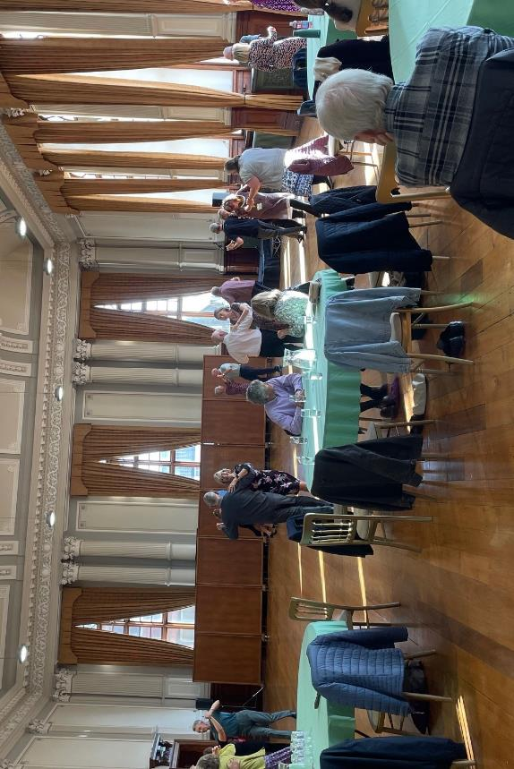

Image: Couples dancing around inside the Great Yarmouth Town Hall while other people sit at tables watching.

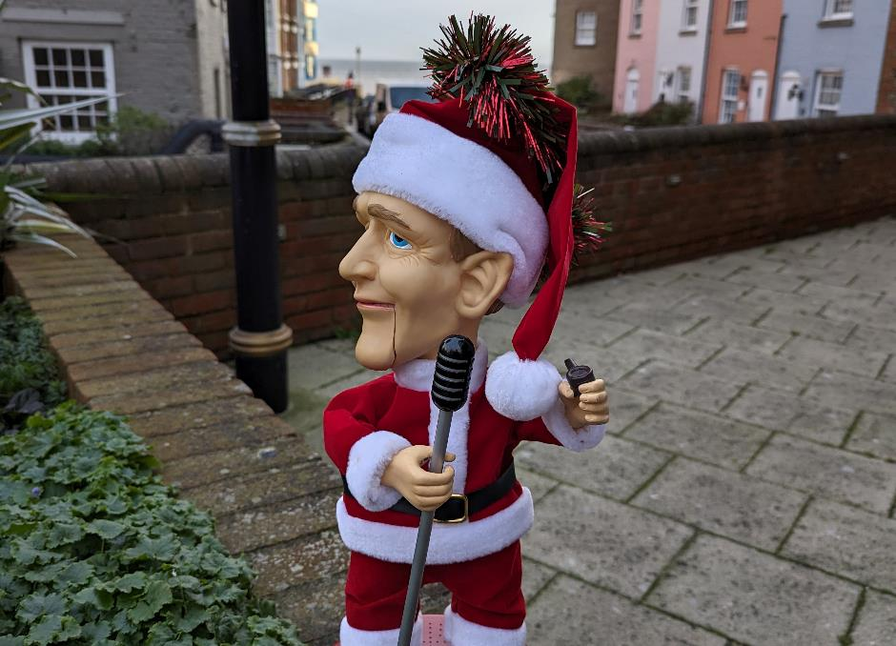

Image: A singing Christmas elf decoration sitting outside Merchants Place in Cromer.

**East Norfolk Activities**

Unless otherwise stated please contact Catherine on 01493 745973 or greatyarmouthhub@visionnorfolk.org. uk.

**Special Events**

Christmas Celebration – Great Yarmouth, 11th December, 11am-1pm

Share sweet treats, festive cheer and good company with other members of the Vision Norfolk community.

Snow White Christmas Panto – Great Yarmouth, 23rd December, 11am-1pm

Join us at St. George’s Theatre for their Christmas Panto. We are asking for a £5 donation to help cover the cost of tickets.

**Regular Activities**

Audiobook Clubs

Our friendly, informal audiobook clubs offer a chance to get together and enjoy a chat about a chosen book. The book clubs are free to join and we can supply a memory stick player if you don’t have one. Contact Mark on 01603 573000 Extension 341.

Cromer Audiobook Club – 3rd Monday of the Month, 2pm-3:30pm

Great Yarmouth Audiobook Club – Last Friday of the Month, 1:30pm-3pm

Bowling – Great Yarmouth, Last Tuesday of the Month, 12pm-3pm

We run group bowling trips to Wellington Pier.

Clip and Climb – Great Yarmouth, Last Tuesday of Alternate Months (28th January, 25th March), 3pm-4pm

Ever fancied rock climbing? Clip n’ Climb is made up of a number of unique climbing elements at the indoor climbing gym at the Great Yarmouth Marina Centre.

Coffee Mornings and Socials

Come and enjoy a cup of coffee, a slice of cake and a chat about everything and anything at one of our socials.

Cromer Coffee Morning – Last Wednesday of the Month, 10am-1pm, Contact Karl on 07864 615929

Great Yarmouth Coffee Morning – Every Wednesday, 10am-12pm

Martham Coffee Morning (and Snooker) – 3rd Monday of the Month, 10am-12pm. Contact Matthew on 01603 573000 extension 455

North Walsham Coffee Morning – 3rd Tuesday of the Month, 10am-12pm, Contact Karl on 07864 615929

Creative Writing – Great Yarmouth, 2nd Friday of the Month, 1pm-3pm

We have started a new Creative Writing Group! We hope to cover a variety of different subjects, and all formats are accepted. No experience is necessary.

Fishy Friday – Great Yarmouth, 1st Friday of the Month, 1pm-2pm

Meet other local people living with sight loss and have a chat over fish and chips. Costs £6.50 per person to cover the food.

Games Morning – Great Yarmouth, Every Thursday, 10am-12pm

Join our fun and welcoming games mornings to try out cards, bingo, dominoes and floor and table games.

Knit, Stitch and Natter – Great Yarmouth, 2nd Thursday of the Month, 1pm-2pm

Join Norfolk Knitters at our group where we learn together how to knit and stitch along with having a good natter.

New Client Drop In Sessions – Great Yarmouth, Last Monday of the Month, 1:30pm-3:30pm

If you are curious to learn about what we do, but haven’t yet got into the hub, we are holding drop-in sessions at St George’s Theatre Cafe.

Life Skills – Great Yarmouth, 2nd Monday of the Month, 2pm-4pm

Each month we will be running a cookery lesson at the hub. Sessions introduce adaptive technology and teach practical skills designed to be transferable to your home kitchen.

Rug Workshops – Great Yarmouth, Last Friday of the Month, 10am-12pm

Join experts from local business Ruskin’s Rugs at the hub. Use their rug making kits to make your own rugs and wall hangings.

Tennis – Gorleston, 2nd Tuesday of the Month, 10:30am-12pm

Give tennis a try at special sessions led by LTA-accredited coach Mike Reynolds. Weather dependent.

Weaving Group – Great Yarmouth, Every Friday, 10am-12pm

Use different types of soaked cane to make baskets of all shapes and sizes. The last Friday of each month weaving will be replaced with rug workshops.

Yoga – Great Yarmouth, 1st and 3rd Wednesday of the Month, 12pm-1:30pm

We recently started a new yoga session with Georgina Huggins, a yoga therapist and teacher. Open to all abilities, no experience is required.

**Other Information**

**Pension Credit Reminder**

With the colder months approaching and concerns around cost of living still very high, we would like to continue to share our tips relating to financial support. This edition we are sharing a reminder to those who qualify to apply for Pension Credit.

Pension Credit is a means-tested benefit for people who have reached state pension age. It is administered by the Pension Service, part of the Department for Work and Pensions.

Why you should apply for Pension Credit

It is estimated that up to 880,000 households across the UK are missing out on Pension Credit, and it is worth on average £3,900 per year. Applications can also be the starting point which leads to additional benefits such as the winter fuel payment, cold weather payment, and help with Council Tax and Housing Benefit. Applying for pension credit can’t reduce your current entitlements.

Who is eligible to apply for Pension Credit

Factors that decide who receives pension credit and how much they receive are complex but the primary factors are age and financial circumstances. You must be of state pension age to qualify, which is currently 66, though it is set to increase further over the next decade.

The Guarantee Credit is the part of Pension Credit that guarantees you a minimum level of income. Should you qualify, the standard minimum you are guaranteed is: £218.15 a week if you are single or £332.95 if you have a partner. To qualify, you must be at the qualifying age and your weekly income, including income from savings, must be less than the guaranteed amount. However the guaranteed minimum may be higher if you qualify for severe disability, are a carer, or have certain housing costs. The additional amounts for severe disability often apply to blind and partially sighted people which guarantees an additional £81.50 a week, or £163.00 a week if both members of a couple qualify.

The Savings Credit is the part of Pension Credit designed to reward people who have saved some money for their retirement. Following a change to the law in 2016, it is being phased out and is only available to existing recipients, and to people who reached state pension age on or before 6 April 2016. If you are eligible to claim the Savings Credit you can only qualify for it if you have pensions or other income (including income from savings) above the Savings Credit threshold which is £189.80 a week if you are single or £301.22 a week if you are a couple.

The most up to date information can be found on www.gov.uk/pension-credit. Applications can be made online or you can request a form calling 0800 99 1234 between 8am to 6pm Monday to Friday. You will need to provide your National Insurance number, information about your pensions and other income and details of your capital, savings and investments.

**Need to talk to your bank? Call 159**

If you need to speak to your bank but don’t have the number on hand you can call 159 and tell the operator what bank your like to speak to.

159 works in the same way as 101 for the police or 111 for the NHS. It’s the number you can trust to get you through to your bank safely and securely, every time. So if you think someone is trying to trick you into handing over money or personal details – stop, hang up and call 159 to speak directly to your bank.

In most cases the call cost the same as a national rate call. Please ask your provider if you are concerned.

Telephone companies involved include:

* BT (including EE and Plusnet)
* Gamma
* O2 (including Giffgaff)
* Sky
* Three
* Vodafone
* TalkTalk
* Virgin Media

If you would like help understanding your entitlements or completing any essential paperwork the Vision Norfolk’s Community Outreach Team can provide assistance over the phone or at home for anyone living with sight loss in Norfolk. Please call 01603 573000 to find out more.

**Contact Details**

Phone: 01603 573000

Email: office@visionnorfolk.org.uk

Norwich

Bradbury Activity Centre, Beckham Place, Edward Street

Norwich, NR3 3DZ

Phone: 01603 573000

office@visionnorfolk.org.uk

King’s Lynn

20 Thoresby College, Queen Street

King’s Lynn, PE30 1HX

Phone: 01553 660808

Email: kingslynnhub@visionnorfolk.org.uk

Great Yarmouth

12 Hall Quay

Great Yarmouth, NR30 1HP

Phone: 01493 745973

Email: greatyarmouthhub@visionnorfolk.org.uk

Registered Charity No. 1206599