**Magpie News - Summer 2025**

Welcome to the Summer edition of Magpie News with updates from Vision Norfolk, your local sight loss charity.

If you would no longer like to receive this newsletter or would like another format please let us know by calling 01603 573000 or emailing office@visionnorfolk.org.uk. Magpie News is currently available by mail in printed, Braille or audio format. A digital format is also available on our website and by email.

**Driving Experience**

In March we were able to hold a very special day of 4x4 off road driving for a small group of people living with sight loss. The sessions were held at Elveden Estate with experienced Explore 4x4 instructors accompanying each driver, keeping them safe and providing steering instructions.

Many people experiencing sight loss say that losing their driving licence is a significant moment for them, so the day was designed to demonstrate that they can still achieve things many thought were not possible.

A dozen people with varying degrees of sight loss took part in the driving experience, tackling the off-road course at The Elveden Estate.

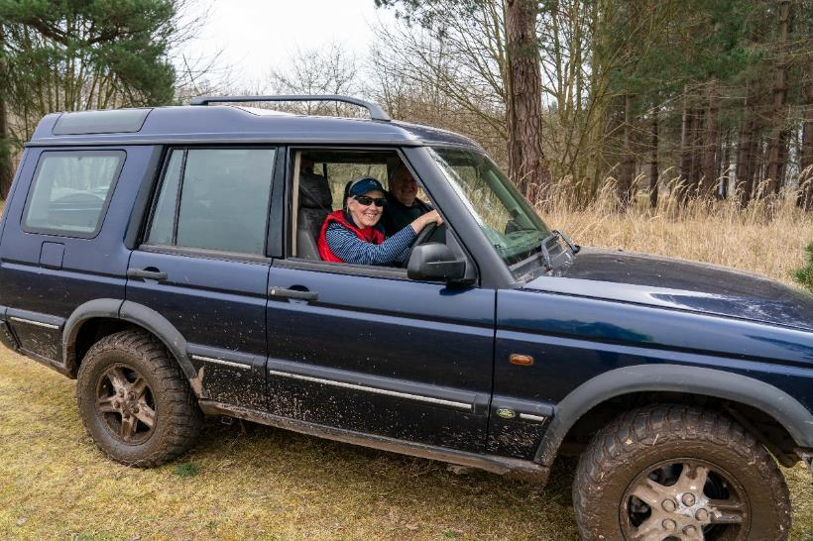

Image: A woman smiling behind the wheel of a slightly muddy four wheel vehicle at a special driving experience for people with vision impairment. There is an instructor sitting in the background beside her.

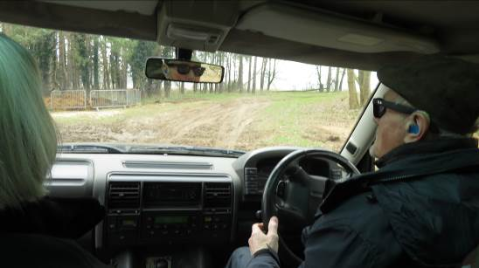

Image: Photo taken from the back seat as a man drives a car down a dirt path.

**In This Edition**

Vision Norfolk News – Page 1

Updates from your local sight loss charity

Children, Young People and Families – Page 8

Learn about our services for local people aged 0 to 25 and their families

Equipment and Technology – Page 10

Updates about equipment and technology including upcoming events and opportunities

Norwich and South Norfolk – Page 14

Updates from our Norwich Community Hub and upcoming events and activities

West Norfolk – Page 23

Updates from our King’s Lynn Community Hub and upcoming events and activities

East Norfolk – Page 30

Updates from our Great Yarmouth Community Hub and upcoming events and activities

Contact Details – Page 36

Find out how to reach us with your questions

**220th Anniversary Summer Garden Party**

Save the Date – Sunday 20th July

We are celebrating 220 Years with a Summer Garden Party at The Bishop’s Garden in Norwich.

Join other members of the Vision Norfolk community from 1pm to 4:30pm as we mark 220 years of supporting people with sight loss across the county. Tickets are just £5 per person, with free entry for children under 16 and wheelchair users.

Mark your calendars and stay in touch for further updates on the event.

**Bank Holiday**

Please be aware that our all our community hubs will be closed on Monday 25th August for the Summer Bank Holiday. Please get in contact with your local hub if you have any questions.

**PIP Reviews and New Applications**

Advice for anyone facing a review of their Personal Independence Payment (PIP).

Please ensure that you treat the review as if it was a new application. Do not assume that the Department for Work and Pensions (DWP) will refer back to any evidence you have provided in the past. Gather up to date evidence including a copy of your Certificate of Vision Impairment (CVI), if you have one. Try to get a recent Patient Report from your doctor and any other pertinent current evidence to accompany your review. Do not send information sheets, leaflets or webpages, these are not appropriate. Always send copies of documents and not originals. Vision Norfolk offices can help with photocopying if required.

For new PIP applications all of the above applies. In addition make sure you have read the questions thoroughly and have given answers which apply to how you manage on a bad day.

For assistance with any DWP application please call Vision Norfolk and ask for help from a Community Outreach Worker

**Vacancy at Hammond Court**

A one-bedroom flat with a small private patio is now available in our supportive community for people with vision impairment. Enjoy accessible, independent living with a part-time on-site warden and thoughtfully designed features.

Contact Barbara Dunn on 01603 573000 to find out more information.

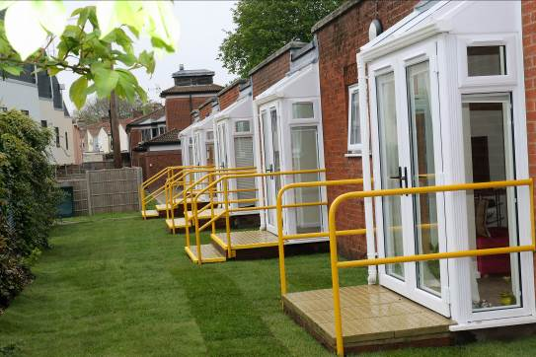

Image: Glass patio door opening onto a green lawn at the back of a line of flats at Hammond Court.

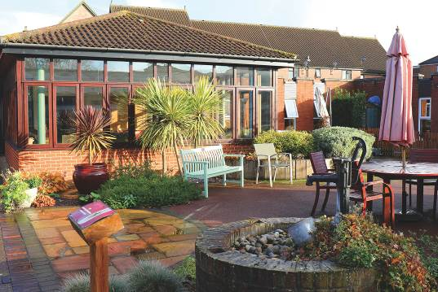

Image: Hammond Court - A small garden patio area with some greenery, benches and an outdoor table.

**Children, Young People and Families**

The CYPF (Children, Young People and Families) department had a busy and exciting Easter period, filled with engaging activities for all ages. Highlights included a dynamic karate workshop that introduced children to new skills and built confidence, wonderful trip to Cavies and Cake for a guinea pig café event as well as a heart-warming intergenerational allotment project session that brought together different age groups to share gardening experiences and connect through nature. Meanwhile, the weekly tennis sessions at East Anglian Tennis Club continue to be a hit, with great attendance and enthusiasm from participants of all skill levels.

Looking ahead, preparations are well underway for a fun-filled summer. A wide range of events are being planned, including a mobile zoo visit, carriage driving experiences, young driver sessions, crazy golf, and a trip to the Hippodrome Circus—ensuring there’s something exciting for everyone.

Additionally, our 220 fundraising campaign has seen fantastic involvement from CYPF families, who have been taking on creative and active challenges to raise funds. If you or someone you know would like to get involved in fundraising, please don’t hesitate to get in touch—we’d love to hear from you!

We continue to offer our much appreciated one-on-one emotional and practical support for families, providing a vital service that helps them navigate the challenges of vision impairment. This includes home visits, guidance on available benefits, grants, and funding for children with vision loss, as well as referrals to a wide range of relevant services and organisations.

We always welcome your input and ideas, so if you have suggestions for new activities or ways we can enhance our support, please don’t hesitate to reach out. You can contact us at CYPF@visionnorfolk.org.uk with any questions or ideas.

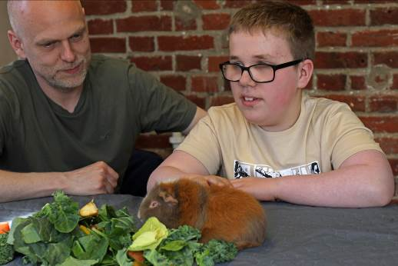

Image: A man and a boy sitting at a table with a guinea pig. The boy is petting the guinea pig while it inspects a pile of leaves.

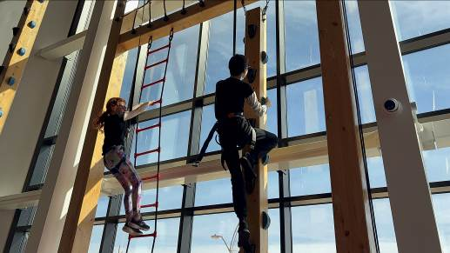

Image: Two young people wearing harnesses climbing up an indoor challenge course.

**Equipment and Technology**



Image: A hand reading the Braille section of a specialised keyboard

If you have any questions about equipment that can support independent living we can provide information and advice at our community hubs in Norwich, King’s Lynn and Great Yarmouth or over the phone. Our Community Outreach Workers are also available for home visits where they can discuss equipment and how your living space can best work for you. To find out more please get in contact with John at 01603 573000 extension 323.

**Opportunities to Talk About Technology**

Tea and Tech – Norwich Hub, last Monday of each month, 1:30pm-3:30pm

Rachael and Darryl Andrews invite you to come along to the Norwich Hub to chat about your technology products. This is not a training session but a discussion session for likeminded people to talk about technology. Please contact Richard on 01603 573000 extension 322.

Tech Support Sessions – Great Yarmouth Hub, last Wednesday of each month, 1pm-2pm

One of our volunteers is offering one-to-one help and support to anyone who might be experiencing issues with their technology. Please be aware these free sessions will need to be booked in advance. Please contact Catherine on 01493 745973.

Vision Zone 2025

King’s Lynn Town Hall, 23rd June, 11am-2:30pm

The Forum Norwich, 3rd September, 10am-2pm

Low vision technology company Optelec is working with Vision Norfolk and other charities to bring their open days to Norfolk, showcasing a variety of local services, groups, assistive technology, products, and much more. No matter what your sight loss condition you are welcome to come along to gain knowledge or hands on experience of new technologies. Entry is free, and representatives from both Optelec and Vision Norfolk will be present to answer your questions. There are two events planned for 2025, one at the King’s Lynn Town Hall and another later in the year in Norwich at The Forum.

VisionAid Visit – Merchant’s Place Cromer, 25th June, 10am-1pm

Join the June Session of the Cromer Coffee Morning for a question and answer session with assistive technology company VisionAid.

Humanware Drop-in Visit – Great Yarmouth Hub, 9th July, 10am-12pm

Assistive technology company Humanware are joining us for a drop in coffee morning on Wednesday 9th July. Please drop by if you are keen to check some of the latest equipment or ask any questions that you have.

**Tech Tip – Smart Speakers**

A smart speaker is a stand-alone device, usually used in the home that takes voice commands. Smart speakers are normally quite small and have just a few tactile buttons. Once set up they can be easily controlled through spoken commands and perform a wide variety of tasks, which can make them very useful for some people with limited sight.

There a few companies that create a variety of smart speaker devices. Different speakers will have different capabilities and will be compatible with different devices, however all are based around the same basic principle of simple spoken commands and perform similar basic functions.

Some functions that most smart speakers will allow you to do include:

* Play radio and music
* Set timers, alarms and reminders
* Create lists
* Get the latest updates on news and weather

Most devices will also allow you to make and receive calls and send texts, though this will need to be enabled through the app on a smart phone.

Additional functions available on most devices allow you to link to compatible devices, such as smart lights which can turn lights on and off by voice command. The ability to use easy voice commands to change heating and devices around the house can make this an extremely useful function however it generally requires additional set up and will need you to own and set up compatible devices.

Smart speakers work off of wifi so you will need reliable internet to use the device. If you lose access to internet it will not work until it is reconnected. Also most smart speakers must be set up using a smartphone.

While many people have found smart speakers useful there are some challenges that are worth being aware of. There is a cost to purchasing the speaker, varying on the device. If you are looking to use more advanced features sometimes there are additional cost or subscriptions. If you are connecting to other smart devices they must be compatible with your speaker in order to be controlled verbally, and will have their own cost. Once set up most people find smart speakers easy to use, but sometimes they can be difficult to set up, especially if you are not a regular smartphone user. An Amazon account is needed to use an Alexa device.

If you would like to discuss smart speakers, or any other piece of assistant technology please feel free to contact us to talk through your personal situation or come by the “Tea and Tech” discussion group to swap stories with others.

**Norwich Hub Updates**

**Allotment Project**

Since the early spring we’ve been getting our allotment plot at Marlpit Community Garden ready for use by keen gardens with sight loss. Young people from the Children, Young People and Families program have joined our more mature gardeners to plan and plant up seeds for the allotment ready for the growing season.

In April there was a session in the Norwich Community Hub to plant seeds which then grew into strong young plants which were moved to their new home on the allotment at the end of May. All going well we are hoping to be able to use some of the harvest in the “Cooking with Sue” practical cooking classes later in this year.

We’d love for more people to get involved in planning and taking care of the allotment plot. Whether you’re a seasoned gardener, interested in learning or just keen to help out, everyone’s welcome. Please get in contact for more details.

The Allotment Project is being funded by the Norfolk Community Foundation through the Greening Our Communities Fund.

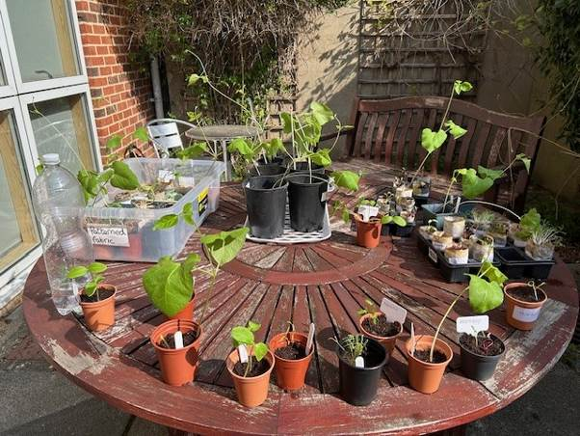

Image: Baby potted plants sitting on a circular table in the sun outside the Norwich Community Hub.

**Evening Activities**

We are holding a variety of events on Tuesday evenings throughout the summer to allow more people to get involved in our services.

Some of our upcoming events include an evening quiz and horse racing fundraiser.

We want our social and wellbeing activities to be accessible to as many people as possible, so please let us know what you would like to get involved in.

**Join Our Choir**

We are starting a choir based out of our Norwich Hub! The first taster session is on the 7th July. No prior singing experience needed. This is your chance to explore your voice, meet new people and be part of something joyful. The group will be led by James Fowler, a now retired Head teacher who has enjoyed singing throughout his life. He began his training as a chorister in Oxford and since then has sung professionally with groups across the UK, Europe and the USA.

**Tennis Returns**

We are looking for a few more people to get involved in our tennis sessions in Waterloo Park in Norwich. The sessions are open to any level of skill and experience and have been specially designed for people with vision impairment. Run by with a coach from the National Tennis Association.

**What’s On – Norwich and South Norfolk**

Unless otherwise stated please contact Richard on 01603 573000 extension 322 or richard.polley@visionnorfolk.org.uk.

Please note: Some of our activities are very popular. Please get in contact if you are interested and if the activity is already full we can put you on the waiting list for when spaces become available.

**Special Events**

Choir Taster Session – Norwich, 7th July

We are starting a choir based out of our Norwich Hub! The first taster session is on the 7th July. No prior singing experience needed! This is your chance to explore your voice, meet new people and be part of something joyful. Contact Mark on 01603 573000 extension 341.

Quiz – Norwich, 8th July, 6:30pm-8:30pm

Put your knowledge to the test in a friendly competition of wits. There will be teams of four. If you don’t have a team, that’s not a problem, teams can be made up on the night.

Golf Clinic at Royal Norwich Golf Club – Norwich, 21st July

We have been invited by England and Wales Blind Golf to participate in a golf clinic for blind and vision impaired people. The clinic is open to those who have played golf before and those who’ve never experienced swinging a golf club.

220 Horse Racing Evening – Norwich, 12th August, From 6pm

Join us for an evening of fun and friendly competition at the Norwich Hub. Please get in contact for more details.

Wellbeing Fair – Norwich, 1st October

We are hosting a wellbeing fair at the Norwich Hub. We will be inviting other organisations to join in and will be sharing information about local services while hopefully providing practical demonstration of wellbeing activities such as crafting, cooking and physical activities.

**Regular Activities**

Allotment Project

Are you interested in gardening, or just want to spend some time out in the fresh air? Vision Norfolk has a plot at Marlpit Community Garden that we are using to explore accessible gardening practice out in the real world. This project is funded by Norfolk Community Foundation through the Greening Our Communities Fund. Contact Mark on 01603 573000 extension 341.

Arts and Crafts – Norwich, Every Thursday, 10am-12:30pm

Undertake a variety of arts and crafts with support from Helen and the volunteers. Contact Helen on 01603 573000 extension 342.

Audiobook Clubs

Our friendly, informal audiobook clubs offer a chance to get together and enjoy a chat about a chosen book. The book clubs are free to join and the audiobooks are supplied. Contact Mark on 01603 573000 extension 341.

Diss Audiobook Club – 4th Friday of Each Month, 2pm-3:30pm

Norwich Audiobook Club – 2nd Monday of Each Month, 1:30pm-3pm

Boccia – Norwich, 1st and 3rd Friday of Each Month, 10am-12pm

Join us for the competitive precision ball sport boccia. Sessions are open to all abilities and levels of experience.

Bowling – Norwich, 2nd and 4th Friday of Each Month, 9:30am-1pm

Come and enjoy some friendly competition with ten pin bowling at Namco Funscape. Transportation available from the Norwich Hub.

Bowls – Norwich, Every Tuesday, 10am-12pm

Whether you’re a newbie or an expert, a traditional game of bowls, is a good excuse to get together. We play the short mat variety inside Activity Hall at the Norwich Hub

Braille Classes – Norwich, Every Thursday

Join our Braille class taught by one of our volunteers. The classes are small, usually on a one-to-one or one-to-two basis.

Coffee Mornings and Socials

Come and enjoy a cup of coffee and a chat at one of our social groups.

Attleborough Drop-in Café – Fortnightly, 11am-12:30pm, Contact Chris on 07743 921430.

Norwich Coffee Morning – Last Monday of Each Month, 10am-11:30am

Norwich Drop-in Café at Plumstead Road Library – Fortnightly on a Wednesday, 11am-12pm, Contact Jo on 01603 573000 extension 454.

Thetford Drop-in Café – 4th Wednesday of the Month, 2pm-3:30pm, Contact Chris on 07743 921430.

Cooking with Sue – Norwich, Monthly on a Thursday (19th June, 31st July, 28th August, 25th September), 2pm-4pm

Each month we will be running a free cookery lesson at our Norwich Hub teaching practical skills that can be used at home.

Creative Writing – Norwich, 3rd Tuesday of Each Month, 2pm-3:45pm

Join a creative writing group that will give you the opportunity to express yourself through the written word. Contact Mark on 01603 573000 extension 341.

Darts – Norwich, 1st and 3rd Friday of Each Month, 1pm-3pm

Join us for a few friendly games of darts. Volunteers are around to help you position or read the numbers on the board if needed.

Glaucoma Support Group - Norwich, 2nd Friday of Each Month, 2pm3:30pm

A self-help and discussion session for local people living with glaucoma created in partnership with Glaucoma UK. We sometimes have speakers in to talk about glaucoma or other subjects.

Macular Group – Norwich, 2nd Friday of Each Month, 12pm-1:30pm

This group is organised and run by the Macular Society. Vision Norfolk staff usually give an update on new equipment and activities and there are sometimes guest speakers.

Photography Group – Norwich, 1st and 3rd Friday of Each Month, 1:30pm-3:30pm

The first meeting in each month is an outdoor photoshoot and the second is an indoor opportunity to review photographs. Some outing may have a cost for refreshments. Contact Helen on 01603 573000 extension 342.

Sailing – Norwich, Fortnightly From 26th June, 12:30pm-5pm

Come and enjoy an afternoon of sailing on the Norfolk Broads. There is a suggested donation of £20 per session paid directly to the Nancy Oldfield Trust. Contact Mark on 01603 573000 extension 341.

Tandem Cycling – Norwich, By Appointment

Tandem cycling allows you to continue to enjoy a good (and safe) bike ride regardless of your vision loss. A sighted guide sits at the front to steer and describe. Gives us a call to set up a time to come in and give it a go. We do now have some availability in the evenings if you can’t make it during regular working hours.

Tennis – Norwich, Fortnightly From Friday 20th June, 11am-12pm

Our inclusive fortnightly tennis session have returned to Waterloo Park with a coach from the National Tennis Association. It is free to take part and all equipment is supplied.

Yoga – Norwich, Every Tuesday, 1pm2pm and 2:15pm-3:15pm

Come stretch and relax with yoga. Sessions are designed to be accessible to all abilities and levels of experience.

**King’s Lynn Hub Updates**

**Exploring Nature**

In the beginning of May we worked with the team at Wild Ken Hill to put together a special sensory tour of the unique ecological restoration project for a group of local people living with sight loss.

The group toured the project, enjoying the sounds and smells as well as the sights of the plants, birds and wildlife which reside there. Expert guide Carl Chapman was on hand to help with species identification and give an insight into the conservation and rewilding work taking place at Wild Ken Hill.

Wild Ken Hill also worked with Slow Ways, an organisation which promotes and encourages accessible walking for all, to create the fabulous short film ‘Walking Blind’ featuring local vision impaired walker Gill and her friend and guide Jen.

See the full film shared on our Facebook page or on the Slow Ways website on https://buildstories. slowways.org/how-does-it-feel-to-walk-blind/.

Many people with vision impairment struggle with social isolation. Together we can find new ways of getting out, meeting up and exploring natural spaces.

Please get in contact to find out how you can get involved in future opportunities to get out and explore nature safely.

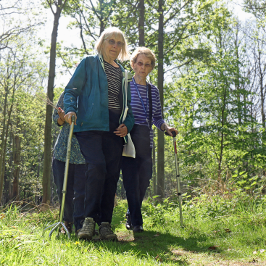

Image: Two women using walking sticks walking through a sunny forest. Another person is walking behind them.

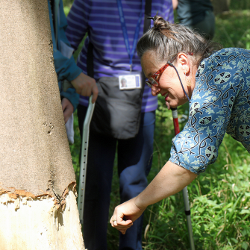

Image: A woman reaching out to feel the texture of a large tree trunk. There are two people using canes standing in the background.

**New Heritage Walks with King’s Lynn Town Guides**

People living with sight loss in West Norfolk are being given the chance to learn about the historical architecture of King’s Lynn with a series of guided walks led by one of the Town Guides.

The walks will explore how King’s Lynn’s unique 12th century development and prosperous Hanseatic trading links gave rise to its medieval market places, guildhalls and churches.

The monthly walks, which will be operating throughout the summer, will alternate between a shorter version concentrating on the Minster, Hanse House and Marriott’s Warehouse, and a longer walk which will also take in the Customs House and King Street.

The walks will include the opportunity to touch and feel parts of the buildings to learn more about their origins and history.

Staff and volunteers will be on hand to guide walkers and describe scenery and objects.

**What’s On – West Norfolk**

Unless otherwise stated contact Abbi on 01553 660808 or kingslynnhub@visionnorfolk.org.uk.

**Special Events**

Sheringham Park - 22nd September

Join us on an accessible outing to explore the beautiful Sheringham Park. We will be joining up with a group from East Norfolk so it should be a great opportunity to meet new people and swap stories.

**Regular Activities**

Archery

Join one of our free archery sessions designed to be accessible for all abilities and skill levels.

Downham Market Archery - 1st Monday of Each Month, 4pm-6pm

Fakenham Archery – 4th Wednesday of Each Month, 2pm-4pm

Art Workshops – King’s Lynn, 1st Friday of Each Month, 1pm-3pm

We hold regular small art workshops with painting, print making, collage and more.

Audiobook Clubs

Our friendly, informal audiobook clubs offer a chance to get together and enjoy a chat about a chosen book. The book clubs are free to join and the audiobooks are provided. Contact Mark on 01603 573000 extension 341.

Dereham Audiobook Club – 3rd Wednesday of Each Month, 10:30am-12pm

Fakenham Audiobook Club - 3rd Monday of Each Month, 10:30am-12pm

Gaywood Audiobook Club – 1st Thursday of Each Month, 2pm-3:30pm

Hunstanton Audiobook Club – 3rd Tuesday of Each Month, 10:30am-12pm

Board Games – King’s Lynn, 4th Thursday of the month, 1pm – 3pm

Join us at the King’s Lynn Hub for an afternoon of cards and board games. Enjoy everything from Snakes and Ladders to Connect 4.

Bowling

Join other local people with sight loss for a good chat and a lively game or two.

Dereham Bowling, Last Friday of the Month, Starting at 11am, Please contact Chris on 07743 921430

Gaywood Bowling – 4th Friday of Each Month, 1pm start

Bowls – Fakenham, 1st Friday of Each Month, 2pm-4pm

Come and enjoy some friendly competition with the traditional British game bowls.

Coffee and Crafts – King’s Lynn, 4th Tuesday of Each Month, 10am-12pm

Join us for a relaxed morning of crafting at the King’s Lynn Hub.

Coffee Mornings and Socials

Come and enjoy a cup of coffee, a slice of cake and a chat about everything and anything at one of our socials.

Dereham Coffee Morning – 1st Thursday of Each Month, 10am-12pm, Contact Chris on 07743 921430

Dereham Social (Darts and Games Afternoon) – 2nd Wednesday of Each Month, 4pm-6pm, Contact Chris on 07743 921430

Downham Market Social – 4th Wednesday of Each Month, 11am-1pm

Fakenham Coffee Morning – 3rd Thursday of Each Month, 10am-12pm

Fakenham Drop-in Café – 1st Thursday of Each Month, 9:30am-11:30am

Hunstanton Drop-in Café – 2nd Wednesday of Each Month, 10am-12pm

King’s Lynn Coffee Morning – 1st and 3rd Tuesday of Each Month, 10am-12pm

King’s Lynn Drop-in Café – 3rd Wednesday of the Month, 10am-12pm

Swaffam Drop-in Café – 3rd Thursday of the Month, 10am-12pm

Guided Walks – King’s Lynn, Monthly on a Tuesday

We are teaming up with King’s Lynn Town Guides to arrange historic guided walks around King’s Lynn.

Knitting – King’s Lynn, 2nd Tuesday of Each Month, 1:30pm-3:30pm

Whether you are a complete beginner who would like to take up knitting or a seasoned knitter, our sessions are a fun and sociable way of getting together with fellow yarn fans.

Pub Club – Locations vary, 2nd Monday of Each Month, 12pm-2pm

A relaxed and friendly group that meet for a chat over lunch at local pubs.

Sit Fit – Downham Market, 3rd Friday of the Month, 1:30pm-3:30pm

A seated exercise class suitable for all adults regardless of age, gender or ability.

Sing 4 Fun – King’s Lynn, Fortnightly on Wednesday, 1pm-3pm

Join Sing 4 Fun, The Sound and Vision Choir, to improve your mental wellbeing, meet new people and most importantly have fun. The choir is run in partnership with The Workshop in King’s Lynn.

Tandem Cycling – King’s Lynn and the Local Area

Join guide riders from Cycling UK West Norfolk for cycle trips around the local area. Please contact us for more details.

**Great Yarmouth Hub Updates**

The Great Yarmouth hub is open Monday to Friday, 9 am until 5 pm. If you’ve not been in before, but would like to see what we do, please drop in.

**Bus Changes**

As you may be aware, they’ve been changing around the gyratory road system in Great Yarmouth, traffic that was once running one way is now running both ways. So a number of bus stops are being moved or removed.

All southbound buses through town are using their new stops in Market Gates.

* X1, X11, 7, 901 to JPH/Belton/ Lowestoft: Stand D
* 1, 1A, 8, 983 to JPH/Lowestoft: Stand E
* 2, 3, 3B to Barrack Est/JPH/Burgh Castle: Stand G

Buses will then stop at a new bus stop on the Quay near the Town Hall, rather than the existing stop outside the Town Hall.

All Northbound buses through town are using their new stops in Market Gates.

* X1, X11, 7, 901 to Norwich: Stand B
* 1, 1A, 8, 983 to Caister/Martham: Stand C

On their way into town from Gorleston buses will stop at a new stop on Regent Street close to the old Post Office – this effectively replaces the current stop on Stonecutters Way.

On leaving Market Gates, the next stop for buses will be Northgate Street opposite the church (1/1A, 7, 8) or outside the Rail Station (X1/X11).

If you have any concerns or if you need more information, please let us know.

**Marking VE Day**

We were honoured to be joined by 91 year-old Army veteran Tony Wilkin and a representative from Blind Veterans UK to mark VE day on the 8th of May.

Tony served as a wireless operator in Egypt from 1952 to 1954. He was diagnosed with macular degeneration about ten years ago, and has been registered blind since 2017.

He spoke about his experience to a gathering at the hub.

**Sponsored Silence**

As it’s the 220th anniversary of Vision Norfolk, we are doing a variety of fundraising challenges to ensure our charity is around for another 220 years. The Great Yarmouth Hub Coordinator, Edward Bates, will be taking on his toughest challenge yet, a 12 hour sponsored silence on Wednesday 16th July. If you want to see how he gets on, feel free to pop into the hub on that day.

**Getting Out and About**

We’re getting out and about in the community to spread the word about Vision Norfolk. Stop by and say hi or encourage your friends to come and ask us any questions they have.

Saturday 28 June - Caister Carnival

Sunday 3 August - Gorleston Cliff Top Festival

**Tickets**

We are fortunate to have been given a few tickets to give away for the afternoon edition of the Summer Circus Spectacular at Hippodrome Circus on 1st September. Tickets are available on a first come, first served. Please contact us for more information.

**What’s On – East Norfolk**

Unless otherwise stated please contact Catherine on 01493 745973 or greatyarmouthhub@visionnorfolk.org. uk.

Audiobook Clubs

Our friendly, informal audiobook clubs offer a chance to get together and enjoy a chat about a chosen book. Contact Mark on 01603 573000 extension 341.

Cromer Audiobook Club – 3rd Monday of Each Month, 2pm-3:30pm

Great Yarmouth Audiobook Club – Last Friday of Each Month, 1:30pm-3pm

Bowling – Great Yarmouth, Tuesday 8th July and 9th September, 12pm-3pm

Meet us at Wellington Pier for a day of bowling.

Coffee Mornings and Socials

Come and enjoy a cup of coffee, a slice of cake and a chat about everything and anything at one of our socials.

Caister Coffee Morning – 1st and 3rd Tuesday of Each Month, 10am-12pm, Contact Matthew on 01603 573000 extension 455.

Cromer Coffee Morning – Last Wednesday of Each Month, 10am-1pm, Contact Karl on 07864 615929.

Great Yarmouth Coffee Morning – Every Wednesday, 10am-12pm

Martham Coffee Morning – First Thursday of Each Month, 10am-12pm, Contact Matthew at 01603 573000 extension 455.

North Walsham Coffee Morning – 3rd Tuesday of Each Month, 10am-12pm, Contact Karl on 07864 615929.

Creative Writing – Great Yarmouth, 2nd Friday of Each Month, 1pm-3pm

We hope to cover a variety of different subjects, and all formats are accepted.

Fishy Friday – Great Yarmouth, 1st Friday of Each Month, 1pm-2pm

Meet other local people living with sight loss and have a chat over fish and chips. Costs £6.50 per person to cover the food.

Games Morning – Great Yarmouth, Every Thursday, 10am-12pm

Try out cards, bingo, dominoes, and floor and table games.

Knit, Stitch and Natter – Great Yarmouth, 2nd Thursday of Each Month, 1pm-2pm

Join Norfolk Knitters at our group where we learn together how to knit and stitch along with having a good natter.

Rug Workshops – Great Yarmouth, Last Friday of Each Month, 10am-12pm

Use kits from Ruskin’s Rugs to make your own small rugs and wall hangings. to make your own small rugs and wall hangings.

Seaside Walks – Various Locations, Last Thursday of Each Month

Join us for a breath of fresh air and a leisurely stroll along one of our many local seafronts.

Tennis Sessions – Gorleston, Last Tuesday of Each Month, 10:30am-12pm

Give tennis a try at special sessions led by LTA-accredited coach Mike Reynolds.

Weaving Group – Great Yarmouth, Every Friday 10am-12pm

Use different types of soaked cane to make baskets of all shapes and sizes.

Yoga – Great Yarmouth, 1st and 3rd Wednesday of Each Month, 12:30pm1:30pm

**Contact Details**

Please get in contact for further details on how we can support you and how you can get involved. Our hubs can be found at:

**Norwich**

Bradbury Activity Centre, Beckham Place Edward Street, Norwich, NR3 3DZ

Telephone: 01603 573000

Email: office@visionnorfolk.org.uk

**King’s Lynn**

20 Thoresby College, Queen Street King’s Lynn, PE30 1HX

Telephone: 01553 660808

Email: kingslynnhub@visionnorfolk.org.uk

**Great Yarmouth**

12 Hall Quay, Great Yarmouth, NR30 1HP

Telephone: 01493 745973

Email: greatyarmouthhub@visionnorfolk.org.uk

Registered Charity Number 1206599