**Vision Norfolk Magpie News**

**Autumn 2025**

Welcome to the Autumn edition of Magpie News with updates from Vision Norfolk, your local sight loss charity.

If you would like this newsletter in another format please let us know by calling 01603 573000 or emailing office@visionnorfolk.org.uk.

Magpie News is currently available by mail in printed, Braille or audio format. A digital format is also available on our website and by email.

**220th Anniversary Garden Party**

On Sunday 20th July we braved the weather and threw an open day and celebratory event at the Bishop’s Garden in Norwich. Despite the soggy grass and the odd downpour, we had a lovely time with staff, volunteers, service users, supporters, and members of the public.

Wet weather aside, we welcomed over 100 guests through the gates and enjoyed an afternoon of games, cakes, and non-alcoholic Pimm’s.

Image: A man and a woman standing underneath a rainbow umbrella in the Bishop’s Gardens. The man is holding a white cane. Norwich Cathedral is behind some trees in the background.

**In This Edition**

Vision Norfolk News – Page 1

Updates from your local sight loss charity

Children, Young People and Families – Page 8

Learn about our services for local people aged 0 to 25 and their families

Equipment and Technology – Page 9

Updates about equipment and technology including upcoming events and opportunities

What’s On – Page 13

Upcoming events that may be of interest to people across the county

Norwich and South Norfolk – Page 15

Updates from our Norwich Community Hub and upcoming events and activities

West Norfolk – Page 24

Updates from our King’s Lynn Community Hub and upcoming events and activities

East Norfolk – Page 33

Updates from our Great Yarmouth Community Hub and upcoming events and activities

Contact Details – Page 40

Find out how to reach us with your questions

**Our New Fundraising and Marketing Executive**

“Hello everyone, I thought this would be a good way to easily introduce myself to everyone, my name is Joe Russell and I am excited to have recently joined Vision Norfolk as the new Fundraising and Marketing Executive. It is an absolute privilege to work for a charity that makes such a huge impact.

I can already see how passionate everyone involved is. I’m genuinely looking forward to learning more about the amazing work being done across the county and to meeting as many of you as possible.

Whether you’re taking part in events, supporting our services, or spreading the word about our work, your contribution is truly valued and really appreciated. Please don’t hesitate to reach out if you’d like to chat, share ideas, or just say hello—I’d love to hear from you!”

Joe Russell, Fundraising and Marketing Executive

You can contact Joe by calling 01603 573000 Extension 367 or emailing joe.russell@visionnorfolk.org.uk

**Taking on the 220 Challenge**

From litter picking to dancing the night away, people have embraced the theme of “220” with creativity and determination, turning it into inspiring challenges that raise vital funds for us.

Our very own Barbara Dunn has already raised £640.00 by walking 220 miles in May, accompanied by her retired guide dog, Cherry. At just nine years old, Poppy skipped 220 times to show her support, bringing in £150. Meanwhile, three-yearold AJ collected 220 pieces of litter and raised an impressive £230.

Others have taken on challenges of stamina and skill. Sherene Cook and her husband Paul completed a tandem ride, while Maggie Wilkinson and the Creative Writing Circle penned a project themed around the number 220, gathering £320 in donations. Mandy and Rosemary from West Norfolk have been making 220 things to sell out of the King’s Lynn Hub and at a Christmas Light and Craft Fayre later in the year, so far they have raised £140.

Community Outreach Worker Chris Linstead pushed himself to the limit, aiming to cycle the 230-mile Rebellion Way and generating £660 in support. Vincent, Steph and Jim Brighton hosted a board games and puzzle event, raising £670 through their shared love of play.

Swimming also made a splash, with young Rhiannon completing 220 lengths (around 1.3 miles) and raising £680 in the process. While Wendy Hirst knitted 220 squares together to make a beautiful blanket, that has been donated to our CYPF team, raising £350.

Dancing has been another joyful way to embrace the challenge. Carol Hall, joined by our very own Gemma Blyth at a weekend event, danced with 220 different partners and together raised £713. And Edward Bates, aka Mr Chatty, chose a quieter, but no less impressive feat: a 12-hour sponsored silence, which brought in £865.

A special shoutout goes to Miranda and Robert Reeves, who completed a 50-mile tandem bike ride, raising an amazing £1,080, making it the highest single challenge we have had so far.

These challenges, along with the other donations and events we have been running have raised over £15,000 plus Gift Aid. This will go a long way in helping us continue our mission of supporting people living with sight loss across our county.

As the 220th Anniversary Challenge continues, we are excited to have several fundraising challenges coming up, which mean we will be even closer to achieving our goal. If you know of anyone who is wanting to take part in the 220 Challenge, please ask them to contact us via fundraising@visionnorfolk.org.uk.

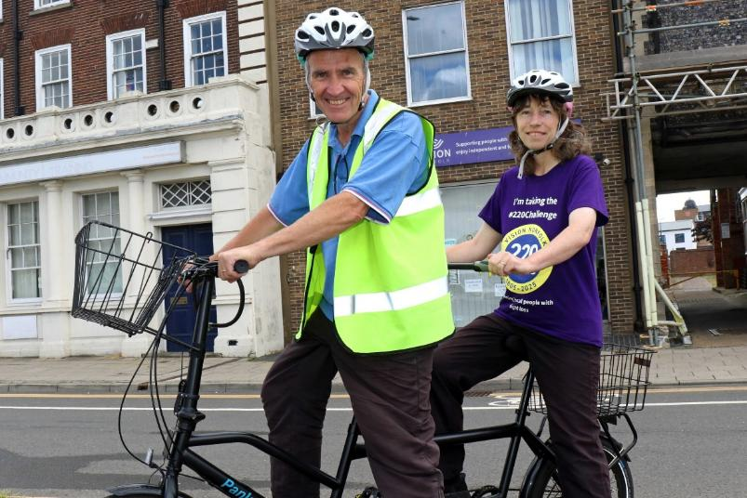

Image: Robert (left) and Miranda Reeves sitting on the back of a tandem bicycle. Robert is wearing a reflective vest and Miranda is wearing a purple t-shirt with the Vision Norfolk 220 logo on it.

**Celebrating Our Wonderful Volunteers**

Vision Norfolk celebrated the work of our wonderful volunteers during the annual Volunteers’ Week which ran from the 2nd to the 8th of June.

On Wednesday 4th of June we transformed the Bradbury Activity Centre’s Hall into a bright, colourful, boisterous, and joyful space for the Volunteers’ Party. The party was everything we could have hoped for, as a chance to celebrate and thank our fantastic volunteers. We had a lovely time catching up with everyone who was able to attend. We enjoyed a delicious lunch from The Feed, a local charitable organisation that supports disadvantaged people in Norwich.

We also held a celebratory lunch in Marriott’s Warehouse in King’s Lynn to celebrate volunteers who couldn’t make it out to the Norwich event.

“As Volunteers Week has been and gone, I want to take a moment to say a heartfelt thank you to every single one of our volunteers — whether you joined us for the celebrations or not.

Your time, energy, and compassion are at the very heart of Vision Norfolk. Every conversation you have, every mile you travel, every hour you give — it all makes a meaningful difference to the lives of people living with sight loss across our county.

We know not everyone could make it to the celebration events, but please know that your contributions never go unnoticed and are always appreciated.

On behalf of the whole team, thank you for everything you do.”

Andrew Morter, Chief Executive

Image: A group of attendees, including five guide dogs at the Volunteers’ Celebration in Norwich.

**Children, Young People and Families**

The CYPF (Children, Young People and Families) department had a busy and exciting summer holiday period, filled with engaging activities for all ages. Highlights included a wondrous day of hands-on science at the Exploring Science Amusement Lab, an exhilarating day of confidence building snow tubing, a chance to learn about reptiles and rabbits at the Our Animal World Mobile Zoo, and much more.

Meanwhile, the weekly tennis sessions at East Anglian Tennis Club continue to be a hit, with great enthusiasm from participants of all skill levels.

We’ve had great participation and feedback from our summer events, so thank you to everyone who took part!

As we recover from the busy summer period, we have already started planning our festive season activities. We are planning a collection of events during October Half Term events and will have our annual Christmas party and train in November and December. The details will be released as they are confirmed on the ‘Monday Mentions’ newsletter which is available weekly by email and on the Vision Norfolk Facebook page. You can also view all our upcoming events on our website by going to “Get Support”, “Children Young People and Families” and then clicking “View our upcoming activities”.

We also continue to offer our muchappreciated one-on-one emotional and practical support for families, providing a vital service that helps them navigate the challenges of vision impairment. This includes home visits, guidance on available benefits, grants, and funding for children with vision loss, as well as referrals to a wide range of relevant services and organisations.

We always welcome your input and ideas, so if you have suggestions for new activities or ways we can enhance our support, please don’t hesitate to reach out. You can contact us at CYPF@visionnorfolk.org.uk with any questions or ideas.

Image: A group of ten children at the snowtubing day at Norfolk Snowsports Club. They’re all wearing helmets and gloves and there is a pile of tubes in the background.

**Equipment and Technology**

If you have any questions about equipment that can support independent living we can provide information and advice at our community hubs in Norwich, King’s Lynn and Great Yarmouth or over the phone. Our Community Outreach Workers are also available for home visits where they can discuss equipment and how your living space can best work for you. To find out more please get in contact with John at 01603 573000 extension 323.

**Opportunities to Talk About Technology**

Tea and Tech – Norwich Hub, last Monday of each month, 1:30pm-3:30pm

Rachael and Darryl Andrews invite you to come along to the Norwich Hub to chat about your technology products. This is not a training session but a discussion session for like-minded people to talk about technology. Please contact Richard on 01603 573000 extension 322.

**2026 Calendars and Diaries**

Large Print 2026 calendars and diaries will be available to buy from the Norwich Hub at the end of September. Our calendar is A3 size, printed black on white with weekends highlighted in yellow. Please get in contact for more details.

**Tech Tip – Be My Eyes App**

The Be My Eyes App is a free app available on iOS and Android devices. It connects blind and partially sighted people to sighted volunteers across the globe through a live video connection.

You can use your camera-enabled smartphone to request instant video support with basic tasks at any time, day or night. It allows for free unlimited calls and is anonymous to allow for the protection of both users and volunteers.

Common tasks that people request help with include:

* Checking expiration dates
* Distinguishing colours
* Reading instructions
* Navigating new surroundings
* Sorting laundry
* Cleaning up a mess or finding stains
* Identifying different types of tea
* Reading bus routes, arrival times or signage
* Describing paintings and statues
* And reading restaurant menus

You can find the app by searching for “Be My Eyes” in the Apple or Google Play store on your smart phone or tablet. Once downloaded the app will take you through a short registration process where you confirm your email, time zone and preferred language. Sighted friends and family can also sign up to be volunteers by downloading the app and selecting the volunteer option during registration.

**Be My AI**

The free app Be My Eyes has recently added an additional feature called Be My AI which provides an image and text description option for people with vision impairment.

The Be My AI feature has been introduced to provide similar support through a discussion with an AI assistant. You can ask the AI to describe a picture in-depth and then have a conversation where you ask follow-up questions or send additional pictures to gather more information

When you open the Be My Eyes App you are presented with the “Get Support” tab which allows you to call a volunteer. However, you can choose to navigate to the Be My AI tab on the bottom of the screen instead. This allows you to take a picture which the app will analyse and describe in depth including any text. You can then either take another picture or press ask more to start a conversation. If you choose to start a conversation a chat will open and where you can ask follow up questions, such as asking to describe a specific part of the picture, a person’s expression, or the colour of different pieces of clothing.

Be My AI can also be used to describe pictures saved on your device. If you go to the photo and go to share, ‘Describe with Be My Eyes’ should come up as one of the sharing options.

The artificial intelligence is not perfect, so the app suggests that you call a volunteer for any safety instructions, such as reading medicine labels. You can choose to call a volunteer at any time by pressing a button in the AI chat or by closing the chat and returning to the regular “Get Support” tab.

The text reading of the app may not be as accurate as other apps like Seeing AI. However, Be My AI does allow you to ask questions about text instead of reading the text from beginning to end, for example summarising a letter or asking about a specific dish on a menu.

The Be My AI feature should now be available on any devices that have the most up to date version of the Be My Eyes App.

Image: The blue and white Be My Eyes logo

**What’s On Vision Norfolk**

Wellbeing Wednesday – 1st October, 10:30am-3pm

Join us at the Vision Norfolk Norwich Hub for a fun and inclusive day designed to support your wellbeing in a sight-loss friendly environment.

* Meet and chat with our visiting organisations including NHS Wellbeing Service, Age UK, and more
* Check out equipment and accessible technology providers
* Pick up healthy eating tips
* Explore local talking newspapers
* Get creative with fun craft activities
* Enjoy gentle seated exercise sessions

For more information, please call us on 01603 573000 or email sue.warnes@visionnorfolk.org.uk.

Driving Experience – Monday 6th October

Following on from a successful session in March we are offering another driving opportunity of a lifetime for blind and vision impaired people!

We are working with the team at Elveden Estate to create a safe and fun driving experience for people living with sight loss. One to one tuition will be provided by experienced driving instructors. This experience is funded by Vision Norfolk so is completely free for participants.

The event is on Monday 6th October at Elveden Estate. Transportation will be provided for participants from our Norwich Hub or you can meet us there.

There are limited spaces so we will be holding a draw of all interested participants to keep things as fair as possible.

Please register your interest by Monday 22nd September by contacting Richard Polley on 01603 573000 extension 322 or richard.polley@visionnorfolk.org.uk.

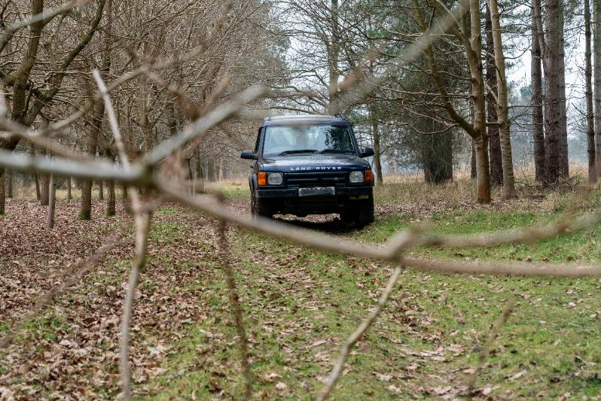

Image: A dark blue 4x4 Land Rover driving through a wooded area.

Annual Public Meeting – 14th October

Vision Norfolk’s Annual Public Meeting will be taking place on Tuesday 14th October, the 220th anniversary of the founding of the charity!

The venue is still to be confirmed, but it will be in the Norwich area. It is open to anyone with an interest in Vision Norfolk and refreshments will be provided.

Please let us know if you’d like to come along. More details will be released on our Facebook page closer to the time or you can contact us for more information by calling 01603 573000 or emailing office@visionnorfolk.org.uk.

**Norwich Hub Updates**

**Golf Clinic**

On Monday 21st July we had the pleasure of attending The Royal Norwich Golf Club for an amazing open day run by England & Wales Blind Golf.

Several of our service users had the opportunity to try out the driving range and even play on the course — many for the very first time!

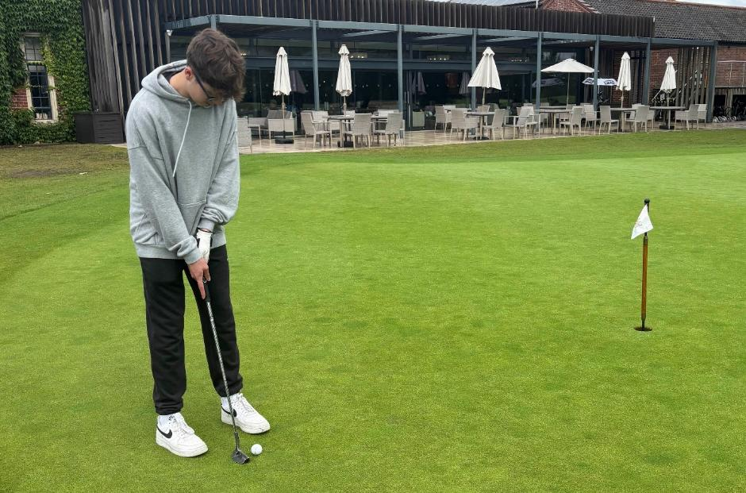

Image: A young man watching as his golf ball goes towards the hole.

**New Choir**

We are starting a choir based out of our Norwich Hub!

No prior singing experience needed. This is your chance to explore your voice, meet new people and be part of something joyful. The group will be led by James Fowler, a now retired Head teacher who has enjoyed singing throughout his life. He began his training as a chorister in Oxford and since then has sung professionally with groups across the UK, Europe and the USA.

Sessions will be taking place fortnightly from September at the Vision Norfolk Norwich Hub. It is free to take part, but donations are welcome.

For more details, please contact Mark on 01603 573000 Ext. 341 or at mark. smith@visionnorfolk.org.uk.

**Sainsbury Centre Visit**

Vision Norfolk took a group of art enthusiasts with sight loss to explore some of the exhibitions featuring contemporary art, historical paintings, ancient atlases and maps from across the globe, examining humanity’s enduring and complex relationship with the sea.

Our thanks go out to the Sainsbury Centre guides Chris and David, who brought the work to life with lots of verbal description and explanations.

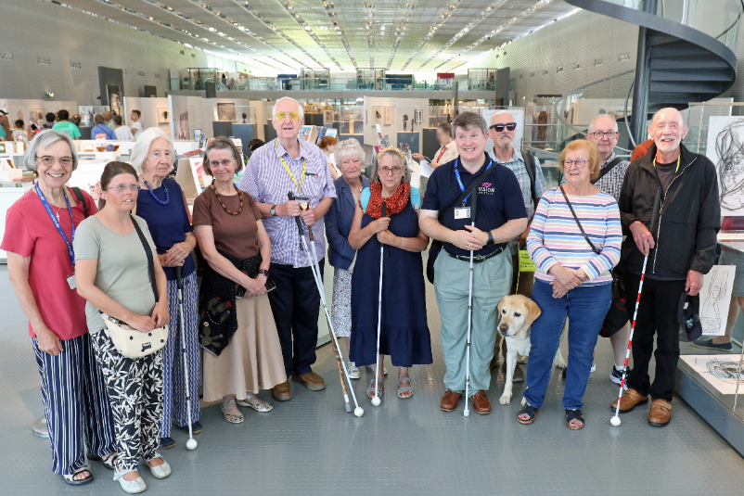

Image: The group of 12 people (and one guide dog) standing inside the main exhibition room of the Sainsbury Centre.

**The Day We Went Flying**

We were delighted to be invited by Vision Norfolk volunteer John Fielding to Priory Farm Airfield, where five of our vision impaired service users had the incredible opportunity to take to the skies in his microlight aircraft.

It was a truly memorable experience for everyone involved!

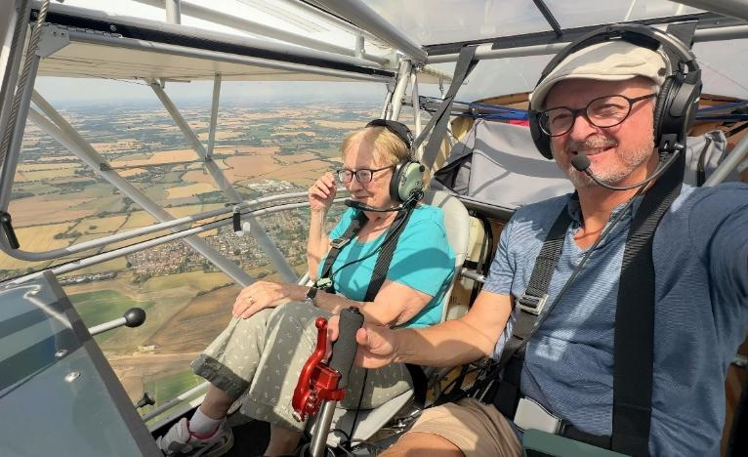

Image: The pilot (right) and a passenger sitting inside the small aircraft in flight. Norfolk fields are visible in the distance through the clear side panel of the aircraft.

**What’s On - Norwich and South Norfolk**

Unless otherwise stated please contact Richard on 01603 573000 extension 322 or richard.polley@visionnorfolk.org.uk.

Please note: Some of our activities are very popular. Please get in contact if you are interested and if the activity is already full we can put you on the waiting list for when spaces become available.

Wellbeing Wednesday – Norwich, 1st October, 10:30am-3pm

designed to support your wellbeing in an inclusive environment. Check out daily living equipment, pick up healthy eating tips, get creative with cras, enjoy gentle seated exercise and learn about other organisations where you can get support including Age UK, NHS Wellbeing Service, Big C Cancer Charity and Chatterbox Talking Newspaper.

Driving Experience – Norwich, 6th October

Following on from a successful session in March we are oering another free driving opportunity of a lifetime for blind and vision impaired people! We are working with the team at Elveden Estate to create a safe and fun driving experience. One to one tuition will be provided by experienced driving instructors. There are limited spaces so we will be holding a draw of all interested participants. Please let us know if you are interested in taking part by Monday 22nd September to be included in the draw.

Christmas Celebration – Norwich, 10th December

Join us for a celebration of the holiday season with music, refreshments and festive cheer at the Norwich Hub. All are welcome. Please let us know by the end of November if you are coming so that we can plan the refreshments accordingly.

Christmas Flower Arranging – 17th December, 10am-2:30pm

Come make a Christmas wreath and winter flower swag. We are holding two separate one-hour sessions to try to make the activities accessible to as many people as possible. Contact Mark on 01603 573000 extension 341.

**Regular Activities**

Allotment Project

Are you interested in gardening, or just want to spend some time out in the fresh air? Vision Norfolk has a plot at Marlpit Community Garden that we are using to explore accessible gardening practice out in the real world. This project is funded by Norfolk Community Foundation through the Greening Our Communities Fund. Contact Mark on 01603 573000 extension 341.

Arts and Crafts – Norwich, Every Thursday, 10am-12:30pm

Undertake a variety of arts and crafts with support from Helen and the volunteers. Contact Helen on 01603 573000 extension 342.

Audiobook Clubs

Our friendly, informal audiobook clubs offer a chance to get together and enjoy a chat about a chosen book. The book clubs are free to join and the audiobooks are supplied. Contact Mark on 01603 573000 extension 341.

Diss Audiobook Club – 4th Friday of Each Month, 2pm-3:30pm

Norwich Audiobook Club – 2nd Monday of Each Month, 1:30pm-3pm

Boccia – Norwich, 1st and 3rd Friday of Each Month, 10am-12pm

Join us for the competitive precision ball sport boccia. Sessions are open to all abilities and levels of experience.

Bowling – Norwich, 2nd and 4th Friday of Each Month, 9:30am-1pm

Come and enjoy some friendly competition with ten pin bowling at Namco Funscape. Transportation available from the Norwich Hub.

Bowls – Norwich, Every Tuesday, 10am-12pm

Whether you’re a newbie or an expert, a traditional game of bowls, is a good excuse to get together. We play the short mat variety inside Activity Hall at the Norwich Hub.

Braille Classes – Norwich, Every Thursday

Join our Braille class taught by one of our volunteers. The classes are small, usually on a one-to-one or one-to-two basis.

Choir – Norwich, Fortnightly on Monday (From 15th September), 10:30am-12pm or 11:30am-1pm

We are starting a choir based out of our Norwich Hub! No prior singing experience needed. This is your chance to explore your voice, meet new people and be part of something joyful. Please contact Mark for details of each session by calling 01603 573000 extension 341.

Coffee Mornings and Socials

Come and enjoy a cup of coffee and a chat at one of our social groups.

Attleborough Drop-in Café – Fortnightly, 11am-12:30pm, Contact Chris on 07743 921430

Norwich Coffee Morning – Last Monday of Each Month, 10am-11:30am

Norwich Drop-in Café at Plumstead Road Library – Fortnightly on a Wednesday, 11am-12pm, Contact Jo on 01603 573000 extension 454.

Thetford Drop-in Café – 4th Wednesday of the Month, 2pm-3:30pm, Contact Chris on 07743 921430

Cooking with Sue – Norwich, Monthly on a Thursday (25th September, 23rd October, 20th November, 18th December), 2pm-4pm

Each month we will be running a free cookery lesson at our Norwich Hub teaching practical skills that can be used at home.

Creative Writing – Norwich, 3rd Tuesday of Each Month, 2pm-3:45pm

Join a creative writing group that will give you the opportunity to express yourself through the written word. Contact Mark on 01603 573000 extension 341.

Darts – Norwich, 1st and 3rd Friday of Each Month, 1pm-3pm

Join us for a few friendly games of darts. Volunteers are around to help you position or read the numbers on the board if needed.

Glaucoma Support Group - Norwich, 2nd Friday of Each Month, 2pm3:30pm

A self-help and discussion session for local people living with glaucoma created in partnership with Glaucoma UK. We sometimes have speakers in to talk about glaucoma or other subjects.

Macular Group – Norwich, 2nd Friday of Each Month, 12pm-1:30pm

This group is organised and run by the Macular Society. Vision Norfolk staff usually give an update on new equipment and activities and there are sometimes guest speakers.

Photography Group – Norwich, 1st and 3rd Friday of Each Month, 1:30pm3:30pm

The first meeting in each month is an outdoor photoshoot and the second is an indoor opportunity to review photographs. Some outing may have a cost for refreshments. Contact Helen on 01603 573000 extension 342.

Sailing – Norwich, Fortnightly From 26th June, 12:30pm-5pm

Come and enjoy an afternoon of sailing on the Norfolk Broads. There is a suggested donation of £20 per session paid directly to the Nancy Oldfield Trust. Contact Mark on 01603 573000 extension 341.

Tandem Cycling – Norwich, By Appointment

Tandem cycling allows you to continue to enjoy a good (and safe) bike ride regardless of your vision loss. A sighted guide sits at the front to steer and describe. Gives us a call to set up a time to come in and give it a go. Weather dependent.

Tennis – Norwich, Fortnightly From Friday 12th September, 11am-12pm

Our inclusive fortnightly tennis sessions have returned to Waterloo Park with a coach from the National Tennis Association. It is free to take part and all equipment is supplied. We will be taking a break for the cooler months after 24th October.

Yoga – Norwich, Every Tuesday, 1pm-2pm and 2:15pm-3:15pm

Come stretch and relax with yoga. Sessions are designed to be accessible to all abilities and levels of experience.

**King’s Lynn Hub Updates**

**Relaxing Sound Bath Sessions**

On Thursday 31st July we were delighted to be joined by Melissa Welham, a professionally trained integral sound healing practitioner, who uses sound to support health and wellbeing.

During the gentle and calming session, Melissa guided everyone through a peaceful journey using sound as a tool to ease tension in the body and quieten the mind.

The session began with a friendly welcome and a clear explanation of what to expect, with time for any questions.

Then, everyone listened as Melissa used her voice to guide everyone through an easy breathing exercise and a short, gentle meditation.

During this time, Melissa slowly began to play the instruments. – such as singing bowls, chimes, and gentle percussion – each creating calming and comforting tones. These sounds are designed to help you feel present and deeply relaxed.

The session was followed by time for refreshments and a discussion on how people felt, the different sounds and how they impacted differently on each person.

Everyone attending said that they would love to come again.

“I really felt a sense of calmness and as I’ve been getting a lot of anxiety with my change of vision this seemed to really help. I’m going to book sessions with Melissa independently after trying this.”

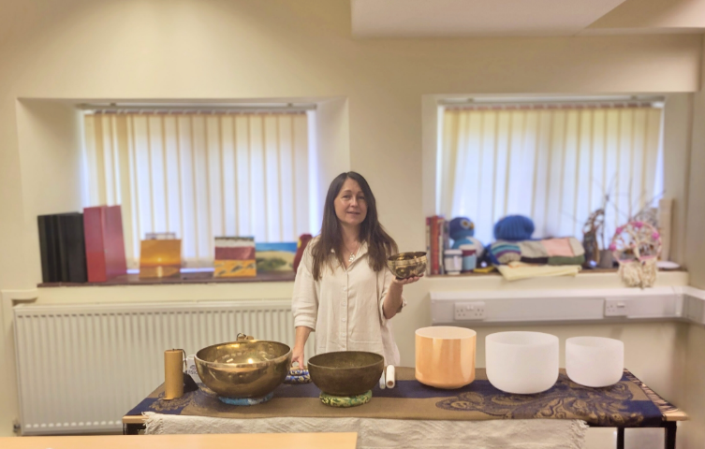

Image: Melissa displaying her sound making instruments set up on a table for the Sound Bath session in the King’s Lynn.

**Sailing in Snettisham**

Spending time around bodies of water, known as blue spaces, can have therapeutic benefits for both physical and mental wellbeing. We have teamed with local sailing experts to provide opportunities for local people living with sight loss to meet up and enjoy some of Norfolk’s beautiful waterfronts.

Throughout the summer the West Norfolk team have been working with Snettisham Sailing Club to provide free accessible sailing sessions to our service users.

These have stopped for the cooler months but we will be examining the feedback from these trial sessions to see whether we can offer more next summer.

Images: Two sailboats on the water. One has an orange sail and the other has a white sail.

**Mark Your Calendars for Holiday Activities**

We have a number of events planned throughout Autumn and winter seasons to continue to offer opportunities to people with sight loss to meet up in a relaxed social environment and try new things. We will be celebrating the holidays (from spooky season to Christmas) and continuing to provide exciting events and activities throughout the cooler, darker months. Please check out our following list of events and activities in West Norfolk or give us a call to talk about what is available.

**What’s On – West Norfolk**

Unless otherwise stated contact Abbi or Penny on 01553 660808 or kingslynnhub@visionnorfolk.org.uk.

**Special Events**

BTransformed – King’s Lynn, 1st October, 10am-12:30pm

Discover your dominant colouring type and receive expert tips on selecting the perfect shade for your wardrobe. Everyone will have a card to take away with them with the 10 colours on, examples on how to wear those colours and advice on accessories. The session is being delivered by Shirley from BTransformed. Places are limited.

Curry Night – King’s Lynn, 9th October, 5pm-7pm

Join us at Wetherspoons in King’s Lynn for Curry Night. This is a fun and informal social activity to give everyone a chance to get to know each other. Food and drink must be paid for individually.

Spooky Walk with the Town Guides – King’s Lynn, 14th October, 2:30pm-4pm

Join the Town Guides on a spooky walk exploring King’s Lynn’s dark history. There is quite a bit of walking and standing for this activity. Places are limited.

Titanic The Musical – King’s Lynn, 15th November, Performance starts at 7:30pm

The award-winning King’s Lynn Players are back at The Corn Exchange performing Titanic the Musical, winner of five tony awards including Best Musical on Broadway. We are hoping to set up a touch tour before the performance, but the timing is still to be confirmed. Tickets cost £18, Essential Companion/Carer costs £10. Places are limited.

Bauble Making Workshop - King’s Lynn, 20th November, 11am-2pm

Join us at Langham Glass in Fakenham to experience the art of glassblowing. There will be a demonstration from an expert and then you will have the opportunity to make your own Christmas Bauble or enjoy a cuppa in the café.

Christmas Quiz – King’s Lynn, 18th December, 1pm-3:30pm

Join us at the King’s Lynn Hub for a fun and festive social quiz.

Christmas Celebration – King’s Lynn, 22nd December, 11am-1pm

Our annual Christmas celebration is back. Open to all. Please get in contact for more details.

A Trip to the Pantomime – Jack and the Beanstalk – King’s Lynn,29th December, Performance starts at 5.30pm

Join Jack, Dame Trott, and loveable Clarabella the Cow for an unforgettable escapade at The Corn Exchange. We are hoping to set up a touch tour before the performance but the timing as still to be confirmed. Tickets cost £25, Essential Companion/Carer costs £10.50. Limited transport may be available.

Christmas Crafts – King’s Lynn

We will be having a Christmas Craft session. Date is to be confirmed still but you can contact us if you are interested and we will keep you informed.

**Regular Activities**

Archery

Join one of our free archery sessions designed to be accessible for all abilities and skill levels.

Downham Market Archery - 1st Monday of Each Month, 4pm-6pm

Fakenham Archery – 4th Wednesday of Each Month, 2pm-4pm

Art Workshops – King’s Lynn, 1st Friday of Each Month, 1pm-3pm

We hold regular small art workshops with painting, print making, collage and more. Free to attend and no prior experience necessary.

Audiobook Clubs

Our friendly, informal audiobook clubs offer a chance to get together and enjoy a chat about a chosen book. The book clubs are free to join and the audiobooks are provided. Contact Mark on 01603 573000 extension 341.

Dereham Audiobook Club – 3rd Wednesday of Each Month, 10:30am-12pm

Fakenham Audiobook Club - 3rd Monday of Each Month, 10:30am-12pm

Gaywood Audiobook Club – 1st Thursday of Each Month, 2pm-3:30pm

Hunstanton Audiobook Club – 3rd Tuesday of Each Month, 10:30am-12pm

Board Games – King’s Lynn, 4th Thursday of the month, 1pm – 3pm

Join us at the King’s Lynn Hub for an afternoon of cards and board games. Enjoy everything from Snakes and Ladders to Connect 4.

Bowling

Join other local people with sight loss for a good chat and a lively game or two with assistance available if required.

Dereham Bowling, Last Friday of the Month, Starting at 11am, Please contact Chris on 07743 921430

Gaywood Bowling – 4th Friday of Each Month, 1pm start

Bowls – Fakenham, 1st Friday of Each Month, 2pm-4pm

Come and enjoy some friendly competition with the traditional British game bowls. There are volunteers available at sessions to aid as necessary.

Coffee and Crafts – King’s Lynn, 4th Tuesday of Each Month, 10am-12pm

Join us for a relaxed morning of crafting at the King’s Lynn Hub.

Coffee Mornings and Socials

Come and enjoy a cup of coffee, a slice of cake and a chat about everything and anything at one of our socials.

Dereham Coffee Morning – 1st Thursday of Each Month, 10am-12pm, Contact Chris on 07743 921430

Dereham Social (Darts and Games Afternoon) – 2nd Wednesday of Each Month, 4pm-6pm, Contact Chris on 07743 921430

Downham Market Social – 4th Wednesday of Each Month, 11am-1pm

Fakenham Coffee Morning – 3rd Thursday of Each Month, 10am-12pm

Fakenham Drop-in Café – 1st Thursday of Each Month, 9:30am-11:30am

Hunstanton Drop-in Café – 2nd Wednesday of Each Month, 10am12pm

King’s Lynn Coffee Morning – 1st and 3rd Tuesday of Each Month, 10am12pm

King’s Lynn Drop-in Café – 3rd Wednesday of the Month, 10am-12pm

Swaffam Drop-in Café – 3rd Thursday of the Month, 10am-12pm

Knitting – King’s Lynn, 2nd Tuesday of Each Month, 1:30pm-3:30pm

Whether you are a complete beginner who would like to take up knitting or a seasoned knitter, our sessions are a fun and sociable way of getting together with fellow yarn fans.

Pub Club – Various Locations, 2nd Monday of Each Month, 12pm-2pm

A relaxed and friendly group that meet for a chat over lunch at local pubs.

Sit Fit – Downham Market, 3rd Friday of the Month, 1:30pm-3:30pm

A seated exercise class suitable for all adults regardless of age, gender or ability.

Sing 4 Fun – King’s Lynn, Fortnightly on Wednesday, 1pm-3pm

Join Sing 4 Fun, The Sound and Vision Choir, to improve your mental wellbeing, meet new people and most importantly have fun. The choir is run in partnership with The Workshop in King’s Lynn.

Tandem Cycling – King’s Lynn and the Local Area

Our popular tandem cycling sessions have returned. Join guide riders from the Cycling UK West Norfolk Group for cycle trips around the local area. We run rides regularly throughout the summer months so please get in contact for more details. The success of our tandem cycling sessions has been greatly aided by the Borough Council of King’s Lynn & West Norfolk Small Grants Scheme whose funding has helped us purchase a new bicycle and safety equipment. We will be taking a break for the cooler months from around the end of October until around April 2026.

**Great Yarmouth Hub Updates**

**Summer Activities**

We’ve had a busy few months in the East, our regular activities are continuing to go well.

In July, the seaside walking group had a great time, visiting the seaside at Cromer, they walked down the promenade and enjoyed lunch by the sea.

In August, we also took a walk round Great Yarmouth to look at the sculpture trail that’s been set up to commemorate historical events that have taken place around the town. Thanks to our volunteer Chris Stanley for putting together such an excellent tour. As it was so popular, this will be repeated on Wednesday 8th October. Please speak to the staff for more information.

We would also like to thank our weaving volunteer, Ken Cole and his wife, Jackie, for hosting the weaving group at their garden, one Friday in August. There was much enjoyment over lunch and some garden games.

We took a group to the Summer Spectacular at the Hippodrome circus. Everyone had plenty of fun, and we’d like to thank the staff at the venue for being so accommodating and making everyone welcome.

**Evening Activities**

We are looking to open the hub once a month, aimed primarily at people, who in the main, can’t access our daily activities, due to work or other commitments. We are looking to try out a pilot to see how this runs, and if successful, we will extend it into 2026. We hope to have a selection of games evenings, which may include video gaming. The sessions are between 6 and 8.30 and will run on the following Tuesdays.

* Tuesday 16 September
* Tuesday 21 October
* Tuesday 18 November
* Tuesday 16 December

Please speak to any of the hub staff if you want more information.

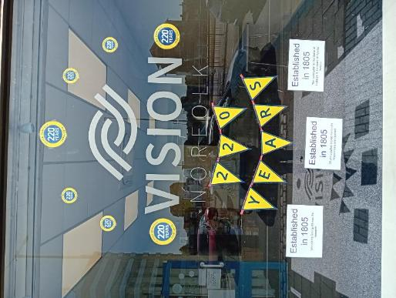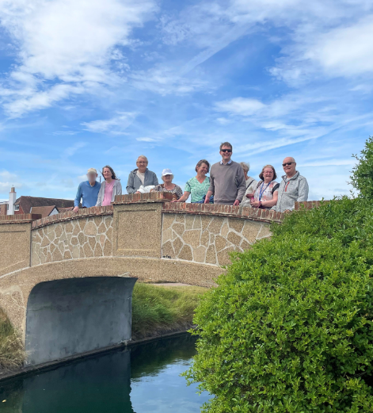

Image – Left: The windowfront of the Great Yarmouth Hub decorated to celebrate Vision Norfolk’s 220th Anniversary.

Image – Right: A small walking group standing on Bridge under a blue sky.

**What’s On – East Norfolk**

Unless otherwise stated please contact Catherine on 01493 745973 or greatyarmouthhub@visionnorfolk.org.uk.

**Special Events**

Trip to Fairhaven Water Garden – Transportation From Great Yarmouth, 23rd September

We are taking a group to Fairhaven Water Garden for a guided tour of the gardens. Transport will be provided from the Great Yarmouth hub, and please bring lunch.

Sculpture Trail – Great Yarmouth, 8th October

Join the Great Yarmouth team for an accessible outing to explore the new Great Yarmouth Art Trail. The trail has 11 sculptures – focusing on themes of maritime and medieval history, arts heritage, seaside, transport and energy. Please be aware there is a fair amount of walking between the sculptures.

Dotty Pottery and Wroxham Barns – Transportation From Great Yarmouth, 28th October

We are going to Wroxham Barns to try out some Dotty Pottery, and explore the surrounding businesses which are situated there. Transport will be provided from the Great Yarmouth hub.

Bowling – Great Yarmouth, 11th November, 12pm-3pm

Meet us at Wellington Pier for a relaxed bowling session designed to be accessible for people living with sight loss.

Aquatics Centre and Whiskey Distillery - Transportation From Great Yarmouth, 25th November

We are running a trip to East Harling for a visit and handling session with reptiles and aquatic pets at Swallow Aquatics. Then in the afternoon we’ll be going on to the English Whisky Distillery for a tour of the site, and a tasting experience. Transport will be provided from the Great Yarmouth hub.

Cromer Pier Christmas Show – Transportation From Great Yarmouth, 9th December

We are celebrating the festive season with a trip to the Cromer pier to watch their Christmas show. Transport will be provided from the Great Yarmouth hub.

Christmas Celebration – Great Yarmouth, 22nd December, 11am-1pm

Our annual hub Christmas party for our clients and volunteers will take place on Monday 22nd December. Please speak to the staff for more information.

**Regular Activities**

Audiobook Clubs

Our friendly, informal audiobook clubs offer a chance to get together and enjoy a chat about a chosen book. The book clubs are free to join and the audiobooks are supplied. Contact Mark on 01603 573000 extension 341.

Cromer Audiobook Club – 3rd Monday of Each Month, 2pm-3:30pm

Great Yarmouth Audiobook Club – Last Friday of Each Month, 1:30pm-3pm

Coffee Mornings and Socials

Come and enjoy a cup of coffee, a slice of cake and a chat about everything and anything at one of our socials.

Caister Coffee Morning – 1st and 3rd Tuesday of Each Month, 10am-12pm, Contact Matthew on 01603 573000 extension 455

Cromer Coffee Morning – Last Wednesday of Each Month, 10am-1pm, Contact Karl on 07864 615929

Great Yarmouth Coffee Morning – Every Wednesday, 10am-12pm

Martham Coffee Morning – First Thursday of Each Month, 10am-12pm, Contact Matthew at 01603 573000 extension 455

North Walsham Coffee Morning – 3rd Tuesday of Each Month, 10am-12pm, Contact Karl on 07864 615929

Creative Writing – Great Yarmouth, 2nd Friday of Each Month, 1pm-3pm

Our creative writing group is growing nicely, but new members are always welcome. We hope to cover a variety of different subjects, and all formats are accepted. No previous writing experience necessary.

Fishy Friday – Great Yarmouth, 1st Friday of Each Month, 1pm-2pm

Meet other local people living with sight loss and have a chat over fish and chips. Costs £7.50 per person to cover the food.

Games Morning – Great Yarmouth, Every Thursday, 10am-12pm

Join our fun and welcoming games mornings to try out cards, bingo, dominoes, and floor and table games.

Knit, Stitch and Natter – Great Yarmouth, 2nd Thursday of Each Month, 1pm-3p

Join Norfolk Knitters at our group where we learn together how to knit and stitch along with having a good natter.

Rug Workshops – Great Yarmouth, Last Friday of Each Month, 10am-12pm

Join experts from local business Ruskin’s Rugs at the hub. Use their rug making kits to make your own small rugs and wall hangings.

Seaside Walks – Various Locations, Last Thursday each month, 1pm-3pm

Join us for a breath of fresh air and a leisurely stroll along one of our many local seafronts. A refreshment stop will be included during the afternoon. Please note our last walk of the season will be 30th October and walks will restart on 26th March 2026.

Tennis Sessions – Gorleston, 10:00am-12pm – Last Session of the Sea

Give tennis a try at special sessions led by LTA-accredited coach Mike Reynolds. Please be aware our last session is September 30th, we will confirm dates for 2026 in future editions

Weaving Group – Great Yarmouth, Every Friday, 10am-12pm

Use different types of soaked cane to make baskets of all shapes and sizes. The last Friday of each month weaving will be replaced with rug workshops.

Yoga – Great Yarmouth, 1st and 3rd Wednesday of Each Month, 12:30pm-1:30pm

Join a yoga session with Georgina Huggins, a yoga therapist and teacher. Open to all abilities, no experience required.

**Contact Details**

Please get in contact for further details on how we can support you and how you can get involved. Our hubs can be found at:

**Norwich**

Bradbury Activity Centre, Beckham Place Edward Street, Norwich, NR3 3DZ

Telephone: 01603 573000

Email: office@visionnorfolk.org.uk

**King’s Lynn**

20 Thoresby College, Queen Street King’s Lynn, PE30 1HX

Telephone: 01553 660808

Email: kingslynnhub@visionnorfolk.org.uk

**Great Yarmouth**

12 Hall Quay, Great Yarmouth, NR30 1HP

Telephone: 01493 745973

Email: greatyarmouthhub@visionnorfolk.org.uk

Registered Charity Number 1206599