Vision Norfolk
Annual Review 2024/25

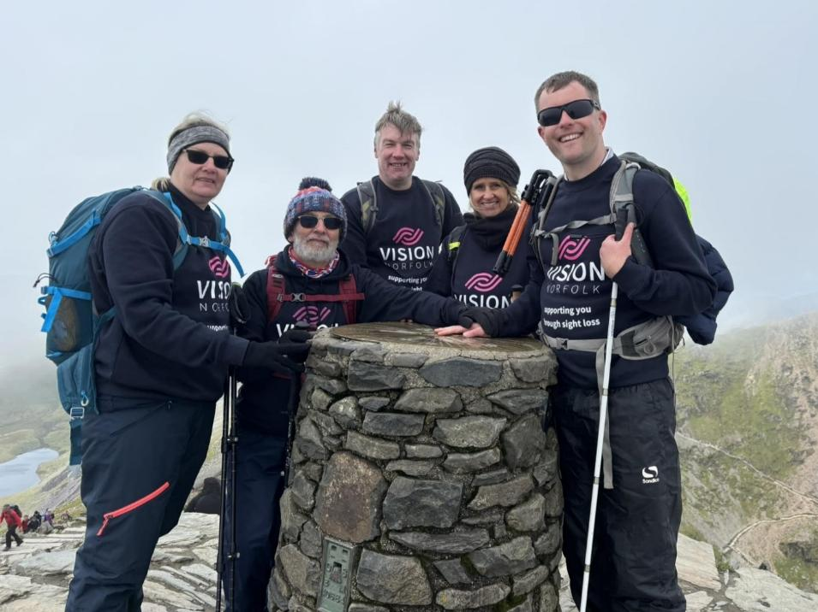
Cover Image: Pictured at the summit of Mount Snowdon raising thousands for Vision Norfolk are staff members (from left) Helen King, Matthew Hodder, Andrew Morter, Barbara Dunn and Ed Bates.

Chair’s Message

It is a pleasure to introduce our Annual Report for 2024/25, during which we entered our 220th year. I am very proud to be Chair of a charity with such a rich heritage, and to able to report a strong 12 months during which we continued to expand our services and engage with ever more vision impaired people in the county.

Reaching a milestone such as our 220th anniversary only happens when an organisation is prepared to embrace change to meet the needs of an ever-evolving world. Both Norfolk and our charity are totally different today than in 1805, and the intervening 220 years have seen many step-changes in the needs of those living with sight loss, and consequently in the way that Vision Norfolk supports them.

As we look to the future, we continue to evolve and develop what we do to ensure the charity is relevant to the needs of Norfolk’s vision impaired people, and chief executive Andrew Morter outlines our key priorities for the coming years in these pages.

2024/25 was a year during which we concentrated on reaching out to more people living with sight loss. An important part of achieving that is our Community Outreach service, relaunched during 2023/24, and which really came into its own during this year.

Taking our services and support out into the community and to vision impaired people living in their own homes is a vital part of increasing the impact of the work that Vision Norfolk does. The team completed over 4,500 interventions during the 12 month period, a significant achievement which has resulted in Vision Norfolk supporting many more people than in recent years.

Alongside visiting people in their own homes, the Community Outreach team has greatly enhanced the range of activities and events which we are able to offer through our hubs in Norwich, King’s Lynn and Great Yarmouth, and in venues all around the county.

Last year I reported on an extensive programme to upgrade the 20 flats in Hammond Court, including expanding 13 bedsit studios into one-bedroom flats, installing new adapted kitchens and bathrooms, and adding patio doors in every flat. This year saw the completion of the second phase of this project, which has seen the refurbishment of the flats in Hammond Court 2.

This has been a significant investment by the charity, and it means that our supported living accommodation is now modern and fit for purpose.

Investment like this is only possible thanks to the generosity of our supporters and fundraisers. It is no secret that the financial environment for all charities is currently very squeezed, with a combination of record demand for services, diminishing statutory funding, and a continuing cost-of-living crisis which means that fundraising has never been tougher.

For our 220th year we have launched our #220Challenge, with the aim of raising £220,000 during the anniversary 12 months to boost the support we can offer. We will report more on this in next year’s Annual Report, but I would like to extend a huge thank you to everyone who has already taken up the challenge - and encourage you to consider doing so if you are inspired by what you read in these pages.

Much of what we do is only possible thanks to the amazing support we receive from our army of volunteers. The charity could not operate without them, and as Chair I extend my sincere gratitude for the time and energy they devote to making the lives of people living with sight loss better. We always need more, so if you want to discover just how rewarding and fun being a volunteer can be, please do get in touch.

Finally, I would like to thank everyone who has worked so hard to put the charity in the strong position it finds itself in as we enter our 220th year. That includes, staff, trustees, volunteers, fundraisers, funders and donors, and of course our wonderful clients whose resolute cheerfulness and determination makes it all worthwhile.

Karen Norton, Chair of the Trustees.

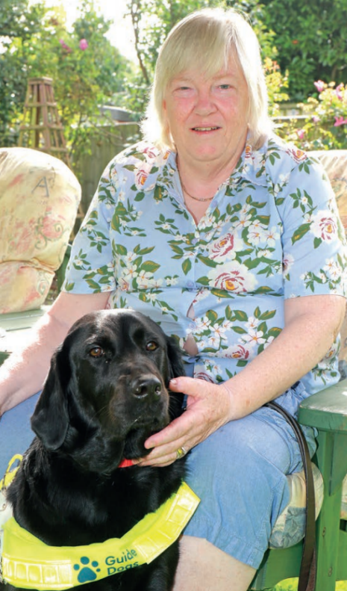
Image: Vision Norfolk Chair of Trustees Karen Norton with her guide dog Mabel.
Chief Executive’s Message

As we enter our 220th year, what strikes me is not just our remarkable longevity, but how much we are still needed. Across Norfolk, around 39,000 people are living with sight loss (a number that is expected to double by 2050), yet 73% are economically inactive – not because of lack of ability or ambition, but because opportunities and support are still too often out of reach. That's not just a statistic; it represents thousands of untapped talents, unfulfilled ambitions, and lives that could be so much richer.

This past year has been transformative for us. In an increasingly challenging world for charities, our transition to a Charitable Incorporated Organisation (CIO) has given us the stability and flexibility to think bigger, move faster and has opened up opportunities to diversify our income streams.

In the three years since I joined, we have seen consistent growth, with the highest number of people accessing our services, taking part in our wellbeing activities, and children and families benefiting from our CYPF services over the past 12 months.

More importantly, our new Community Outreach Service completed its first full year, directly supporting people in their own homes and local communities across Norfolk. The difference this service makes cannot be overstated – for many of our clients, we're the bridge between diagnosis and independence, and this person-centred, place-based model means they can access the services they need in the right place and at the right time for them.

But we know we can do more. Too many people still navigate their sight loss journey alone, never knowing that vital support exists. Our Eye Care Liaison Officers are brilliant at helping people at the moment of diagnosis, but we're only reaching a fraction of those who need us. That's why we're working hard to increase capacity and expand this vital service to ensure that fewer people fall through the gaps of the current system.

Looking ahead, I'm excited about three game-changing priorities.

First, digital inclusion. I believe digital technology is as important today as Braille was 100 years ago. Technology isn't just useful for people with sight loss – it's revolutionary. Yet many remain excluded from this digital world that the rest of us take for granted. Our clients have told us clearly how important this is to them through their feedback. We will continue to develop and improve our projects around digital technologies to ensure that everyone with sight loss can access these life-changing tools, including the incredible possibilities that artificial intelligence now offers.

Secondly, we are aiming to tackle the employment crisis head-on. When only 25% of working age people with sight loss are in work, we're wasting extraordinary potential, and we want to challenge the misconceptions and dismantle the barriers that prevent blind and vision impaired people, especially young people, from gaining meaningful employment. We will be working in partnership with other local charities and directly with Norfolk employers to show that this untapped talent pool exists right on their doorstep.

Finally, we will continue to improve our services to reach people earlier. Every month of isolation after diagnosis is a month too long. We're hoping to build partnerships and improve pathways, particularly with the NHS, so that from the moment someone loses their sight, they know they're not alone and can have immediate access to the practical and emotional support they need.

Alongside these priorities, we'll be conducting a comprehensive services review to ensure that every service delivers real impact, value for money, and measurable improvements in independence and quality of life.

None of this would be possible without our incredible team of trustees, staff, and volunteers, who bring passion and expertise to everything we do. To our supporters, your continued belief in our mission motivates and energises us, enabling us to transform lives every single day.

Vision Norfolk has been supporting people for 220 years, but I've never been more optimistic about our future. Together, in our 220th year – and for generations to come – people with sight loss in Norfolk are not defined by what they’ve lost but empowered by what they can achieve.

Andrew Morter, Chief Executive

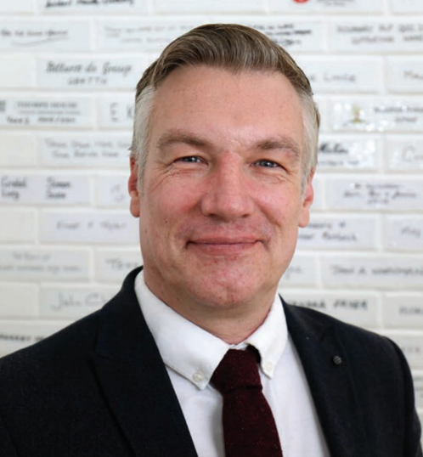
Image: Andrew Morter, Chief Executive of Vision Norfolk
Vision Norfolk’s 220th Anniversary

2025 marks the 220th anniversary of Vision Norfolk, which was founded in 1805 by Thomas Tawell, a Norfolk-based ironmonger. Tawell had become blind the previous year, and his response was to purchase land and property to establish institution for the benefit of the ‘indigent blind’ in the city.

Today the charity he formed is called Vision Norfolk and provides a wide range of support for people living with sight loss right across the county.

The need is now greater than ever, with almost 40,000 people in Norfolk living with sight loss, a figure which is projected to grow significantly in the next two decades.

Vision Norfolk is responding by widening the scope and reach of its services, always looking to introduce new initiatives to meet evolving needs (such as digital inclusion). To support this, we have created the 220 Fundraising Challenge, aiming to raise £220,000 during our anniversary year.

Vision Norfolk – The first 220 years
1805: Thomas Tawell founded the Asylum for the Benefit of the Blind in Norwich
1829: First item of Braille published. Invented by Charles Barbier as a tool for night writing, it was then adapted for use by blind people
1889: A new frontage facing Magdalen Street
1900: Mat making workshop established
1920: Government introduces new bill following WWI, making it a duty of local authorities to “promote the welfare of blind persons” and keep a register of blind and partially sighted people
1921: The white cane was invented by James Biggs to assist him after losing his sight in an accident
1931: Guilly d’Herbemont recognised the benefit of the white cane and started a movement to provide it with legal status in traffic, supported internationally by Lions Clubs
1934: Brush making and knitting activities are introduced with a shop opened in Castle Meadow to sell crafts
1948: New centre for the social care of blind people opened at Catherine Wheel Opening, Norwich
1951: A mechanical Braille machine was introduced – the Perkins Brailler
1955: On 14 October, an anniversary dinner marks 150 years
1970: Thomas Tawell House, a new care home specialising in support for people with sight loss, is formally opened by Princess Alexandra and Lord Alex
1985: Land on which the activity workshops were held was sold for £101,000
1988: The organisation is renamed Norfolk and Norwich Association for the Blind
1992: All five hospitals within Norfolk open an eye clinic
2003: Nokia designs the first mobile phone for the blind and partially sighted
2005: Celebration dinner held to mark 200 years of the organisation’s history
2006: Braille Sense launched as the first digital Braille notetaker
2010: After much fundraising, HRH The Queen officially opens the Bradbury Activity Centre
2020: Name changed to Vision Norfolk
2025: 220 Fundraising Challenge launched

Norfolk’s Sight Loss Challenge
- 38,000 people in Norfolk live with sight loss
  - 41 per 1,000 people, compared to 33 per 1,000 nationally
- Over 5,000 are registered blind
- Expected to rise to 47,900 by 2032, and over 75,000 by 2050
- 12,350 patients a year wait over 18 weeks for eye care – around 42% of all patients
- People with sight loss are three times more likely to experience difficulties with isolation, unhappiness and depression
- 75% of working-age blind/partially sighted people are not in employment

The 220 Fundraising Challenge
To mark our 220th year, we have launched the 220 Fundraising Challenge, with the aim of raising £220,000 to help boost the support we can give to people living with sight loss in Norfolk.

We are challenging people to come up with 220-themed fundraising ideas. Early initiatives have included cycling 220 miles around Norfolk, climbing Britain’s three highest mountains in 220 minutes each, making and selling 220 stuffed toy animals, and even dancing with 220 different partners in one weekend. Others are taking on the challenge of raising £220, or even £2,200, through their activities.

If you would like to get involved during our 220th year, find out more at www.visionnorfolk.org.uk/get-involved/fundraise-for-us.

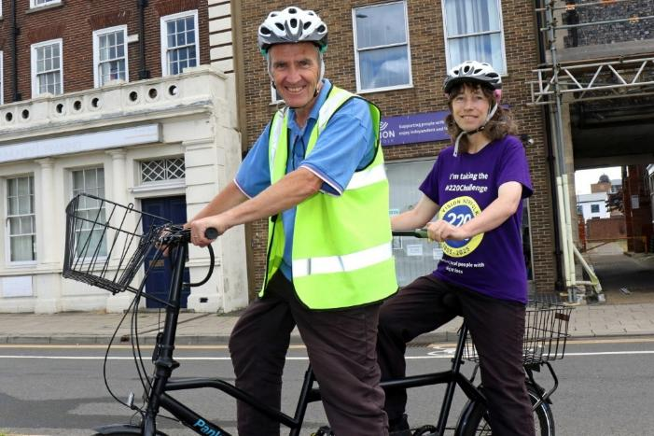
Image: Vision impaired cyclist Miranda Reeves got on their tandem for an early 220 Challenge.

2024-2025 Facts & Figures

- 1,398: patients supported by our Eye Clinic Liaison Officers in the county’s eye clinics
- 444: Certificates of Vision Impairment completed
- 4,521: interventions by our Community Outreach Service for vision impaired people in their home or local community
- 4,004: calls made by volunteers via our Telefriends service during the year
- 419: support interventions by our Children, Young people and Families Service
- 281: families attended events in the Children, Young People & Families programme
- 46: new referrals received for children newly diagnosed with sight loss
- 550: activity sessions completed during the year
  - audio book clubs
  - cookery classes
  - coffee mornings
  - creative writing
  - sports, including:
    - darts
    - short mat bowls
    - yoga
    - archery
    - boccia
    - tennis
    - sit fit
    - tandem cycling
    - sailing
    - ten-pin bowling
  - technology classes
  - arts and crafts including pottery, weaving, art and photography
  - walks
  - games mornings
  - gardening
  - escape room
  - 4x4 driving
- 3,319: people took part in activity sessions

Supporting Young People and Their Families

Our Children, Young People and Families Service has supported 419 families over the past 12 months, providing a family-centred approach, with emotional and practical support for the whole family, including home visits, information days and help with navigating key meetings with professional bodies.

In addition, the team assists with Education, Health and Care Plan (EHCP) applications and accessing benefits, grants and other resources to support the child’s development and independence.

There is also a range of fun activities for the children to take part in, including tennis, archery, gardening, indoor climbing, canoeing, pizza evenings, music sessions, trips, and not forgetting our annual summer and Christmas parties and Christmas Train Trip.

All of these events are set-up in a way which promotes the child’s confidence and social skills in a safe, friendly and welcoming environment, whilst also giving parents an opportunity to receive support and share experiences with other parents.

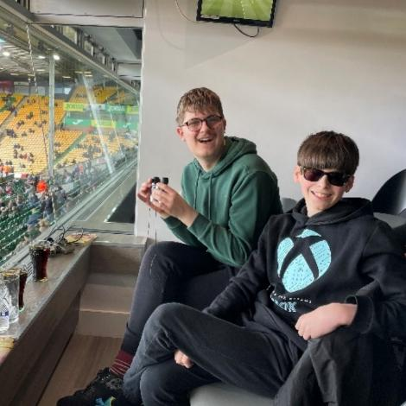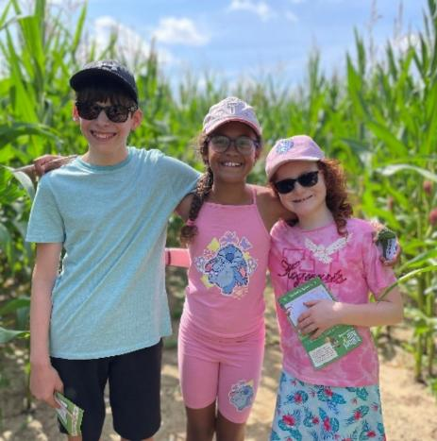
Image – Left: Two boys sitting inside a box at the Norwich City Football Club (Carrow Road).
Image – Right: Three young people with their arms around each other standing in a corn maze.

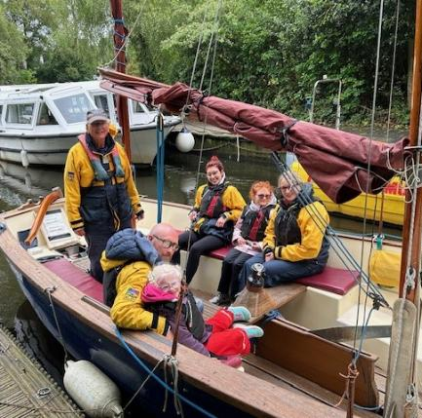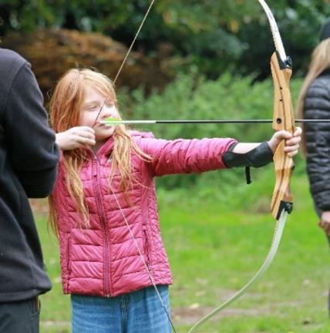
Image – Left: Adults and children siting in a boat ready to go on a sailling trip.
Image – Right: A girl aiming a bow and arrow.
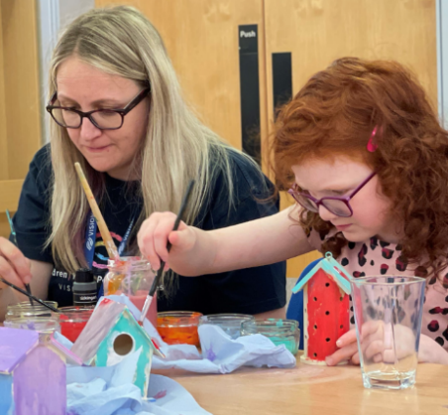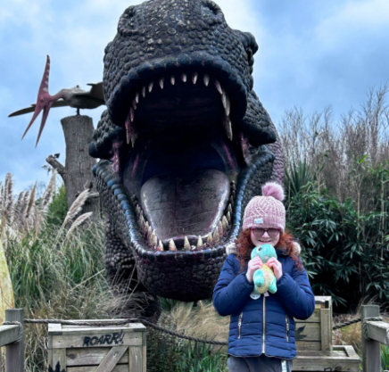
Image – Left: A girl and a woman sitting at a table painting bird houses.
Image – Right: A girl holding a plush toy standing in front of the open mouth of a t-rex.

Montage of Images with Captions

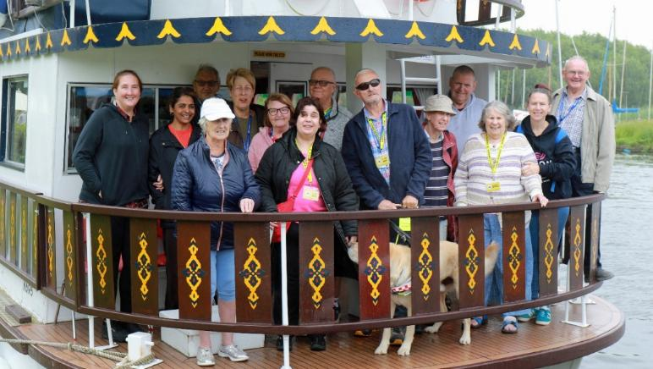
A group from the Great Yarmouth hub enjoy a day out on the Norfolk Broads on board the ‘Southern Comfort’.


Jamie Carter getting ready to tackle a challenging 4x4 driving course at Elveden, one of a dozen people with varying degrees of sight loss who took to the wheel.
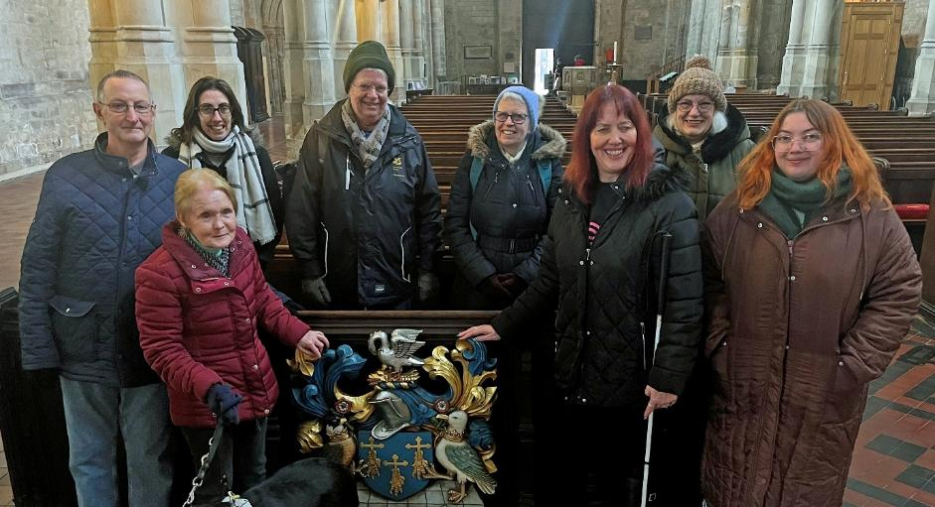
The King’s Lynn hub got together with local town guides to offer a series of fascinating history walks in the town.

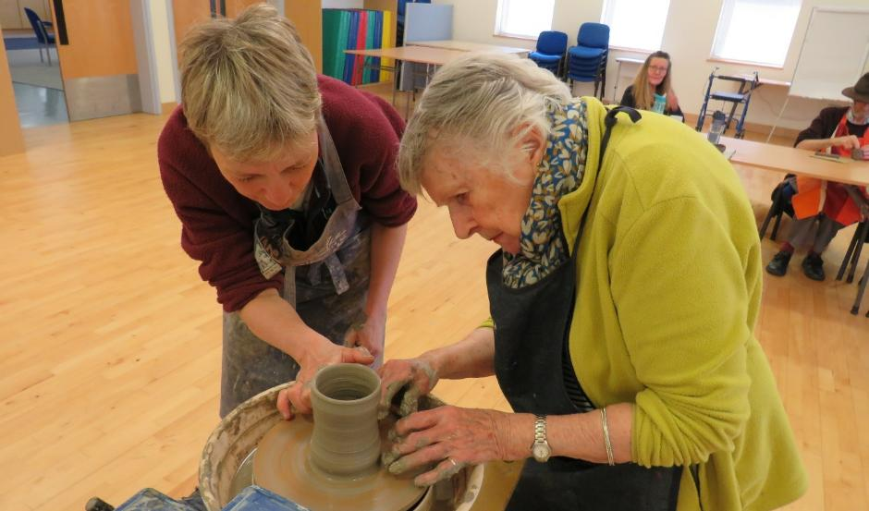
A group tried their hands at pottery during a session at the Norwich hub, including the tricky challenge of throwing a pot on the wheel.

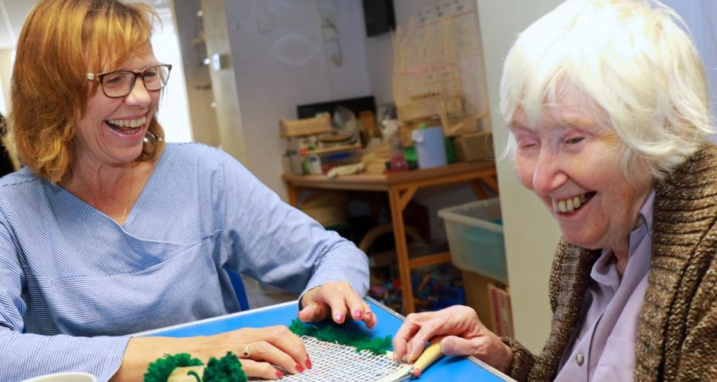
Christine Pyzer (left) of Ruskins Rugs helps Dawen Wright during a rug-making workshop at the Great Yarmouth hub.

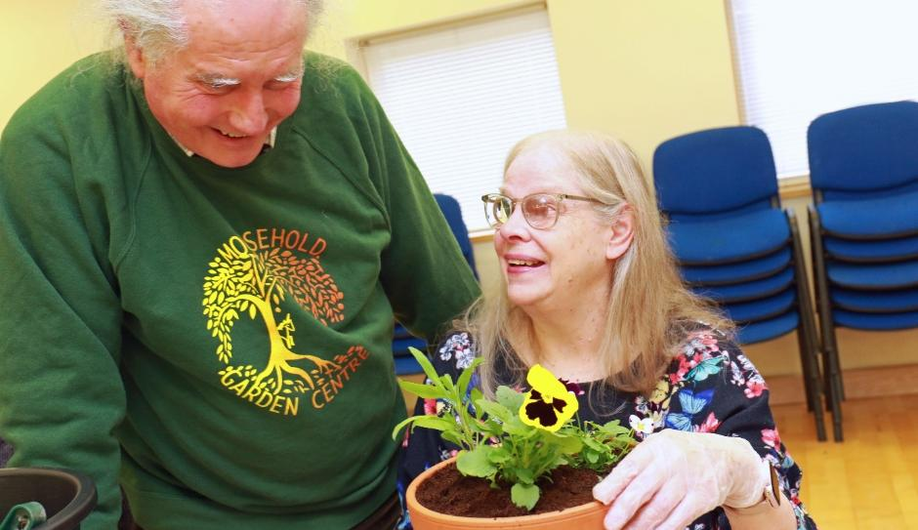
Tim Gee of Mousehold Garden centre helps Annabel Clifton plant up a pot during a gardening workshop at the Norwich hub.

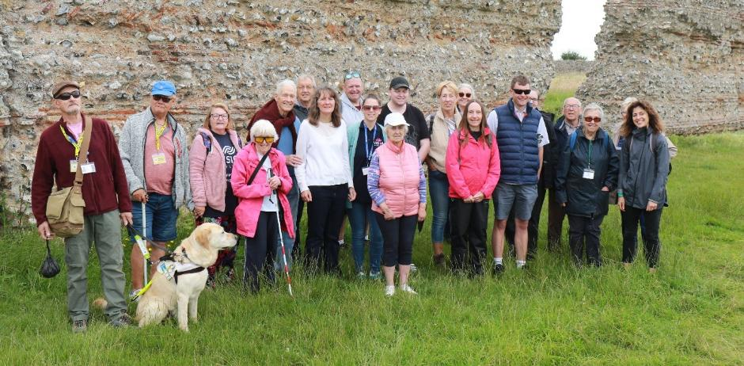
The Romans were on the agenda when a group visited Burgh Castle on a fascinating guided walk led by a local history expert.

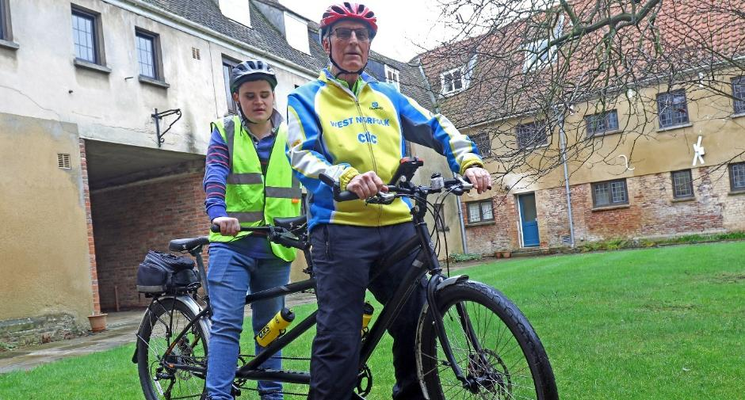
Vision impaired people in the west of the county can take to the road on a tandem which was funded by King’s Lynn and West Norfolk Borough Council.
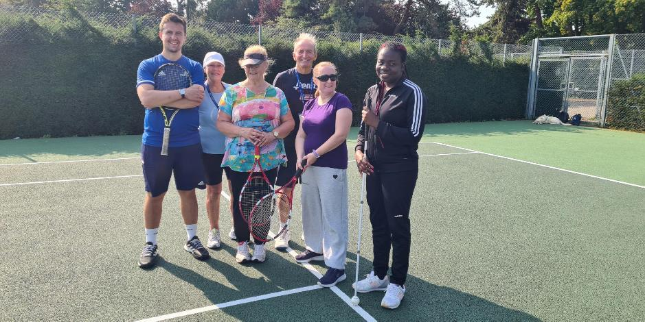
A series of special sessions proved that sight loss is no barrier to enjoying tennis – with expert coaching from professionals

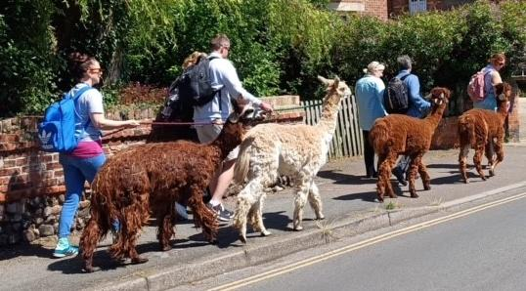
A group tries out a novel type of guide dog! Actually, walking with alpacas was one of the more unusual activities on offer during the year.

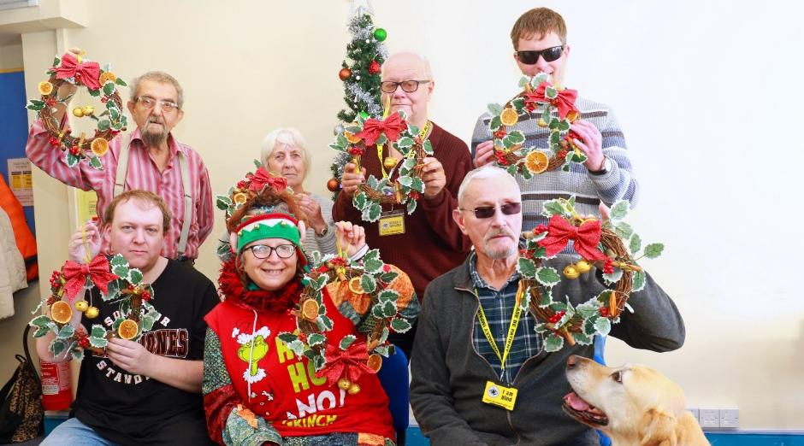A group got into the Christmas spirit with a special wreath-making workshop.

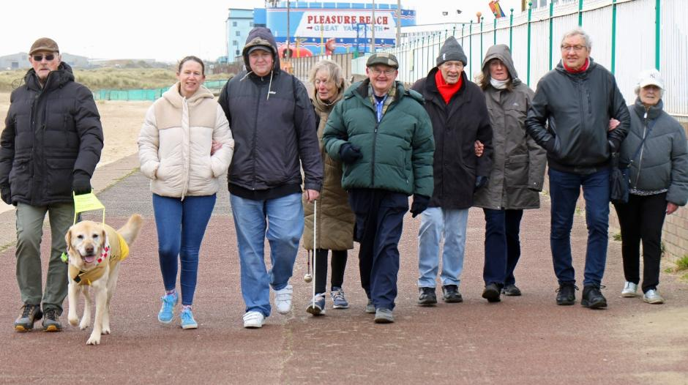
A series of guided walks from the Great Yarmouth hub across the summer explored the seafront and sight of the resort.
Vision Norfolk Volunteers

The role played by Vision Norfolk’s wonderful army of volunteers in delivering services to clients and ensuring the smooth running of the charity is immense.

Over 100 volunteers are involved across the organisation, from telephone befriending to driving minibuses, fundraising to helping out on leisure activities.

“Without our wonderful volunteers we would simply not be able to offer the range of services that we do for vision impaired people across Norfolk,” says Vision Norfolk chair of trustees Karen Norton.

“The demand for our services continues to grow, and it is only through the dedication and loyalty of our army of volunteers that we are able to meet that demand.

“Volunteering is a richly rewarding thing to do, and we would very much welcome anyone who is thinking of volunteering some time to consider helping Vision Norfolk.”

Case Study: Ken Cole
Retired teacher Ken Cole has been leading basketweaving sessions at the Great Yarmouth hub for 17 years, having fallen into volunteering by accident.

“My daughter Emily has albinism and is vision impaired, and one Friday in 2008 my wife popped into Vision Norfolk’s Yarmouth office to seek some help obtaining a bus pass for her. It happened to be on a Friday morning when a craft session was taking place. She told me that some of the people taking part had told her that they would like to try their hand at basket-weaving.

“She mentioned that I used to do basketwork at school, so I was sort of volunteered by my wife. That was in 2008, and I’ve been doing it ever since.”

Ken had worked in industry as a pipefitter before becoming a teacher, so he enjoys working with practical things as well as instructing others.

“I hadn’t really thought about doing volunteering, I kind of got seconded into it, but I enjoy it. I have always enjoyed teaching people, and volunteering here allows me to do that.”
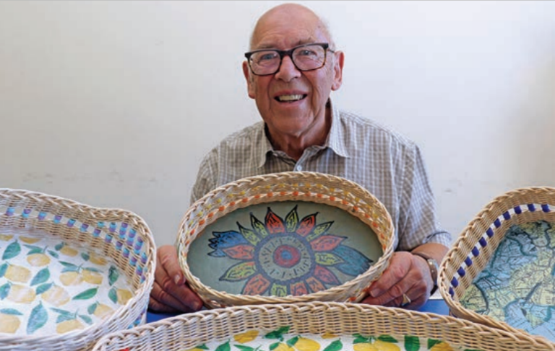
Image: Volunteer and retired teacher Ken Cole, who leads basket-weaving session at the Great Yarmouth Hub.

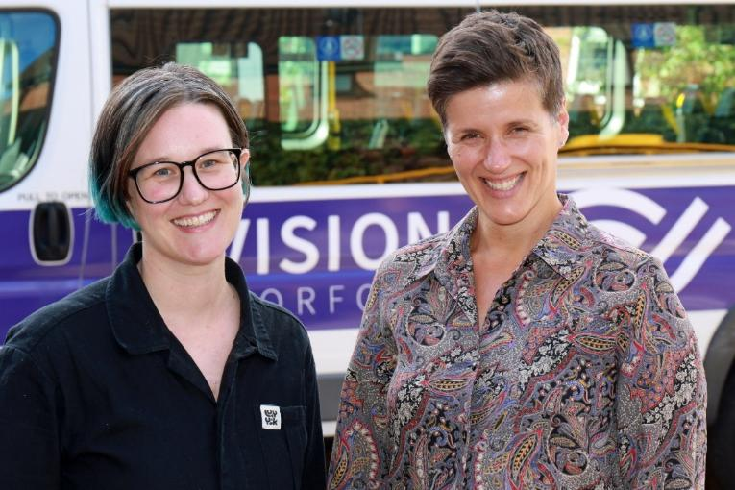
Image: Vision Norfolk volunteer engagement coordinators Sophie Chapman-Smith (left) and Emily Orford

Sidebar
Would you like to offer your services as a volunteer for Vision Norfolk?

Our team of volunteers undertake a huge range of activities, including helping at sports and leisure activities, advising at eye clinics, being Telefriends, driving, fundraising, escorting and guiding, and working in the charity’s equipment and information centres.

For more information, go to www.visionnorfolk.org.uk/get-involved/volunteer, email volunteers@visionnorfolk.org.uk, or call on 01603 573000.

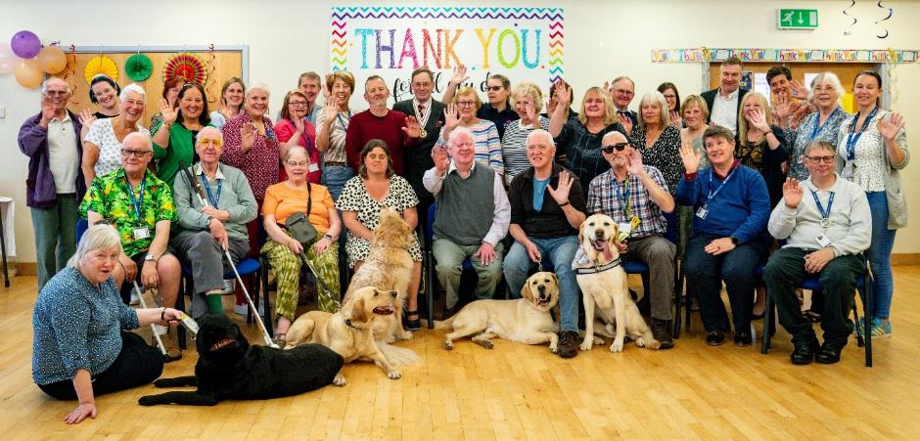
Image: Vision Norfolk celebrated the contribution of its volunteers at a special party at the Bradbury Centre.

The Financial Year

For 2025 our financial performance continued to show an overall deficit, which this year was compounded by a poor result from our investment portfolio. As is widely known, stock market returns were impacted by global trade tariffs and other factors, and this has affected our financial performance - in common with other charities dependent on investment returns.

Our core income reduced slightly but we were again hugely grateful for a number of large legacies during the year, together with all those who support our fundraising activities and give to the charity on an ongoing basis.

Our expenditure increased as a result of the determination of the leadership team and the trustees to invest in a new growth strategy to increase income and enhance the charity’s profile. We hope this investment will generate good returns in future years.

The overall reduction in reserves this year was £640k of which £168k was due to the revaluation of our investment portfolio. 90% of our reserves are either restricted or designated for particular purposes, and are necessary to continue to offer the wide range of services we are committed to for the benefit of vision impaired people across Norfolk.

The trustees are determined that the charity becomes financially sustainable for the future so that we can continue to benefit those people we support. We will only be able to achieve this with the financial support of those who continue to so generously give to our work.

Julian Foster, Treasurer

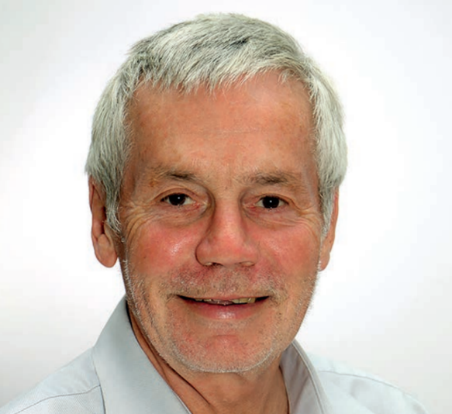
Image: Julian Foster, Vision Norfolk Treasurer

- Reserves decreased by £640k compared to by £66k last year, due to operating deficit from wide range of activities for vision impaired people
- Legacy income contributed £541k compared to £568k last year
- Year on year investment performance reduced to £15k overall compared to £406k last year
- New fundraising growth strategy incurred £77k of costs expected to benefit in future years

Income 2024-25
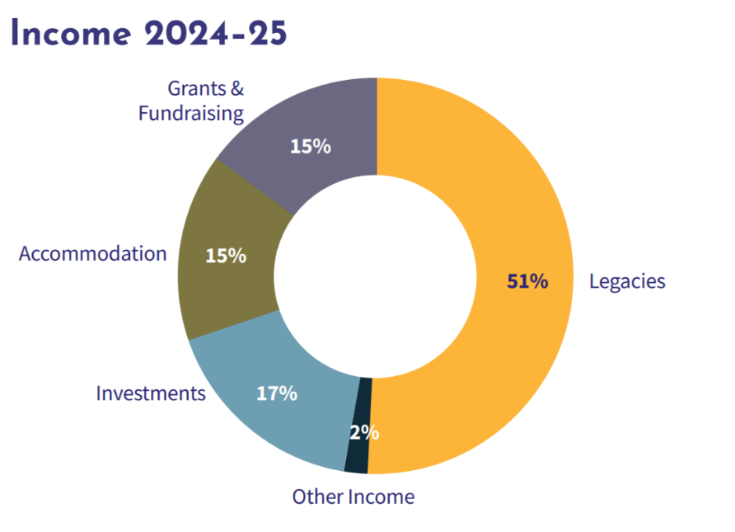
- 51% Legacies
- 17% Investments
- 15% Accommodation
- 15% Grants and Fundraising
- 2% Other Income

Expenditure 2024-25
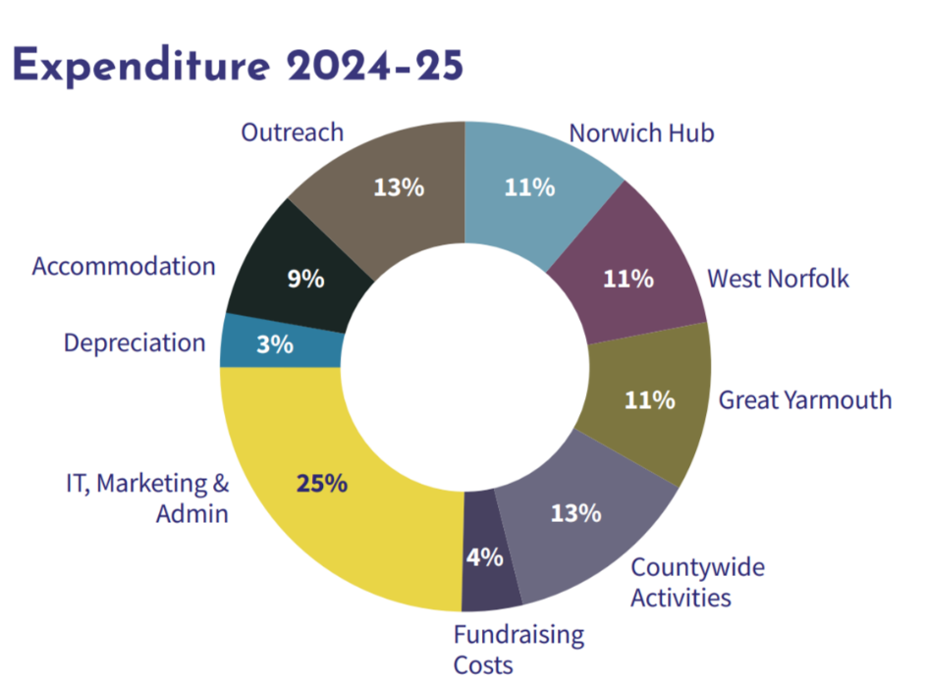
- 25% IT, Marketing & Admin
- 13% Outreach
- 13% Countywide Activities
- 11% Norwich Hub
- 11% West Norfolk
- 11% Great Yarmouth
- 9% Accommodation
- 4% Fundraising Costs
- 3% Depreciation

Back Cover
Vision Norfolk Annual Review 2024-2025

Head Office:
- Bradbury Activity Centre, Beckham Place, Edward Street, Norwich, NR3 3DZ
- 01603 573000

West Norfolk Hub:
- 20 Thoresby College, Queen Street, King’s Lynn, PE30 1HX
- 01553 660808

Great Yarmouth Hub:
- 12 Hally Quay, Great Yarmouth, NR30 1HP
- 01493 745973

Full financial accounts, details of Patrons, Presidents, Vice-Presidents, Trustees, Executive Staff and other officers, along with other statutory information, can be obtained by downloading the charity’s 2024/25 Financial Statements from www.visionnorfolk.org.uk/about-us/reports.
Printed copies can be requested by calling 01603 573000. To receive this report in other formats (Braille, larger print, audio CD & USB and email) please contact office@visionnorfolk.org.uk or 01603 573000. Vision Norfolk is a charity registered in England and Wales (No. 1206599).

