Magpie News
Winter Edition 2025
The latest news and events from Vision Norfolk
Empowering vision impaired people for 220 years

In the newsletter: Our brand-new 2025 Christmas card collection.

Technology Update: The latest innovations helping people live more independently.

Behind every vision-impaired child is a family learning to cope. When Barbara’s son Marcus was diagnosed with acute lymphoblastic leukaemia, the treatment left him almost completely blind. Read Barbara’s story.
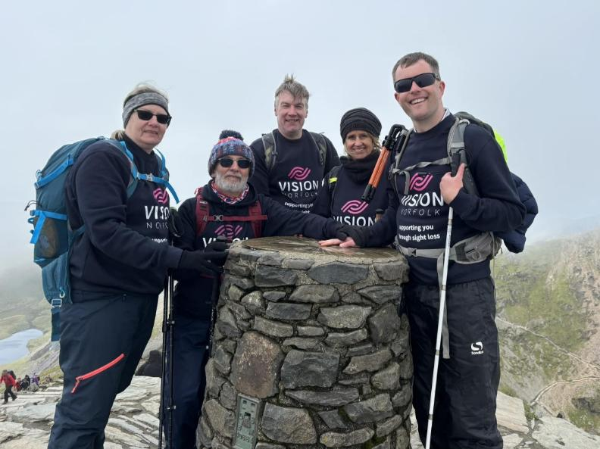
Image: Vision Norfolk staff members at the summit of a mountain
In This Edition: Winter 2025

A Festive Message – Page 3
A refreshed look for Magpie News

News From Across Vision Norfolk – Page 4
Latest community highlights

Children, Young People and Families – Page 7
See how our CYPF team is making a real difference

Parenting Through Sight Loss – Page 9
Barbara Dunn and her son Marcus

Equipment and Technology – Page 11
Latest innovations that help with independent living

Sending Christmas Cheer – Page 16
and more fundraising triumphs

News From Norwich – Page 21
Local updates, events and stories from our Norwich community hub

News From King’s Lynn – Page 25
Local updates, events and stories from our King’s Lynn community hub

News From Great Yarmouth – Page 29
Local updates, events and stories from our Great Yarmouth community hub

A Festive Message to Our Readers

Welcome to the new-look winter 2025 edition of Magpie News.
You’ll notice that we’ve had a bit of a makeover – keeping the magazine fresh and relevant to hopefully attract new readers and supporters. Long-time readers will notice that instead of listing every single activity, we’re now highlighting three or four key events from each hub, making the new format more accessible for all. Our goal is to keep Magpie News useful and engaging for everyone.
We’d love to hear your thoughts – we’ll look out for any recurring themes that we can address, to keep Magpie News interesting and a helpful resource for our readers. You can reach out to me directly at: joe.russell@visionnorfolk.org.uk. From me and everyone here at Vision Norfolk, we wish you a Merry Christmas and a Happy New Year.


Image: Joe Russell, Fundraising and Marketing Executive at Vision Norfolk, smiling.

News From Across Vision Norfolk

Highlights from our community – read the full stories online.

Celebrating 220 Years
On 14 October, we marked our 220th anniversary with our Annual Public Meeting. A big thank you to everyone from the Vision Norfolk community who joined us – the atmosphere was fantastic. Guest speakers Francesco Sabatino and Rob Sears were brilliant, but it was the powerful stories shared by our service users that truly reminded us why we’re here. Here’s to another 220 years of making a difference together!
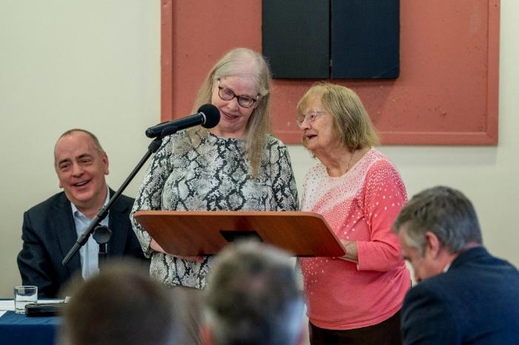
Image: Two service users share their stories at a podium.

Off-Road Driving Experience
At our free off-road driving event in October, we gave people with varying degrees of sight loss a chance to get behind the wheel at Elveden Estate, supported by expert instructors from Explore 4×4. Robert, one of the participants said, “I felt a bit emotional as I haven’t driven in 28 years – but our guide Malcom was very calm and it wasn’t a problem at all!”
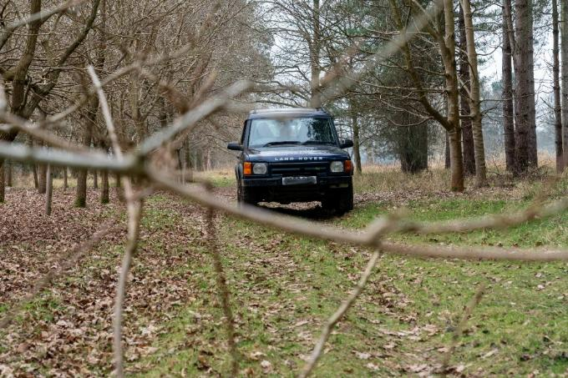
Image: A 4x4 car off-roading between trees.
Visit From Local Author
We’d like to say a big thank you to local author Robert Taylor and his wife Jane for joining us at our King’s Lynn Coffee Morning. Robert, who is registered severely sight impaired, shared extracts from his books LionHeart and Wish Dead List, and spoke about his experiences as a blogger on Travelling Blind. His talk was so well received that the coffee morning ran into the afternoon amid lively conversation and chatter.

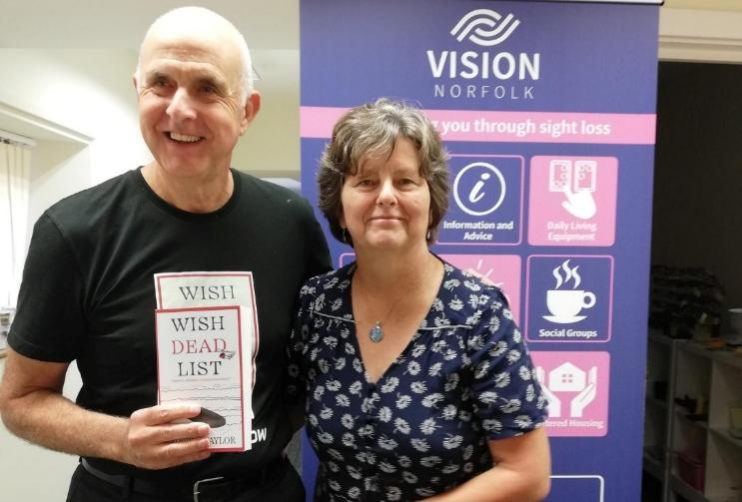
Image: Local author Robert Taylor and his wife, Jane.

Want to stay up to date? Visit visionnorfolk.org.uk/news read these stories in full and more!

Children, Young People and Families

See how our CYPF team is making a real difference.

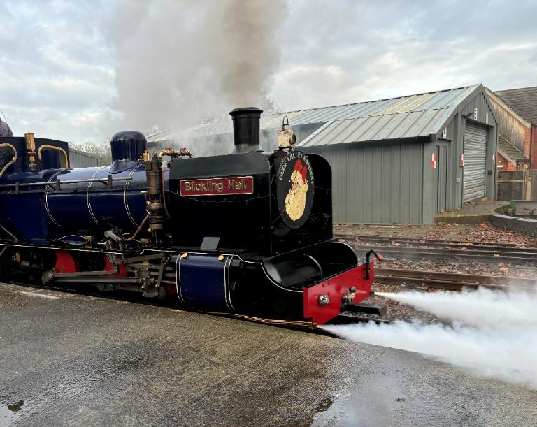
Image: The Festive Express train arrives at the platform.

It’s been an incredibly busy and rewarding year for the Children, Young People and Families (CYPF) team – a wonderful time to pause and reflect on the impact and joy we’ve shared.
Over the past year, more than 400 families have joined our events and activities, and we’ve delivered over 200 outreach visits and tailored support sessions across Norfolk. These numbers reflect the strength, warmth and inclusivity of our growing CYPF community, and the difference that connection and support make to children and families living with sight loss.
As Christmas approaches, we’re excited to offer activities including a magical trip to BeWILDerwood, an allotment session, a climbing adventure, and our much-loved Festive Express and CYPF Christmas Party. The popularity of these events is a testament to our shared enthusiasm and sense of togetherness – and spaces fill up fast!
For the new year, we’re already planning an exciting event calendar designed to bring families together, create memories, and support children and young people to grow in confidence and independence. Plus, we’ll continue offering vital one-toone emotional and practical support for families, including home visits, benefits guidance, funding advice, and referrals to specialist services.
We always welcome feedback from families to help us shape the future of our service. So if you have any ideas for new activities, events, or how we can enhance our support – we’d love to hear from you.

Any ideas? If you have a suggestion for a new activity or other ways we can support you, please contact us at CYPF@visionnorfolk.org.uk.

Our Story
Parenting Through Sight Loss

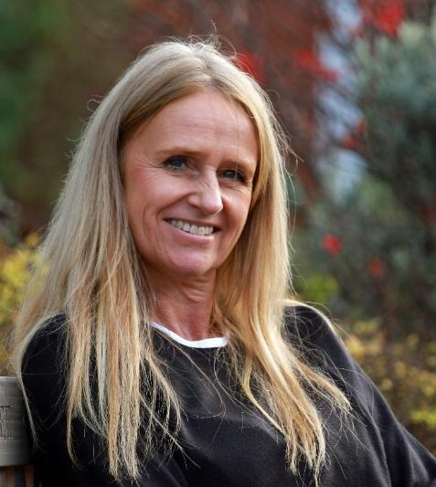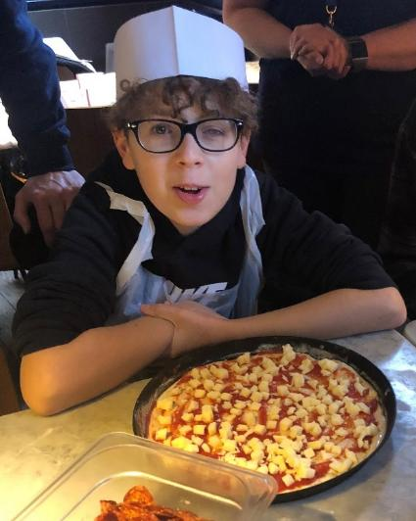
Image – Left: Barbara smiling at the camera
Images: Marcus in a disposible chef hat and apron sitting in front of a pizza

Barbara Dunn, Vision Norfolk

When Marcus was just seven years old, he was diagnosed with acute lymphoblastic leukaemia (ALL), a life-threatening blood cancer. Within days, he was in a medically induced coma at Great Ormond Street Hospital. And when he woke, his mother Barbara realised her son couldn’t see. He had haemorrhaged into both eyes, leaving him blind.
“Christmas that year was spent in hospital,” recalls Barbara. “His brothers unwrapped his presents and described them to him. I found the sight loss harder to deal with than the cancer. None of the other children had gone blind – it didn’t seem fair.”
During their three months in hospital, the family met Paula, an Eye Clinic Liaison Officer who was herself blind. “Paula completely changed our outlook,” says Barbara. “She made us laugh and gave us hope that Marcus had a future – that we all did.”
Marcus’s chemotherapy lasted three and a half years, followed by multiple eye surgeries during which time he suffered bilateral retinal detachments. It was tough for the whole family.
“Simple things like parties and sleepovers became complicated. Marcus’s brothers sometimes felt left out – we were all adjusting to a new normal.”
Support from Vision Norfolk and Norfolk County Council helped Marcus regain confidence – through equipment, Braille lessons, and activities where he met other children with sight loss.
Now, ten years on, Marcus is studying for his A-levels and thinking about applying to university. “His sight is unstable,” Barbara says, “but we’re better equipped now. He can’t drive like his friends, but he has the strength to tackle every obstacle. I am so proud of him.”
Barbara’s message for other parents? “It’s OK not to be OK. It’s different for everyone – just take your time, choose whatever path feels right for you and don’t be afraid to ask for help. You don’t have to do this alone.

If you have a child who has experienced sight loss and would like support, please contact our Children, Young People and Families service.
Equipment and Technology

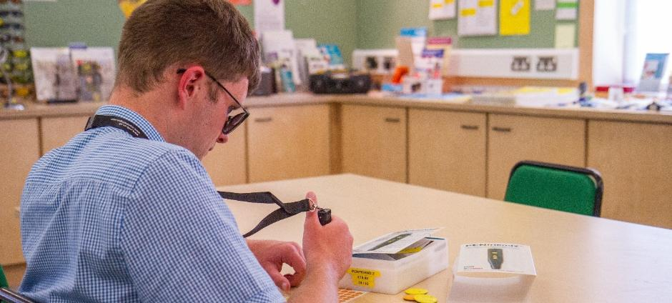
Image: Someone trying out daily living technology in the Norwich Equipment Centre.

The latest innovations helping people live more independently.

If you have any questions about equipment that can support independent living we can provide information and advice at our community hubs in Norwich, King’s Lynn and Great Yarmouth or over the phone. Our Community Outreach Workers are also available for home visits where they can discuss equipment and how your living space can best work for you.
To find out more please get in contact with John on 01603 573000 extension 323.

Opportunities to Talk About Technology

Tea and Tech – Norwich Hub, last Monday of each month, 1:30pm-3:30pm
Rachael and Darryl Andrews invite you to come along to the Norwich Hub to chat about your technology products. This is not a training session but a discussion session for like-minded people to talk about technology. Please contact Richard on 01603 573000 extension 322.

Humanware Equipment Demonstrations – Norwich Hub, 26th January 2026
From January, Chris Moreton from assistive technology company Humanware has agreed to spend the last Monday of each month in our equipment centre in Norwich. He will be available to discuss any questions you have about Humanware equipment and give you a chance to try out their latest tech. He will be available during and after Tea and Tech sessions and at various times throughout the day.

2026 Calendars and Diaries
Large print 2026 calendars and diaries are now available to buy from the Norwich Hub. Our calendar is A3 size, printed black on white with weekends highlighted in yellow. Calendars are £8. We also sell large print diaries from pocket to A4 size which cost between £8 and £11.50 depending on the style and size.
Please get in contact for more details.

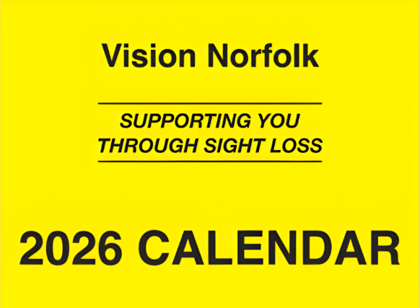
Image: The front of the 2026 Calendar with black text on a yellow background that reads “Vision Norfolk, Supporting You Through Sight Loss, 2026 Calendar”.

New Equipment on Display
We have some new equipment on display at the Norwich Hub for anyone to try to see how it works for you.

OrCam Read 3 Handheld Device
This is a small versatile reading device that can scan and read out full pages of text or connect to a computer or tablet to use as a magnifier. It has easy to use tactile buttons which scans a full A4 page with one touch of a button. Complete with stand. £1,890 plus carriage.

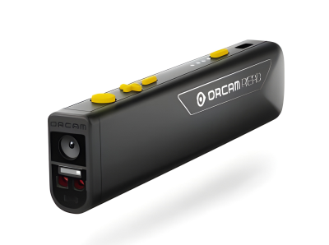
Image: The Orcam Read which is a small black scanner with yellow buttons.

Clover 10 Video Magnifier
This is a portable video magnifier with a large 10” display, it has simple easy to see controls, line markers to help follow text distance viewing and mirror image for make-up or shaving. Complete with stand. £945 plus carriage.

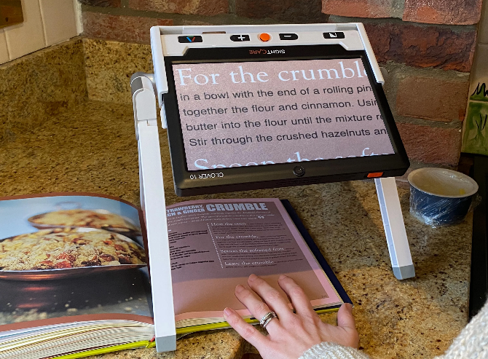
Image: The Clover 10 magnifier, which is a large standing screen, being used to read a recipe book.

Want to know more?
Find out more about how technology supports independent living at visionnorfolk.org.uk/get-support/equipment-centres.

Sending Christmas Cheer!
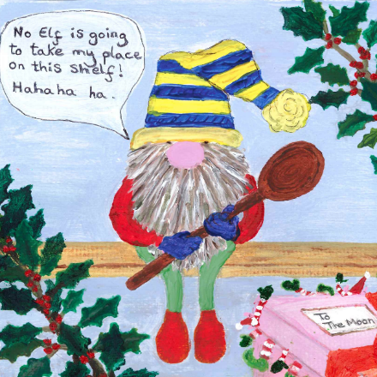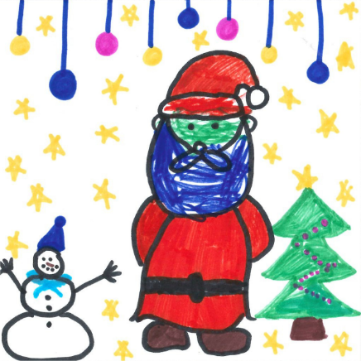
Image – Left: A cheerful painted gnome with a long grey beard and striped, yellow-and-blue hat sits on a shelf surrounded by holly. He holds a wooden spoon and says, “No Elf is going to take my place on this shelf! Hahaha ha.” A pink gift box nearby reads “To the Moon.” There are parts of legs and hats of Elves poking out.
Image – Right: A bright drawing showing Santa with a blue beard standing beside a snowman and a green Christmas tree. The background is filled with yellow stars and hanging blue, pink, and purple baubles.

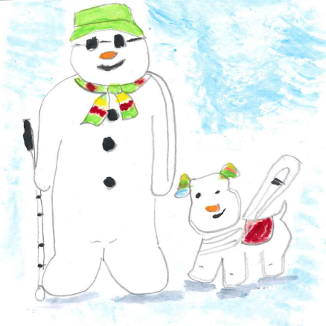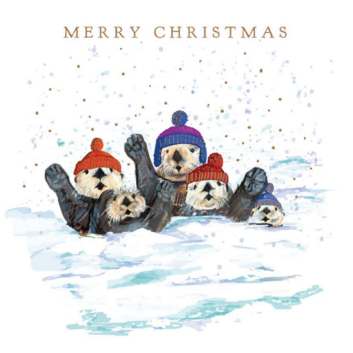

Image – Left: A smiling snowman wearing dark glasses a green hat and scarf and holding a white cane, stands beside a white dog with a red harness and green-and-red ear decorations. Both stand on snow under a pale blue sky.
Image - Right: Five otters wearing colourful woolly hats play together in the snow. They wave happily with their paws raised, while snowflakes fall gently around them.

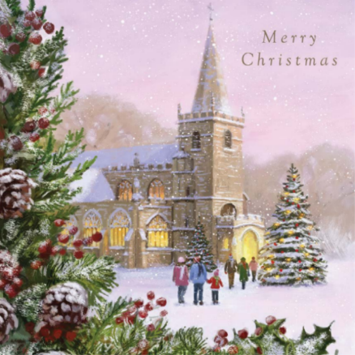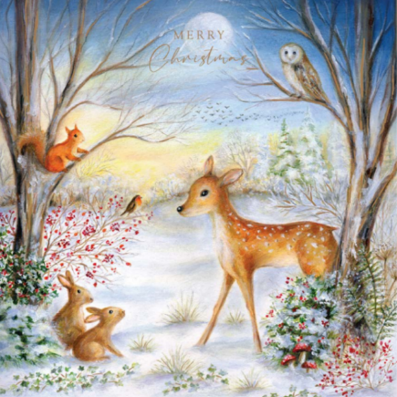
Image – Left: A snowy church glows warmly under a pink winter sky. A decorated Christmas tree stands outside, surrounded by people walking through the snow. In the foreground, pine branches with red berries and frosted pinecones frame the scene.
Image – Centre: A peaceful woodland scene at dusk, with a deer standing in the snow and an owl, squirrel, and robin perched among bare winter trees. Red berries, ivy, and tiny mushrooms add festive touches of colour.

We’re delighted to share our brand-new 2025 Christmas card collection.

The first three of this year’s beautiful designs were created by our talented service users, with every penny raised helping us continue supporting people living with sight loss across Norfolk.
Packs of 10 cards are just £3.99 and are available to buy from our community hubs in Norwich, King’s Lynn, and Great Yarmouth, as well as from The Original Norwich Charity Christmas Card Shop located inside The Church of St Peter Mancroft. The card shop will be open 10:45am to 3pm Monday to Saturday until 13th December.
We are also accepting designs for our 2026 cards. If you are living with sight loss in Norfolk and would like to give designing a festive card a go, please scan your designs and send them to the email below or drop them by one of our hubs. The final cards are square 140x140mm but you are welcome to send us larger designs that can be shrunk down.

For more information, or any questions, please email fundraising@visionnorfolk.org.uk. Merry Christmas and thank you for your support!

More Fundraising Triumphs!

Three Peaks Triumph
A huge congratulations to our very own, Andrew, Barbara, and Helen who successfully completed the iconic Three Peaks Challenge, conquering Ben Nevis, Scafell Pike and Snowdon. Not only saw them reach each summit in 220 minutes but they also raised over £4,000 in the process. We’re very proud of their achievement and grateful for their commitment to supporting vision impaired people across Norfolk.

Run Norwich Heroics
We also want to thank Chris Waller, who alongside his guide Ade, took on Run Norwich, a 10K race around the city and finished in under an hour. Chris’s effort raised over £900, showing that with the right support, anything is possible. Thank you, Chris and Ade, for helping us make a difference.
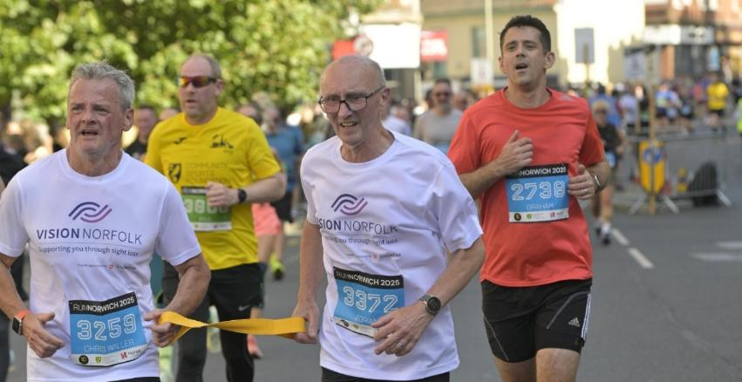
Image: Chris and guide Ade using a tether while running in the race in Vision Norfolk tops.

Clare’s Chillswim Triple Crown Victory
We’re thrilled to celebrate the incredible achievement of Clare McCarthy, who has successfully completed the Chillswim Triple Crown 2025, one of the UK’s most demanding open water swimming challenges. This prestigious accolade involves swimming the full length of the three largest lakes in the Lake District, all within the same calendar year:
Coniston 5.3 miles | Ullswater 7.5 miles | Windermere 11 miles
Each swim is a standalone endurance event, but completing all three in one season earns swimmers the coveted Triple Crown title. Clare tackled these swims with unwavering determination, braving cold waters, unpredictable weather, and long hours of physical exertion. Her commitment to training and fundraising has been nothing short of inspirational.
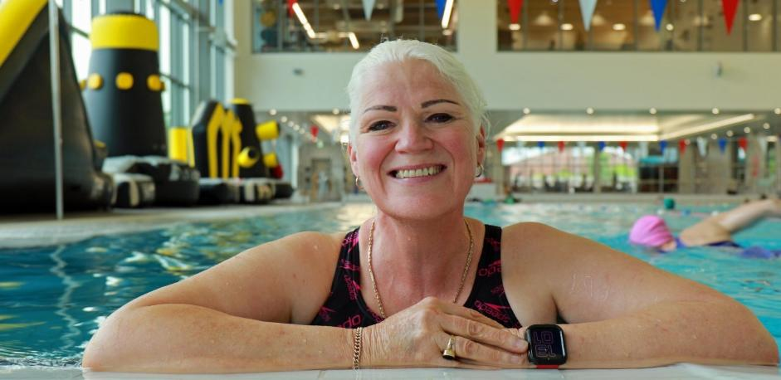
Image: Clare smiling at the camera from the side of a pool.

Feeling Inspired? Download our fundraising pack today: visionnorfolk.org.uk/get-involved/fundraise-for-us.
News From Our Norwich Hub
Local updates, events and stories from our Norwich community hub.

Allotment Update
In February, we launched a special gardening project thanks to a Greening Our Communities grant from the Norfolk Community Foundation. With raised beds built by Little Plumstead men’s shed and soil delivered by the Good Gym, children, young people, and adults with vision impairment planted seeds and moved them to their new outdoor home.
In August, staff, volunteers, and clients visited our allotment at Marlpit Community Gardens to harvest a bumper crop of potatoes, carrots, w. Back at the BAC, they turned the produce into homemade chips, microwave crisps, and a delicious chocolate beetroot cake, enjoying a day full of laughter and teamwork.
The allotment group, along with families from our CYPF service, are now planning and planting overwintering crops such as shallots and winter peas - keeping the garden thriving through the colder months.
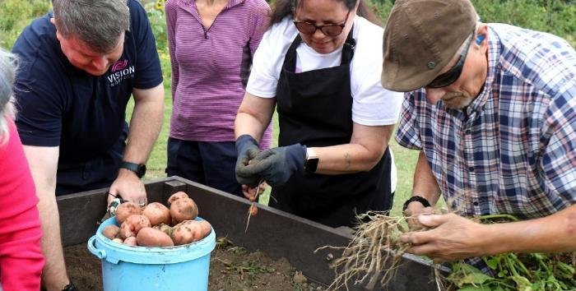
Image: group of people harvesting potatoes from a raised bed.
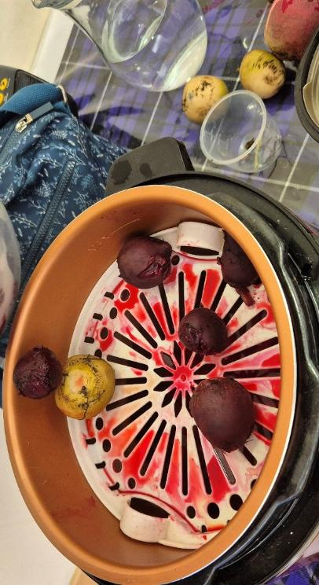
Image: Potatoes and beetroot being prepared to cook.

Wellbeing Wednesday
On Wednesday 1st October, Vision Norfolk welcomed people living with sight loss, along with their families, friends, and carers, to a special wellbeing event focused on health, support, and connection.
Visitors enjoyed healthy eating tips, gentle seated exercise, hands-on crafts, and demonstrations of the latest accessible technology and equipment. We were also joined by a fantastic range of partner organisations offering advice and information.
Research by RNIB (2024) shows that adults with sight loss are five times more likely to report poor health, often facing barriers to food, exercise, and social opportunities – making events like this vital.
It was a fantastic turnout, and we loved connecting with our community. Thank you to everyone who joined us!

What’s on in Norwich and South Norfolk

Christmas Celebration
10th December, 2:30pm-4:30pm
Join other members of the Vision Norfolk community for a celebration of the holiday season with music, refreshments and festive cheer at the Norwich Hub. All are welcome. Please let us know by the end of November if you are coming so we can plan the refreshments accordingly. Arrive at 2pm for a 2:30pm start.

Christmas Flower Arranging
17th December, 10am-2:30pm
Learn about multisensory flower arranging while making a Christmas wreath and winter flower swag. It is free to take part and all materials are supplied. We are holding two separate one-hour sessions to make the activity accessible to as many people as possible. Please get in contact for more details and to book your place.

Regular Activities
For a full list of all activities in your area visit: visionnorfolk.org.uk/norwich-hub

New! Inclusive Indoor Tennis Sessions
fortnightly on a Monday 17/11, 1/12, 15/12, 10:30am-11:30am
With adaptations available to allow for fair and fun games for all. Sessions will take place at Easton College with transportation available from Norwich Hub. The minibus will be leaving at 10am, returning at noon.

New Sessions! Short Mat Bowls
1st and 3rd Monday of each month, 1:30pm-3:30pm
Sessions are played with blindfolds, and held inside the Activity Hall at the Norwich Hub. (existing sessions will continue on Tuesdays, 10am-12pm)

New Sessions! Boccia
2nd and 4th Friday of each month, 1:30pm-3:30pm
Join us for boccia, at our Norwich Hub. Sessions are played with blindfolds. (existing sessions will continue every 1st and 3rd Friday of the month, 10am-12pm)

Cooking With Sue
monthly on a Thursday (29/01, 26/2, 26/3)
Each month we run a free cookery lesson at our Norwich Hub teaching practice skills that can be used at home. These are taught in groups for about 8 months at a time to allow everyone to grow their skills and try out different recipes. From January we will be starting with new participants so it’s a perfect time to get involved. Please get in contact to let us know if you’re interested.

New! Choir
We have started a choir at our Norwich Hub! Explore your voice, meet new people and be part of something joyful.
News From Our King’s Lynn Hub
Local updates, events and stories from our King’s Lynn community hub.

The Seahenge Gallery
In September, our King’s Lynn group enjoyed a fascinating talk and handling session at Lynn museum, learning all about the Seahenge Gallery. Seahenge is a 4,000-year-old timber circle revealed by shifting sands at Holme Beach in the 1990s. Measuring 6.6 metres across, it’s made up of 55 oak posts that once stood up to 3 metres tall.
During the visit, attendees viewed original sections of Seahenge, along with large and small models. Everyone was thrilled to handle a genuine piece of the ancient timber, as well as other artefacts, before exploring the rest of the museum.
A huge thank you to Zena, one of our wonderful volunteers, for providing transport and acting as a sighted guide throughout the visit.
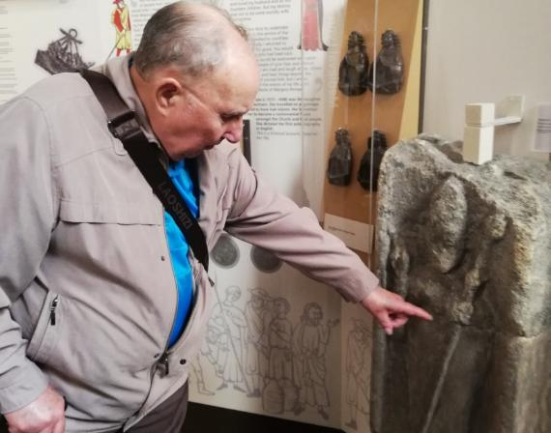
Image: A service user pointing at an ancient artifact.
BTranformed Colour Analysis
Experiencing sight loss doesn’t mean losing an interest in colour or personal style. On 1st October, Shirley from BTransformed led a fantastic colour analysis session, helping attendees discover their dominant colouring type and learn which shades best complement them.
Everyone enjoyed the experience and were amazed at how the right colours can boost confidence and transform an outfit. Each participant took home a card with ten personalised colours, advice on mixing shades, and even found their perfect lipstick match. A big thank you to Shirley for an inspiring and confidence-boosting session!

Yoga Taster Session
As part of our commitment to supporting wellbeing, we held a trial accessible yoga session with Toni Markham from Here and Now Yoga in September. The session was well attended and received great feedback, with many expressing interest in future classes.
We’re now exploring schedules and venues and hope to share news soon about more opportunities to get involved.

What’s On in West Norfolk

Christmas Quiz
18th December, 1pm-3:30pm
Test your knowledge and get to know other people living with sight loss in a friendly, relaxed environment. Join us at the King’s Lynn Hub for a fun and festive social quiz. Free to take part and open to all.

Christmas Celebration
22nd December, 11am-1pm
Join other members of the Vision Norfolk community for our annual fun and festive Christmas Celebration at the King’s Lynn Hub. Festive refreshments will be provided and there will be a prize for the best Christmas jumper. Free and open to all.

Pantomime Time!
Jack and the Beanstalk
King’s Lynn, 29th December, Performance starts at 5.30pm
Join Jack, Dame Trott, and Clarabella the Cow for an unforgettable adventure at The Corn Exchange! We’re hoping to arrange a touch tour before the show (time to be confirmed).
Tickets: £25, Essential Companion/ Carer: £10.50. Limited transport may be available.

Regular Activities
For a full list of all activities in your area visit: visionnorfolk.org.uk/kingslynnhub.

Board Games Club
4th Thursday of each month, 1pm–3pm
Join our new board games club at the King’s Lynn Hub for an afternoon of cards and games.
Enjoy everything from Snakes and Ladders to Connect 4. Tactile and large print versions of games are available and there will be staff and volunteers around to help as required.

Coffee and Crafts
4th Tuesday of each month, 10am–12pm
Join us for a relaxed morning of crafting (and chatting) at the King’s Lynn Hub.

Archery
Sight loss shouldn’t prevent you from trying new and exciting things. Join one of our archery sessions designed to be accessible for all abilities (and skill levels). Expert instruction and guidance will be available.
Downham Market Archery
1st Monday of each month 4pm-6pm.
Fakenham archery
4th Wednesday of each month, 2pm-4pm.

News From Our Great Yarmouth Hub
Local updates, events and stories from our Great Yarmouth community hub.

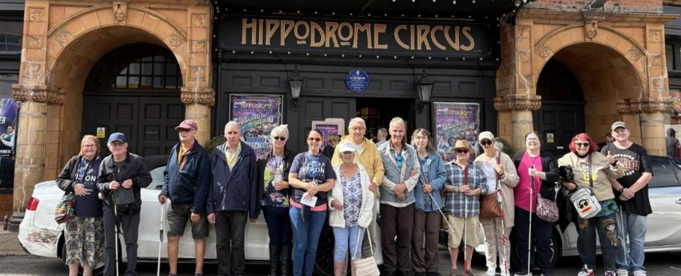
Image: Group of Vision Norfolk service users and volunteers standing outside the Hippodrome Circus.

Running Away with the Circus
We were thrilled to be able to take a group of our service users to the Summer Spectacular at the historic Hippodrome Circus in Great Yarmouth. The Hippodrome has been dubbed one of the seven wonders of the British seaside and is Britain’s only surviving total circus building.

Fairhaven Water Garden
A group from the Great Yarmouth area had a special day out in the Norfolk Broads exploring the sights, smells and sounds of the Fairhaven Woodland and Water Garden. The 130 acre organic woodland garden has 3 miles of fully accessible paths which we explored a small part of before enjoying a small picnic.
Great Yarmouth Art and Sculpture Trail
In September and October, our Great Yarmouth hub organised two special outings for our service users to explore the town’s new public art trail, featuring 11 tactile sculptures celebrating Great Yarmouth’s maritime, medieval, and artistic heritage. A huge thank you to volunteer Chris, who provided wonderful audio descriptions throughout the tour.
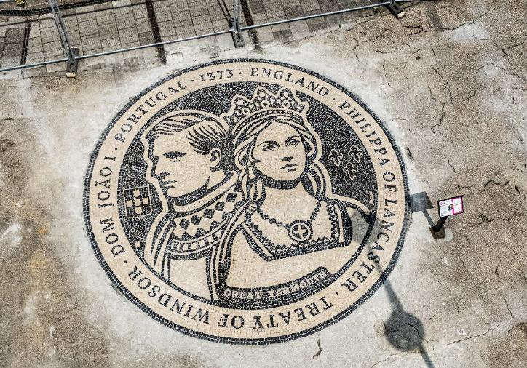
Image: Outdoor ground mosaic depicting The Treaty of Windsor

What’s On in East Norfolk

Cromer Pier Christmas Show
9th December
We are celebrating the festive season with a trip to Cromer Pier to watch their Christmas show. Transportation is available from our Great Yarmouth Hub from 12.30pm for the 2.30pm show. Spaces are limited so please let us know as soon as possible if you’re interested in coming along.

Christmas Celebration
22nd December, 11am-1pm
We are excited to once again be hosting our annual Christmas party for service users, volunteers and other members of the Vision Norfolk Community. The party will be taking place at the Great Yarmouth Hub and there will be a variety of festive refreshments available. All are welcome. Please let us know if you are interested in coming along so we can plan refreshments accordingly.

Regular Activities

For a full list of all activities in your area visit: visionnorfolk.org.uk/great-yarmouth-hub.

Pub Club
1st and 3rd Thursday of each month, 1pm-3pm
Join our new social club for people living with sight loss in the Great Yarmouth area! There is a variety of accessible games available, such as darts, tabletop billiards, cards, and dominoes to name a few, as well as the opportunity to try award-winning cider or beer from the bar. This will be held at Blackfriars Tavern in Great Yarmouth. This is an activity where we meet at the venue. No booking needed, just drop in.

Cribbage Club
Every Thursday, 10am-12pm
Join us at the Great Yarmouth Hub for weekly Cribbage games. No experience is required, we are happy to teach anyone who has never played before. Each session we will split up into groups of 3 or 4 for a relaxed game or two.

Knit, Stitch and Natter
2nd Thursday of each month, 1pm-3pm
If you have a passion for needlecraft, then you will enjoy this group. Please bring your own needlecraft project from home or simply join us for another opportunity to work on your rug from our other popular group, which takes place on the last Friday of the month in the Great Yarmouth Hub. Supplies are provided and it is free to take part.

Creative Writing
2nd Friday of each month 1pm-3pm
Our creative writing group, based at the Great Yarmouth Hub, is growing nicely but new members are always welcome. We hope to cover a variety of different subjects, and all formats are accepted. All are welcome, no previous writing experience necessary.

Contact Details

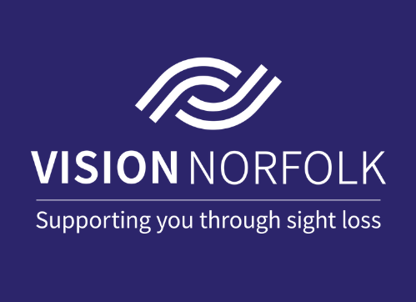
Image: The white Vision Norfolk logo on a blue background with the text “Vision Norfolk, Supporting you through sight loss”.

For further information on how we can support you and how you can get involved:
Website: visionnorfolk.org.uk
Telephone: 01603 573000
Email: office@visionnorfolk.org.uk

Our hubs can be found at:

Norwich
Bradbury Activity Centre, Beckham Place, Edward Street, Norwich NR3 3DZ
Telephone: 01603 573000
Email: office@visionnorfolk.org.uk

King’s Lynn
20 Thoresby College, Queen Street, King’s Lynn PE30 1HX
Telephone: 01553 660808
Email: kingslynnhub@visionnorfolk.org.uk

Great Yarmouth
12 Hall Quay, Great Yarmouth NR30 1HP
Telephone: 01493 745973
Email: greatyarmouthhub@visionnorfolk.org.uk

To stop receiving information from Vision Norfolk, please get in touch and we’ll update your preferences.

Registered charity number: 1206599

