Magpie News
Spring Edition 2026
The latest news and events from Vision Norfolk. Empowering vision impaired people for 220 years.

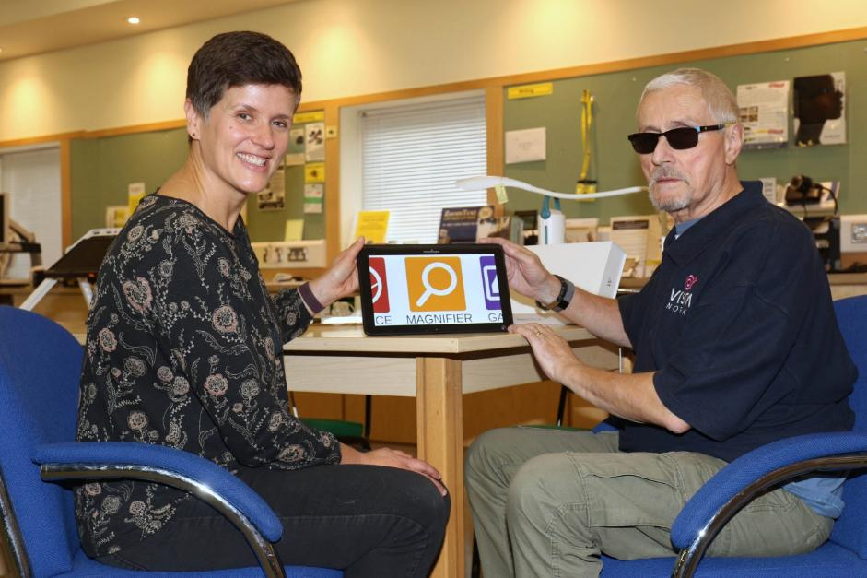
Image: A picture of two people smiling with a tablet between them open to the Magnifier app.

In This Edition: Spring 2026

A warm welcome – Page 3
Happy Spring!

News from across Vision Norfolk – Page 3
Latest community highlights

Children, Young People and Families – Page 5
See how our CYPF service is making a real difference

Voting with Sight Loss – May Elections – Page 7
Feedback on The McGonagle Reader

Equipment and Technology – Page 9
Support accessing the digital world

The 220 Challenge – Page 12
And more fundraising triumphs

News from Norwich – Page 16
Local updates, events and stories from our Norwich community hub

News from King’s Lynn – Page 20
Local updates, events and stories from our King’s Lynn community hub

News from Great Yarmouth – Page 24
Local updates, events and stories from our Great Yarmouth community hub

A warm welcome to Our Readers

Welcome to the Spring Edition of the Magpie News!
We are looking forward to a great 2026. In this newsletter you will find updates from the first couple months including a project aimed at increasing digital inclusion and February Half term adventures with our CYPF service. As we look forward to warmer weather, we are aiming to reach more people across the county with new accessible events and activities that you can get involved with.
If you have any questions about this newsletter, or would like it in another format, please get in touch with your local community hub. Our contact details are on the back cover.
Due to bank holidays all our community hubs will be closed Friday 3rd April, Monday 6th April, Monday 4th May and Monday 25th May. If you have any questions or concerns, please get in touch. All our contact details can be found at the back of the newsletter.

News from across Vision Norfolk

Highlights from our community.

Increasing access to the digital world
In January, Vision Norfolk launched a new programme to support people with sight loss to gain digital skills in a friendly, practical, and accessible way. This has included: drop-in technology support sessions, equipment demonstration days, and one-to-one volunteer support setting up accessibility features on smartphones and tablets.
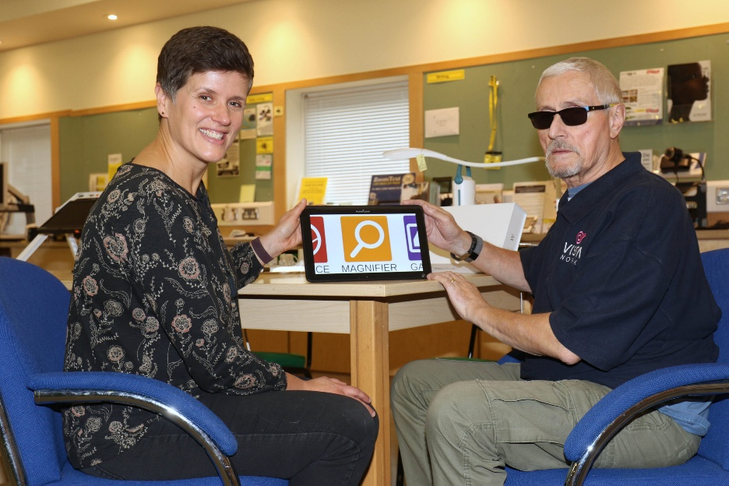
Image: Two people and a tablet in the Norwich Equipment Centre

Join our Hammond Court community in Norwich
Hammond Court offers independent living in a safe, accessible environment. Residents live in their own self-contained flat thoughtfully designed to promote independence and confidence, with accessible layouts and features tailored for vision impaired residents. The community also offers opportunities for social interaction within a friendly and supportive environment.
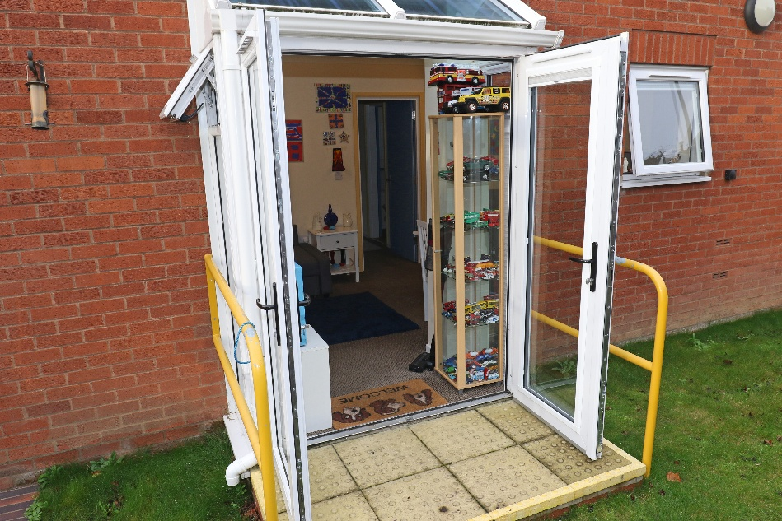
Image: The small patio entrance to a flat at Hammond Court

New North Norfolk coffee mornings
We have started four new coffee mornings across North Norfolk to reach out to new people and continue to grow our community. Joining the long-standing coffee morning in Cromer are the new monthly events in Sheringham, Holt, Wells-next-the-Sea and North Walsham. Join us for a friendly chat, advice and support regarding living life with vision impairment. For more details, please call 07864 615929.

Image: Photo of a mug of coffee with a foam smile.

Want to stay up to date? Visit visionnorfolk.org.uk/news to read these stories in full and more!

Children, Young People and Families

See hour our CYPF service is making a real difference

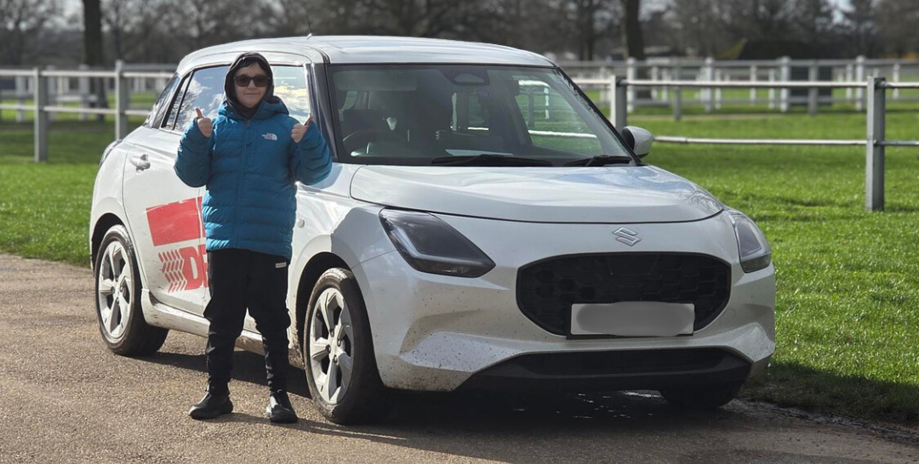
Image: A young driver standing next to his car for the session.

The CYPF Outreach Service continues to grow in popularity, with more young people and families engaging in our diverse and expanding programme of activities. Our outreach work plays a vital role in this success. By working closely with schools, families, and partner organisations, we ensure that opportunities are accessible, inclusive, and tailored to individual needs. Our team provides consistent support, builds trusted relationships, and reaches young people who may otherwise face barriers to participation. Through community engagement, collaborative partnerships, and word-of-mouth recommendations, awareness of the service continues to increase, reflecting the positive impact it has across the county.
February half term was another fantastic success. We were delighted to offer Young Drivers sessions for eight vision impaired young people, giving them the opportunity to build confidence and independence in a safe, supportive environment. We also hosted an Apple Store workshop, where participants explored creative digital skills while we further strengthened and developed our valued partnership with Apple.
As spring approaches, our programme continues to expand with a range of exciting and enriching opportunities. We are planning a visit to Jimmy's Farm & Wildlife Park, a trip to the iconic Hippodrome Circus, an archery session to help develop focus and resilience, alongside a high-energy visit to Gravity Trampoline Park.

Any ideas? If you have a suggestion for a new activity or other ways we can support you, please contact us at CYPF@visionnorfolk.org.uk

Our Story
Finding Independence at the Ballot Box

Voting is a fundamental right. The Elections Act 2022 requires officials to make provisions for an independent and secret vote.

The McGonagle Reader
One recent adaptation that is being provided by some voting stations is a McGonagle Reader. These devices function in a similar way to the existing tactile voting device however they are also able to read you the candidates’ names and election information allowing for more independence when voting.
Two of our service users, Shaun and David, shared their feedback on using the McGonagle Reader at their local polling stations in the 2024 elections.
Shaun shared their feedback:
“The main massive difference this new version provides, is a full independence of being able to appreciate who the candidates are, and place our mark, all without any assistance from anyone at all.”
“It was mostly a good experience for us both, they placed the machine on a table, and we were able to sit down in front of it. David had some difficulties with a bright window that he was facing, it had blinds pulled down for privacy, and I was concerned that my table was too exposed to anyone passing by.
But, apart from that, we put on the headphones that came with the machine, which produced a very clear and good quality audio, and we proceeded to select the candidate and place our marks. It was as simple as that, all without needing anyone having to read the voting paper for us etc.
We totally encourage anyone to get into contact with their own Election Office and request them to purchase one of these very clever machines.”
While councils are beginning to acquire the McGonagle Reader, it is important to know that there is not a machine at every single polling station. It is important you contact your appropriate Local Registration Office well in advance to book it. When you reach out, you will likely need to coordinate the specific time and place you plan to vote so the council can ensure the machine is at your polling station when you arrive.

Norfolk Elections – May 2026 Deadlines
- Register to Vote: Monday 20th April
- Postal Vote Application: Tuesday 21st April (by 5)
- Proxy Vote Application: Tuesday 28th April (by 5)
- Election Day: Thursday 7th May

Equipment and Technology

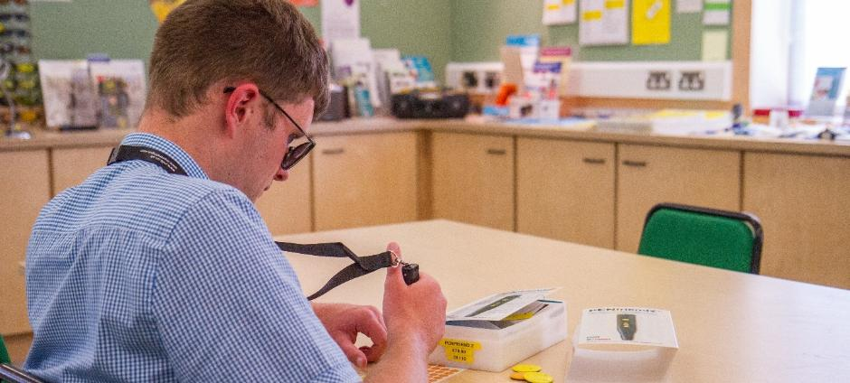
Image: Someone trying out daily living technology in the Equipment Centre.

The latest innovations helping people live more independently.
If you have any questions about equipment that can support independent living, we can provide information and advice at our community hubs in Norwich, King’s Lynn and Great Yarmouth or over the phone.
Our Community Outreach Workers are also available for home visits where they can discuss how your living space can best work for you.

Vision Norfolk’s Digital Inclusion Project
In January 2026 Vision Norfolk launched a new programme to support people with sight loss to gain digital skills in a friendly, practical, and accessible way. This project has been made possible due to funding from the Digital Inclusion Innovation Fund from The Department for Science, Innovation and Technology.
So Far, We Have Provided:
- Drop-in Technology Support Sessions in Norwich, Great Yarmouth and King’s Lynn
- Equipment Demonstration Days with Optelec and Humanware
- One-to-one volunteer support with smartphones, tablets, laptops, magnifiers, and accessible apps
A big thank you to our pioneering Digital Skills Volunteers who have been working so hard to get this support up and running.
If you’re looking for support or have any questions, please call us on 01603 573000.

Opportunities to Learn About Equipment
Optelec Equipment Demonstrations
Norwich Hub, 29th June, 10:30am-3pm
Merchant’s Place Cromer, 29th July ,10am-12:30pm
A representative from assistive technology company Optelec will be joining us to share their expertise. They will be available to discuss any questions you have about equipment and give you a chance to try out their latest technology.
Tea and Tech Drop-in Session
Great Yarmouth Hub, 28th Apil, 10am-12pm
Come and have a cup of tea (or coffee), a biscuit and a chat about technology. Whether you’re just getting started or want to feel more confident using your device, we are here to help you get the most out of your technology.

Tech Tip- Smart Phone Accessibility Features
There are a variety of features available on smartphones that can make them easier to use for people with limited sight. To make your phone more accessible maximise built-in features like screen readers, magnification, high contrast, and large text. Following are some settings that you can explore to find what works best for you.
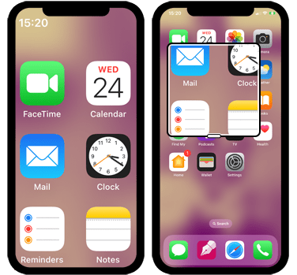
Image: Two images of a smartphone screen. On the left the screen the apps are large. On the right the magnification tool is being used.

Display Settings
Most phones will allow to alter how things appear on the screen to find what works best for you. For example, you may be able to increase font size, use bold text, set high contrast, invert colours, or use grayscale for better visibility.
Using the zoom feature or the dedicated magnifier will enable you to enlarge parts of the screen temporarily.

Screen Readers
One key feature that should be available on most smart phones is a screen reader. Once enabled, screen readers provide spoken descriptions of items on the screen. They change the way you navigate and interact with your phone so all important information is read to you, and your phone can be used entirely through swipes, gestures and voice commands.

Digital Assistants
Digital assistants (such as Siri or Google Assistant) are controlled through spoken commands and can perform certain tasks such as making calls, sending texts, setting timers/alarms, and searching the web. Digital assistants work whether or not you’ve enabled your screen reader and should also allow you to turn on your screen reader through spoken command.

Get Support!
To find out more please call us on 01603 573000 or contact your local hub.

The Final Push: What will your 220 Challenge be?

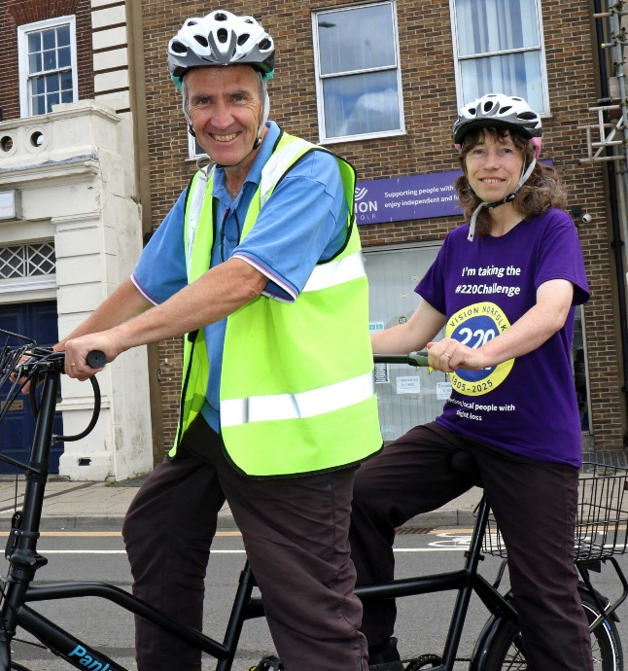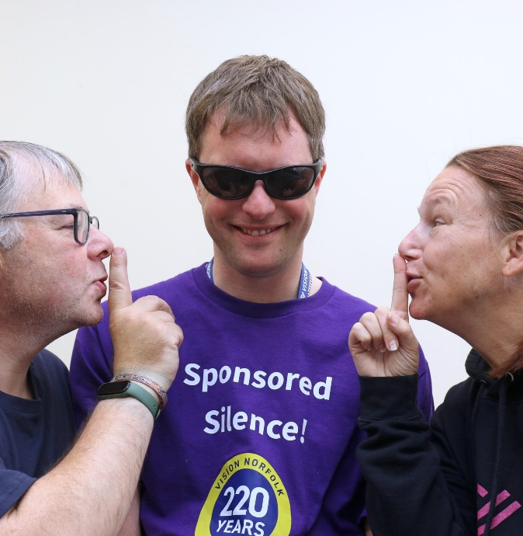
Image – Left: Two people on a tandem bicycle. The woman on the left is wearing a t-shirt that says “I’m taking on the 220 challenge”.
Image – Right: A man in top that says “Sponsored Silence” with two people shushing him.

Our 220th anniversary year has been a landmark journey for Vision Norfolk, marked by a huge variety of incredible challenges undertaken across the county. We’re so grateful for everybody’s support, from sponsored litter picks and tandem bike rides to open-water swims, marathons, and mountain hikes.
Every mile covered and every pound raised has brought us closer to ensuring that no one in Norfolk has to face sight loss alone……but we aren’t at the finish line yet.
With our 220th year now coming to a close, we are making one final push. We need your help to reach our ultimate fundraising goal and secure the future of our essential services. Whether you want to take on something physical, something creative, or something quirky, the stage is set for you.

Think Local, Act Local
Do you belong to a local community group, a sports club, or have children at a local school? We are looking for groups to join our mission. Suggest Vision Norfolk as their chosen charity to support; by doing so, you will be playing a vital part in our charity's 220-year history.

What will your 220 Challenge be?
Join the movement, help us celebrate over two centuries of support, and make this final chapter our most impactful one yet.

Ready to start?
Get involved by visiting visionnorfolk.org.uk/get-involved/fundraise-for-us/ or email fundraising@visionnorfolk.org.uk to request your free fundraising pack.
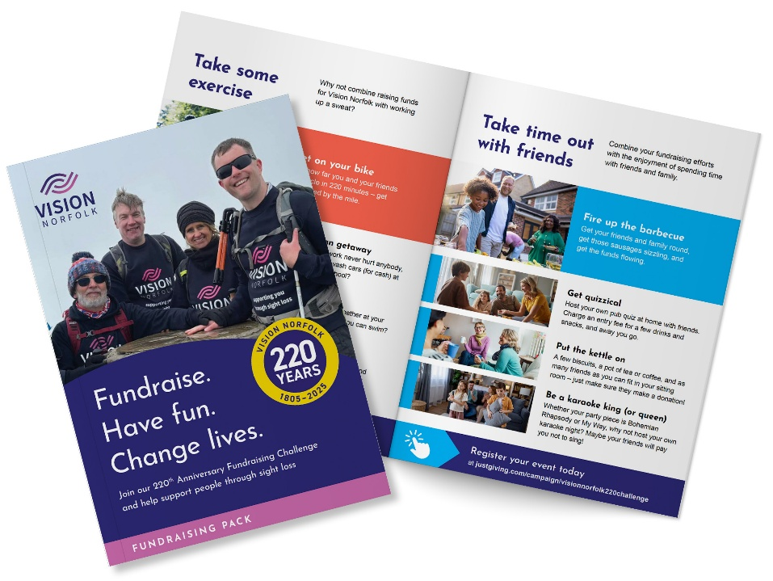

Image: The front and one of the interior pages of the Vision Norfolk fundraising pack.

Fundraising Triumphs

Blackfriars Tavern
The team at The Blackfriars Tavern in Great Yarmouth, who host our monthly pub club, recently stepped up to support our 220 Challenge. Through monthly quizzes and a special Christmas card evening, landlords Pharez Smith and Rachael Seaward, along with their wonderful patrons, raised a brilliant £303 - smashing their initial £220 goal.

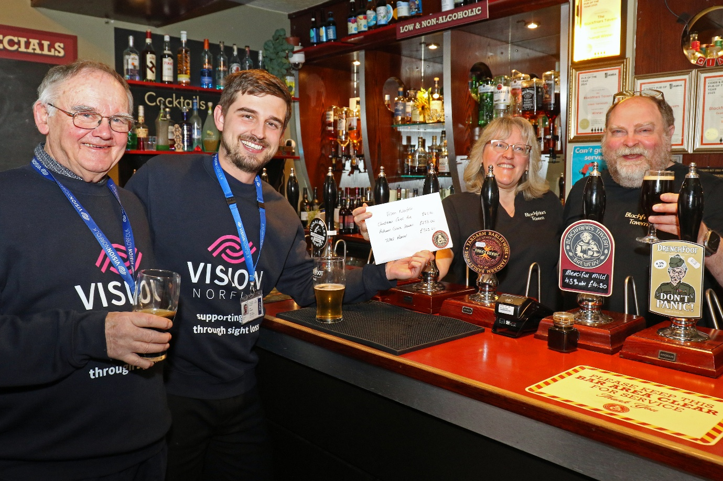
Image: Rachael and Pharez Smith from Blackfriars Tavern standing behind the bar and handing an envelope to Chris and Joe from Vision Norfolk.

Rosie and Hannah’s Raffle
A massive well done to Rosie and Hannah, who recently stepped up to support us. Through a raffle and a variety of other fantastic fundraising activities, including a fun pyjama day at a local dance studio, they raised an incredible total of over £3,000. Rosie’s son uses our CYPF service, while Hannah has personally received support from the Neonatal Intensive Care Unit (NICU). The funds will be split 50/50 between us and the NICU.

Wayne Lount
A massive thank you to Wayne, who after going an entire year without cutting or shaving his hair, he braved the shave on the 1st of January and raised a brilliant £303. Wayne took on this challenge to give back for the support his family has received from our CYPF service, from providing guidance through schooling to joining in on our family outings.

Feeling Inspired? Download our fundraising pack today: visionnorfolk.org.uk/get-involved/fundraise-for-us

News from our Norwich Hub

Local updates, events and stories from our Norwich community hub.

Update on Anglia Square
The demolition of Anglia Square has begun!

Road Closure and Public Transport
Throughout February and March, parts of Magdalen Street and Edward Street have been closed while the big machines demolished the areas closest to the road. This has caused disruption to the bus timetables as well as traffic and pedestrian routes.
At the time of writing Magdalen Street has reopened however the junction to Edward Street remains closed. Please note major bus diversions are in place until Edward Street fully reopens. It is currently estimated this will not be before Thursday 16th April. Please contact the bus companies for the most recent updates on bus diversions.
If you are worried or unsure about travel to our hub please get in touch.

Parking
Unfortunately, the car parks on Edward Street, including RCP- Edward Street and RCP-Broadside Warehouse have now closed permanently.
Colegate Car Park and the recently reopened St Crispins car park are both approximately 8 minutes walk away.
We have a drop-off and pick-up point immediately outside the front door of the hub and we can reserve on-site parking for a limited number of wheelchair users if notified in advance.

Wroxham Barns Trip
On Wednesday 25th of February we had perfect weather for a trip to Wroxham Barns. We filled the minibus with excited clients, volunteers, and staff and headed off into the sunshine. The group had the opportunity to see newborn lambs, including three sets of triplets! They also saw ponies, alpacas, rabbits, and more animals.
There was the chance to browse the craft shops and generally enjoy the fresh air and sunshine. Thank you to the volunteers who helped out on the day and provided valuable assistance to ensure that our clients were able to make the most of fantastic day.

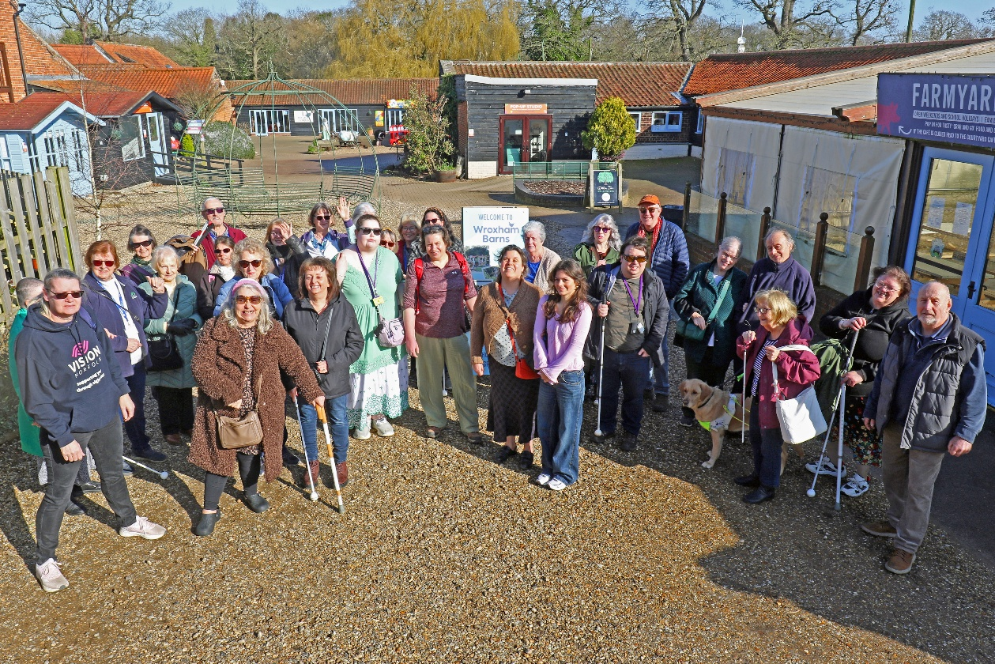
Image: The group of participants, staff and volunteers at Wroxham Barns

What’s on in Norwich and South Norfolk

Summer Evening Events - Starting in April, Running throughout Summer 2026
We will be running a series of evening social activities throughout the summer to hopefully give people who are busy during the day the chance to join us at the hub. Full details will be available via our leisure activities mailing list and added to our website and social media channels. If you have any ideas of activities you would like see in the evenings, please let us know!

Pottery Sessions - 16th April, 14th May, 18th June, 2pm-4pm
Accessible pottery sessions are coming back to the Norwich Hub this Spring. These are free small group sessions with an expert. All participants will get a chance to on the wheel with some one-to-one support and will walk away with their own creations. Spaces are limited.
For a full list of all activities in your area visit: visionnorfolk.org.uk/norwich-hub

Regular activities

Diss Audiobook Clubs - 4th Friday of the month, 2pm-3:30pm
We are looking for some more members to join our friendly audiobook club based at the Diss Library. The monthly meetings are informal, social and everyone has an opportunity to give their thoughts and opinions on the audiobook of the month. Books are supplied for free on an USB memory stick or CD.

Glaucoma Support Group - 2nd Friday of the month, 2pm-3:30pm
Our Glaucoma Support Group is a self-help and discussion session based out of the Norwich Hub. We hope to introduce speakers to talk about Glaucoma, and other interesting subjects. We would love for some more members to take part, so please get in touch to find out more.

Dance and Movement Sessions - First Thursday of the Month, 1:30pm-2:30pm
Join Compass Dance at our Norwich Hub. Movement to music is an excellent way to keep fit, be it seated or standing. These sessions are designed to be accessible for people living with sight loss and staff and volunteers will be available to provide support as required.

New sessions! Short Mat Bowls - 1st and 3rd Monday of each month, 1:30pm-3:30 pm
Due to popular demand we have added new sessions for Short Mat Bowls in the Norwich Hub! Please let us know if you would like to come along and give it a go. The existing sessions will continue on Tuesdays, 10am-12pm.

News from our King’s Lynn Hub

Local updates, events and stories from our King’s Lynn community hub.

Do you live in the Swaffham, Emneth, Outwell or Upwell areas?
We would like to provide more activities for people living with sight loss in and around Swaffham, and the Emneth, Outwell and Upwell areas.
We would welcome feedback from anyone living in these areas as to the types of support and activities you would be interested in. Please do get in touch if you have any ideas, or if you would like to be the first to know when any new activities may start. Please contact us on 01553 660808, or at kingslynnhub@visionnorfolk.org.uk.

True’s Yard Visit
In February a group from King’s Lynn went to True’s Yard Fisherfolk Museum to find out about our local history.
The tour, led by Dr. Paul Richards, told us all about the historic North End of Lynn, where fishermen and their families lived for hundreds of years. Most of the buildings were demolished over the years, but some still remain. For example, the two late 18th century cottages in True’s Yard, and parts of the museum building itself (which used to be a Fisherman’s pub!).
In the cottages, we found out how the small space would sometimes house 11 people, and that in cold weather fish would be sorted on the brick floor in front of the fireplace. The second cottage was made up to represent how it would have looked in the 1930s, with décor influenced by fishing communities from the Netherlands. This was very special for one member of our group, as she was born in the North End and some of the donated furniture in this cottage was from her family members.

Sing4Fun! Update
The Sing4Fun! group has had a busy few months! In 2025 we worked towards a podcast project, where every member of the group chose a song that meant something to them, and we got to record it at a professional recording studio. These recordings, which include interviews about the stories behind the songs, are being finalised and should be available to listen to soon.
We ended the year with performances at Black Shuck, Woodlands Care Home and Poco Lounge, bringing Christmas cheer to people across West Norfolk.

What’s on in King’s Lynn and West Norfolk

Macular and More Group - Please come along and join us at our Macular and More Group in Downham Market Methodist Church on the 3rd Tuesday of each month. The active and friendly group has a programme of speakers and activities throughout the year. The group began as a Macular Group but we’ve opened it up to anyone experiencing sight loss, so please get in touch or pop in if you are interested.
21st April, 1:30pm-3:30pm - In April we are pleased to be joined by Lorcan Parnell, who will be talking about the Digital Switch Over.
19th May, 1:30pm-3:30pm- We will be joined by an expert coming in to talk about Fire Safety with practical tips so you can feel safe at home.
16th June, 1:30pm-3:30pm- Lauren from Sensory Support will be joining us to talk about the support that they provide and how Vision Norfolk and Sensory Support work together.

Sailing in Snettisham - 17th April, 8th May, 5th June
Sailing will be starting again in April, in conjunction with Snettisham Sailing Club. The free sessions will run monthly until September, and there will be spaces for 8-10 people.

For a full list of all activities in your area visit: visionnorfolk.org.uk/kings-lynn-hub

Regular activities

Yoga - Monthly on a Thursday (16th April, 21st May, 25th June), 2pm-3pm
We are pleased to say that we will be holding seated yoga sessions monthly throughout the year. The sessions are led by Toni Markham, of Here and Now Yoga, and will be held at the West Norfolk Deaf Association.

Tandem Cycling - Mondays from 4th May
We are pleased to say that this year we will once again be working with the West Norfolk branch of Cycling UK, to provide tandem rides. Rides are tailored to individual requirements and include a stop off for a refreshing cuppa. We would also like to ask that if there is anyone in the Swaffham area that would be interested in having a go, then please get in touch, as we are hoping to hold a taster session in Swaffham in June.

Downham Market Craft Group - 1st Wednesday of the month, 10am-12pm
We have added a new Craft Group at the Downham Market Methodist Church. Bring along something you are already making, or join in with the range of crafts on offer.

News from our Great Yarmouth Hub

Local updates, events and stories from our Great Yarmouth community hub.

English Whisky Company Tour
At the end of 2025 the team from Great Yarmouth took a group to the English Whiskey Company for a tour around the distillery.
The party were given a special tour of the distillery and maturing warehouses, before tasting the award-winning English whisky in the distillery’s tasting room.
During the tour, led by operations director Lee James, the group were able to smell the product at various stages during its distillation, including the mash tun where the barley is mixed with water from the distillery’s bore hole, the tanks where the wash is initially fermented, and the stills where the whisky is double distilled.

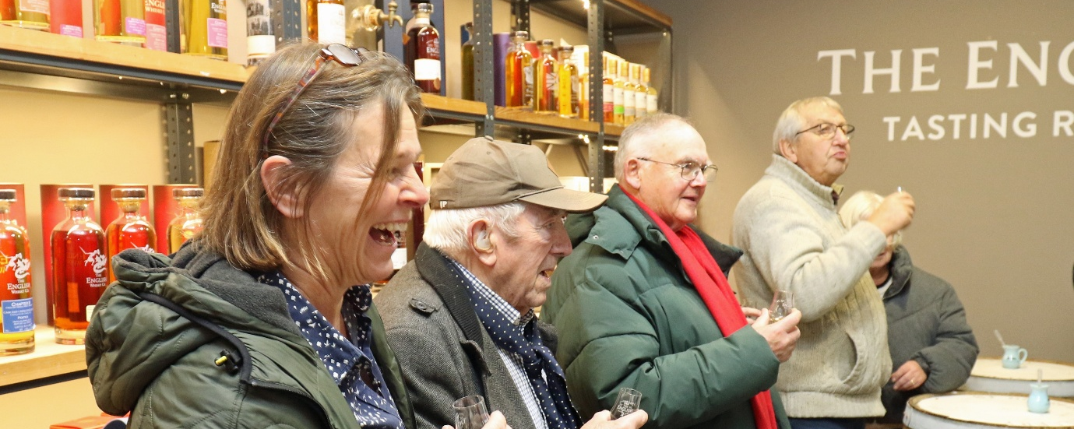
Image: A line of participants standing inside The English Whisky Tasting Room holding whisky shots.

Town Hall Tour
The team at the Town Hall Great Yarmouth welcomed a group of our service users for a special tour!
The group participated in a touch tour of ceremonial objects, visited the chambers where the voting takes place, and even met the mayor.

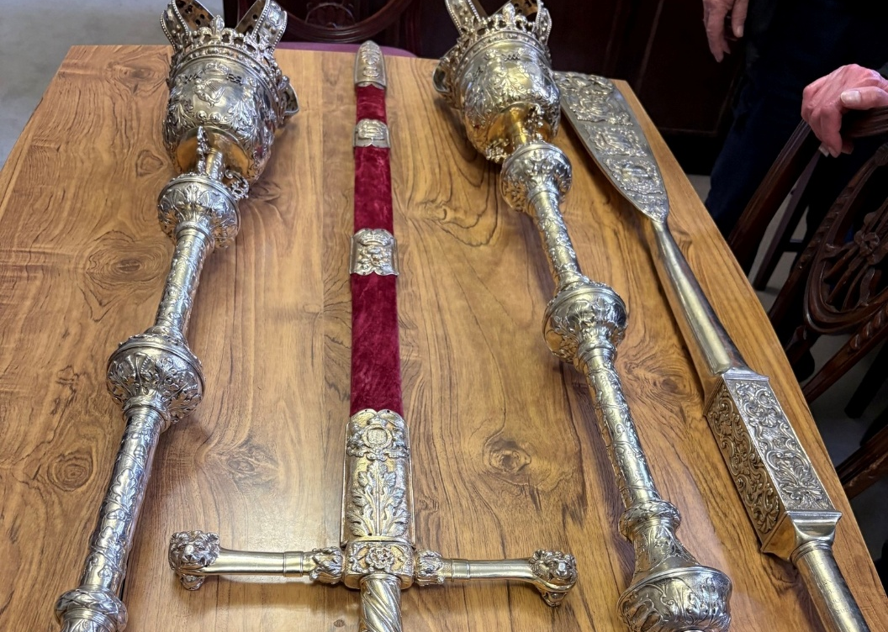
Image: A ceremonial sword and sceptres.

What’s on in Great Yarmouth and East Norfolk

Pottery Workshop - 27th April, 10:30am-1:30pm
Join our free pottery session with Wayside pottery. We have spaces for 10 people, and can start a waiting list if it gets booked up.

Seaside Walks - 28th April, 26th May, 30th June
Join us for a breath of fresh air and a leisurely stroll along one of our many local seafronts. A refreshment stop will be included during the afternoon. Various locations will be on offer. Get in touch for full details!
For a full list of all activities in your area visit: visionnorfolk.org.uk/great-yarmouth-hub

Regular activities

Great Yarmouth Audiobook Club - Last Friday of the Month, 1:30pm-3pm
Our audiobook clubs meet up at local libraries across Norfolk. They offer a chance to get together and enjoy a chat about a chosen audiobook. The monthly meetings are informal, friendly and everyone has an opportunity to give their thoughts and opinions on the audiobook of the month. Books are supplied for free on an USB memory stick or CD.

New Games Sessions - 1st Monday of the Month, 2pm-4pm
Explore accessible game options and get to know other people living with sight loss in a friendly relaxed environment. Our games sessions are free to attend and all games are provided.

Braille Classes - 2nd and 4th Thursday, 1pm-3pm
Join our free Braille class taught by one of our volunteers. This is by appointment so please get in touch if you would like to come along.

Tennis - 2nd Friday of The Month, 1pm-3pm
Tennis at the Gorleston Tennis Club is back! Give tennis a try at special sessions led by LTA-accredited coach Mike Reynolds. We use special tennis balls, some have bells so they make a noise while others are larger so they move more slowly.

Breakfast Club - Last Wednesday of the Month, 10am-12pm
On the last Wednesday of the month, we’re starting a breakfast club at the Troll Cart in Great Yarmouth. Get out in the local community and get to know other people living with sight loss in a relaxed environment. Staff and volunteers will be there to provide support if required.

Contact Details

For further information on how we can support you and how you can get involved:
Website: visionnorfolk.org.uk
Telephone: 01603 573000
Email: office@visionnorfolk.org.uk

Our hubs can be found at:

Norwich
Bradbury Activity Centre, Beckham Place, Edward Street, Norwich NR3 3DZ
Telephone: 01603 573000
Email: office@visionnorfolk.org.uk

King’s Lynn
20 Thoresby College, Queen Street, King’s Lynn PE30 1HX
Telephone: 01553 660808
Email: kingslynnhub@visionnorfolk.org.uk

Great Yarmouth
12 Hall Quay, Great Yarmouth NR30 1HP
Telephone: 01493 745973
Email: greatyarmouthhub@visionnorfolk.org.uk

To stop receiving information from Vision Norfolk, please get in touch and we’ll update your preferences. Registered charity number: 1206599.

