Magpie News – Summer Edition 2026

The latest news and events from Vision Norfolk. Empowering vision impaired people for 220 years.

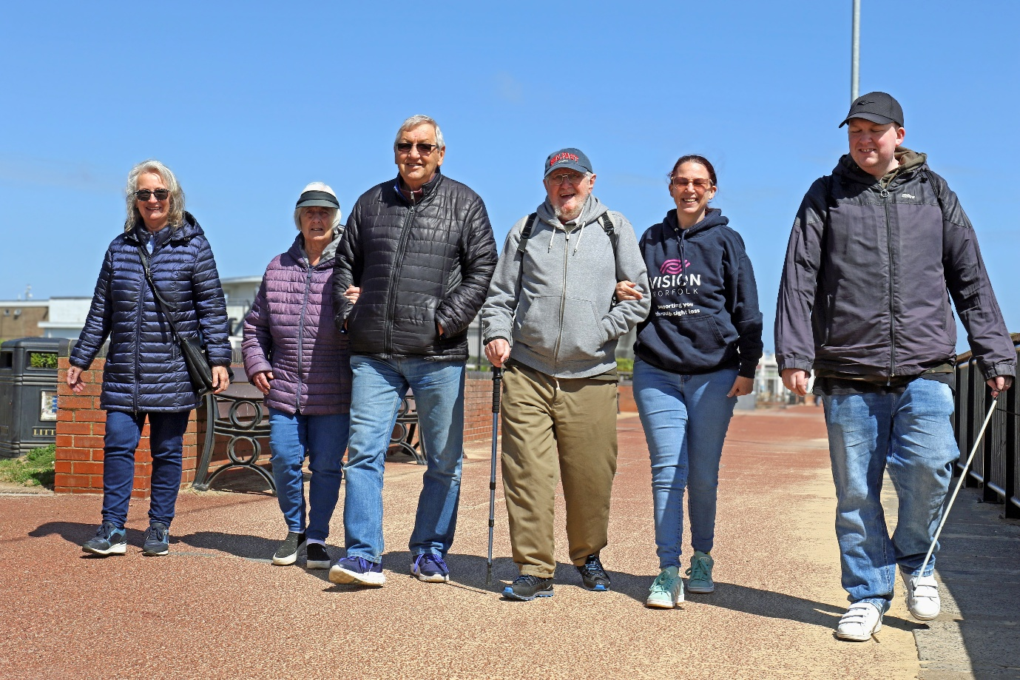
Image: A group of six people walking along the Gorleston promenade on a sunny day.

In This Edition: Summer 2026

A warm welcome – Page 3
Happy Summer!

News from across Vision Norfolk – Page 3
Latest community highlights

Children, Young People and Families – Page 6
See how our CYPF team is making a real difference

Parenting with Sight Loss – Judy’s Story - Page 7
The fears, doubts and beauty of raising sighted children

Equipment and Technology – Page 9
Equipment for independent living and support with accessing the
digital world

The 220 Challenge – Page 12
And more fundraising triumphs

News from Norwich – Page 15
Local updates, events and stories from our Norwich community hub

News from King’s Lynn – Page 19
Local updates, events and stories from our King’s Lynn community hub

News from Great Yarmouth – Page 23
Local updates, events and stories from our Great Yarmouth community hub

Happy Summer!
Welcome to the Summer Edition of the Magpie News!
In this newsletter you will find updates from the Spring season including Easter Holiday and May Half Term family adventures with the CYPF team, exciting news from the Norwich allotment and a special choir performance at the Fakenham Beer and Gin Festival.
As we look forward to the summer months, we are aiming to reach more people across the county with new accessible events and activities that you can get involved with.
If you have any questions about this newsletter, or would like it in another format, please get in touch with your local community hub. Our contact details are on the back cover.
Due to the bank holiday all our community hubs will be closed Monday 31st August.
If you have any questions or concerns, please get in touch. All our contact details can be found at the back of the newsletter.

News from across Vision Norfolk
Highlights from our community.

Sensory garden at the Sandringham Flower Show
We are thrilled to be teaming up with Norfolk garden designer Rajul Shah to create a special sensory garden at this year’s RHS Sandringham Flower Show in July! The ‘Vision in Bloom’ garden cube is number 443 at the show, which will take place 22nd - 26th July. The garden is one of a number of Community Cubes – special spaces offered by the RHS for local community groups.

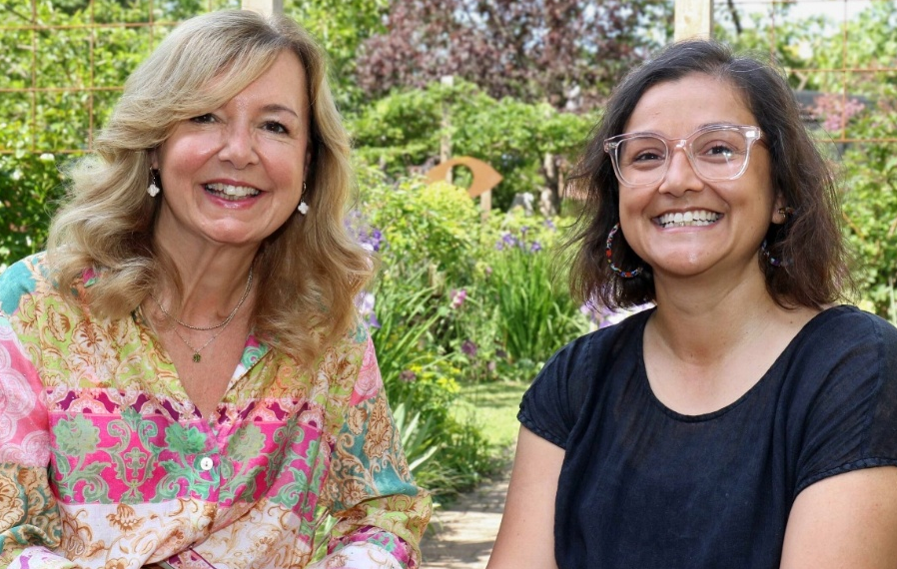
Image: Trustee Rachael (left) and garden designer Rajul.

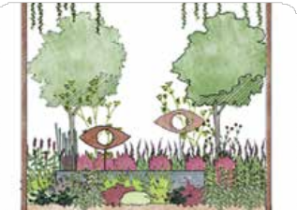
Vision in Bloom

Image: ‘Vision in Bloom‘ garden design.
The central theme of the garden is vision and sight. Shapes were inspired by microscopic images of the structure and anatomy of the eye. The garden will incorporate all the senses, to ensure it can be enjoyed by everyone. There will be plants with interesting textures, strong scents, culinary herbs, and plants with movement that create sound, such as whispering and rattling grasses.

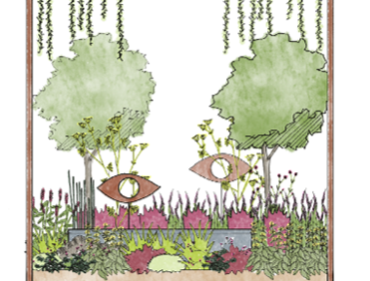
Image: The ‘Vision in Bloom’ garden design.







Thank you to our wonderful volunteers

Image: ‘The Volunteers’ Week logo.
The first week of June is national Volunteers’ Week. Volunteers are involved throughout Vision Norfolk: as telefriends, drivers, activities volunteers, and more. We truly couldn’t do it without them! In honour of Volunteers’ Week we held a special celebration at Fairhaven Woodland and Water Garden and attended the Volunteer Extravaganza at The Forum Norwich to reach out to more potential volunteers.

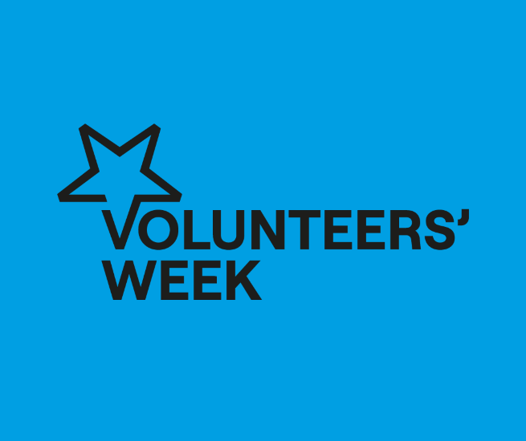
Image: The Volunteers’ Week logo.

Want to stay up to date? Visit visionnorfolk.org.uk/news to read these stories in full and more!

Children, Young People and Families

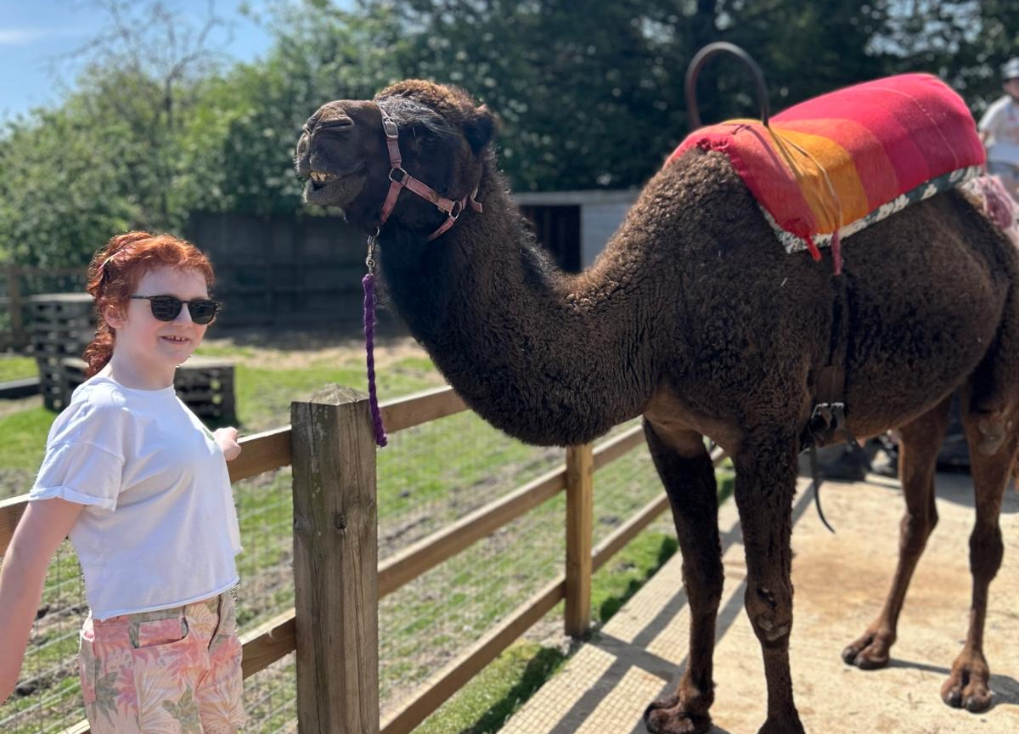
Image: A girl standing proudly next to a camel.

See how our CYPF service is making a real difference.

With the brighter weather on the horizon and the CYPF outreach service remaining popular, we can look forward to summer filled with events. Young people can look forward to climbing sessions designed to build confidence and resilience, a summer party bringing everyone together to celebrate and socialise, zoo trips offering fun and educational experiences, and much more. We are excited to continue providing opportunities that encourage independence, friendship, wellbeing, and enjoyment for all involved.
The May half term was another wonderful success and opportunity for families to socialise and spend some time together, offering a variety of engaging and enriching experiences for families. The young people enjoyed an exciting archery session, a session as part of our ongoing allotment project and a fantastic visit to the Camel Park with a fun-filled day of exploration, animal encounters, and social interaction.
We are also incredibly proud that the service has been nominated for a Flourish Award, recognising the positive impact, dedication, and inclusive opportunities provided by the team. This nomination reflects the continued hard work of staff, volunteers, families, and partnerships with other organisations who help make the service such a valued part of the community and provide a holistic support for the entire family.
Any ideas? If you have a suggestion for a new activity or other ways we can support you, please contact us at CYPF@visionnorfolk.org.uk.

Our Story - Parenting with Vision Impairment – Judy’s Story
When my son was 2 days old, a young doctor congratulated me on having a fine boy who would be able to help me and look after me!
My husband and I both had some useful sight, but it was deteriorating. I was concerned about how I was going to look after him.
I was afraid people would think I couldn’t cope, and this did lead to my becoming very safety conscious and house proud. Crawling and toddling presented the safety challenges all parents face, plus my not always being able to see where he was or what he was doing. I kept the house quiet so that I could hear him moving around and dressed him in bright colours so that it was easier to see him. When I didn’t want him under my feet in the kitchen, I put him in a play pen or in the highchair where he could see me and we could interact.
Making up bottles was tricky. Measuring the powder was simple, levelling off each scoop with the edge of a knife. I could just about make out the markings on the side of the bottle to measure the water. A talking measuring jug would have been useful but unfortunately they didn’t exist at the time. Spoon feeding was slow and messy. I would find baby’s chin with one finger and then offer the spoon. He soon learned to home in on it. I was relieved when he took the spoon and fed himself.
My son assumed all adults were like his dad and me. My neighbour was amused when he put things in her lap to show them to her or took her hand and led her to things he wanted her to see!
My biggest challenge came when the children grew older. I didn’t what to rely on them too much. When we went to the cinema, museums or other attractions, I did need their cooperation. They were good at reading signs, entrance, exit, toilets and places to buy food. I tried hard not to ask them to describe things to me.
I wanted to let them grow up without feeling burdened by my vision impairment. I hope I succeeded, but I haven’t found the courage to ask.
Judy Manning

Many parents with disabilities face uncertainty, discrimination and additional challenges. Please reach out with your concerns and we can be a listening ear, put you in touch with others in similar situations and help you explore what equipment and support is available. You are not alone!

Equipment and Technology
The latest innovations helping people live more independently.

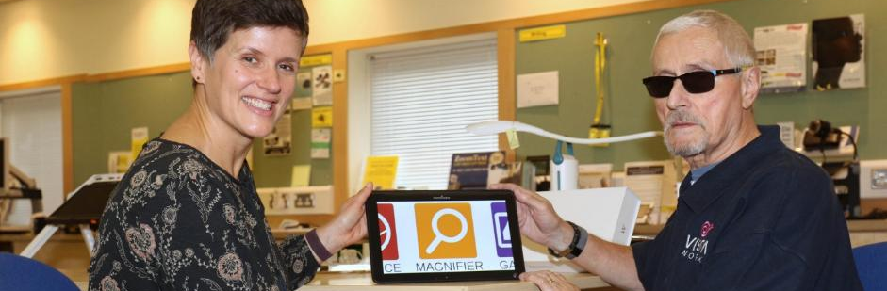
Image: A woman and a man sitting inside the Vision Norfolk Equipment Centre in Norwich. Between them is a tablet that is open to show the Magnifier app.

If you have any questions about equipment that can support independent living, we can provide information and advice at our community hubs in Norwich, King’s Lynn and Great Yarmouth or over the phone.
Our Community Outreach Workers are also available for home visits where they can discuss how your living space can best work for you.

Opportunity to Lean About Technology
- Norwich Hub – Every Monday and Thursday, 10am-1pm
- Great Yarmouth Hub – Last Tuesday of the Month, 10am-12pm
- King’s Lynn Hub – By Appointment
Come and have a cup of tea (or coffee), a biscuit and a chat about technology and accessibility features. Whether you’re just getting started or want to feel more confident using your device, we are here to help you get the most of your technology. Please get in touch if you have any questions. If you would like support, but can’t make it into our hubs please get in touch.

Equipment Demonstrations
- Monday 29th June 10:30am-1pm, Norwich Hub, Optelec and HumanWare
- Monday 27th July 10:30am-1pm, Norwich Hub, HumanWare
- Wednesday 29th July 10am-12:30pm, Merchants Place Cromer, Optelec
- Monday 28th September 10:30am-1pm,Norwich Hub, HumanWare
Experts from low vision equipment companies Opetelec and HumanWare will be joining us throughout the year to demonstrate their latest equipment and answer your questions. These are drop-in sessions so you don’t need to book ahead of time, however if there is something particular you would like to see please let us know.

Equipment Highlight – WeWalk 2 Smart Cane

Traditional long canes support users to get around independently by creating a wider field of touch to detect obstacles. They are also a widely recognised symbol of vision impairment prompting members of the public to give you extra space when out and about. Technology company WeWalk has created a “smart” version of the cane, with integrated technology to allow for additional features.

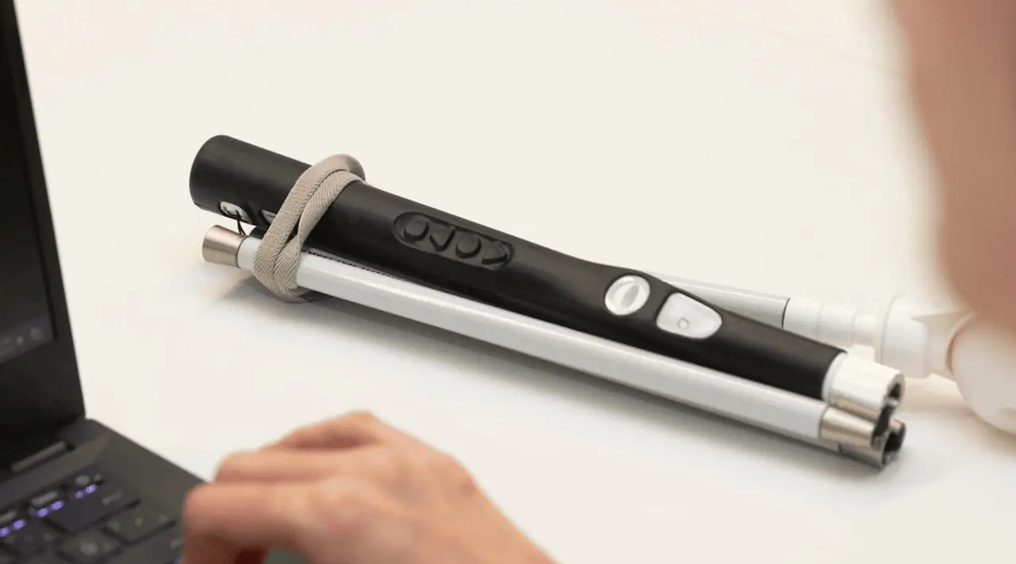
Image: A folded up WeWalk 2 cane sitting on a white table next to a laptop computer.

Design
The WeWalk 2 looks and feels similar to a traditional cane but has the addition of variety of tactile buttons and a built-in speaker. It is slightly heavier than a traditional cane and folds into 5 parts with a strap on the handle to allow for easy transport.

Functions
- Obstacle Detection – A sensor at chest height omits beeps or vibrates to warn about high obstacles such as tree branches.
- Turn by Turn Voice Navigation - Select a destination through the smartphone app and the cane will guide you. Destinations can be saved or searched for in the moment.
- A Bright Torch – You can switch on a light to make yourself more visible to traffic and other pedestrians.
- An integrated AI assistant – A microphone on the back of the can allows you to speak to the assistant to ask questions such as “Where is the nearest McDonald’s?” or used to search the internet for information additional information. This requires the app and data.

Give it a Try!
Vision Norfolk has a WeWalk 2 cane in our equipment centre in Norwich. This is available for anyone to come and try out to see how it works and what it feels like. Give us a call.

Get Support
To find out more please call us on 01603 573000 or contact your local hub

Summer Garden Party at Bishop’s Garden
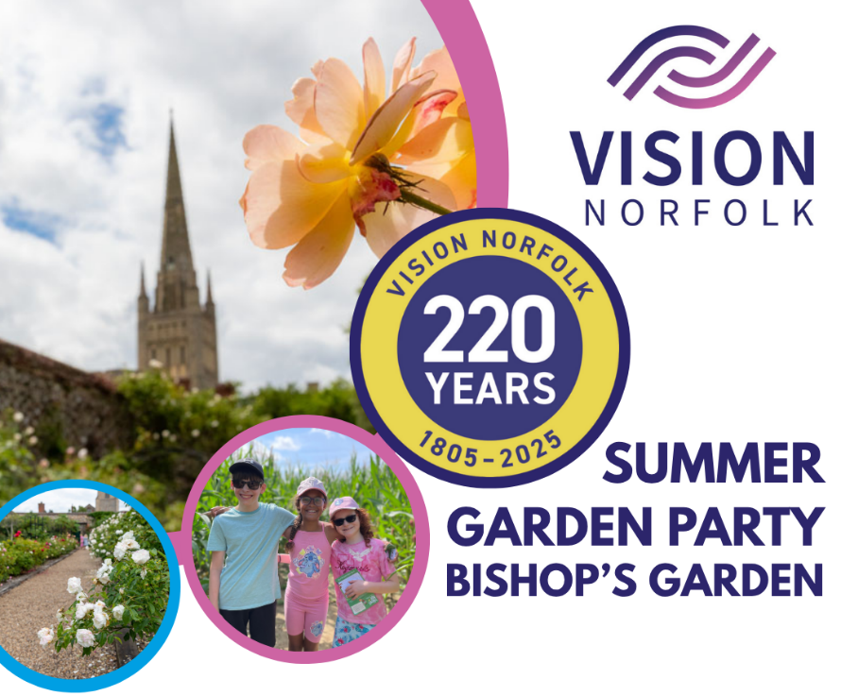
Image: Graphic advertising the Summer Garden Party with the Vision Norfolk logo, the text “Summer Garden Party Bishop’s Garden” and colourful bubbles containing the 220th Anniversary logo, two photos of Bishop’s Garden and a photo of three young service users.

Help us celebrate our 220th year of supporting people living with sight loss in Norfolk!

Sunday 26th July, 1pm-4:30pm, Last Entry 4pm
Bishop’s Garden, Norwich, NR3 1SB

Live Music, raffle, children’s games, and much more!

Tickets can be bought online or at the door
- £5 for Adults
- Free for children under 16 and wheelchair users

Image: QR code (link below)
https://visionnorfolk-bishopsgarden-220summergardenparty.eventbrite.com/

Assistance dogs only please. No parking on site, the nearest pay and display is by the Adam and Eve Pub.

If you have any questions please call us on 01603 573000 or email fundraising@visionnorfolk.org.uk.

Fundraising Triumphs

Quiz Night
In May the regular quiz group at Gallow Sports Centre in Fakenham chose Vision Norfolk to be their charity of the month. It was a fabulous night of general knowledge (and some very specialised knowledge) complete with drinks, a raffle and great company. At the end of the evening Vision Norfolk walked away with £315 towards our 220th Anniversary Appeal to support Vision Norfolk’s future. We are very grateful to everyone who joined in on the evening and made us feel welcome.

Run Norwich 2026
We have six runners who will be taking part in Run Norwich this year in aid of Vision Norfolk. Chris, Lynsey, Robert, Alison, Jordan and Andrew will be taking on the 10K run on Sunday 6th September. Fundraising has already begun with £142 collectively raised so far.
If you’d like to find out more about the runners and show your support, you can go to the link on our website: www.visionnorfolk.org.uk/run-norwich-2026/

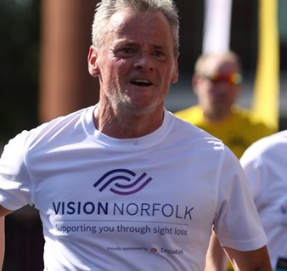
Image: Chris running in Run Norwich 2025 wearing a Vision Norfolk top.

Co-Op Fundraising
We’re pleased to announce that we’ve been chosen by the East of England Co-op’s Norwich Colman Road Foodstore and Dereham Riverside Foodstore as their Local Giving charity for the summer.
Over the next three months, they’ll be collecting donations for us and raising awareness of the work we do.
Pop into the stores to get involved and donate.
Feeling Inspired? Download our fundraising pack today: visionnorfolk.org.uk/get-involved/fundraise-for-us

News from our Norwich Hub

Local updates, events and stories from our Norwich community hub.

Gardening Update
The summer seeds have been sown!
Our Norwich gardening group meet regularly to share their love of horticulture and swap tips for gardening with vision impairment. Last year, the group started its own allotment. In April the were able to grow with the addition of a greenhouse to raise seedling for the allotment. The project is about more than just gardening, it supports wellbeing, confidence and social connection in a fun, inclusive setting.
The group is open to everyone, from newbies and expert gardeners, so please get in touch if you want to find out more.
The allotment project, including the new greenhouse, has been supported by a grant from Norfolk Community Foundation’s Greening Our Communities Fund.

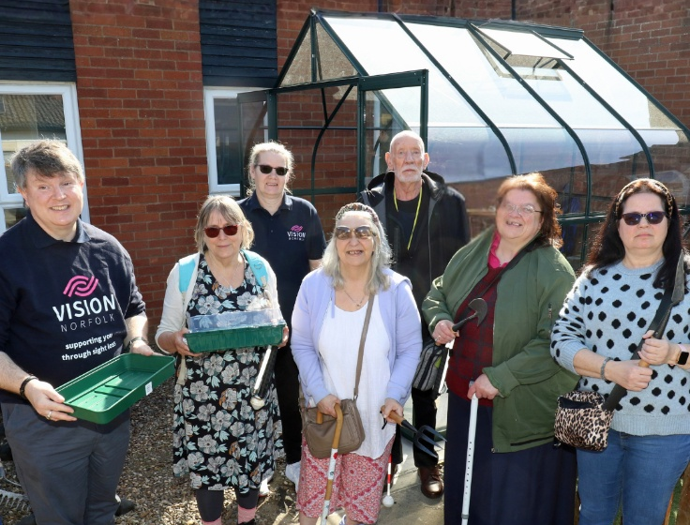
Image: Members of the gardening group with the new greenhouse.

Accessible Tandem Cycling Rides in Norwich
We are pleased to announce that we are now offering more opportunities to join tandem cycle rides around Norwich!
What are the benefits of cycling?
Cycling is a low impact form of exercise which can help to improve your cardiovascular fitness and lower body strength. It’s a great way of enjoying the outdoors, making it a good mood booster too!
How does it work?
Vision Norfolk has tandem bicycles which we maintain and store at our Norwich Hub. To make your ride as safe and enjoyable as possible, we will pair you with one of our volunteer cyclists who are trained as tandem pilots to support people with vision impairment.
We will set up a time that works for both you and your pilot. Rides can be organised during the day or in the evenings or weekends. It’s free to take part, and we are happy to chat to you about any questions you may have.

What’s on in Norwich and South Norfolk

Sailing on the Norfolk Broads - Our sailing group is looking for new members!
We have teamed up with the local sailing experts at the Nancy Oldfield Trust at
Neatishead to provide opportunities for local people with vision impairment to meet up and enjoy the waterfront at Barton Broad. Whether you’re already a sailing expert, or have never been out before, you are welcome to come and give it a go.
Trips take place fortnightly on a Thursday between April and October. A minibus departs the Vision Norfolk Norwich Hub at 12:30pm, returning around 5pm. There is a £25 suggested donation to Nancy Oldfield Trust per sessions (a bursary scheme is available if you have difficulties affording this).

New Cooking Group Starting Soon - A new group of our popular cooking class will be starting on Thursday 22nd October 2026!
Each month we run a free cookery lesson at our Norwich Hub teaching practical skills that can be used at home. These are taught for about 8 months at a time to allow everyone to grow their skills and try out different recipes. Spaces are limited so please let us know if you’re interested in joining in.
For a full list of all activities in your area visit: visionnorfolk.org.uk/norwich-hub

Regular activities
Norwich Macular Group - 2nd Friday of the Month, 12pm-1:30pm
The Macular Society run local support groups to provide information and support to those with Macular Disease. The Norwich group is run out of the Norwich Hub with updates from Vision Norfolk staff on new equipment and activities as well as regular speakers. The meetings are open to anyone affected by central vision loss.

Glaucoma Support Group - 2nd Friday of the Month, 2pm-3:30pm
Our Glaucoma Support Group provides a free peer support and discussion space for anyone affected by Glaucoma. Guest speakers covering a variety of topics will often visit both the Glaucoma and Macular Group.

Photography - 1st and 3rd Friday of the month, 1:30pm-3:30pm
The Photography Group is a fortnightly social group for people with vision impairment. Both cameras and smartphones are welcome. Meetings include local outdoor photo shoots and sessions reviewing photos at the Norwich Hub.

News from our King’s Lynn Hub

Local updates, events and stories from our King’s Lynn community hub.

The Choir Performs at the Fakenham Gin & Beer Festival
The Vision Norfolk Choir has been out there having fun and sharing music!
This was the biggest gig to date, and the first time performing with microphones and a full sound system. We are very grateful to the organisers and attendees for being such a supportive audience. It was such a confidence booster for the members, and they, as always enjoyed singing together.
The choir is a social group for local people to get out, meet up and fight the isolation that can come with sight loss. It meets at the Gaywood Community Centre on the 1st and 3rd Wednesday of each month. If you would like to come along and give it a try, please get in touch.

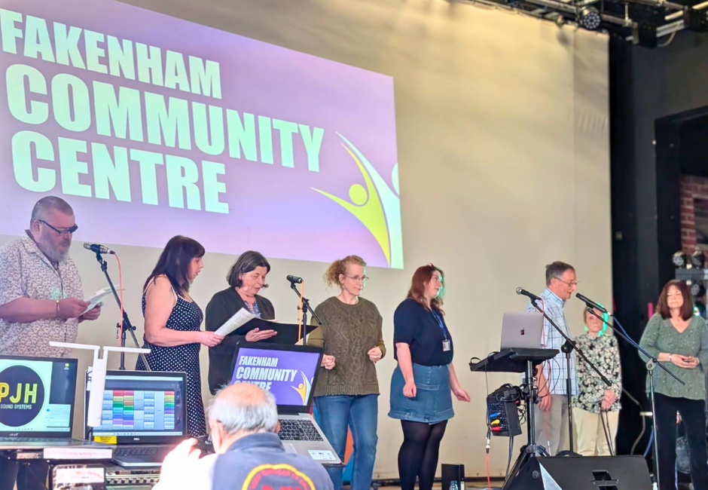
Image: Eight members of the choir singing on a stage with the Fakenham Community Centre logo in the background.

Guest Speaker from the Deaf Association
On Tuesday the 19th May the Downham Market Macular and More group was joined by Sarah from the West Norfolk Deaf Association (WNDA), who gave us a very helpful and informative talk on the services and support offered by the WNDA.
The session highlighted the importance of regular hearing tests and taking the time to look after our hearing. Following the talk Sarah stayed at the meeting to chat with group members and discuss individual questions and concerns.
A programme of speakers is planned throughout the year, as well as some more formal mix and mingle sessions. The group meetings on the 3rd Tuesday of each month, from 1:30 until 3:30, at Downham Market Methodist Church, Paradise Rd, Downham Market PE38 9JE.

What’s on in West Norfolk

Swaffham Carpet Bowls - Taster Sessions - Monday 29th June and 27th July, 12:30pm-1:30pm
Have you always wanted to give bowls a try? Are you looking for a new accessible social group near you? We will be running two trial sessions of Carpet Bowls at the Swaffham Community Centre. This will be a relaxed group with volunteers on hand to provide support as required. We are trying to gauge interest, so if you would like to join in, but can’t make the sessions, please let us know.

Seaside Trip to Hunstanton - Thursday 9th July
Enjoy a relaxed day at the beach with a special trip out to the great Norfolk seaside. Transportation is provided to and from the King’s Lynn Hub. Please get in touch for the full details.

Macular and More Guest – Talking Newspapers - Tuesday 21st July, 1:30pm-3:30pm
A representative from the local talking newspaper will be joining our July Macular and More meeting. Talking newspapers provide free news to people living with vision impairment in accessible formats. Come along to the talk to learn about the talking newspaper network, what goes into making the newspapers and to ask any questions you have.
For a full list of all activities in your area visit: visionnorfolk.org.uk/kingslynnhub

Regular activities

Marshland St James Coffee Morning - 2nd Wednesday of the month, 10:30am-12:30pm
We have started a new drop-in coffee morning at the Marshland St James Hall. Everyone is welcome to join us for coffee, cake and a friendly chat.

Historic Walks with The King’s Lynn Town Guides - Monthly on a Tuesday, 2pm-4pm (approximately)
Learn about the historical architecture of King’s Lynn with a series of guided sensory walks led by one of the Town Guides. The walks will include the opportunity to touch and feel parts of the buildings to learn more about their origins and history.

Snettisham Sailing - Monthly on a Friday (10th July, 14th August, 11th September)
Join accessible sailing sessions with experts from Snettisham Beach Sailing Club. Participants will be in a two-man dinghy paired with a volunteer from the Snettisham Beach Sailing Club who will teach you how to sail around the lake. The sessions are free and designed for people living with vision impairment. There is a hoist which can be used to assist people in and out of the dinghy if needed.

News from our Great Yarmouth Hub

Local updates, events and stories from our Great Yarmouth community hub.

Sunshine and Seafront Walks
Seafront walks are back in Great Yarmouth!
The first walk of 2026 took place in April, where walkers enjoyed the sunshine during a stroll along Gorleston’s promenade.
The two-hour walks each end in a café where walkers can get tea and cakes. Staff and volunteers are available to guide and provide support as required.
Enjoy the fresh air and meet new friends while getting a bit of exercise. Join our monthly seafront walks for people with vision impairment designed to boost physical and mental wellbeing.

Earth to Ear Workshop
Have you really listened to your plants? In April we held a very special “Earth to Ear” workshop in the Great Yarmouth Library.
It was a great workshop, and everyone found the experience of connecting probes to plants and hearing the sounds they made fascinating. We would like to thank everyone at the library and the organiser, Catherine Jones, who worked with us to make this the success it was.

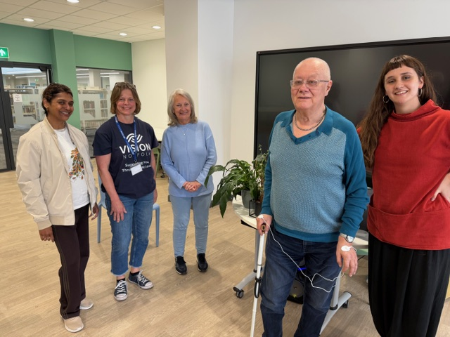
Image: Five “listeners” standing with one of the plant test subjects.

Archery in Corton
Sight loss shouldn’t prevent you from trying new and exciting things!
Following on from success trial sessions earlier in the year we will be holding regular monthly archery session in Corton designed to be accessible for all abilities (and skill levels). Instruction and guidance will be available.
The session will take place on at Warner Hotel Corton, 2 The St, Corton, Lowestoft NR32 5HR. Please get in touch to find out more.

What’s on in Great Yarmouth and East Norfolk

Summer Show at Cromer Pier - Tuesday 1st September
We are planning a special trip out to the Pavilion Theatre on Cromer Pier in September to see their Summer Show. For 24 years, this award-winning seaside spectacle has been the only full season end of the pier show in the world, blending cheeky British humour, dazzling performances, and West End production values that rival the best theatres in London. Please get in touch as soon as possible to let us know you are interested in joining us.
For a full list of all activities in your area visit: visionnorfolk.org.uk/greatyarmouth-hub

Regular activities

Ormesby St Margaret Coffee Morning - First Thursday of the Month, 10am-12pm
Drop by Hirst’s Farm Shop Café and enjoy a cup of coffee, a slice of cake and a chat about everything and anything at one of our socials for local people with sight loss.

Gorleston Tennis - 2nd Friday of the Month,1pm-3pm
Give tennis a try at special sessions led by a LTA-accredited coach. Vision Norfolk is partnering with Gorleston Tennis Club to hold tennis sessions specifically designed for local people with living with sight loss. We use special tennis balls, some have bells so they make a noise while others are larger, so they move more slowly.

Creative Writing - 2nd Friday of the month, 1pm-3pm
Join our writing and storytelling group for local people living with sight loss
in Great Yarmouth. We hope to cover a variety of different subjects, and all formats are accepted. No experience necessary.

Cribbage - Every Thursday, 10am-12pm
Join us at the Great Yarmouth Hub for weekly Cribbage games. No experience is required, we are happy to teach anyone who has never played before. Each session we will split up into groups of 3 or 4 for a relaxed game or two.

Bowling - 2nd Tuesday of the month, 12pm-3pm
Join us at Wellington Bowl on Wellington Pier for a day out and a couple of games.

Contact Details

For further information on how we can support you and how you can get involved:
Website: visionnorfolk.org.uk
Telephone: 01603 573000
Email: office@visionnorfolk.org.uk

Our hubs can be found at:

Norwich
Bradbury Activity Centre, Beckham Place, Edward Street, Norwich NR3 3DZ
Telephone: 01603 573000
Email: office@visionnorfolk.org.uk

King’s Lynn
20 Thoresby College, Queen Street, King’s Lynn PE30 1HX
Telephone: 01553 660808
Email: kingslynnhub@visionnorfolk.org.uk

Great Yarmouth
12 Hall Quay, Great Yarmouth NR30 1HP
Telephone: 01493 745973
Email: greatyarmouthhub@visionnorfolk.org.uk

To stop receiving information from Vision Norfolk, please get in touch and we’ll update your preferences. Registered charity number: 1206599.

