Magpie News – Autumn Edition 2026

The latest news and events from Vision Norfolk.

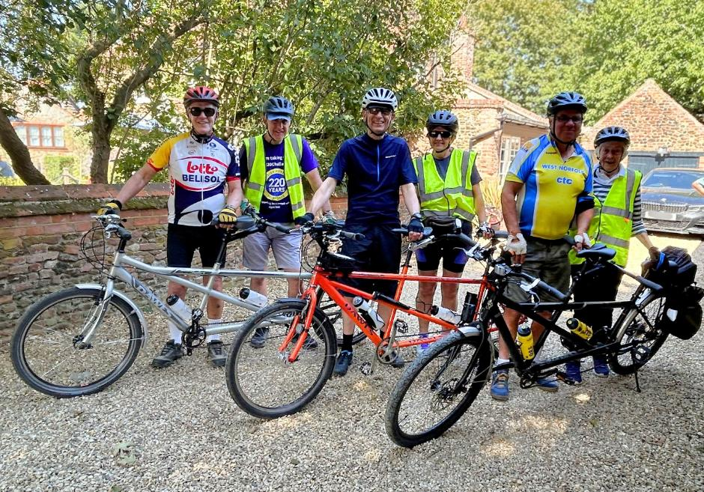
Image: Three pairs of tandem cyclists standing next to their bikes on a sunny day.

In This Edition – Autumn 2026

News from across Vision Norfolk – Page 3
Latest community highlights

Children, Young People and Families – Page 6
See how our CYPF service is making a real difference

My Journey with Technology – Rick’s Story – Page 8
Exploring the new ways to use a mobile phone

Equipment and Technology – Page 10
Equipment for independent living and support with accessing the digital world

Fundraising Triumphs – Page 12
Support from our community

News from Norwich – Page 15
Local updates, events and stories from our Norwich community hub

News from King’s Lynn - Page 19
Local updates, events and stories from our King’s Lynn community hub

News from Great Yarmouth – Page 23
Local updates, events and stories from our Great Yarmouth community hub

A Warm Welcome

Welcome to the Autumn 2026 Edition of the Magpie News!
We’ve had a very exciting summer here at Vision Norfolk with lots of outdoor activities exploring local history, getting active and expanding the community across the county. We also had some wonderful days out meeting supporters at The Bishop’s Garden in Norwich and representing the charity at the Sandringham Flower Show.
As Autumn approaches we look forward to our 221st anniversary on the 14th of October and of course the approach of the Christmas season.
Thank you to everyone who has supported us over the last few months and everyone who has used our services. Every one of you is a valuable member of our community.

Save the Date! Wednesday 14th October

Our Annual Public Meeting will be taking place at our Norwich Hub on Wednesday 14th October, the 221st anniversary of the founding of the charity! Last year we enjoyed moving talks from service users and local experts. We hope to make 2026 another year to remember.

News from across Vision Norfolk

Highlights from our community.

Join our Hammond Court Community in Norwich
Hammond Court offers independent living in a safe, accessible environment. Residents live in their own self-contained flat designed to promote independence, with layouts tailored for vision impaired residents. The community offers opportunities for social interaction within a supportive environment. We have one flat available on the 1st floor.
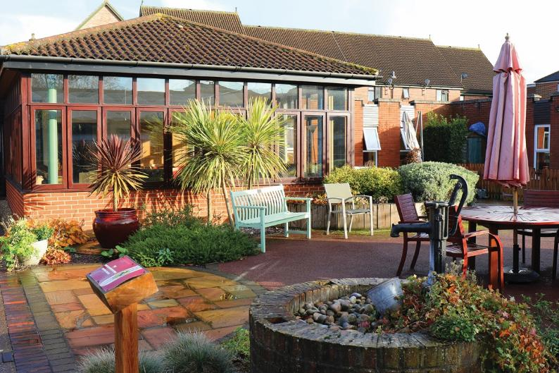
Image: The Hammond Court communal outdoor space.

Summer Garden Party at Bishop’s Garden
Thank you to everyone who came to our Summer Garden Party. We were truly overwhelmed by the incredible support and positivity! Over 400 people attended the event, helping us raise an amazing £3,100. We want to say a special thanks to the Bishop’s Garden team, TATS Buskers for their musical performance, and our wonderful volunteers!

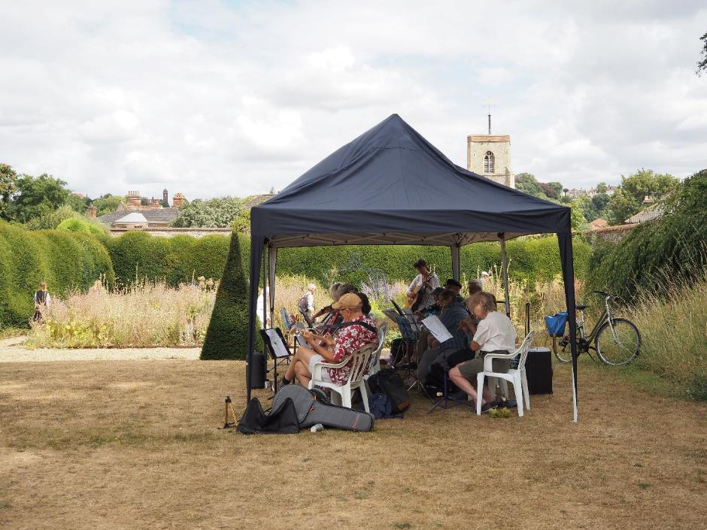
Image: TATS Buskers playing music under a gazebo.

The Sandringham Flower Show
July 22nd-26th we presented the ‘Vision in Bloom Garden’ at the RHS Sandringham Flower Show. The garden was designed to demonstrate how everyone can find joy through gardens with a range of sensory elements. We chatted to people from all walks of life and received press coverage including an interview with RNIB Connect Radio.
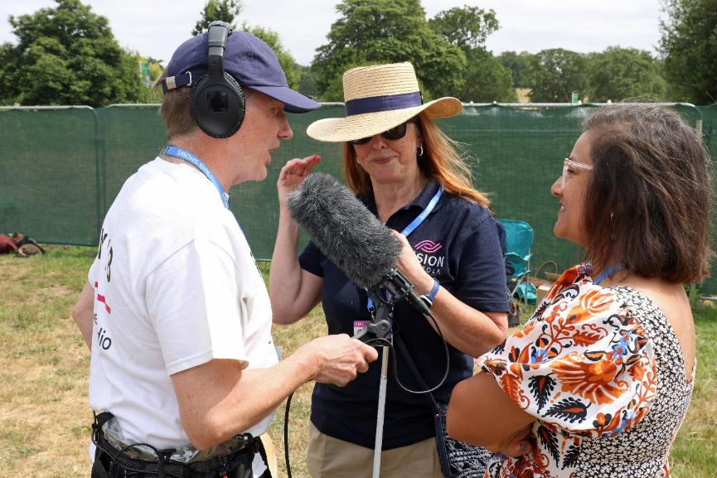
Image: The RNIB Connect Radio interview.

Want to stay up to date? Visit visionnorfolk.org.uk/news to read these stories in full and more!

Children, Young People and Families

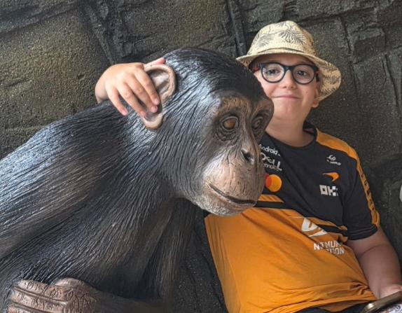
Image: A boy and a statue of a monkey.

It has been a busy and exciting summer for Vision Norfolk’s Children, Young People and Families (CYPF) service. We are delighted to share that we have been selected as a finalist for the Flourish Awards, recognising the impact on families living with sight loss across Norfolk.
The summer has also been packed with opportunities to get involved, including tennis sessions, our Children’s Summer Party, a session at the allotment, alpaca trekking, the Maize Maze, and fantastic days out at Bressingham Steam Museum and Colchester Zoo. It has been wonderful to see so many new families enjoying these activities, trying new things, making memories and connecting with one another.
Meanwhile our outreach service has continued to provide families with practical support, information, signposting and advice tailored to their individual needs.
As we head into autumn, there is still plenty to look forward to. On 13th September, Vision Norfolk will be joining VICTA for a Hautbois Family Day, bringing families together for a day of activities, fun and connection. We are really looking forward to working alongside VICTA and welcoming families to what promises to be a fantastic event.
Any ideas? If you have a suggestion for a new activity or other ways we can support you, please contact us at CYPF@visionnorfolk.org.uk

Our Story – My Journey with Technology

As we head into autumn, there is still plenty to look forward to. On 13th September, Vision Norfolk will be joining VICTA for a Hautbois Family Day, bringing families together for a day of activities, fun and connection. We are really looking forward to working alongside VICTA and welcoming families to what promises to be a fantastic event. I had always had a mobile phone, and I always saw it as a necessity to stay in contact whilst on the move, but with my failing sight I struggled to see the screen and find the buttons.
I have never been too interested in technology. If I can be honest, I’d say sometimes I’m frightened of it, of doing something wrong or even breaking it, but I have been repeatedly assured this can’t happen.
I was told switching to a smartphone would be the best way. My daughter sold me her old iPhone, and I started getting to grips with it. Vision Norfolk has sessions that provide help for us to learn how to use our phones in the best way. I had great help working one-to-one basis with one of their dedicated volunteers. With time and support I’ve learned to think of my new phone as a friend.
All I needed was the confidence to try and with the support from the team, I started to explore the new world that my phone can offer me.
The most difficult thing for me was being able to see where I needed to touch on the screen to operate the phone. But with my smartphone I’m able to talk to it and listen to its response. Using spoken commands, I can tell my phone to call my daughter, or call for a taxi, or even find out what the weather will be tomorrow. No more fumbling for a button!
There are also free apps which I installed on my phone. My two favourites are called Be My Eyes and Seeing AI. I can ask the phone to open one of these apps to help me read a newspaper, describe a scene, identify what label is on a tin and more.
At the age of 80 I must admit I’m a bit of a slow learner but once I understood the very basics, and practiced some of the features I was told about, I have definitely been able to lead a richer and more fulfilling life.
Vision Norfolk demonstrate many kinds of mobile phones which all do some of what I have described. I would ask everyone reading this just to consider what you might be missing by not trying this technology.
I even used my phone to write this story, by using speech-to-text and then sending it by email!
- Rick Scotcher

Start Your Journey
Call us on 01603 573000 to set up an appointment to talk about how we can support you to make the most of technology.

Equipment and Technology

The latest innovations helping people live more independently.

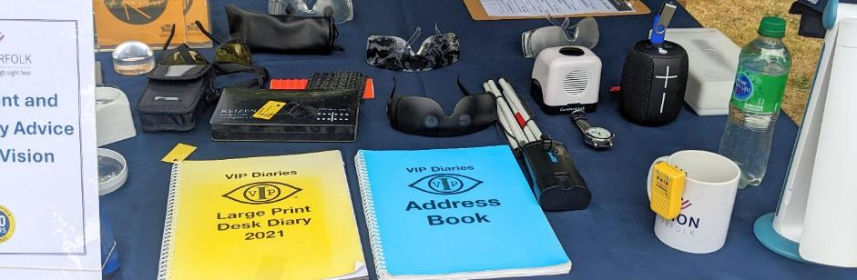
Image: An event table set up with large print diaries, talking clocks, liquid level indicators, sim specs, and other pieces of equipment.

Opportunities to Learn About Technology
Get one-to-one support with technology and accessibility features from one of our expert volunteers.
- Norwich Hub – Drop-in support every Monday from 10am until 1pm. Support available on other dates by appointment.
- Norwich Millenium Library – Drop-in support available on the first Thursday of the month from 10am until 12:30pm in the American Library Meeting Room
- King’s Lynn Hub – Support available by appointment.
- Great Yarmouth Hub – Drop-in support on the last Tuesday of the month from 10am until 12pm. Support available on other dates by appointment.
Please contact us if you have any questions or if you want to make an appointment.
Want to know more? Find out more about how technology supports independent living at visionnorfolk.org.uk/get-support/equipment-centres

Equipment Demonstrations
Experts from low vision equipment companies will be joining us throughout the year to demonstrate their latest equipment and answer your questions. These are drop-in sessions and anyone is welcome.
- Monday 28th September – Humanware will be at the Norwich Hub from 10:30am until 1pm
- Monday 19th October - Optelec will be at the Norwich Hub from 10:30am until 1pm
- Tuesday 20th October - Optelec will be at the King’s Lynn Hub from 10am until 12pm, and Downham Market Methodist Church from 1:30pm until 3:30pm
- Monday 26th October – Humanware will be at the Norwich Hub from 10:30am until 1pm
- Wednesday 25th November – Optelec will be at Merchant’s Place in Cromer from 10am until 12:30pm
- Monday 30th November – Humanware and Synaptic will be at the Norwich Hub from 10:30am until 1pm

Re-Chargeable Magnifiers
We now have a range of re-chargeable hand magnifiers from Optelec to complement our range of battery-operated magnifiers from Optima. They cost a little bit more, but you don’t have to keep buying batteries. They are part of Optelec’s Green Line range made of recycled plastic.

Equipment Sale!
From Tuesday 20th October until close of business on Friday 23rd October, there will be an autumn sale of former demonstration and second-hand equipment at Vision Norfolk’s Norwich Equipment Centre in Norwich. This will be during normal business hours, 9:30am-4pm.
On sale will be a range of magnifiers, overshields, electronic magnifiers, electronic text to speech readers, lamps, watches and many, many more items, too numerous to mention.
Come along and grab yourself a bargain..!!

2027 Calendars
This year, because of a huge increase in production costs, the large print A3 Vision Norfolk Calendar will be priced at £12.
We are hoping to have stock by the end of October. The calendars will be available from the Vision Norfolk centres in Norwich, Kings Lynn and Great Yarmouth. As in previous years we also be able to send out via mail order. Payment can be made via card over the phone or by cheque through the post.
We are unable to post out calendars with an invoice for payment later.

Get Support
To find out more please call us on 01603 573000 or contact your local hub.

Fundraising Triumphs

Walking Angles Way
Mark Chamley from Diss Rotary Club walked the entirely of Angles Way, 78 miles from Great Yarmouth to Knettishall Heath, to support Vision Norfolk, Retina UK, and Global Sight Solutions!
Mark has Retinitis Pigmentosa which has left him with no useful sight. His wife, Bernadette, was with him every step of the way as his trusted guide. They passed historic churches and stopped in nearby villages including Somerleyton, Beccles and Bungay to try out local cafes and restaurants.
In total they raised an amazing £4500 to be shared equally between the 3 charities (£1500 to Vision Norfolk).

Tandem Cycling for Norfolk Churches Trust and Vision Norfolk
On Saturday 12th September Robert Taylor will be joining the annual Norfolk Churches Trust Charity Bike Ride, aiming to cycle to 25 churches in one day. Robert is registered as Severely Sight Impaired, with only a small amount of peripheral vision remaining. Before this year, he had not ridden a bicycle in well over fifty years. That all changed in late May when he discovered that Vision Norfolk offered tandem cycling sessions with cyclists from the West Norfolk CTC.
Due to Vision Norfolk’s role in getting Robert back on the bike, The Norfolk Churches Trust have agreed that 40% of the money raised for Robert’s ride will go towards Vision Norfolk, with the remaining 60% going towards St Andrew’s Church in Little Massingham.
Find out more and support Robert by following the link below. givewheel.com/fundraising/19880/roberts-blind-bike-ride/

Christmas Cards
This year we will be clearing out our stocks of Christmas cards. Cards on sale will include designs created by our talented service users as well as professional designers. There are cute animals, snowmen, church scenes, mischievous gnomes and more!
They will be available at each of our community hubs and at the Original Norwich Charity Christmas Card Shop inside St Peter Mancroft from Tuesday 20th October.
Since it’s a clear out bonanza year, once we sell out of a design it’s gone!

Feeling Inspired? Download our fundraising pack today: visionnorfolk.org.uk/get-involved/fundraise-for-us

What a monthly donation makes possible

Monthly gifts give us a steady and predictable income, so we can plan ahead and invest in meeting needs, delivering services and ensuring we are there when people need us:
- Providing emotional and practical support at the point of diagnosis and from our community outreach teams
- Offering social events and activities that help reduce isolation and rebuild confidence
- Organising specialist activities for children and young people
- Advising on life-changing assistive technology
- Supporting people with sight loss to navigate benefits, education and everyday challenges

When you give monthly, whether it’s £5, £10 or £20 a month, it’s more than a donation – you’ll be part of a community that’s committed to helping people with sight loss live the life they choose.

Join our community of Supporters – become a regular giver today
visionnorfolk.org.uk/get-involved/make-a-donation

News from our Norwich Hub

Local updates, events and stories from our Norwich community hub.

Guest Speaker
Mr. Saad Mahnoud Khan, consultant at the Eye Clinic at the NNUH, came into the Norwich Hub on Friday 12th June to give a talk at a special joint session of the Glaucoma and Macular Support Groups. Mr Khan spoke about eye health, and a variety of eye conditions. We are very pleased with how well received the talk was, with lots of audience questions and other professionals coming into the hub to listen in.
We are hoping to be able to secure more professional guest speakers in the future, if you have anyone you’d like to hear from, please get in touch.

Summer Evening Activities
On Tuesday 9th June we were thrilled to be joined by TATs buskers for a relaxed musical evening. They entertained everyone with a mix of everything from international folk to popular tunes. A good time was had by all, and the evening even saw a bit of impromptu dancing from some of the more surefooted attendees.
On Tuesday 14th July, the hub doors were open late once again for a quiz night. It was a lively contest, with only one point in it in the end. Team members Rick, Jackie, Michael, and Laura were worthy winners, combining their shared knowledge of everything from geography to films to take home the coveted trophy.
If you have any thoughts about evening activities, including suggestions for the future, please get in touch.

Microlight Flight
In June a small group of clients travelled to Priory Farm Airfield for a very special opportunity. John, one of our brilliant volunteers, took four service users up in his microlight plane for a thrilling experience!
Dave, who attended, said that it was “absolutely fantastic, beautiful weather, loved every minute of it. A real once in a lifetime opportunity”. He added that John was a true gentleman, who carefully explained all the safety procedures, and checked in with everyone during the flight to make sure they each felt safe and comfortable.
A big thank you to John for giving this group such a unique experience.
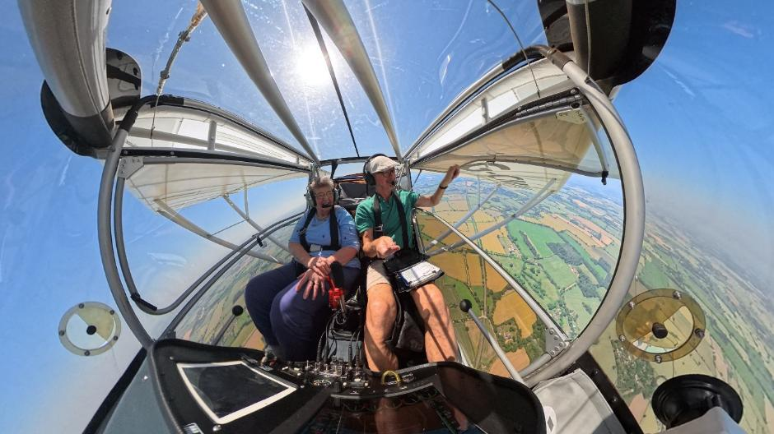
Image: A 360-degree photo of two people sitting inside a small plane.

What’s on in Norwich and South Norfolk

Trip to Dad’s Army Museum – 7th October
We have just organised a special outing to the Dad’s Army Museum in Thetford. Learn the story of the hit BBC television series in a dedicated museum in spitting distance to many of the filming locations. Transport is available to and from the Norwich Hub. Please get in touch to book your free place.

Trip to Norfolk Tank Museum - 16th October
Join us for a hands-on experience at The Norfolk Tank Museum. Their collection of tanks, weapons and militaria, are predominantly from the 20th Century and the Cold War Period. They also have examples of armoured cars, artillery, uniforms and an extensive collection of British small arms. Transportation is available to and from the Norwich Hub. Please get in touch to book your free place.

Norwich Christmas Celebration - 9th December, 2:30pm-4:30pm
Join other members of the Vision Norfolk community for a celebration of the Christmas season with music, refreshments and festive cheer at the Norwich Hub.

For a full list of all activities in your area visit: visionnorfolk.org.uk/norwich-hub

Regular Activities

Audiobook Clubs in Norwich and South Norfolk
Our audiobook clubs offer a chance to get together and enjoy a chat about a chosen audiobook. The monthly meetings are informal, friendly and everyone has an opportunity to give their thoughts and opinions on the audiobook of the month. Books are supplied for free on an USB memory stick.
Diss Library, 4th Friday of the month, 2pm-3:30pm
Vision Norfolk Norwich Hub, 2nd Monday of the month, 1:30pm–3pm

Photography Group - 1st and 3rd Friday of the month, 1:30pm-3:30pm
The Norwich Photography Group is a fortnightly group for photographers living with vision impairment. Both cameras and smartphones are welcome. Meetings include local outdoor photo shoots and sessions reviewing photos at the Norwich Hub.

Dance Workshops - First Thursday of the Month, 1:30pm-2:30pm
Join Compass Dance at the Norwich Hub. Movement to music is an excellent way to keep fit and these sessions are designed to be accessible to everyone.

News from our King’s Lynn Hub

Local updates, events and stories from our King’s Lynn community hub.

Tandems
We are now in an amazing fourth year of our Tandem Cycling partnership with the West Norfolk Branch of Cycling UK. Where has the time gone?
From May to October there are the options of weekly sessions for people to get out and about, supported by pilots from WNBC UK, as well as the chance to join the long group rides once a month, for those people who fancy a ride of 30 miles or more.
The usual weekly rides travel across local areas including Castle Rising, Sandringham, Stow Bridge and Walpole, stopping for refreshments along the way.
The weekly rides are usually between 6 and 20 miles, and are very much tailored to the requirements of the individual riders.
We now have an option for rides in the Swaffham Area if anyone fancies a little go on a “bicycle made for two”.

Hunstanton Walk
On Thursday 9th July, a small group took a trip to Hunstanton to enjoy a sunny seaside day. We started with a relaxed walk up the promenade, taking in the cool breeze and sounds of the sea. We then went and enjoyed fish & chips, and an ice cream in the sunshine before heading back to King’s Lynn. Everyone enjoyed the opportunity to get out in the sunny weather and have a “proper seaside day out”.
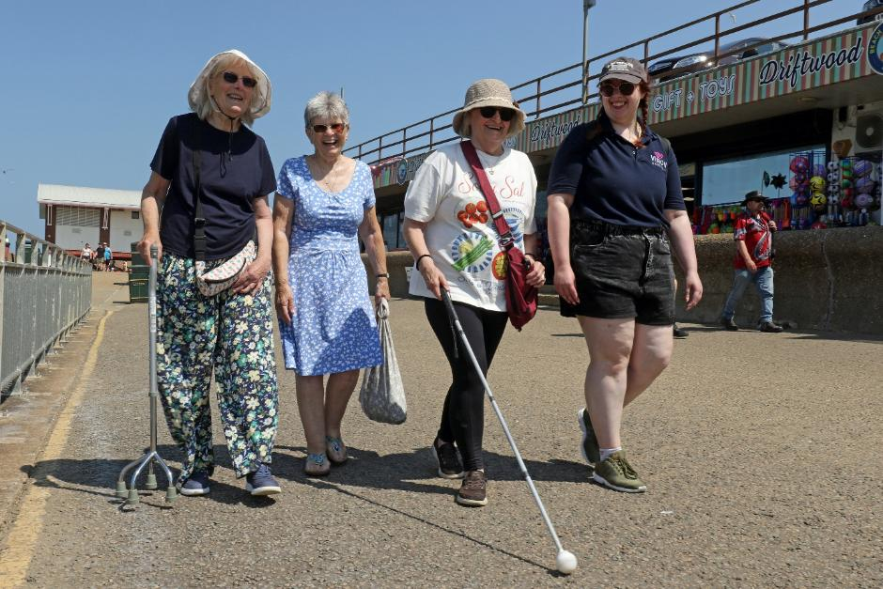
Image: Four women walking along a sunny promenade, smiling at the camera.

Stow Hall Garden visit
We also held a special trip to the beautiful Stow Hall Gardens.
The sun shone brightly as we led a leisurely walk around the scented gardens, full of flowers, fruits and wildlife. Whether stopping to smell the blooms, quietly watching the deer, or taking a gentle sway on the garden swing everyone enjoyed the chance to relax and enjoy their surroundings.
No visit is complete without refreshments, and a chuckle at the café’s name ‘Fork Handles’ (for those of us who remember the famous Two Ronnies Sketch).

What’s on in King’s Lynn and West Norfolk

Macular and More - 3rd Tuesday of the month, 1:30pm-3:30pm
The Macular and More group in Downham Methodist Church welcomes all those living with vision impairment to their monthly sessions.
The vibrant friendly group provides the opportunity to support one another,
share tips and have a jolly good natter. Most sessions also include a speaker.
Upcoming dates for the diary include:
20th October - Speaker from Age UK, and equipment demonstration by Optelec
17th November - Speaker from Hodmedods Hedgehog Rescue
15th December - Macular and More Christmas Party, featuring a performance from the Sing4Fun! Choir

West Norfolk Christmas Celebration - Thursday 3rd December, 11–1, at St Faiths Community Hub in King’s Lynn

For a full list of all activities in your area visit: visionnorfolk.org.uk/kings-lynn-hub

Regular activities

Boccia - 3rd Monday of the month, 2:30pm-4:30pm
New time same friendly group! Taking place at the Alive Leisure Centre in Downham Market. All levels of experience are welcome.

Downham Craft Group - 1st Wednesday of the month, 10am-12pm
Join the friendly and sociable group at the Downham Methodist Church. Led by our amazing volunteers Sherry and Zena. Offering a variety of fun craft activities from pebble and glass painting, to jewellery and eco-friendly cleaning products. The group aims to be fun and informal, making everyone welcome and you don’t have to be an expert to take part – just have a go and have fun.

Marshland St James Coffee Morning - 2nd Wednesday of the month, 10:30am-12:30pm
Our monthly coffee mornings at the Marshland St James Community Centre are well underway, and it would be lovely to welcome a few more people from the local area to come along and enjoy a friendly chat and a cuppa.

News from our Great Yarmouth Hub

Local updates, events and stories from our Great Yarmouth community hub.

New - Cooking and Independent Living Skills
We are starting new cooking group based at the Great Yarmouth Hub! Sessions will focus on independent living skills, exploring equipment and techniques to stay safe in the kitchen when cooking for yourself at home.
There will be four sessions, exploring a different recipe each time.
15th September, 1:30pm–3:30pm
20th October, 1:30pm–3:30pm
17th November, 1:30pm–3:30pm
1st December, 1:30pm–3:30pm
If you’re interested in joining in, please get in touch. It’s free to take part and all materials are supplied by Vision Norfolk.

Exploring East Norfolk on Foot
Throughout the Summer we have been making use of sunlight by running special walking tours around Great Yarmouth exploring the often-overlooked history and art of East Norfolk.
We explored several of the Great Yarmouth Borough Council’s guided walks including the ‘Quayside and Seaside’ walk exploring Great Yarmouth’s sister town of Gorleston-on-Sea.
The ‘Rows and Red Herrings’ walk explored the historic South Quay and how the herring industry was important for the town.
Volunteer Chris Stanley also lead a tour of the Great Yarmouth Sculpture Trail providing lively descriptions along the way.
We have our next two walks scheduled for 14th September and 6th October, and we are hoping to run a few more walking tours before the winter darkness draws in.

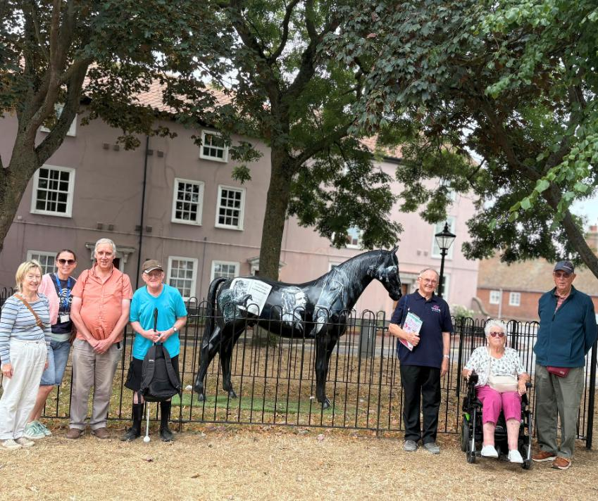
Image: The sculpture trail group posing around a statue of a horse.

What’s on in Great Yarmouth and East Norfolk

Folk Singing Taster Session - 29th September, 1pm-3pm
Join us at the Great Yarmouth Hub for a folk singing taster session. No experience necessary, just a willingness to share some joy and music with others. We are trying things out at this stage. If it’s popular, we’ll put on more sessions.

Great Yarmouth Christmas Celebration - 9th December, 11am-2pm
We’re excited to once again be hosting our annual Christmas party for service users, volunteers, and other members of the Vision Norfolk community. The party will be taking place at the Great Yarmouth Hub and there will be a variety of festive refreshments available. Please let us know if you’re interested in coming along.

Christmas Panto - 15th December
Join us for a special trip to Britannia Pier for their Christmas Panto – Beauty and the Beast. Step inside a world of enchantment, where spellbinding magic, lavish costumes, dazzling sets, and laugh out loud comedy come together in a festive extravaganza. The performance will be audio described and we are in the process of setting up a touch tour of some of the sets and props.

For a full list of all activities in your area visit: visionnorfolk.org.uk/great-yarmouth-hub

Regular activities

New - Musical Afternoons - 2nd Friday of the month, 2pm-4pm
We are getting out of the hub and back into the Blackfriars Tavern for a new social group. The pub have local music acts on Friday afternoons, so you should be able to enjoy a bit of live music and a lively atmosphere. Refreshments are available to purchase at your own expense.

New - Freestyle Crafts - 2nd Thursday of the month, 1pm-3pm
This is a new relaxed crafting group. Bring along something you’d like to
work on, ask us for a suggestion, or just bring yourself and be inspired by the people around you. We will provide crafting supplies and refreshments. Please let us know if you’d like to work on something specific.

Creative Writing - 3rd Monday of the month, 1:30pm-3pm
Based in the Great Yarmouth Hub, our Creative Writing Group is open to all formats and levels of experience. We cover a variety of topics, with optional writing prompts available each month.

Contact Details

For further information on how we can support you and how you can get involved:
Website: visionnorfolk.org.uk
Telephone: 01603 573000
Email: office@visionnorfolk.org.uk

Our hubs can be found at:

Norwich
Bradbury Activity Centre, Beckham Place, Edward Street, Norwich NR3 3DZ
Telephone: 01603 573000
Email: office@visionnorfolk.org.uk

King’s Lynn
20 Thoresby College, Queen Street, King’s Lynn PE30 1HX
Telephone: 01553 660808
Email: kingslynnhub@visionnorfolk.org.uk

Great Yarmouth
12 Hall Quay, Great Yarmouth NR30 1HP
Telephone: 01493 745973
Email: greatyarmouthhub@visionnorfolk.org.uk

To stop receiving information from Vision Norfolk, please get in touch and we’ll update your preferences.

Registered charity number: 1206599.

